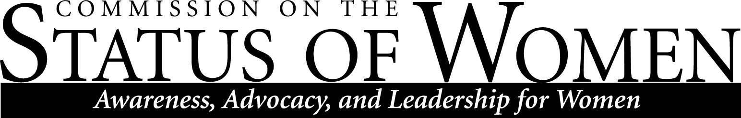
Monday, October 28, 2019, 11:30 – 12:30 p.m. | Havasupai A/B

Minutes

- Welcome and Roll Call
Heather Coate
Gabe Montan͂o
Calvin Legassie
Samantha Clifford
Juana Martinez
Chelsea Green
Sanjam Ahluwalia
Briana Adusei
Monica Jamison
Jill Christensen
Pam Powell

- Success on last tea party
- The last tea party was successful and had a great turnout.

- Gender wage gap data
- Discussion on what to do with data collected from the gender wage gap and how to disseminate the information to the public
- Gabe Montan͂o also addressed why budget information is no longer made public. He said that it is due to fraud and all budget book information can be requested by contacting human resources
- Suggestion to gather more data on pay equity data (Robust data model)
- Sanjam encourages commission members to keep pushing to get data out to the public. She also addressed that this work on gender equality had been going on for about 6 years and commission members should keep working to see the result to the end
- Sanjam said that ASU is doing a similar thing in fighting gender pay inequality gaps on campus
- Gabe Montan͂o addressed that data should have resolutions. He also talked about the need to address data in ways such as:
- Determining how the inequality of the gender pay gap works within the content of the discipline
- Making sure the data presented has all the disparities taken into context
- Data should have resolutions
- Focusing on what part of the inequality will be tackled
- Reframing
- Demographics
- Sanjam addressed that data is been tracked by tenure and non-tenure
- Deliberation to keep this work on the agenda for the semester
- Sanjam addressed the possibility of talking to someone at of human resources to access more information on pay to understand the necessary resources
- Getting historical understanding of data will be important
- Gathering more information on how people are hired and promoted will also be important pieces of data
- OGEI- Still moving forward
- Possibility of having someone from human resources come in next meeting and talk more on OGEI

- Menstrual Health products
- Days for Girls wants to partner with NAU
- Two women who are currently working with Days for Girls have previously worked for NAU. Also, Planned Parenthood is interested in partnering with NAU on this project
- The purpose of this project is to make menstrual products available free of charge for students on campus
- Discussions on how to make this project sustainable
- Discussions on how to make products free for students
- Sanjam addressed that students are charged a mandatory health fee, a discussion was raised on what the fee is for and transparency on where the money goes
- Discussion on funding and support for this project so that it is sustainable
- Discussions on who will pull the strings to get the necessary people on campus involved on this project
- Ideas on having student groups work on getting the word out for the project
- Possibilities of having ASIF come in and talk about the project
- Making the project more centralized to the institution
- Making project grass rooted
- Discussion on executing this project before the end of the semester
- Discussion on the budget for the project
- ASU and UA are interested in this project as well
- Possibilities of using reusable products
- Possibilities on having the project funded by the Green Fund
- Sanjam will be in contact with Josh Spear who works with the Green Fund to talk more about project funding

- Childcare resource
- The commission’s website will link to the Office of the Dean of Students childcare resources
- Childcare voucher is only for NAU students

- Flexible schedule policy
- Discussion on addressing this with human resources
  - Why this has been taken away from classified staff?
- Discussion on inviting Josh Mackey, Chief Human Resources Officer, to the next meeting to talk and answer questions

Meeting ended 1:30 pm

