April CSW Agenda
April 27, 2022 10-11:30 a.m.
Join Zoom Meeting
https://nau.zoom.us/j/85667351830
Meeting ID: 856 6735 1830
Password: 329242

Northern Arizona University sits at the base of the San Francisco Peaks, on homelands sacred to Native Americans throughout the region. We honor their past, present, and future generations, who have lived here for millennia and will forever call this place home.

- 10:00- 10:10 Dr. Luis Fernandez, HSI Advisor to the University Provost- 10 minutes
- 10:10- 10:20 Expand the installation of menstrual items dispensers and providing the products- Bjorn Flugstad, Senior Vice President Finance and Business Services, Kinsey Kavanaugh Vice President of Student Affairs, Margot Saltonstall, Vice President of Student Affairs
- 10:20- 10:25 Approval of Minutes- 5 minutes
- 10:25- 10:55 Updates of sub-committees- 30 minutes
Menstrual Health and Solutions – Wendy Wetzel and Sanjam Ahluwalia,
- Samantha contacted Justin DiNardi on 3/23/22: Initially, these units were installed in the university union with an understanding that they would be restocked by ASNAU/Union staffers. This has been confirmed by Stephanie Bauer.
Fundraising – Lauren Copeland-Glenn and Nena Bloom,
Programming - Mary Ruetten and Heather Rist,
- No More Miss America: The Pageant Turns 100
Child-care - Pamela Powell and Frances Riemer,
Equitable Academic Work Practices - Jennifer Blaney
- Memo sent 3/29/22 by Co-Com to President Rivera-Cruz
- Response: Thanks, Jamie. I appreciate the memo and the thoughtful work that has gone into it. I will review and share with the provost and others. We look forward to advancing the conversation in the weeks ahead as our work comes into sharper focus with the finalization of our strategic roadmap. Please extend my thanks to all who participated in this effort.
- 10:55-11:00 Announce Fifth Annual Women’s and Gender Studies Program and the Commission on the Status of Women Essay, Poetry, and Art Contest winners
- 11:00- 11:05 Announce Diversity awards results
  - Dilofarid for Faculty,
  - Lauren Copeland-Glenn for Staff
  - Sydney Felsen for Student
  - PERIOD at Flagstaff for group/organization
- 11:05-11:25 Third draft of the Strategic Roadmap feedback to the co-chairs so we can bring this to Co-Comm
  - CSW Vision: We envision NAU as a welcoming, diverse, and family friendly community that serves as a model of gender equity.
  - CSW Mission: The Commission on the Status of Women (CSW) makes recommendations to the President and leadership about women’s issues addressing concerns in university policies, practices, and programs to enact constructive change. The NAU Commission on the Status of Women:
    - promotes and advocates for gender equity, parity, and inclusivity
    - fosters a diverse, safe, and welcoming campus environment
    - helps to create a family friendly community
  - Please provide comments
- 11:25- 11:30 Upcoming Events
  - Arizona Women in Higher Education is excited to announce the 2022 annual conference entitled Bridging Divides: Building Constructive Collaborations is scheduled for April 6-8, 2022
- https://news.nau.edu/period-poverty/
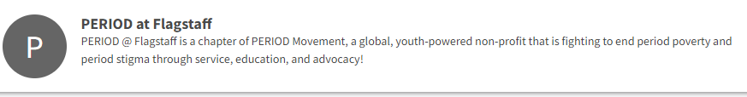
- Other Items
- Next semester meetings 10-11:30 every second Wednesday of the semester.

