2019 Faculty Pay Equity Report

This report examines faculty wages in order to investigate pay equity across the university. Official data was made available through Northern Arizona University’s Institutional and Research Analysis (IRA) pages and the Integrated Postsecondary Education Data System (IPEDS) website. The second section contains data generated based on the “University Salary Appendix” in the FY 19 NAU Budget.

See the Appendix for a narrative on the challenges of accessing relevant wage-related data.

FINDINGS: AVAILABLE INFORMATION

Several NAU-generated reports yield important preliminary insights about pay equity. For example, according to NAU’s IRA website, as of Fall 2018, the average salary for female faculty at NAU is $11,309 less than the average salary for male faculty.

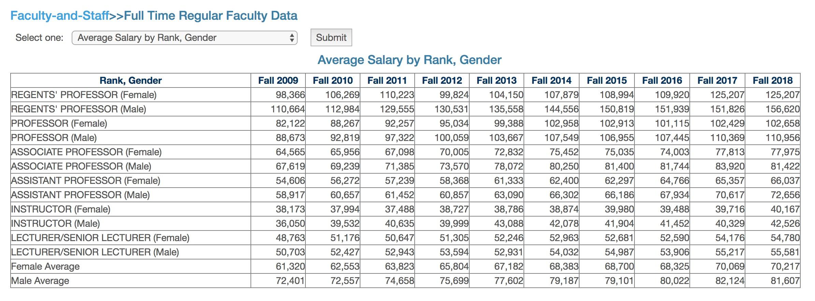

This chart also illustrates that the pay gap between male and female faculty has been increasing over the past six years, from a recent (possibly all time) low of $9,895 in 2012 to the 2018 $11.309.

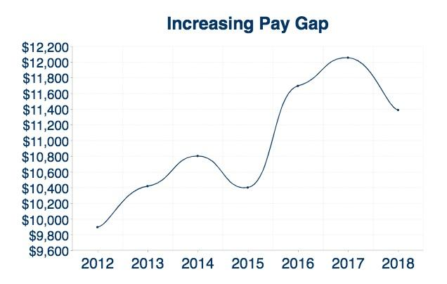

We believe that this pay gap is partly due to the fact that female faculty are overrepresented in non-tenure-track (NTT) lines and underrepresented in tenured/tenure-track (TT) lines. While we recognize that NTT and TT lines mean different things in different colleges, our calculations show that TT lines pay more at every rank and in every college than comparable NTT lines, as later figures will demonstrate. Thus, the overrepresentation of women in NTT lines would translate into lower average salaries.

The difference between male and female faculty by tenure eligibility is considerable. According to NAU’s Fall 2018 Quick Facts: Full-Time Faculty by Tenure and Rank, female faculty comprise about 51.4% (606/1,180) of the full-time faculty body but make up only 41% of TT lines (226/551) and over 60% (380/629) of NTT lines. In fact, if we group faculty by tenure eligibility and gender, female NTT faculty comprise the largest portion of the full-time faculty population and female TT faculty the smallest.

Female NTT faculty 32.2% (380 / 1180)
Male TT faculty 27.5% (325 / 1180)
Male NTT faculty 21.1% (249 / 1180)
Female TT faculty 19.2% (226 / 1180)

Female faculty also make up the majority of our part-time faculty. 2018 data is not yet available, but the 2017-2018 Fact Book lists 593 Temporary Part-Time Postsecondary Teachers in Fall 2017; of these, 382, or 64.4% are female. (Please note: these numbers presumably only count part-time faculty working in the fall semester when the count is taken, not the entire year.)

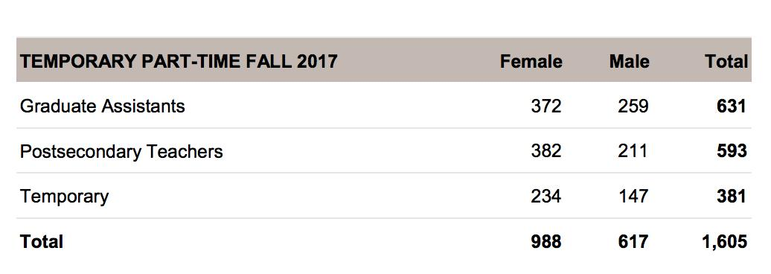

Overall, then, we can see considerable discrepancies in tenure eligibility by gender: in 2017, TT lines were 59.9% male and 40.1% female while NTT lines were 39.3% male and 60.7% female and PT lines are 35.6% male and 64.4% female.

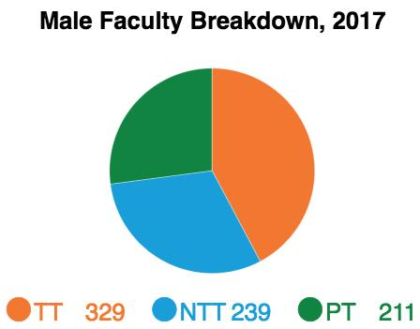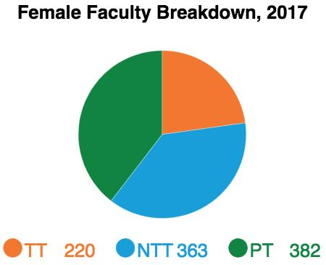

Race and ethnicity appear to have less impact on tenure eligibility than gender. Although NAU does not post statistics regarding numbers of faculty by tenure status and race/ethnicity, this data is available through the IPEDS website. According to IPEDS data, in 2017, NAU had 1,132 full-time faculty; 891 (78.7%) were white, 166 (14.7%) were people of color, 35 (3.1%) were non-resident aliens, and 40 (3.5%) were of unknown race/ethnicity. That distribution remains roughly consistent regardless of tenure eligibility.

2017 Faculty by Race and Tenure Eligibility
 | Total FT Faculty | TT Faculty | NTT Faculty
White | 891 / 78.7% | 433 / 78.9% | 458 / 78.6%
People of Color | 166 / 14.7% | 78 / 14.2% | 88 / 15.1%
Non-Resident Alien | 35 / 3.1% | 18 / 3.3% | 17 / 2.9%
Unknown | 40 / 3.5% | 20 / 3.6% | 20 / 3.4%
Totals | 1132 / 100% | 549 / 100% | 583 / 100%

However, the distribution varies dramatically when we take gender into consideration. Men of color are far more likely to have tenure-track positions than women of color. Although 56.6% of our full-time faculty of color are female, they make up only 43.6% of TT lines but 68.2% of NTT lines.

2017 Faculty of Color by Gender and Tenure Eligibility
 | Total FT Faculty of Color | TT Faculty | NTT Faculty
Male Faculty of Color | 72 / 43.4% | 44 / 56.4% | 28 / 31.8%
Female Faculty of Color | 94 / 56.6% | 34 / 43.6% | 60 / 68.2%
Totals | 166 / 100% | 78 / 100% | 88 / 100%

Although race and ethnicity affects the tenure-eligibility of female faculty, the inequalities are far less substantial.

2017 Female Faculty by Race and Tenure Eligibility
 | Total FT Faculty | TT Faculty | NTT Faculty
White Female | 451 / 78.6% | 174 / 79.1% | 277 / 78.2%
Female Faculty of Color | 94 / 16.4% | 34 / 15.5% | 60 / 16.9%

Comparing the breakdown of 2017 female faculty by tenure eligibility shows that women of color are more likely to be NTT whereas white women are more likely to be TT or PT. Of the 702 white female faculty, 174 (24.8%) were TT, 223 (31.8%) were NTT, and 305 (43.4%) were PT. Of the 158 female faculty of color, 34 (21.5%) were TT, 60 (38%) were NTT, and 64 (40.5%) were PT.

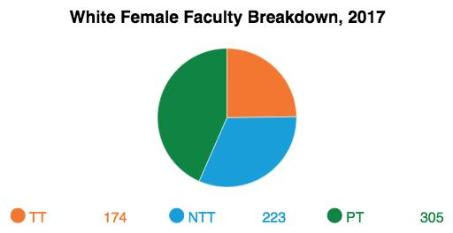 | 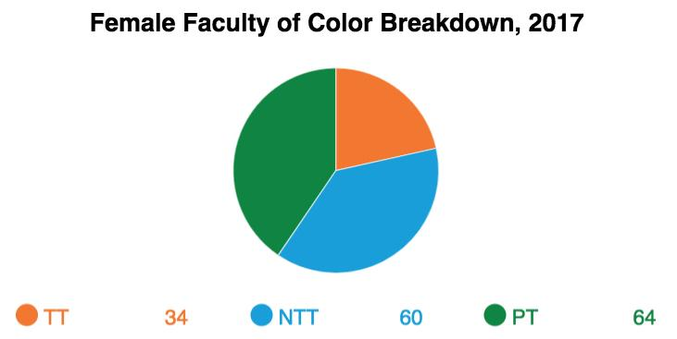
It would seem, then, that gender is far more responsible for pay inequalities than race.

FINDINGS: SALARY INDEX

The statistics above have limitations. For one, they do not allow us to consider the impact of pay differences by discipline. However, using the “University Salary Appendix” at the end of the FY 2019 NAU Budget Book, we were able to provide more detailed data about faculty salaries by rank, college, and department.

We first converted the document into an Excel spreadsheet and sorted on the column “Title.” After removing faculty with “Chair” or “Director” in their title, we were left with the following breakdown.

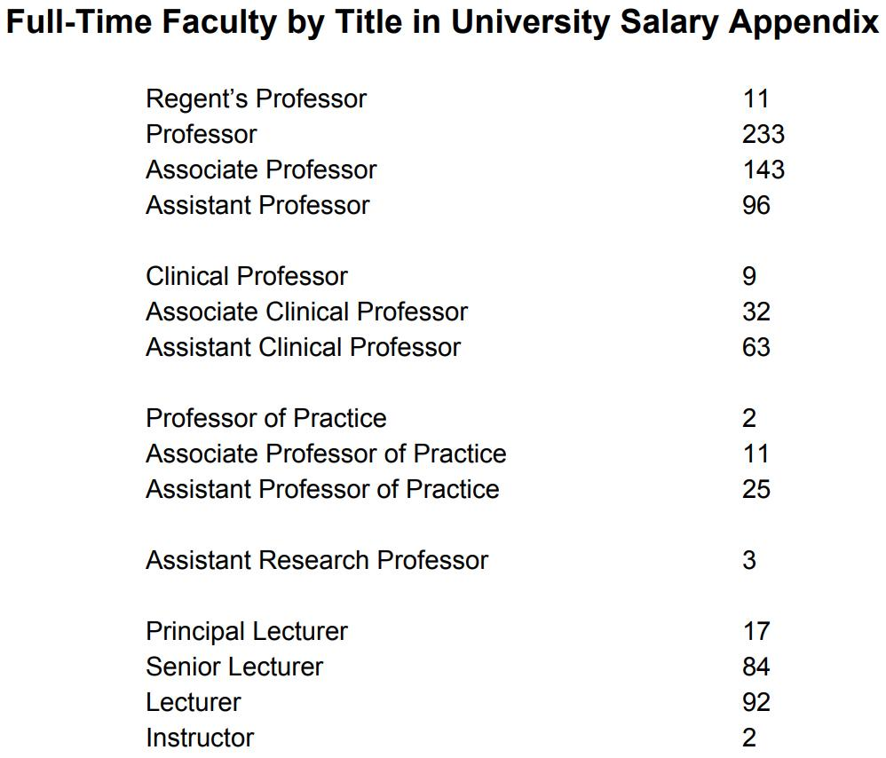

Assuming that the FY19 budget is roughly equivalent to FY18 numbers, we can see that the appendix is missing a considerable number of faculty, primarily because the salary appendix does not include faculty who are paid out of CIF (Central Instructional Funding) money. For example, while the appendix lists only 84 senior lecturers and 92 lecturers, NAU’s IRA Quick Facts for 2018 suggests that these totals should be 92 and 200, respectively. This is one reason why relying on the University Salary Appendix for these calculations is problematic.

Using the salaries in the Appendix is additionally problematic because the appendix does not indicate if salaries are for 9-, 10-, 11-, or 12-month contracts. Associate chairs, for example, are frequently on greater than 9-month contracts, but without that contextual information, their salary would appear to be substantially higher than their peers. However, information available through IPEDS shows that women are more likely to be on greater than 9-month contracts. In Fall 2017, 55 men had greater than 9-month contracts compared to 64 women. Therefore, if anything, the following data will be skewed such that it will reveal less inequality than actually exists since the salaries of women are more likely to be unduly inflated by length of contract.

We first adjusted salaries for faculty who were not 100% FTE. If a faculty member had two .50 FTE lines from different departments, we calculated his/her salary by adding those two lines together. For faculty working less than full-time, we used their part-time salary to calculate their full-time rate. For example, we calculated that a faculty member making $56,576 for .60 FTE would have a full-time salary of $94,293. We then sorted all full-time faculty by rank and gender, excluding chairs and directors, in order to compare average salaries by rank and gender for titles with sufficiently large enough numbers for comparison:

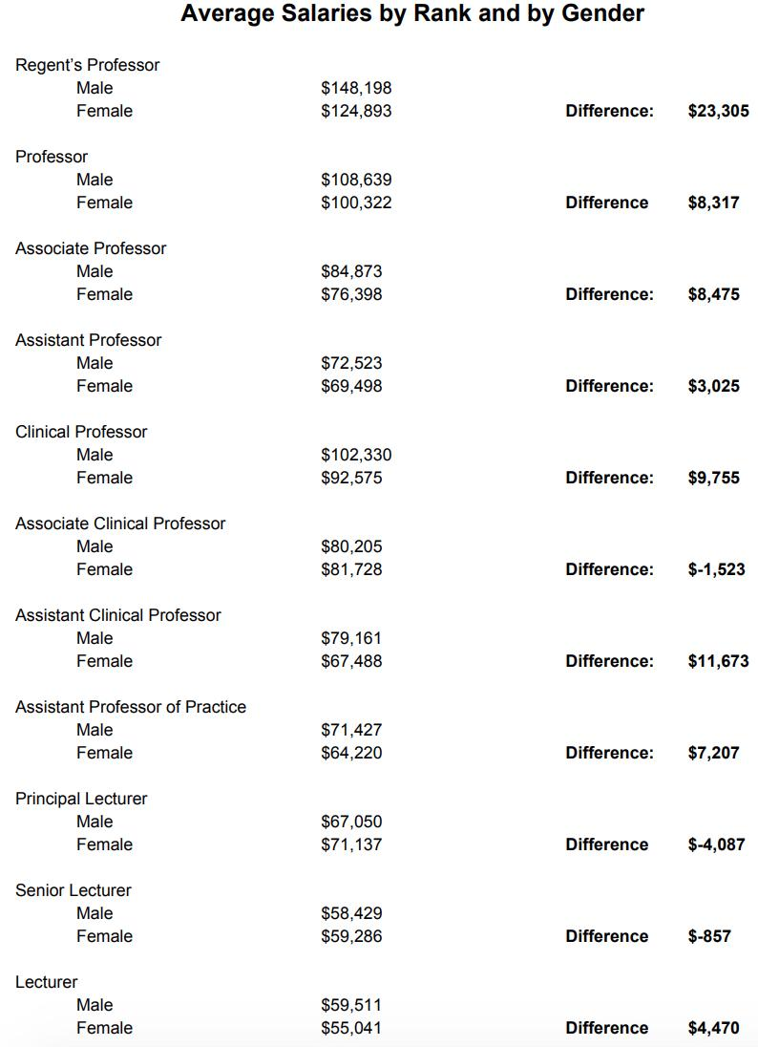

These calculations provide an incomplete picture because they do not take into consideration all full-time faculty, only those included in the University Salary Appendix. Furthermore, these figures do not consider time in rank. However, we do find it significant that disparity exists even at the lowest ranks, where, presumably, differences in time in rank should be negligible.

We recognize that comparing faculty across disciplines is problematic. Without having data that includes CIP code--which was part of our original request--we tried to account for these differences by calculating average salaries by college. We included chairs and directors in these calculations. As you can see, in every college, female faculty have a lower average salary than their male faculty. In fact, across colleges, the average difference is $9,914.

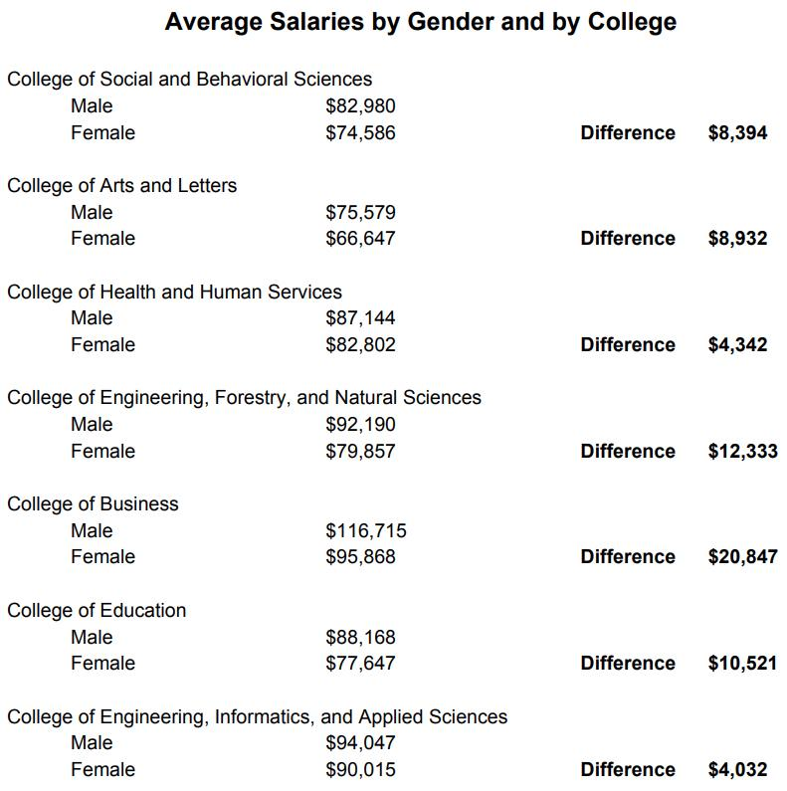

Again, we think that the likely cause for these gendered differences in average salaries within colleges is that female faculty are overrepresented in NTT lines. Although NTT and TT lines mean different things across colleges, as the following chart shows, regardless of college or rank, NTT lines have lower salaries than comparable TT lines. (Please note that we included lecturer, senior lecturer, and principal lecturer salaries in the NTT assistant, associate, and professor averages, respectively.
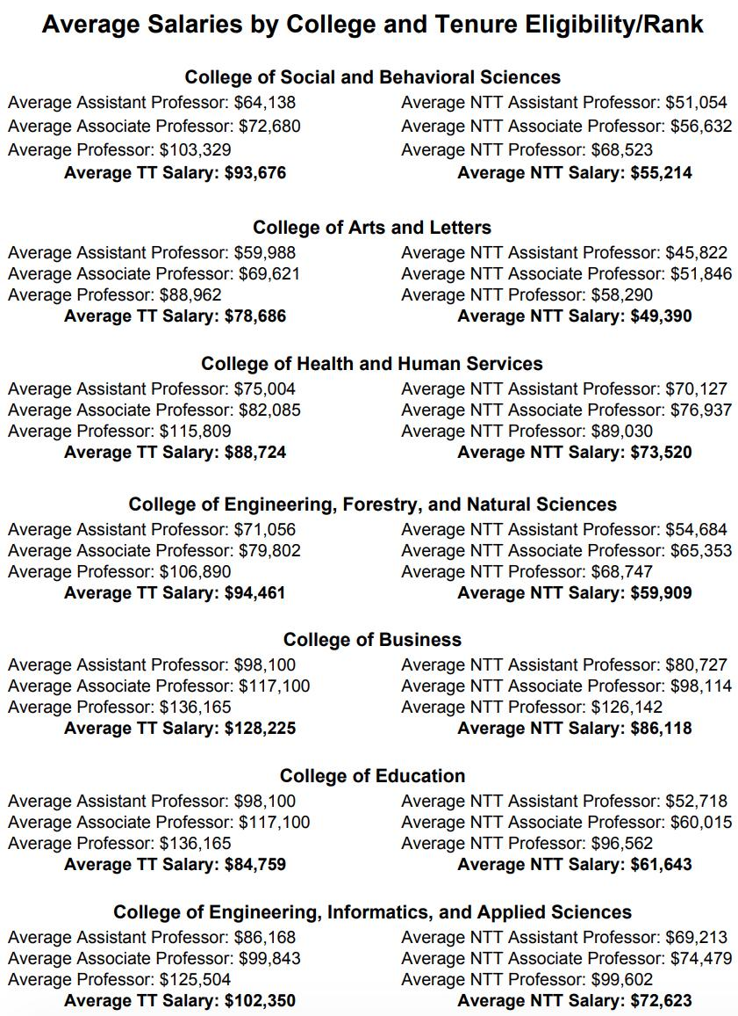

Based on the incomplete list of faculty that we generated from the FY19 Budget, we were also able to examine the gender breakdown of faculty by tenure eligibility for each college (excluding Honors and Yuma and excluding chairs and directors). We discovered that in every college, the ratio of women to men increases when we move from TT to NTT lines.

College of Social and Behavioral Sciences
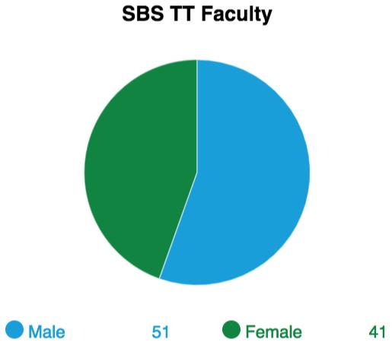 | 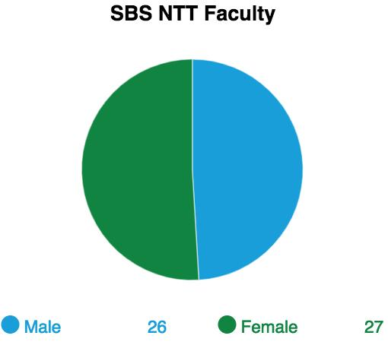

College of Arts and Letters
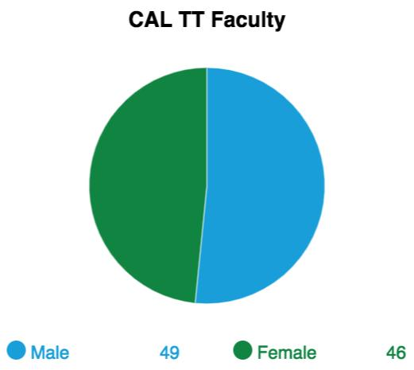 | 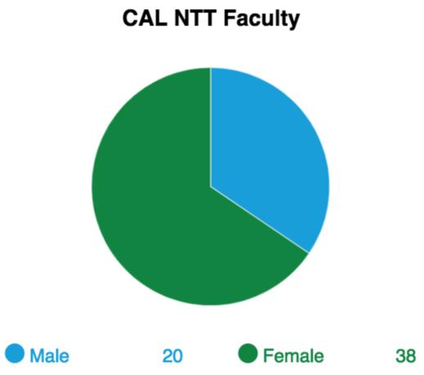

College of Health and Human Services
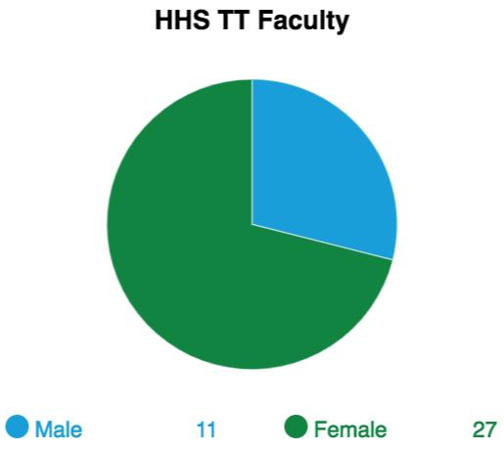 | 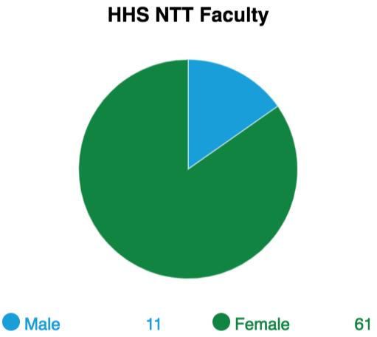

College of Engineering, Forestry, and Natural Sciences
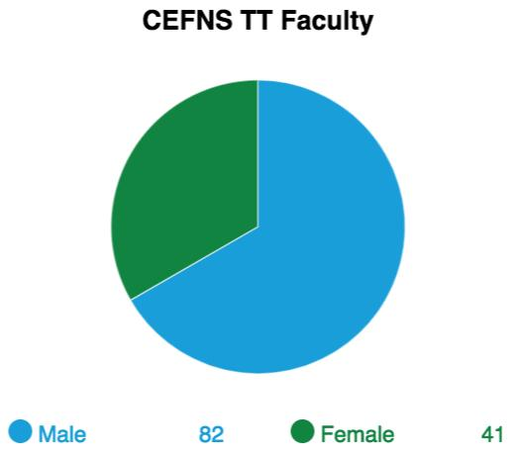 | 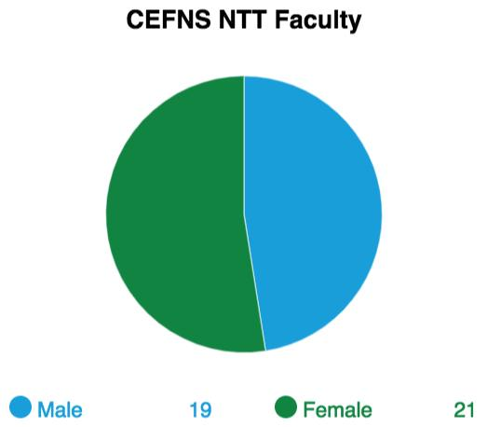

College of Business
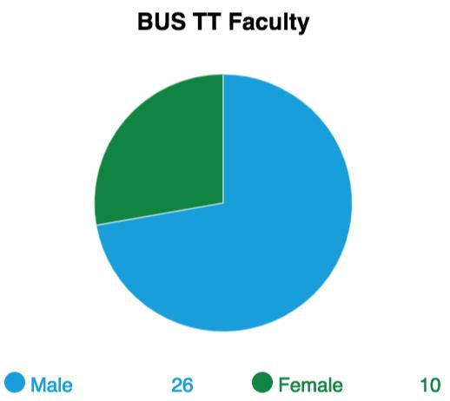 | 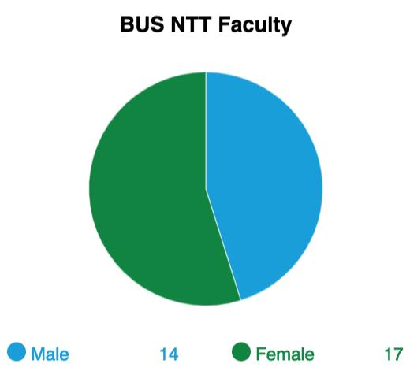

College of Education
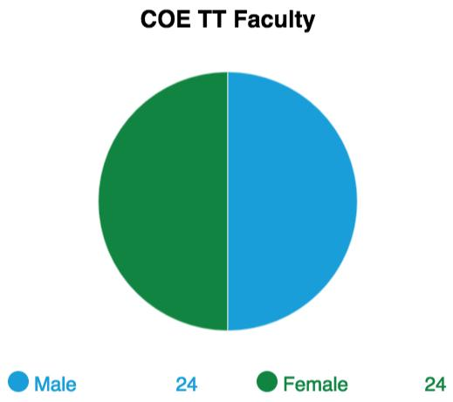 | 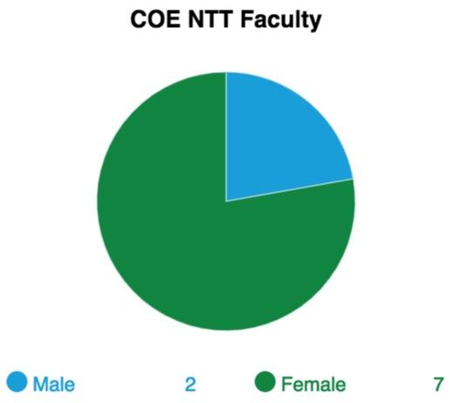

College of Engineering, Informatics, and Applied Sciences
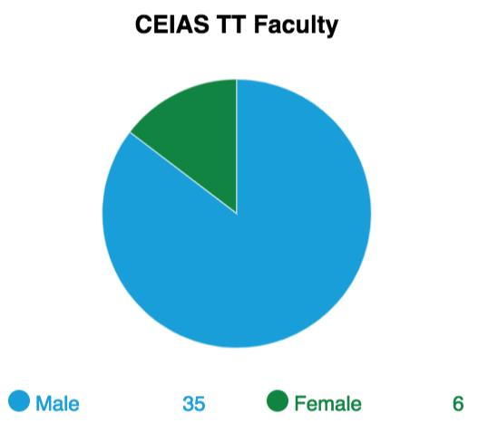 | 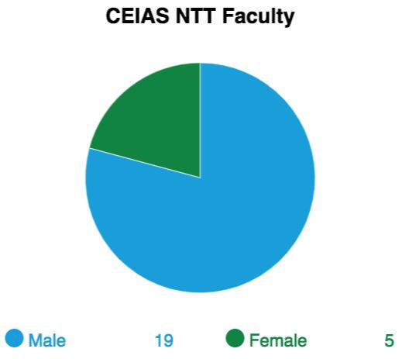

Because every college has a higher proportion of female faculty in NTT lines than in TT lines and because in every college, NTT faculty make less than TT faculty at every level, the average salaries of female faculty will be considerably less than male faculty.

Conclusions

At this point, we suggest that there is a significant pay gap based on gender at our university and that the most apparent cause of this inequity is the overrepresentation of female faculty in NTT lines.

While we have only considered salary differences, the overrepresentation of women and women of color in NTT lines has other serious effects that extend far beyond salary. NTT faculty, for example, are ineligible for various internal awards and grants (such as those sponsored by the Faculty Grants Program). Furthermore, NTT faculty are now no longer able to apply for sabbaticals, according to the most recent communications from the Provost’s office. Finally, NTT faculty are far less likely, if eligible at all, to receive other perks that would not appear in a simple budget, such as start-up funds, summer funding, and course releases. We have no way of measuring the full extent of inequity by gender because the total worth of faculty contracts is not being tracked.

Appendix

Background on Data Availability

In February 2018, during a University Leadership Program session focused on “Negotiation,” Karen Renner raised the question of what impact gender played in terms of salary, separate from negotiation abilities, as she had recently discovered that NAU’s Institutional and Research and Analysis (IRA) page showed that male faculty were currently making on average over $12,000 more than female faculty. In response, Roger Bounds told her that such statistics could be misleading and that more variables needed to be considered since salaries differed so widely across disciplines. Using the current NAU Budget Book, Renner then produced another set of data that allowed her to compare male and female faculty by rank and college. However, she recognized that the results had many limitations--most serious being that the “University Salary Appendix” is incomplete, for it does not list salaries for faculty who are paid out of Centralized Instructional Funds.

In a desire to produce more complete and accurate data, Renner emailed Bounds on February 15 to request a list of all faculty salaries at NAU. Bounds responded the next day, explaining the factors that needed to be taken into consideration when doing pay equity research. He also mentioned that he had already requested “a good data set for just this kind of question” from IRA and that IRA was “on it and will get it to us ASAP” but that they were currently busy with another project. In response, Renner offered to do the research herself and, based on Bounds’ recommendations, asked for “[a]n excel sheet with CIP [Classification of Instructional Programs] code, rank, years in rank, gender, and salary.” She also offered to discuss methodology before doing any computations and stressed that she would share the results afterward.

Not receiving a reply, Renner followed up on Feb. 28. She let Bounds know that her preliminary research suggested that “the introduction of NTT ranks ha[d] increased gender inequity, at least in the past five years.” After a few exchanges, Bounds then wrote on March 7 that he would arrange a meeting with her, him, and Laura Jones, the Chief Institutional Data Officer, “to explain the nuances and make sure [I] ha[d] good data.” A meeting was set up for March 27. However, on that day, Bounds cancelled the meeting.

Renner then approached the co-chairs of the Commission on the Status of Women (CSW), Debra Edgerton and Sharon Gorman, with her research and asked for their assistance gathering more data. CSW made several requests for data in April 2018. Renner shared her research with CSW at their meeting on April 23, 2018, and officially joined the Data Collection sub-committee. On May 15, Renner shared more research with Bounds and made another request for data. Renner and Bounds met shortly after; during the meeting, Boundr mentioned the possibility that an independent company might be hired to do research on the issue. On August 30, Renner emailed Bounds to follow up. Receiving no answer and expecting no new data, she then began working on a formal report for CSW using the most recent data available. As she was finishing up the report in march 2019, Renner followed up again with Bounds, but he had no new information about the hiring of such a company. Renner shared a draft of the report with CSW in March and with other groups from whom she hoped to gather feedback, including Roger Bounds, Priscilla Mills (Assistant Vice President for Equity Compliance), the NTT Council, the Commission on Ethnic Diversity; and the Faculty Senate Executive Committee.

At the final CSW meeting of the year in April, a majority of the commissioners present decided that the results of the report should be shared with NAU leadership and the community as well as on the CSW website in support of information transparency. After the meeting, Debra Edgerton, then co-chair, emailed Renner that she personally disagreed with the decision to post the report on the CSW website and therefore did not want her name associated with the report, even though a majority of commissioners had voted to do so. She wrote that “when the report goes out, it can come from the commission under its name, but if you sign it, it can only be signed by you. (Or you can sign it from the commission).”

However, before the report could be shared, Renner received an email from Priscilla Mills on May 6 that read as follows:

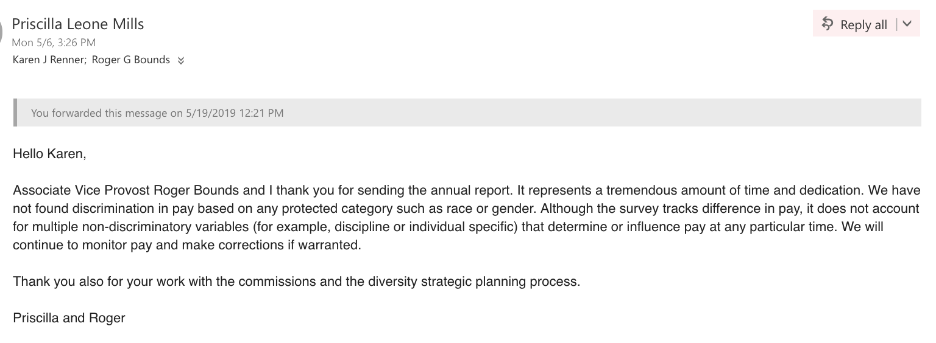

Essentially, the very information that CSW had requested multiple times in order to produce a more robust report was now being used to rule out the validity of the report. Renner forwarded the email to the new co-chairs, Sanjam Ahluwalia and Frances Riemer, and asked how she should proceed.

On May 18, Renner then received an email from Debra Edgerton explaining that she was working on the CSW annual report and asking for an update about the pay equity report. Renner forwarded the above information and asked to see the full report. Edgerton refused to share the report with her or, ultimately, to allow Renner to give any input, even though Renner had acted as co-chair from October to May. Renner then emailed Priscilla to apprise her of the situation and sent her some language that she wished to be included-- she felt it was especially important that Dr. Cheng be apprised of the report and its outcome. Priscilla responded with the following email:

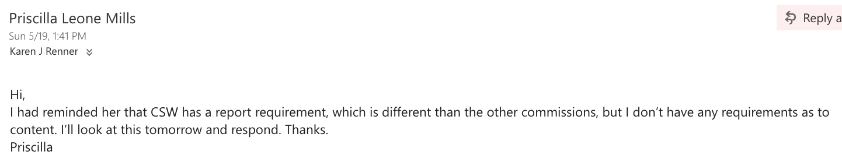

As of July 19, Renner had not received a response.

Renner added in information about the events that took place in May and forwarded the information again to the Faculty Senate and the co-chairs of CSW. The report was also forwarded to Brittany Blanchard to be placed in the Open Knowledge archive and to Sean Evans, of Special Collections, in case they would like to preserve a copy there since another similar pay equity report from 1990 is housed there (LB2334.3.A6 A535).

https://www7.nau.edu/pair/reports/FacultyTrend, “Average Salary by Rank, Gender.” As of March 18, 2019.
https://in.nau.edu/institutional-research/quick-facts/, “Fall 2018 Full-Time Faculty by Tenure and Rank.”
https://in.nau.edu/wp-content/uploads/sites/129/2019/03/2017_2018FactBook.pdf, p. J4.
See Fall 2017 Quick Facts, p. 9. https://in.nau.edu/wp-content/uploads/sites/129/2018/10/Fall2017QF.pdf.
To access this data, go to https://nces.ed.gov/ipeds/, select “Use the Data,” and “Look up an Institution.” After inputting Northern Arizona University (ID# 105330), select “Reported Data,” choose the year you wish to examine, and select “Human Resources.”
Budget Books can be found here: https://nau.edu/budget/reports/.

