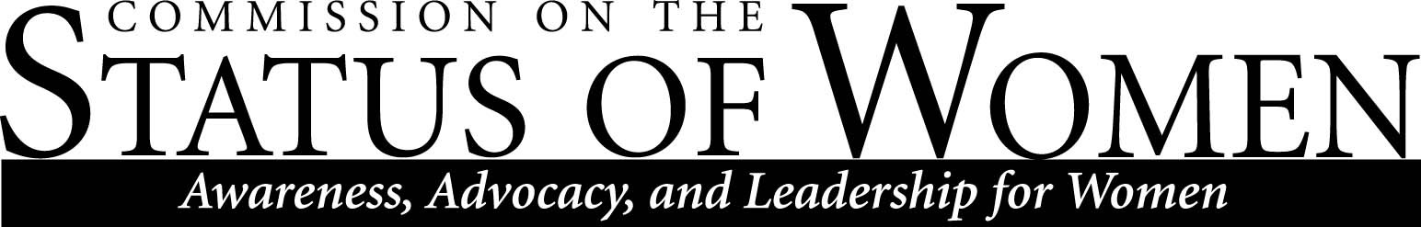

Commission on the Status of Women
Wednesday, April 13, 2011
10:00-11:30
Havasupai C, NAU Campus

AGENDA

Announcements
- First Annual Early Childhood Fair, Sat. 4/9 9:00-12:00, Coconino High School
- NAU Diversity banquet, Tues. 4/26 5:30-7:00, High Country Conference Center
- Martha Portree CSW Scholarship awardees: Angela Martin-Costa, MS Ed Leadership; Amy Tixier, El Ed, Cont Prof

Reports/Updates
- Statement guns on campus
- Child Care Task Force and related: Pam Powell

Discussion
- Night parking permit: Erin Stam and Kira Russo

- CSW Scholarship guidelines

- Election of new co-chairs 2011-2013

Fall 2011 meeting schedule
- Wednesday, 9/14/2011-10:00-11:30

The mission of Northern Arizona University's Commission on the Status of Women is to foster a positive climate that promotes full and equal opportunity for women in the university community. The Commission's objective is to educate the university community and make recommendations to the President about women's issues so that concerns in university policies, practices, and programs that affect women can be addressed to bring about constructive changes.
Contact CSW at CSW.Office@nau.edu for more information.

