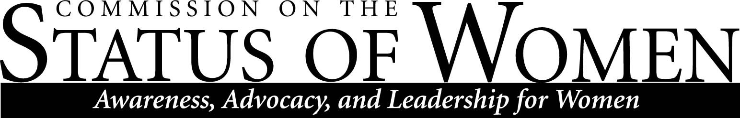

Commission on the Status of Women
Monday, November 5th 2012, 1:30 – 2:30 pm
Location: Performing Arts 143, Conference Room

1:30 – 1:40 Introductions and announcements
- Romeo and Juliet Play
- Vagina Monologues casting is complete: Show February 15-16, 2013 Dubois Center
1:40 – 1:50 Update on Council for Equity and Inclusion
- Official name for the all-encompassing council on the diversity commissions: Council for Equity and Inclusion; the ‘clearing house’ for all programs!
- Discussed continued work on cultural mapping; invite speaker in December meeting
- Follow up with Karen on breakdown of gender differences by University Departments; also invite for December meeting
1:50 – 2:05 Report on and discussion of parking
- Continued concerns regarding safe environment for female student on campus at night.
- Proposed ideas include extra lighting, more escort services, earlier class hours, longer bus times.
- Collaborate with Facilities and NAUPD to secure campus at night.
2:05 – 2:20 Scholarship drive; possibilities with ASWI
- Proposed to establish CSW Facebook events page
- Planning to incorporate a scholarship drive for all diversity commission scholarships at the Diversity Awards Dinner Spring 2013
2:20 – 2:30 Diversity Awards Dinner (April 10, 2013), and other priorities

Contact CSW at CSW.Office@nau.edu for more information.

The mission of Northern Arizona University's Commission on the Status of Women is to foster a positive climate that promotes full and equal opportunity for women in the university community. The Commission's objective is to educate the university community and make recommendations to the President about women's issues so that concerns in university policies, practices, and programs that affect women can be addressed to bring about constructive changes.

