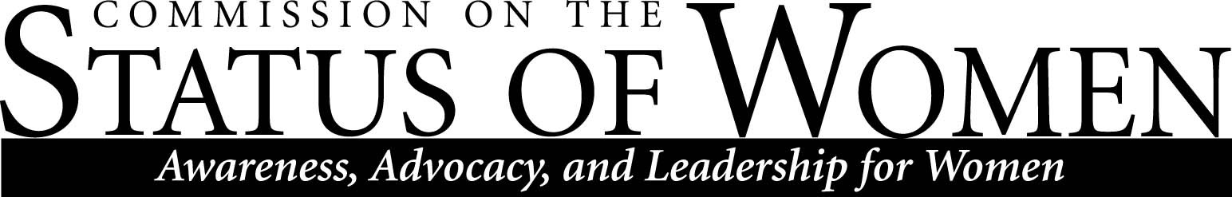
Monday, August 31
12:00 – 1:30 p.m.
Cline Library, Room 169 (Teaching Commons)

Meeting Minutes

Meeting called to order at 12:01 p.m. by CSW Co-Chair Andrea Houchard.

Members present:
- Andrea Houchard, Philosophy in the Public Interest.
- Heidi Feignbaum, Mechanical Engineering.
- Will Cordeiro, Honors Program.
- David Camacho, Special Assistant to the President.
- MaryLynn Quartaroli, Undergraduate Research.
- Meredith Heller, Women’s and Gender Studies.
- Paul W. Jagodzinski, Dean, College of Engineering, Forestry, and Natural Sciences.
- Amanda Loveless, Equity and Access.
- Maggie Vanderberg, Computer Science.
- Danielle Gervasio, Comparative Cultural Studies.
- Pamela Powell, Teaching and Learning.
- Alexandra Carpino, Comparative Cultural studies.
- Jamie N. Baxer, Equity and Access.
- Arturo Magana, Anthropology.
Business:
- Welcome and introduction by Andrea and Heidi.
- Members introduce themselves.
- Announcements
  - Welcome brunch, in partnership with AAUW and ASWI to be held on Saturday October 10th, from 10 a.m. to noon. This is an opportunity to engage the NAU community and recruit new members—all new hires, men and women, can join CSW. We’ll send an email reminder.
  - Communication: general messages should go to CSW-General. Specific questions should be addressed to either Andrea or Heidi.
- CSW’s purpose:
  - CSW is a research commission which advises NAU’s president on women’s issues. We have a direct line to the president.
  - Last year we wrote an executive report on our findings. We plan to do this again. The executive report is a strategically organized collation of subcommittee findings.
  - We have a BbLearn website, an NAU website, Listserv, etc.
    - The BbLearn website is a place for subcommittees to have shared folder and workspace if they choose. Subcommittees may also choose to collaborate using Dropbox or some other means. Each subcommittee should establish their own preferred way of collaborating.
    - The listserv will be used for annnouncements.
  - We should encourage advocacy and recruit women on NAU’s staff, faculty, and student body.
- CSW’s structure:
  - CSW is made up of subcommittees.
  - Discussion of subcommittees:
    - Gender Parity members: Paul Jagodzinski, Rachel Koch.
    - Child Care members: Paul Jagodzinksi, and Pamela Powell.
    - Portree and Fundraising members: Pamela Powell and Alexandra Carpino.
    - Women’s Health members: Will Cordeiro (Chair), Amanda Loveless, and Meredith Heller.
    - Non-tenure Track members: Danielle Gervasio (Chair), Maggie Vanderberg
    - Strategic Planning and Collaboration members: Andrea Houchard and Heidi Feigenbaum.
  - Discussions on subcommittees:
    - Childcare members discussed advocating for men with children.
    - Women’s health members discussed newly formed committee; goal is to gather information for an actionable plan for parental leave. ASU and U of A have 6 weeks of paid parental leave. NAU has the federal minimum standard.
    - David Camacho discussed comparing NAU with ASU and U of A:
      - CSW can draw on H.R. for help on data and costs.
      - NAU offers CSW assistance on research.
      - At times it’s best to “shame” NAU into action.
      - Concrete data is best.
      - It’s smart/good to align CSW’s goals with other university goals.
      - Friday’s meeting at BAC will discuss student climate findings relevant to CSW.
    - Collaboration with Committee for Ethnic Diversity:
      - Currently this committee offers online trainings.
      - There’s a potential for collaborative projects—e.g. Black History Month, Women’s Month, Hip-Hop, etc.
    - Women @ NAU—Advance Grant:
      - Committee requested CSW’s 2014 executive report.
      - Committee is to highlight concerns at the institutional level—will work with other subcommittees.
Meeting adjourned at 1:10 p.m. by CSW Co-Chair Andrea Houchard.

