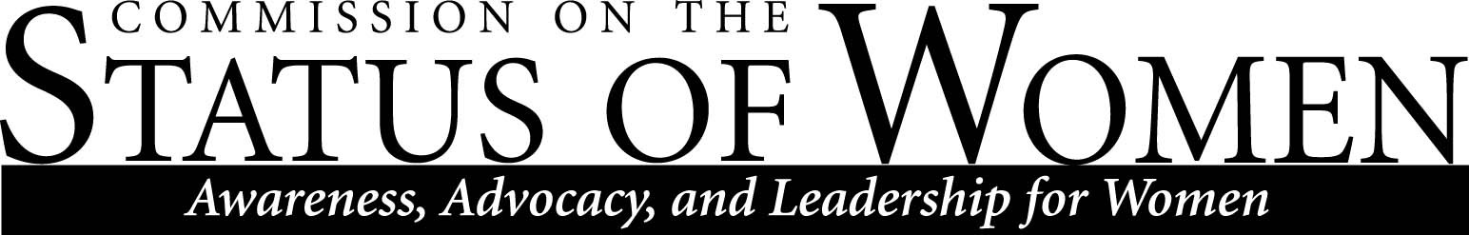
Monday, November 2nd, 2015
12:00 – 1:30 p.m.
Babbitt Administration Center, Room 206

Meeting Minutes

Members Present

- Andrea Houchard, andrea.houchard@nau.edu, philosophy
- Heidi Feigenbaum, heidi.feignbaum@nau.edu, mechanical engineering
- Maggie Vanderberg, maggie.vanderberg@nau.edu, CS/EE
- Jaime Baxter, jaime.baxter@nau.edu, EAO
- Sharon Gorman, sharon.gorman@nau.edu, ELC
- Meredith Heller, meredith.heller@nau.edu, WGS
- Dan Kain, daniel.kain@nau.edu, office of the provost
- Pam Powell, pamela.powell@nau.edu, teaching and learning
- David Camacho, david.camacho@nau.edu, office of the president
- Jaimie Paul, jamie.paul@nau.edu, career development
- Arturo Magana, am838@nau.edu, anthropology

Welcome and Introductions
- Meeting called to order at 12:02 by Heidi Feigenbaum.

Announcements
- No new announcements.
Seeking New Co-Chair
- Andrea will step down from co-chair position at the end of fall semester. Andrea stated non-tenure track professors do not receive credit on SOE, that there is a notable difference in status and rank between tenure and non-tenured professors, even though they carry out the same work.
- Heidi opened discussion to the commissioners present. Heidi asked if anyone is willing to serve as a new co-chair.
- Commissioners elected Sharon Gorman as the new co-chair. Sharon will serve as co-chair along with Andrea and Heidi for remainder of the fall semester. Then, in the Spring semester, Sharon and Heidi will serve as co-chairs.
Report from Welcome Brunch
- The welcome brunch allowed CSW members to make good connections with the community—ASWI. The provost attended and introduced himself.
- Someone suggested next year CSW should hold welcome brunch during work hours, like a Friday afternoon closer to the start of the fall semester. If held during work hours, commissioners expect more people to attend meeting.
- Commissioners discussed Productive Beginnings Conference.
- David Camacho stated he will provide CSW with a commission banner.
Results from Diversity Symposium
- Facilities and development sponsored symposium, at the urging of the Commission of Ethnic Diversity.
- Discussion topics: unpaid labor, accessibility, equity, awareness.
- David asked commissioners if they have any ideas for faculty development.
  - Non-tenure track: promotion process and negotiation.
    - COFS document: https://nau.edu/Equity-and-Access/_Forms/Conditions-of-Faculty-Service/
  - Gender inequality.
- David said to commissioners that he and Dan Kain are researching unconscious bias at the university, as per provost suggestion.
Request for Information: Lecturers, Senior Lectures, by Gender
- Commissioners requested pay/salary information—any information not on the budget book is not publically available. Commissioners requested more data on gender/degree and pay, along with more transparency.
  - Dan will research and present findings at next CSW meeting.
Report on NSF Advance Grant
- Letter of intent is due Friday.
- Grant focuses on women in STEM fields. Commissioners discussed role models and peer mentors, and identifying women/resources.
- Independent group: attempt to help NAU faculty/staff negotiate salaries, child policies, etc.
- Grant work
  - Backup childcare
  - Babysitting network
  - Website network—but issues of liability surface.
- Active recruiting
  - Women are taxed to serve on hiring committees—this is not the best way to establish diversity in the academy.
  - A lot of other schools hire recruitment teams, not NAU.
  - Need a more active recruitment process, more creativity.
  - Having low $ creates a problem when recruiting.
Reports from Committees
Out of time
Dannielle will email information.
Arturo Magana will email a survey concerning next meeting location.
David wants CSW to set out a clear set of goals—strategic planning.

