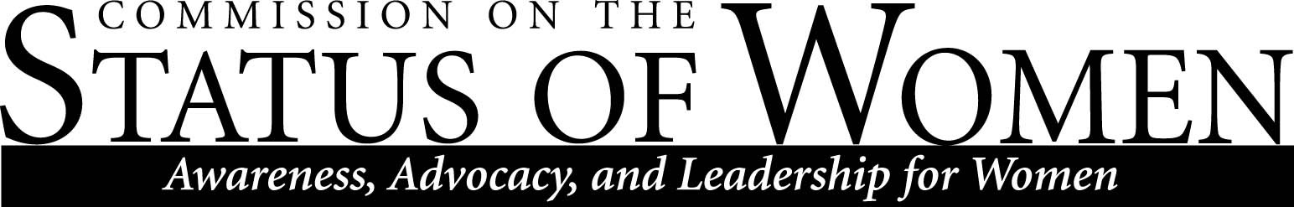
Monday, October 5, 2015
12:00 – 1:30 p.m.
Cline Library, Room 169 (Teaching Commons)

Meeting Minutes

Members Present

- Heidi Feigenbaum, heidi.feignbaum@nau.edu, mechanical engineering
- Maggie Vanderberg, maggie.vanderberg@nau.edu, CS/EE
- Will Cordeiro, william.cordeiro@nau.edu, honors program
- Danielle Gervasio, danielle.gervasio@nau.edu, CCS
- Carol Lorek, carol.lorek@nau.edu, AAUW
- Jaime Baxter, jaime.baxter@nau.edu, EAO
- Sharon Gorman, sharon.gorman@nau.edu, ELC
- MaryLynn Quartaroli, mtq2@nau.edu, UC-UG
- Meredith Heller, meredith.heller@nau.edu, WGS
- Andrea Houchard, andrea.houchard@nau.edu, philosophy
- Dan Kain, daniel.kain@nau.edu, office of the provost

Welcome and introductions
Announcements
- AAUW, ASWI, CSW Welcome Brunch
Saturday October 10 (10:00 a.m. – noon)
- Email: “Friends of CSW” for things not from us.
- Jim Coleman, the provost, along with new faculty, will attend the welcome brunch.
- Commissioners suggested next year’s welcome brunch should be held during weekday work hours.
- Paul Jagodzinski would like to ask Lauren Huenneke to join CSW.

Sign-up for sub-committees
- CSW has no formal process of becoming a member—one just comes to meetings and/or joins a sub-committee.

Report from meeting with Jennus Burton and Diane Verkest and general FMLA discussion:
- Given budget cuts this year, can’t spend real dollars on this.
- If commissioners have examples of more flexible compassionate donation of leave &/or more flexible FMLA from other universities (that don’t cost real dollars)—please send suggestions to HR.
- Discussion on CSW website about FMLA, how to navigate the process, and how to negotiation for yourself.
- HR serves as a liaison to CSW.

Reports from sub-committees
- Gender Parity
- Child Care
- Women's Health
  - Paid parental leaving—report from meeting with HR & VP of finance and administration.
- Non-tenure track
  - Where should we be going with this?
  - Promotion for non-tenure track: See COFs, update CSW website to have this info.
  - No security = need to do extra stuff.
  - Look into Coach Survey for information.
  - Make contact with Season.
  - Maggie attend non-tenure track meetings?
- Strategic Planning & Collaboration
  - Slides posted on BBLearn study of campus climate for transgender students and minorities at NAU.
  - Cline library bathroom: important for families, those with disabilities, and globally.
Next meeting
- November 2nd, 2015, at Babbitt Administration Center Conference Room, 12:00-1:30p.m.

