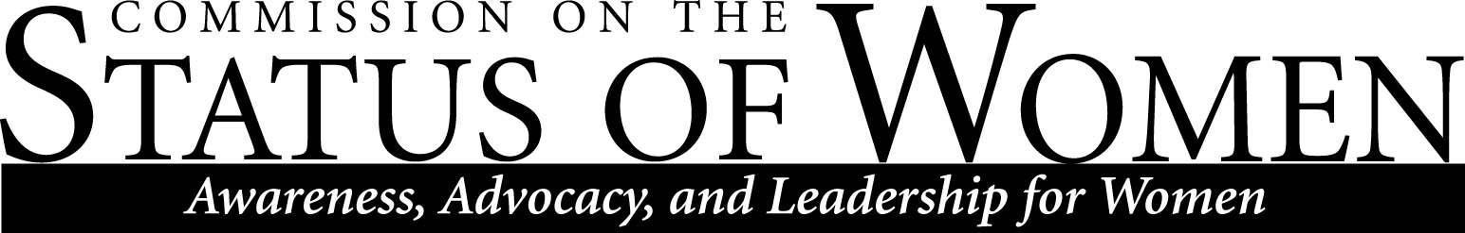
Monday, April 22, 2019, 12:00 – 1:30 p.m. | Cline Library, Room 131 (Student Media area)

Minutes

- Welcome and Roll Call
  - Karen Renner
  - Debra Edgerton
  - Megan Trout
  - Michele Lee
  - Calvin Legassie
  - Bo Schwabacher
  - Sanjam Ahluwalla
  - Danielle Gervasio
  - Madione Schutten
  - Jennifer Koehmstedt
  - Frances Riemer
  - Danielle Gervasio

- Announcements
  - Information about HR Benefits Committee meetings.
    - PDF reviewed about HR benefits committee. A representative is needed.

  - The Diversity Awards dinner/reception will take place on May 2 6:00 to 7:30 p.m. Our winners are
Student: Michele Lee
Faculty: Debra Edgerton
Staff: Sharon Gorman
Organization: WGS
RSVP by April 26 here: https://alumni.nau.edu/eventregistration.aspx?evt=538.

  - Portree Scholarship update (Debra). This will be the final year that the ROTC will support CSW and the Portree scholarship because the organization is “going in another direction.” We now need to think of other ways to support the scholarships. Donations can be designated on the upcoming Giving Day May 1st through NAU Foundation. More information about giving on the CSW website: https://nau.edu/csw/give-now/. Give Online: https://alumni.nau.edu/giving.aspx?SKIPINTRO=Y or https://foundation.nau.edu/naupayrolldeduct.aspx?APPEAL=NAUPD. Search funds for “Portree Commission Status of Women Schp” or “Commission on the Status of Women.” The fund number for the Martha Portree Scholarship is fund 4904. We can’t lose this scholarship. It is the most tangible thing CSW does by supporting single mothers trying to get an education. I challenge our membership to make a one time donation of $20 this year through the above fund number. If everyone gives, we will have enough to support two scholarship next year.

  - The letter from the co-chairs of CSW, CED, CDAD, and LGBTQIA Commission regarding the change in format to the Diversity Awards dinner was sent to Dr. Cheng, Joanne Keene, and Priscilla Mills on Saturday, April 13. A copy is attached. No response has been received.

  - Discussion of status of Diversity Fellow hiring. Professor Gabriel Montano will begin this summer.
    - http://www.jackcentral.org/news/president-rita-cheng-chooses-a-new-diversity-fellow/article_344a7778-8cc7-5bd8-94d6-66533bf49c4d.html

- Discussion and vote on Pay Equity report (Karen).
  - Karen provided update on feedback received and revisions made.
  - Michele Lee shared that it had been provided to Graduate Student Government and Karina, the Associate Dean of the Graduate College.
  - Discussion of where lecturers and principal lecturers are averaged into assistant professor. This is common for NTT reporting.
  - Discussion of who to disseminate the report to: more limited recipients versus campus-wide.
    - Motion to disseminate to the more limited recipient list. Seconded. All in favor, passed unanimously.
    - Discussion of including it on the website or not.
      - Discussion of including a deadline of when it will be put up on the website, or not. I.e. “This is the opportunity for providing feedback.”
        - Motion to post on website a month after the report is disseminated. Discussion of motion. Motion amended to include a clause in the email when disseminated and include on the website after the semester is over. Seconded. 1 nay, 1 abstention, all other ayes so the motion passes. The letter will go out from the commission at-large and not both co-chairs since one of the co-chairs voted against the motion (and requested this note be added to the minutes).
    - Discussion of including co-chairs or not.
  - Discussion of desired impact of the report.

- Discussion of co-chair and direction of CSW moving forward (Debra, Karen).
  - Discussion of using a more organic “feminist organizing” model which may involve amending by-laws. Rather than a chair, spread duties out amongst interested members and have a point-of-contact for things like the website.
  - Discussion of status of CSW and why participation may be low.
  - Discussion of nominating as co-chairs Sanjam Ahluwalla and Frances Riemer for one-year only. Calvin motioned. Seconded. All in favor, no opposition.
  - Discussion of meeting location.

- Report out from subcommittees.
  - Archiving subcommittee update provided.
    - New student will be doing an internship in the fall through Public Humanities.

- Report out regarding Diversity Strategic Plan Task Force meetings (Karen and Debra). Next meetings: DSP Priorities Task Force: 4/22, 2:30-4:00 pm; DSP Metrics Task Force: 4/24, 10-11:30 am. Both will take place in the Graduate College Conference Room, A109.

- Discussion of future meetings of co-chairs and beginning of fall 2019 semester all-commission gathering.

