Table of Contents
Completing the form 1
Workflow 8
Reporting Dashboards 33
Email Templates 34
Document Retrieval 54
User Group Access 55

Completing the form
- Log into the form here.
- The submitter information will populate following form load.
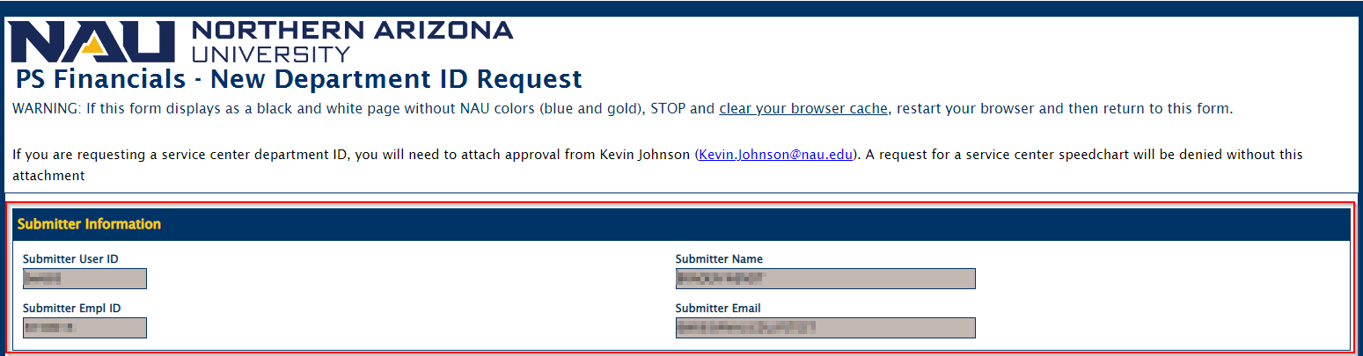

- Information will be collected on the New Department ID Request. The first step is to provide the Department Prefix.
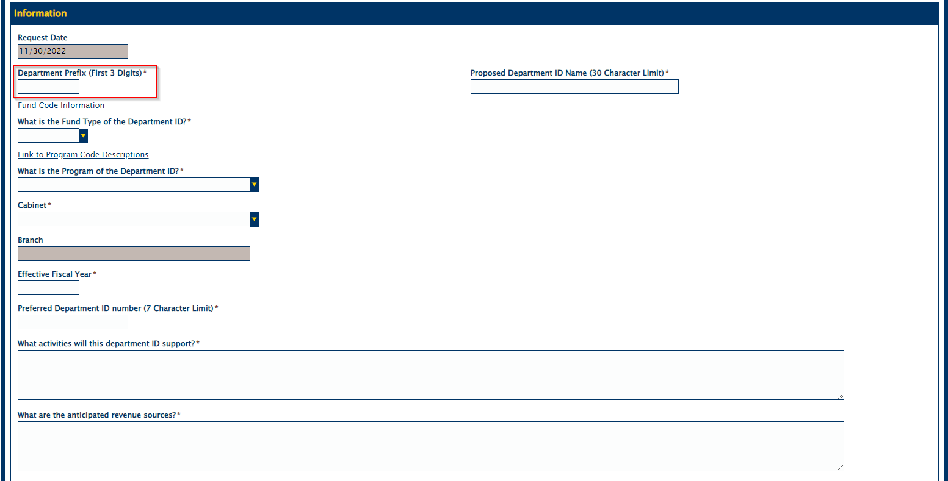
- Provide the fund type of the Department ID. Note that there is a link above the field that will lead to additional information about Fund Types.
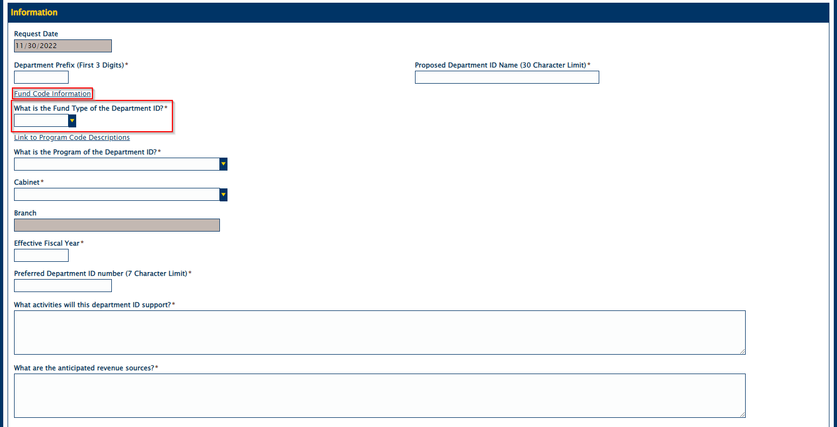

- Next step is to provide the program of the department ID.
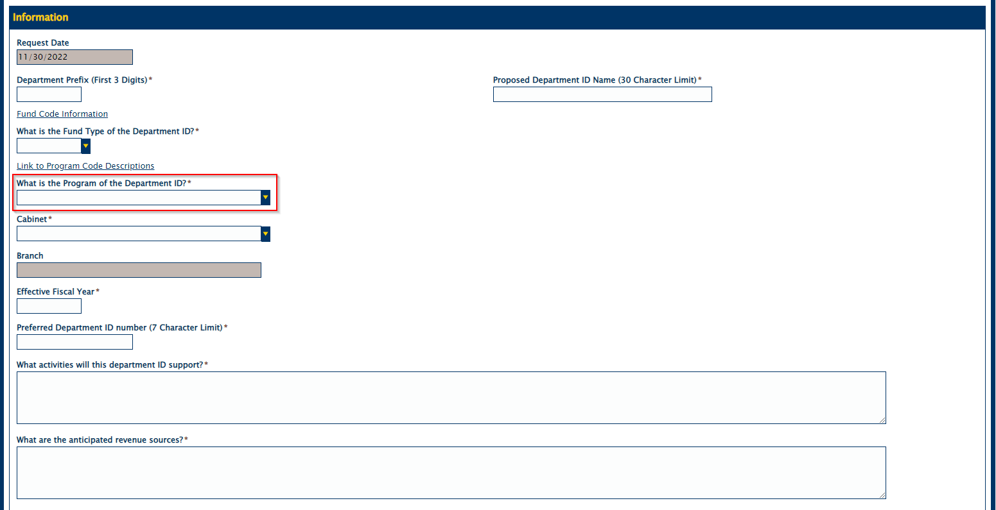
- Cabinet and Branch fields are filled next. Note that Branch fills off the Cabinet that you choose.
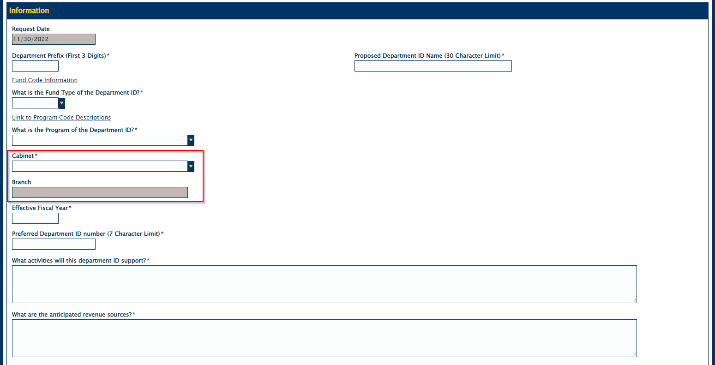

***Once cabinet is chosen this box will appear***
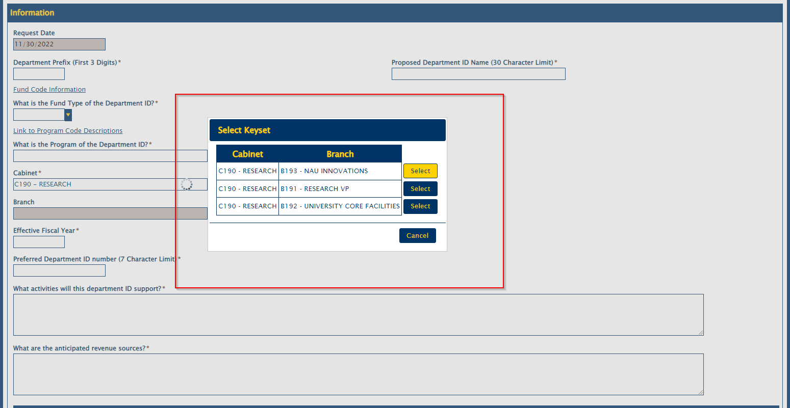
- Next step is to provide the fiscal year.
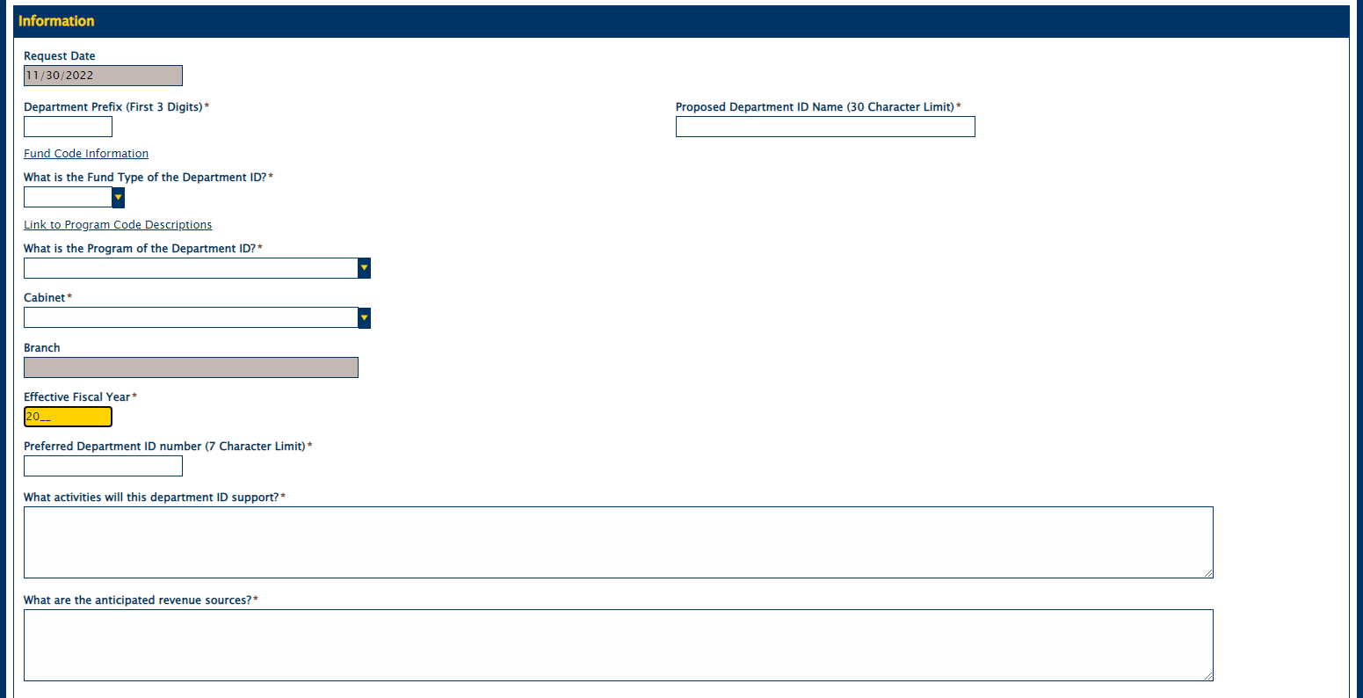

- Provide the Preferred Department ID number.
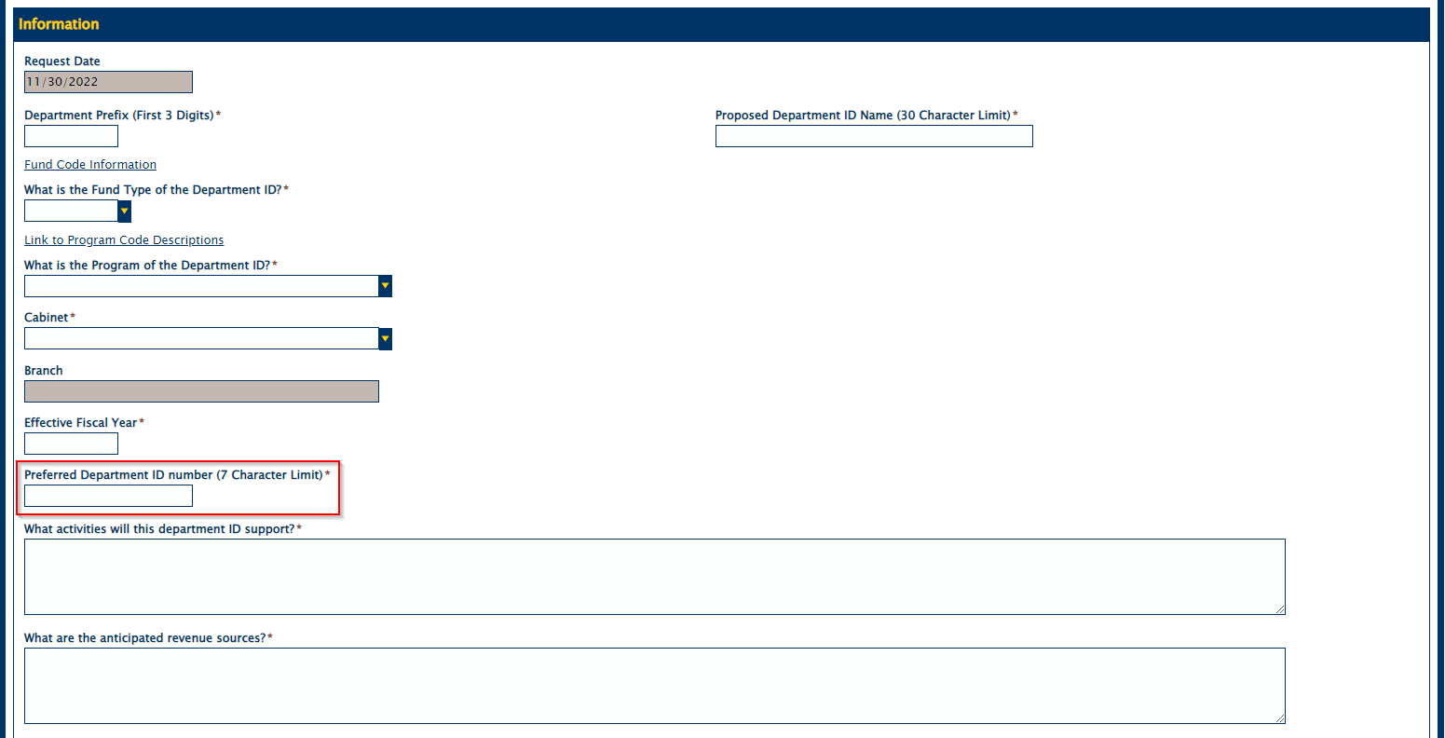
- Fill in the Proposed Department ID Name field.
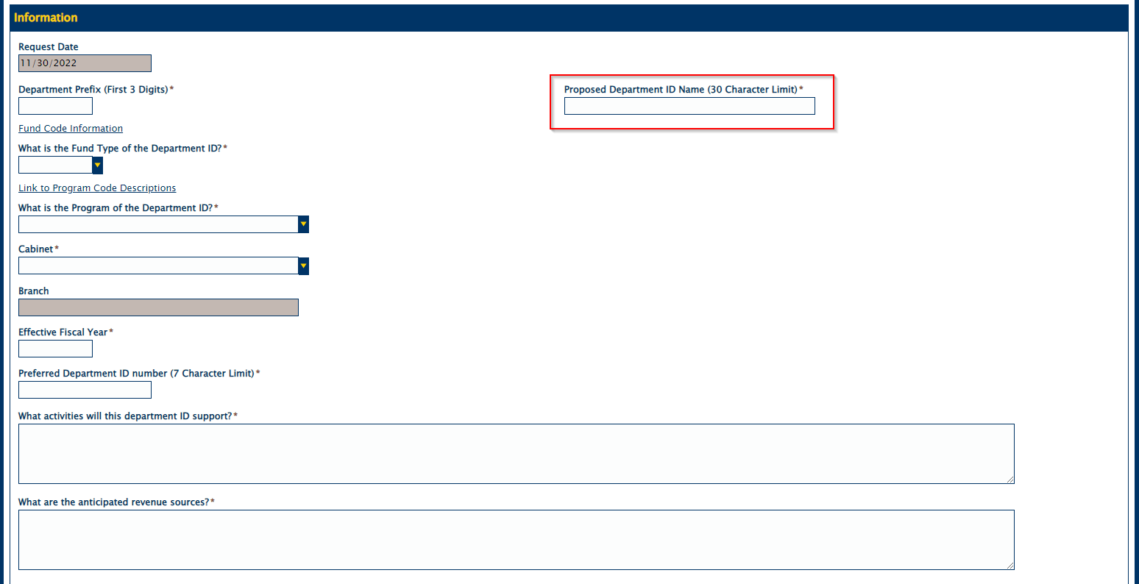

- Fill in the two text fields with the appropriate information.
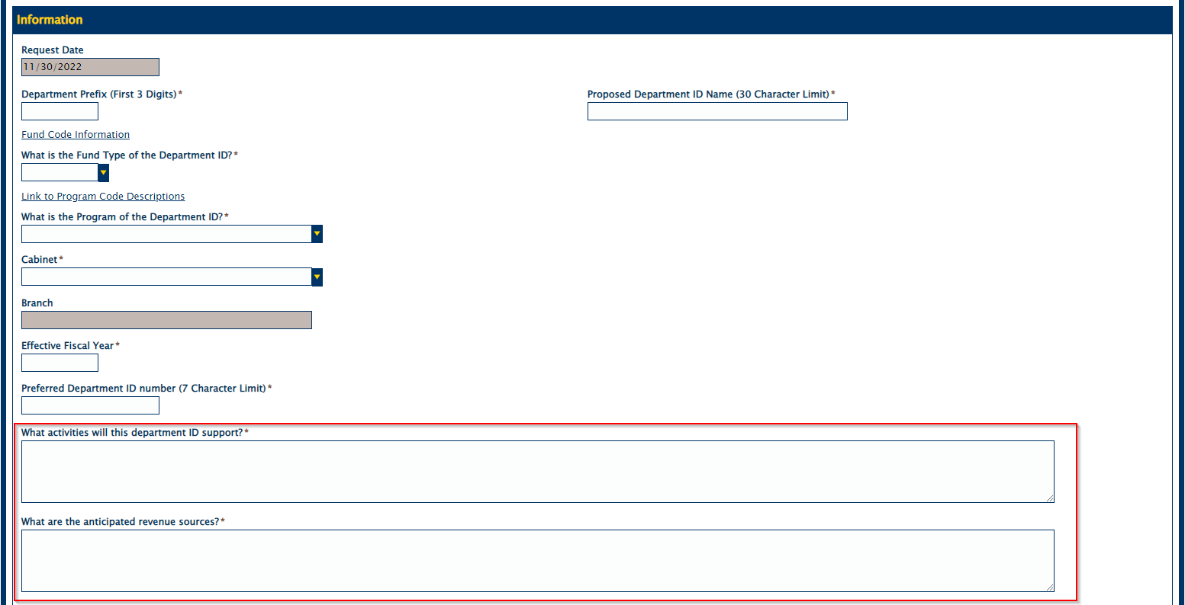
- Indicate the anticipated expense types.
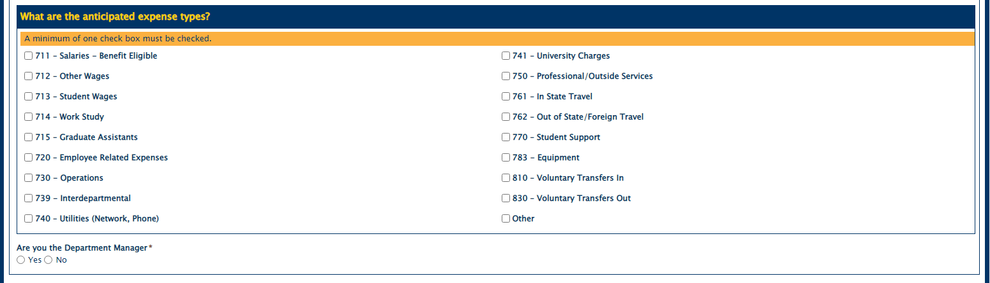
- Mark whether the submitter is the Department Manager. Steps will differ slightly based on that decision.
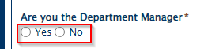

***Submitter is not the Department Manager***
Provide the next Department Manager’s information by filling in the first and last name field and hitting the search button.
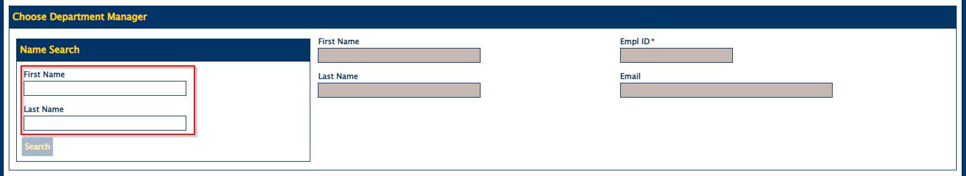

***Submitter is the Department Manager***
Provide the next approvers information by filling in the first and last name field and hitting the search button.
As the Department Manager, the submitter must choose to approve (or deny) the form and mark the check box to acknowledge the information.
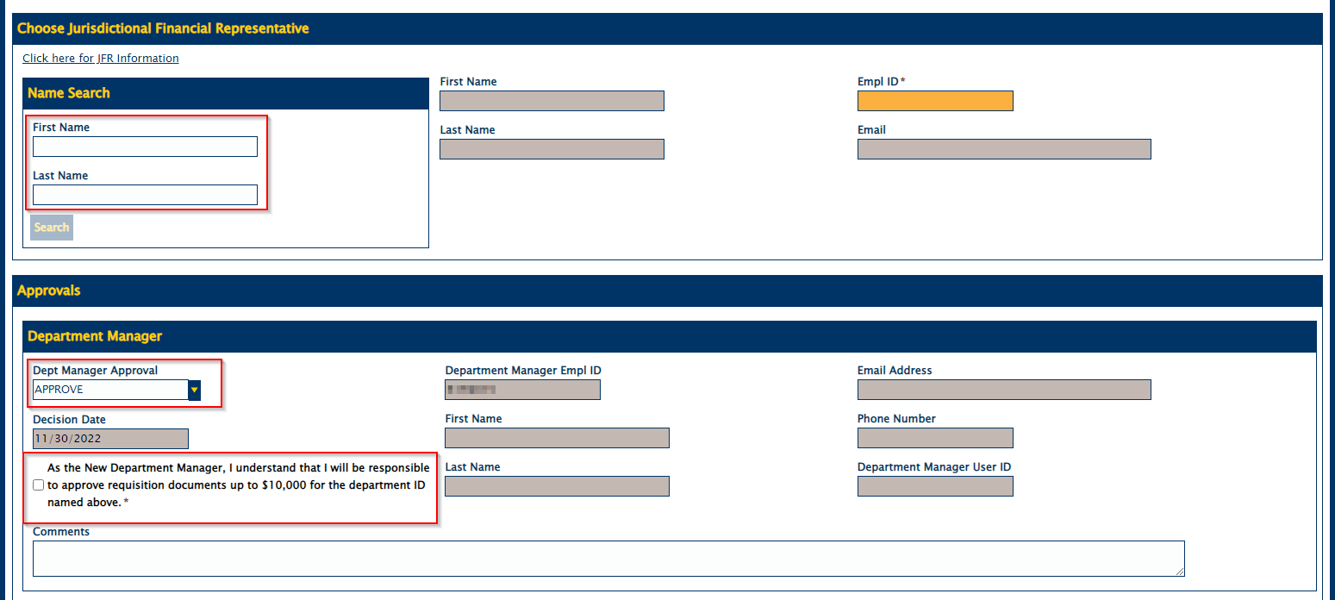
- Once all of this is complete the submit button will be read-write and the submitter can submit the form.

Workflow
- Once the form is submitted, the submitter will receive a submission confirmation email within 30 minutes.
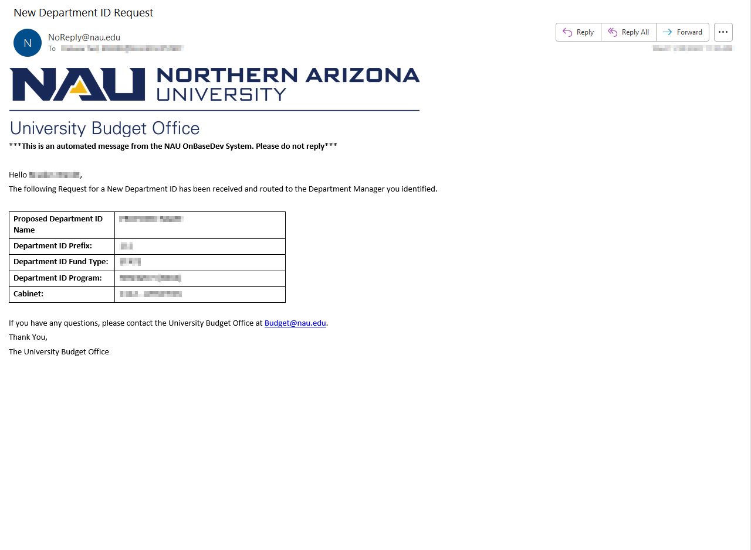

- The Department manager will receive a submission received notification.
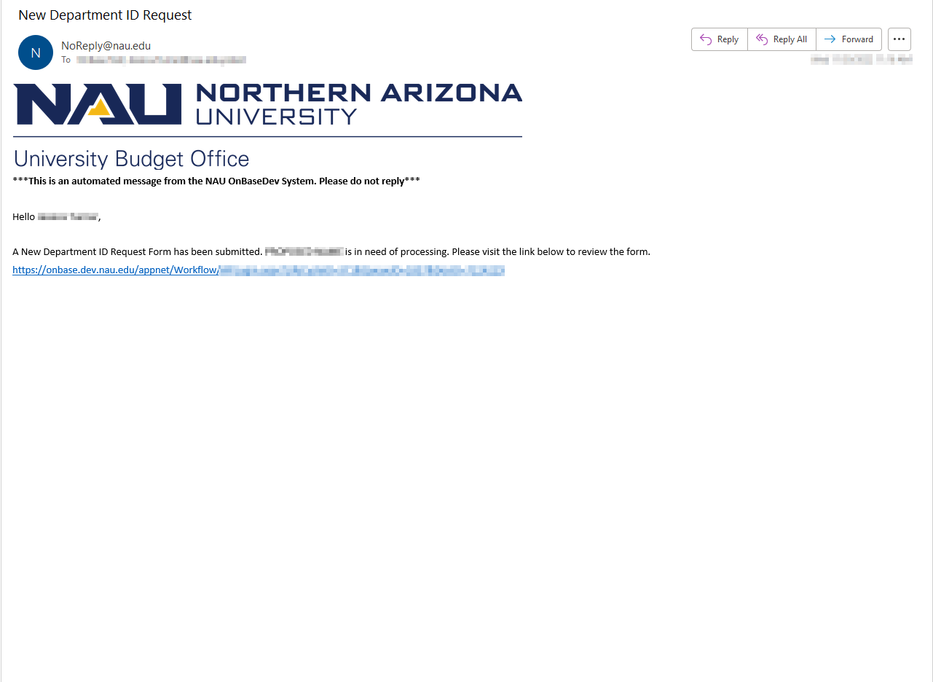

- Once the Department Manager clicks the link in the email notification, it will bring them to the form where they can approve or deny the request:
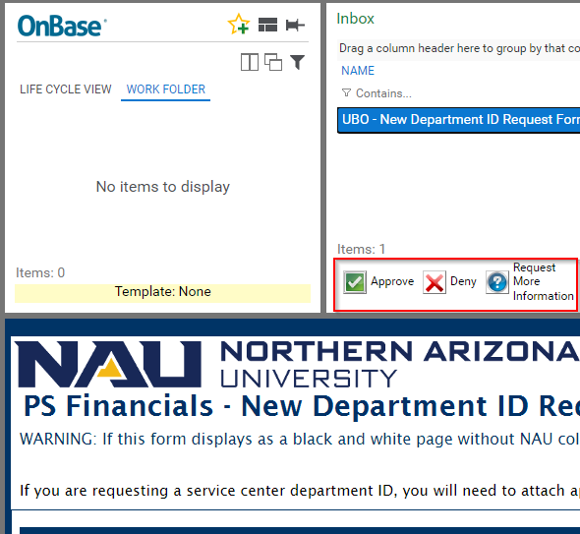

- If the Department Manager denies or requests more information, then the submitter will be notified.
***If Department Manager denies***
(Sent to Submitter)
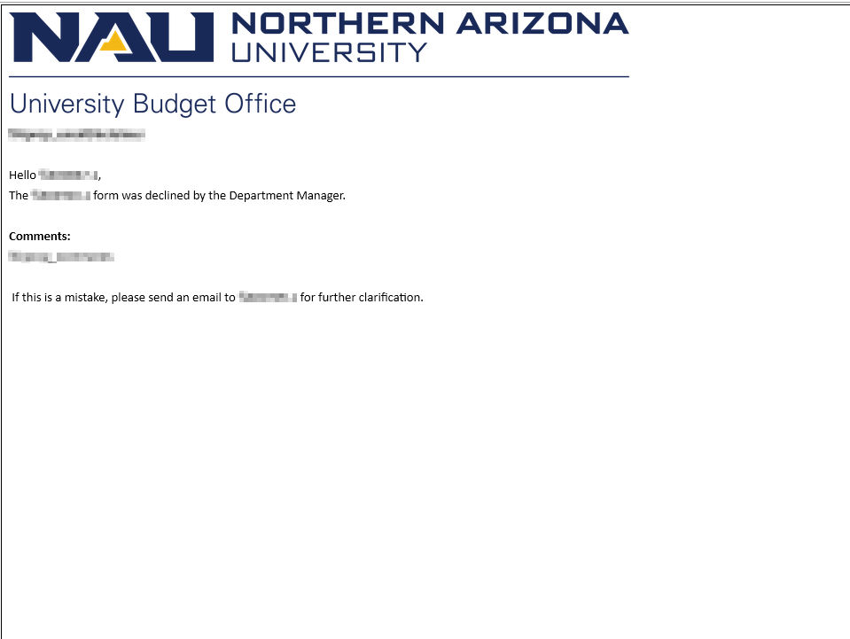

***If Department Manager Requests More Information***
(Sent to Submitter)

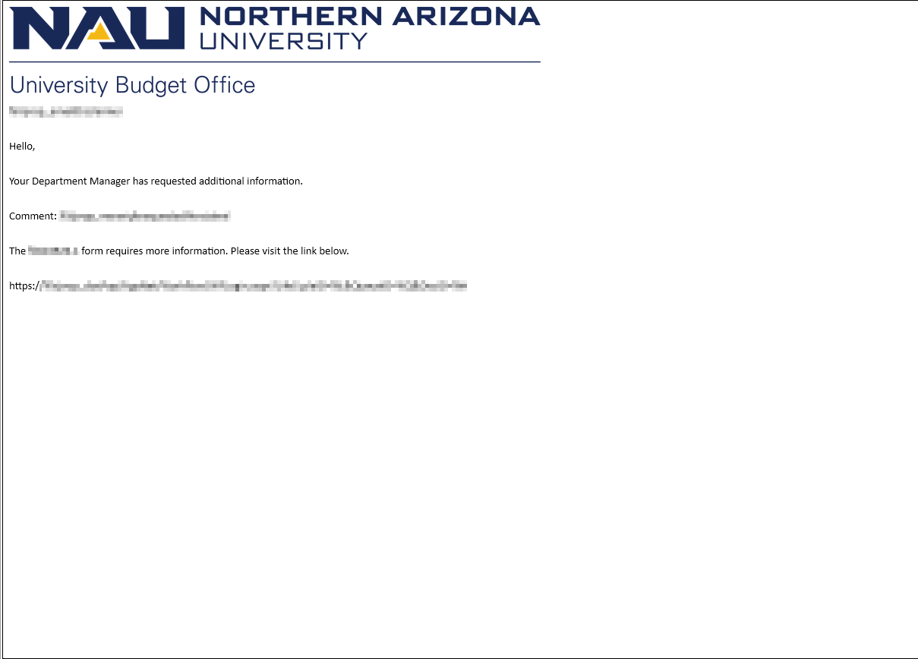

- If Department Manager approves the form, it will go to Fiscal Operations Manager.
Note: The Fiscal Operations Manager is only involved in this process when the cabinet chosen by the submitter is “C200 - ACADEMIC AFFAIRS”. Otherwise, the FOM is bypassed entirely, and it goes directly to the Jurisdictional Financial Representative.
If this is the case the FOM will receive this notification.

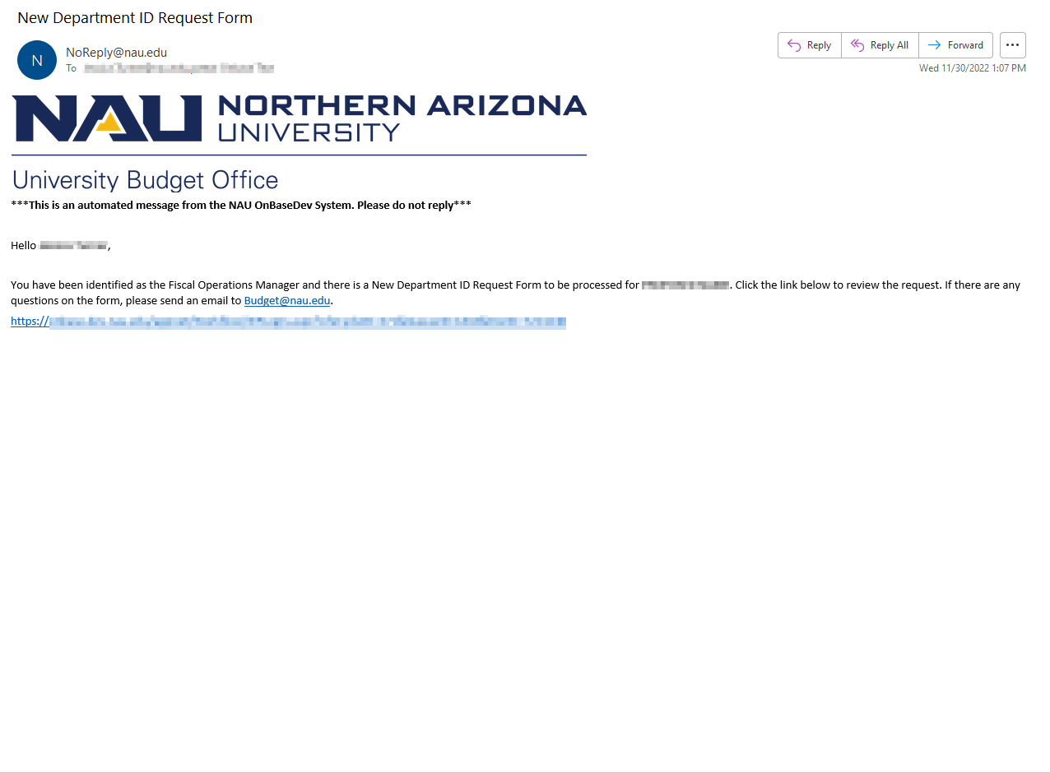

- Once the FOM clicks the link in the email notification, it will bring them to the form where they can approve or deny the request:

***If the FOM denies the form***
(Sent to Submitter)

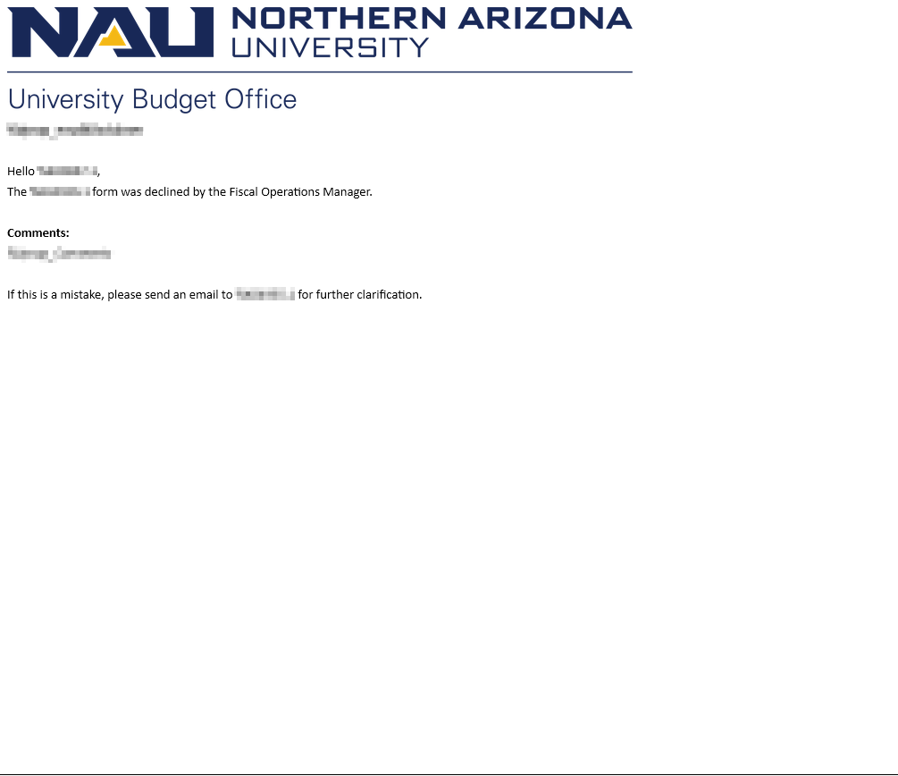

***If the FOM Requests More Information***
(Sent to Submitter)

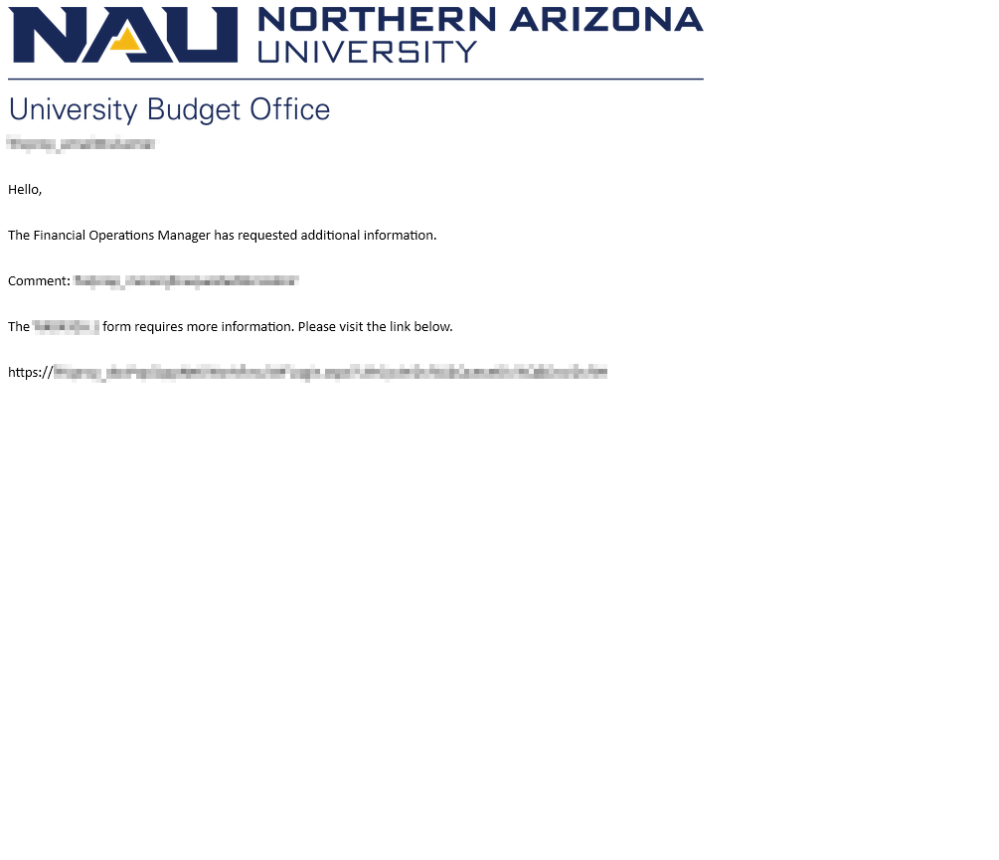

- If the FOM approves the form, it will go to the JFR. The JFR will receive this notification.
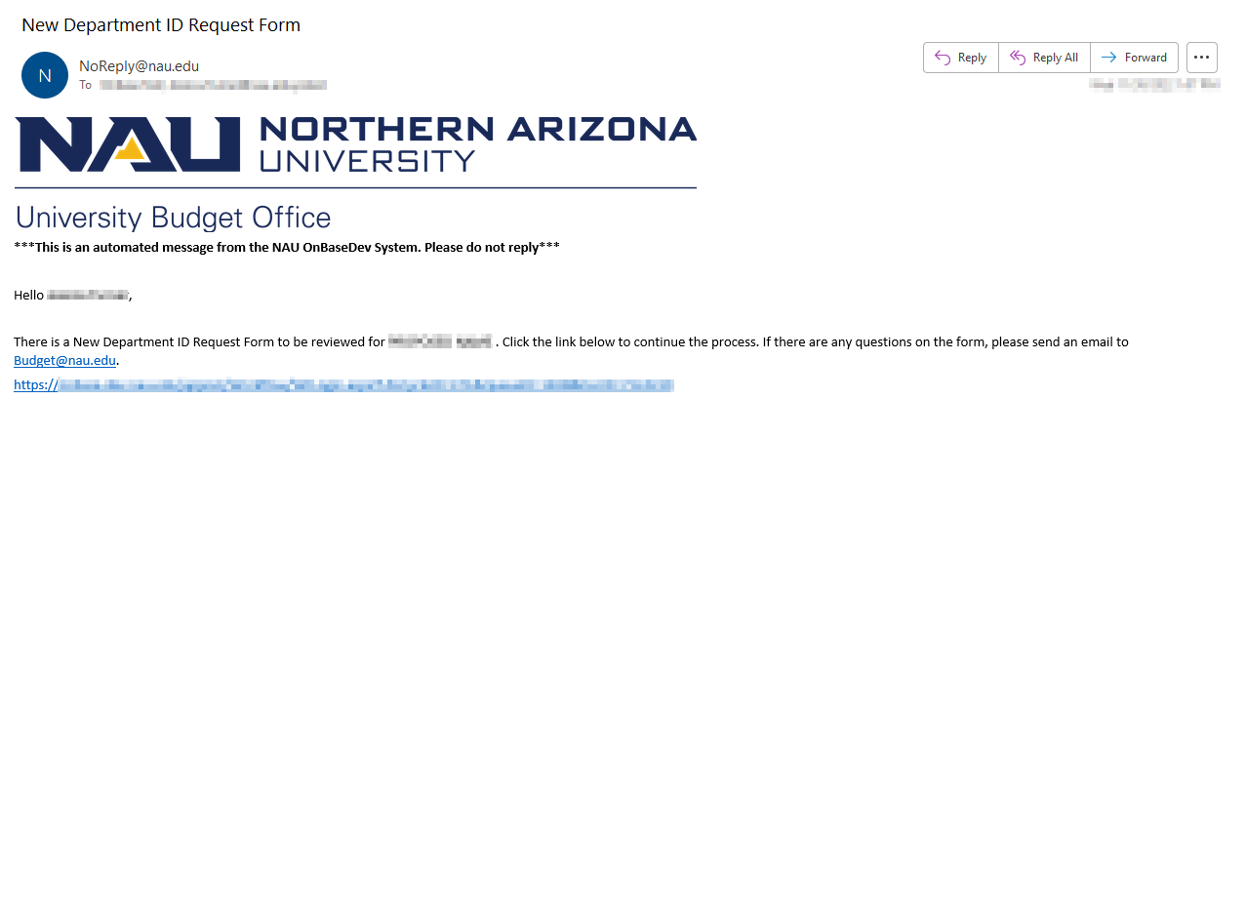

- Once the JFR clicks the link in the email notification, it will bring them to the form where they can approve or deny the request:

***If JFR denies the form***
(Sent to Submitter)

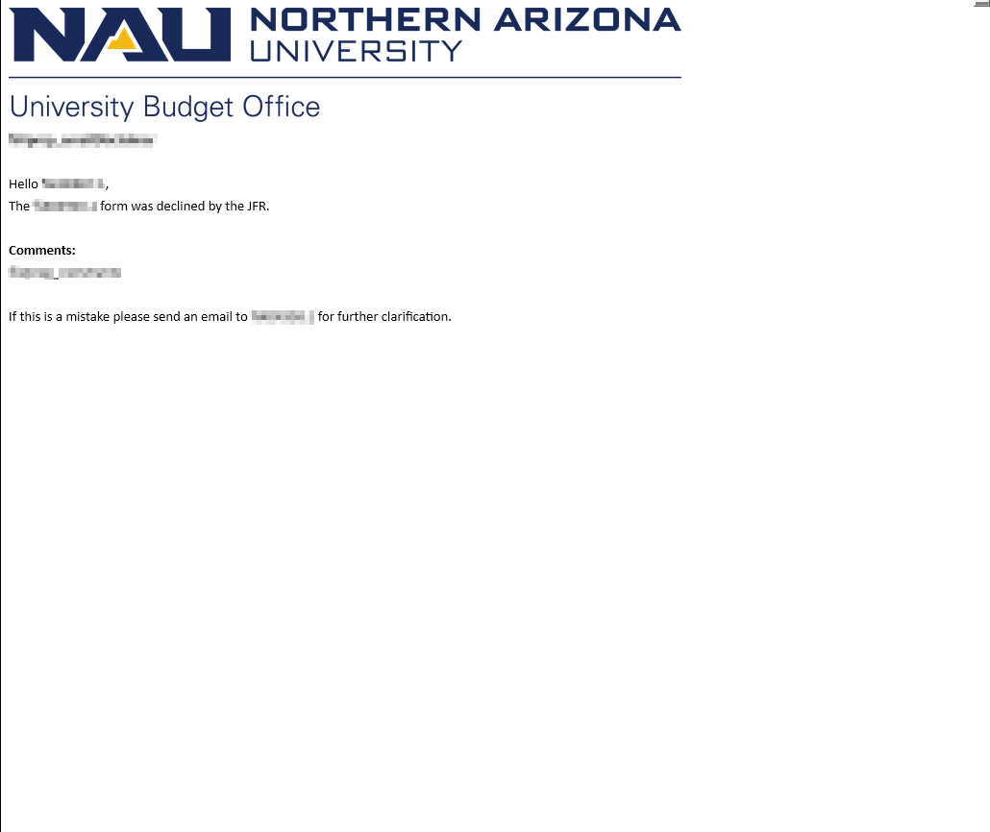

***If JFR Requests More Information***
(Sent to Submitter)

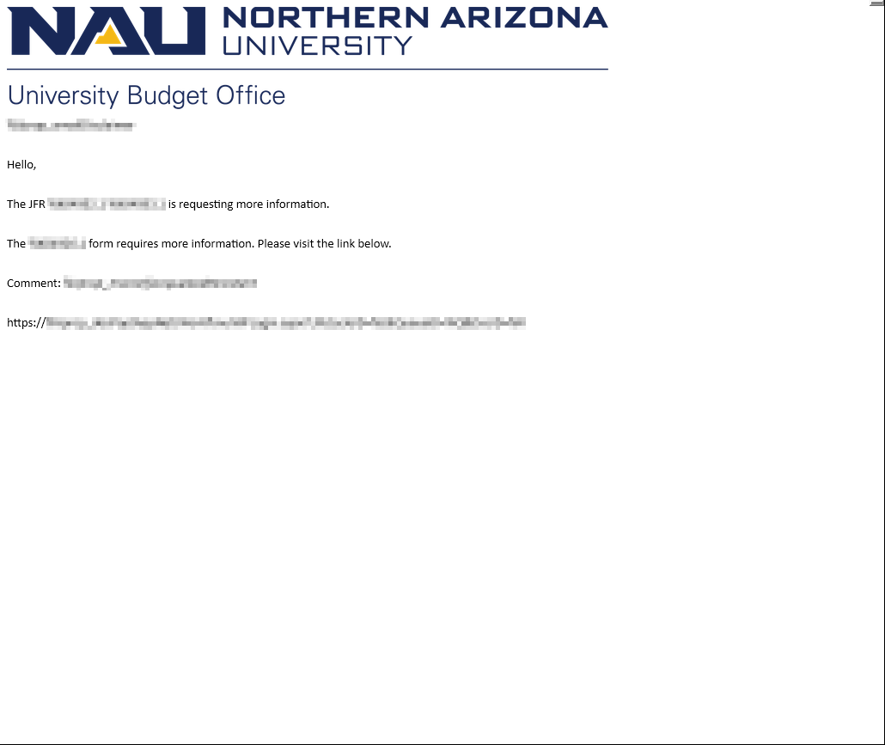

- If the JFR approves, it will go to the University Budgeting Office. The UBO will receive this notification.
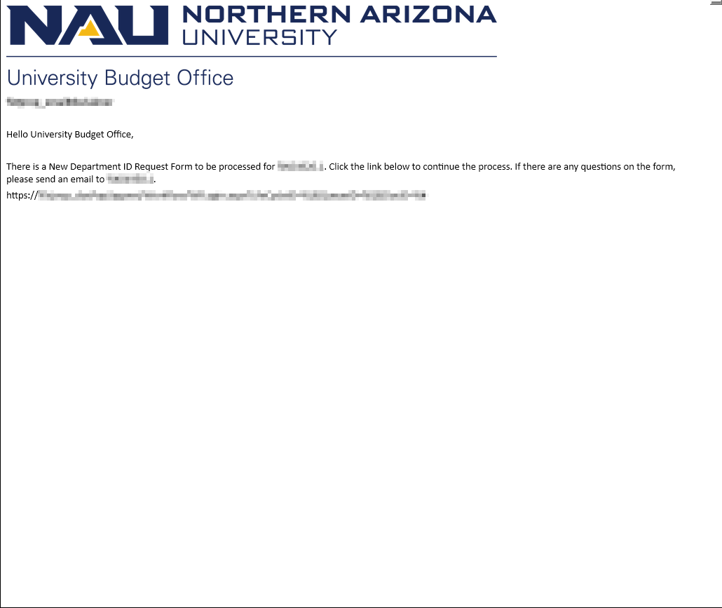

- Once the UBO clicks the link in the email notification, it will bring them to the form where they can approve or deny the request:

***If UBO denies the Form***
(Sent to Submitter)
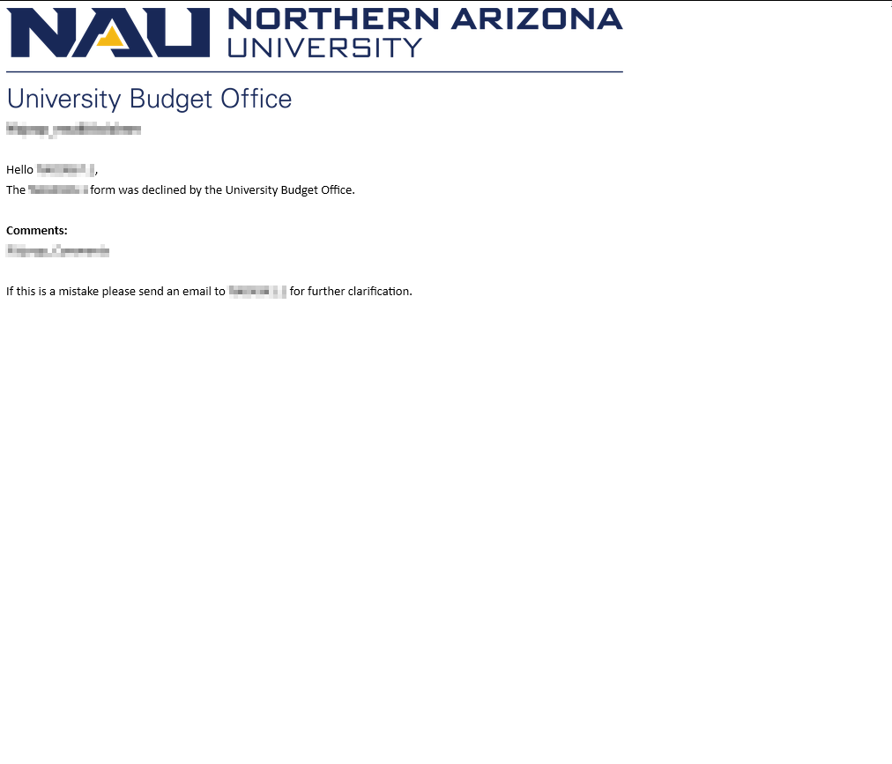

***If the UBO Requests More Information***
(Sent to Submitter)
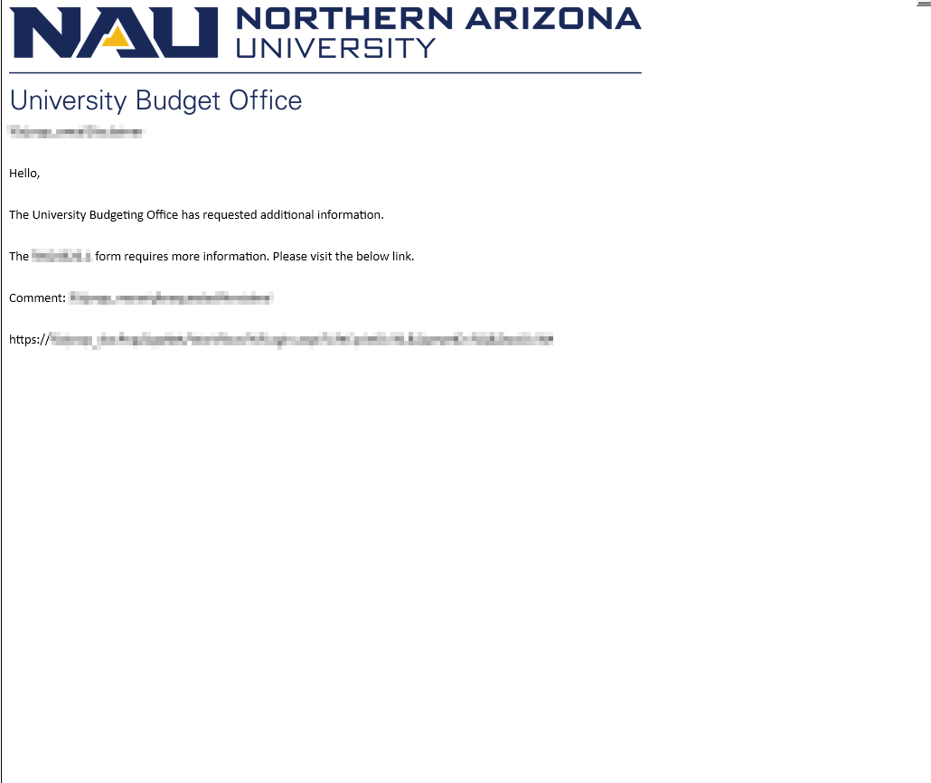

- If the UBO approves, it will go to the Comptroller for reviewing. The Comptroller will receive this notification.
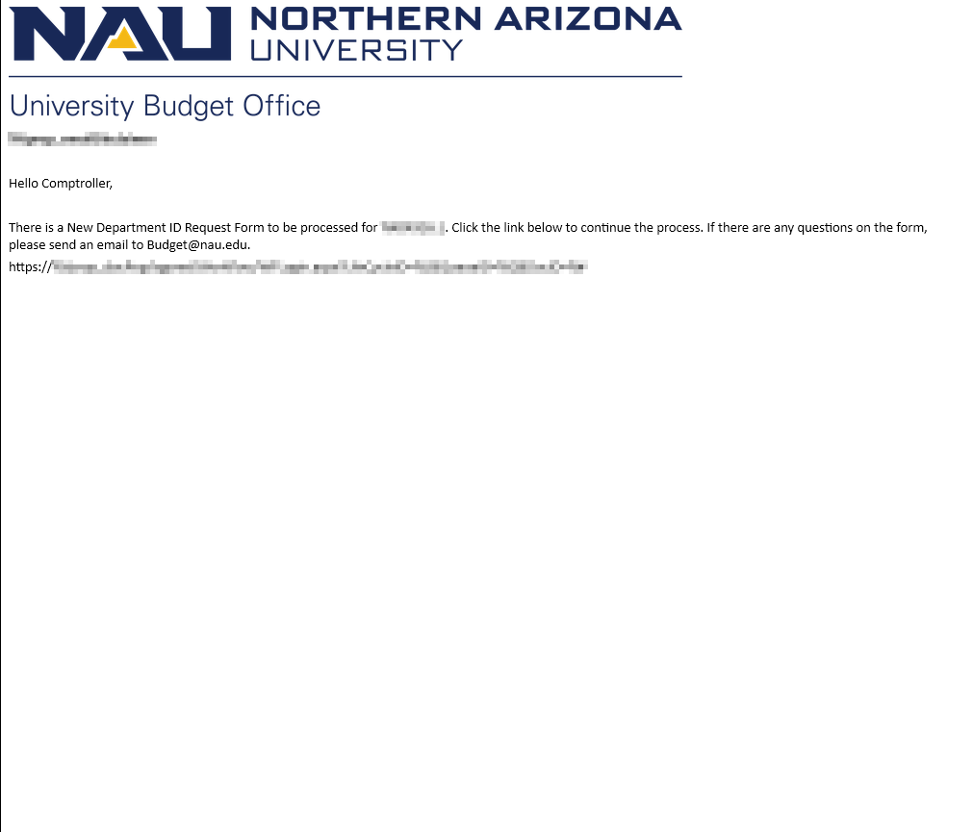

***If Comptroller denies the Form***
(Sent to Submitter)
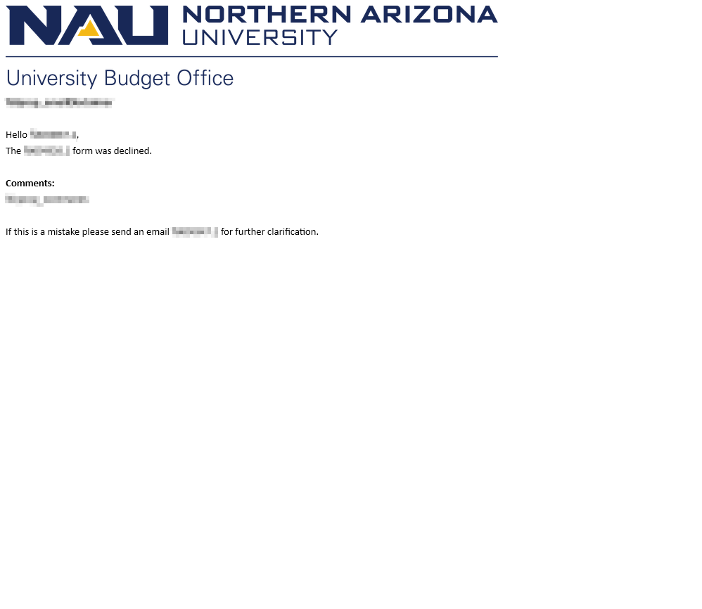

***The Comptroller Requests More Information***
(Sent to UBO)
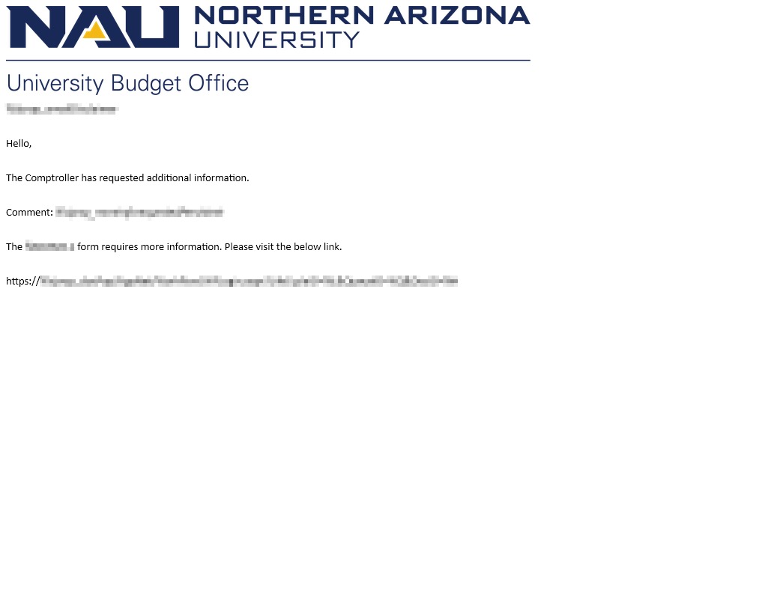

- If the Comptroller Reviewer approves, it will go to the Comptroller Inputter. The Comptroller Inputter will receive this notification.
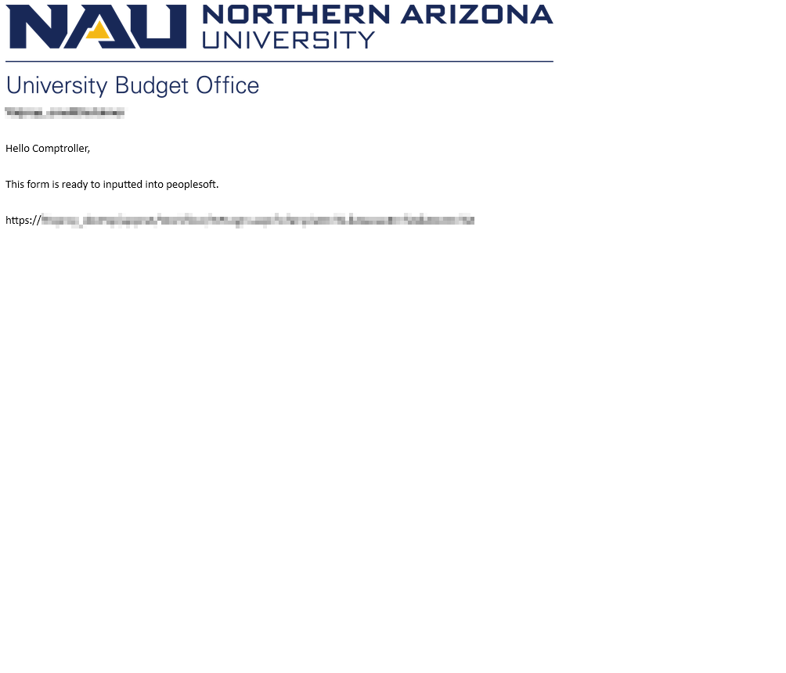

- The Comptroller Inputter will mark this form as inputted via the ad hoc task in OnBase.
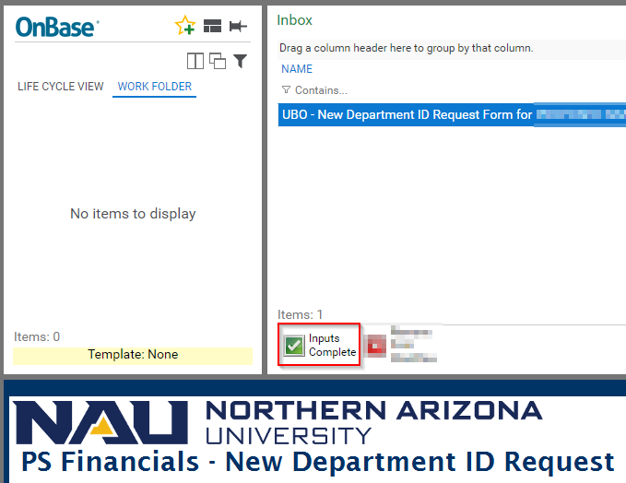

***Notification to all involved once Comptroller Inputs***

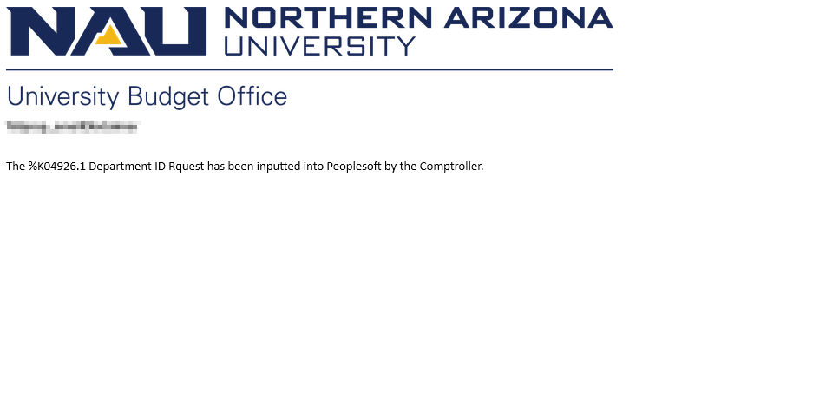

- Once Comptroller Inputter marks the form as inputted, it will go to the Budget Analyst for Confirmation. The Budget Analyst will receive this notification.
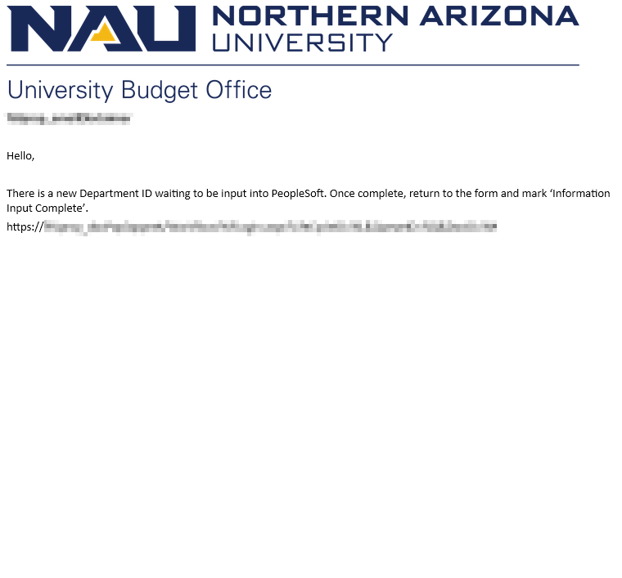

- Budget Analyst will mark the form as inputted through an ad hoc task.
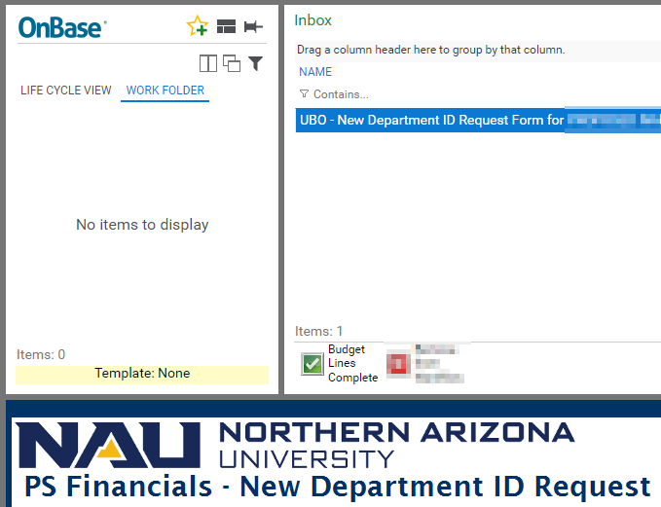

- The form will exit workflow after Budget Analyst confirms.

***This notification will send to all***
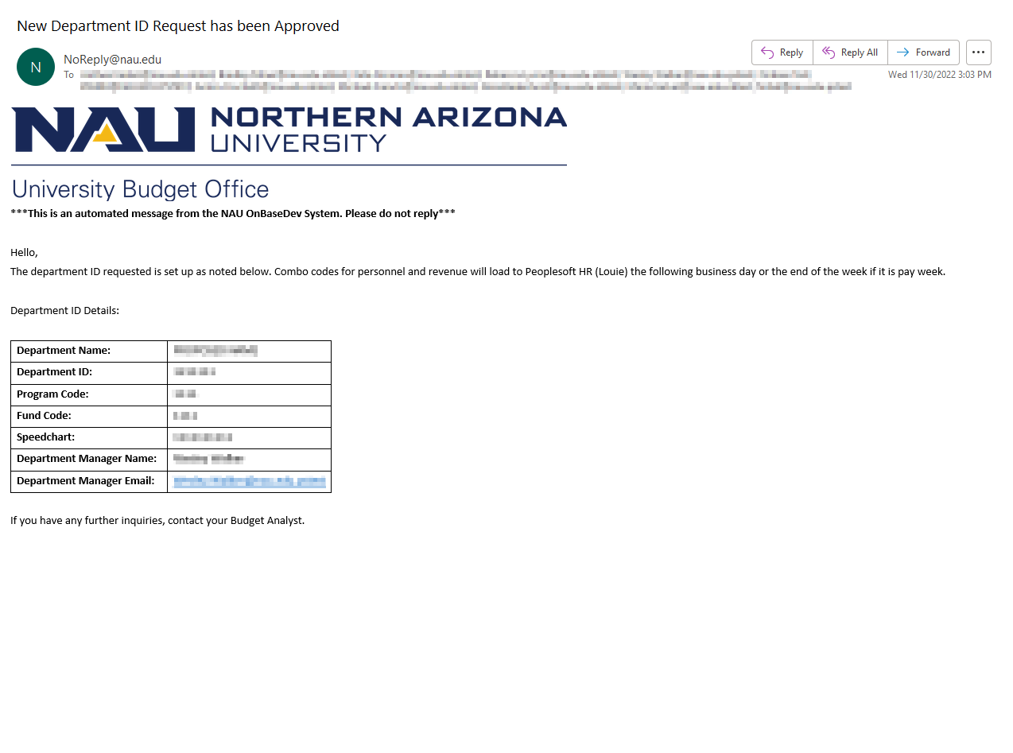

Reporting Dashboards

UBO – New Department ID Request Workflow Inbox
UBO – New Department ID Request Document Query

Email Templates

To Submitter – Successful Submission
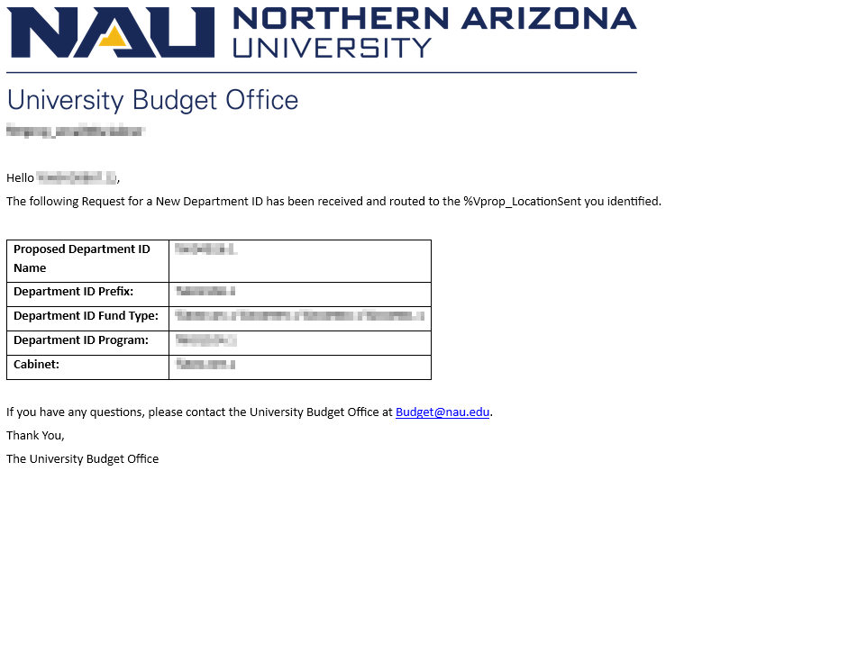

To Department Manager – Review Form
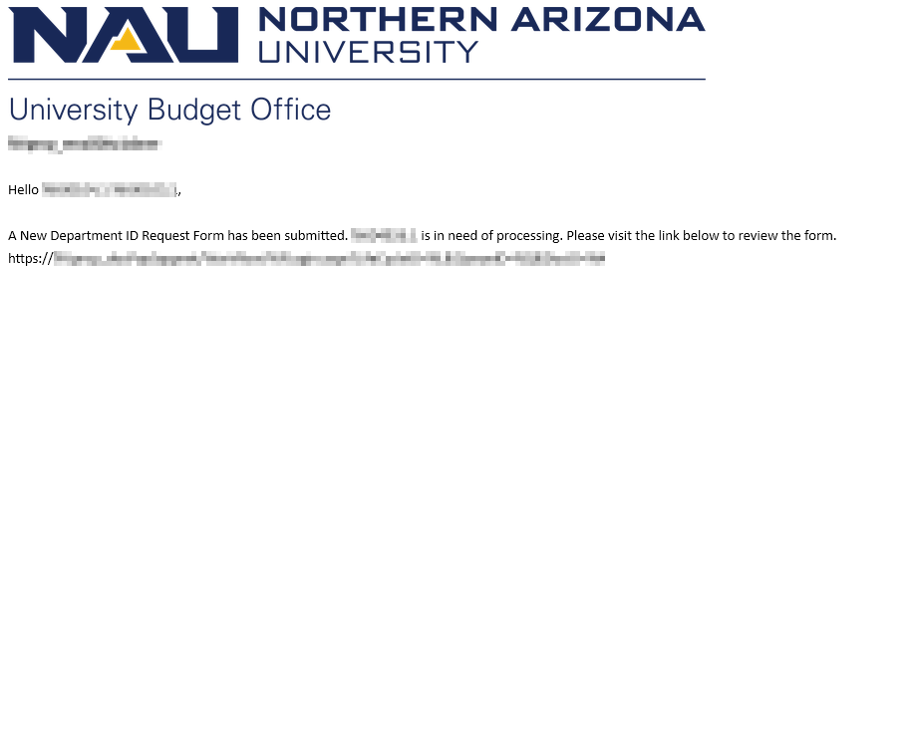

To Submitter - Department Manager Denial
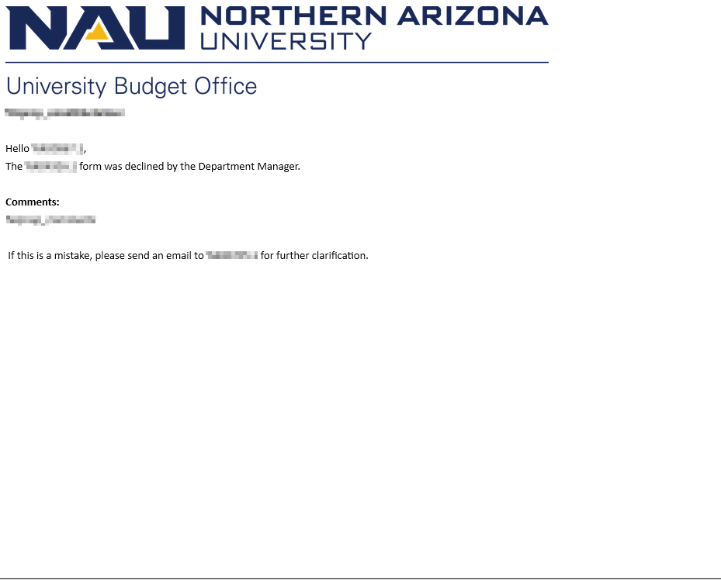

To Submitter – More information Required from Department Manager

To Financial Operations Manager – Review Form
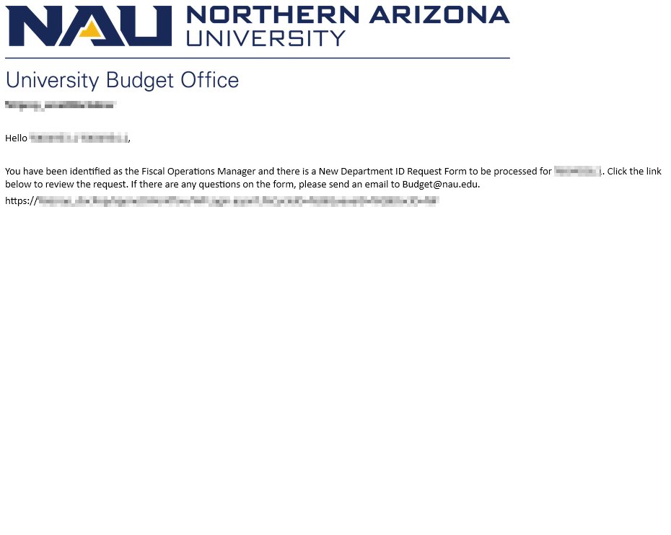

To Submitter – Financial Operations Manager has denied
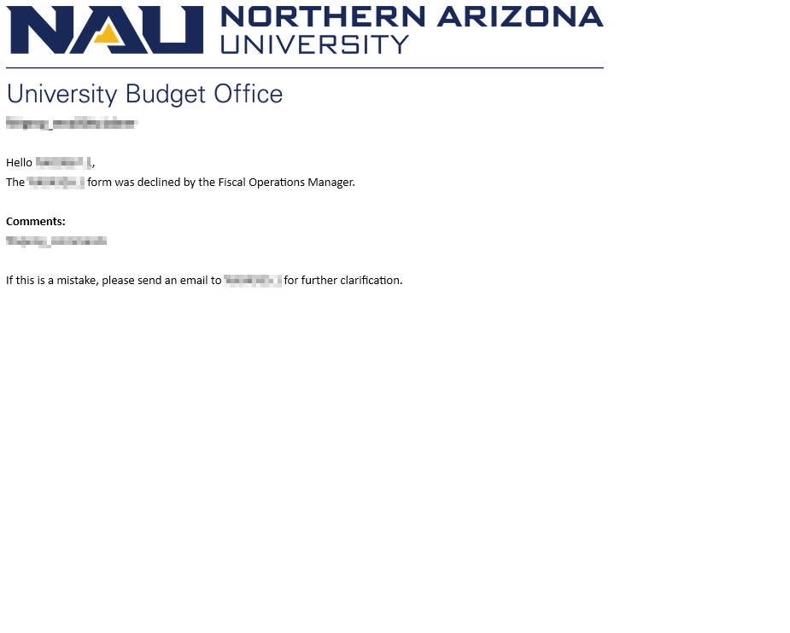

To Submitter – Financial Operations Manager Requires More Information
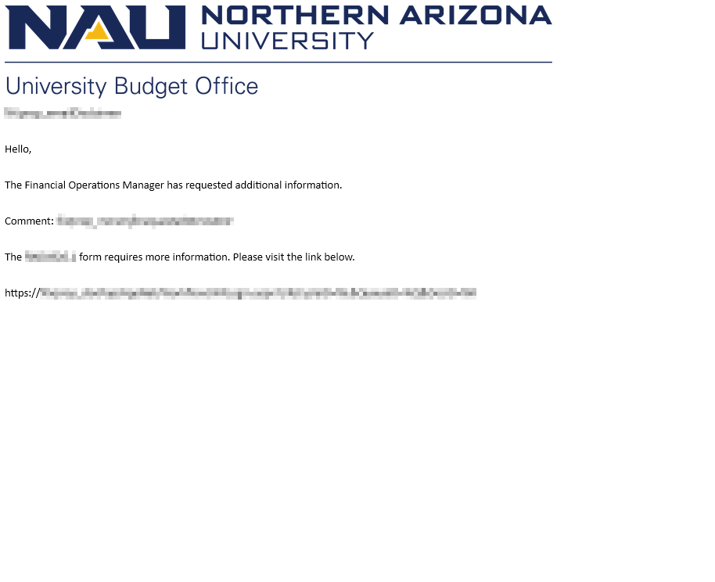

To Jurisdictional Financial Representative – Review Form
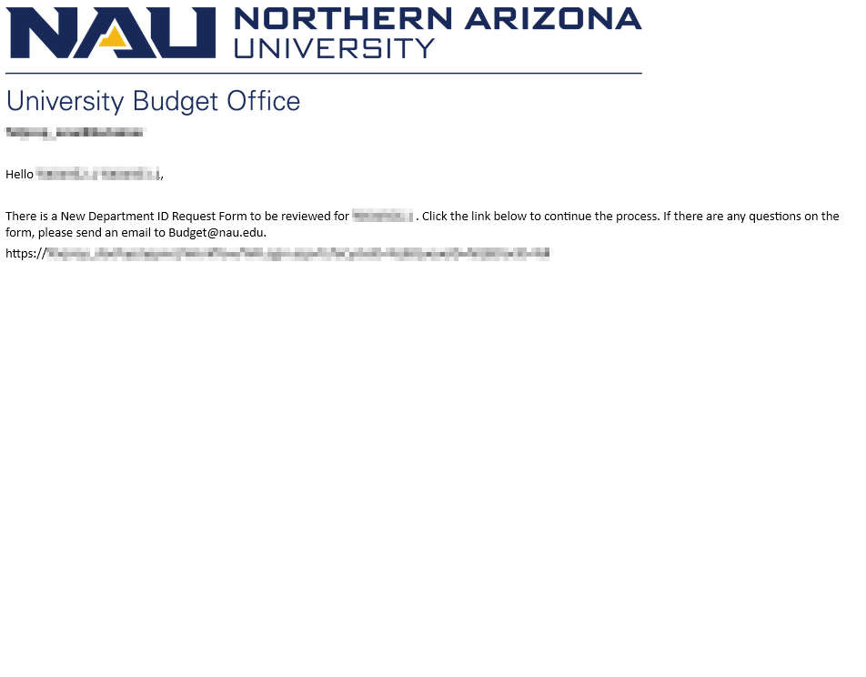

To Submitter – Jurisdictional Financial Representative Denied
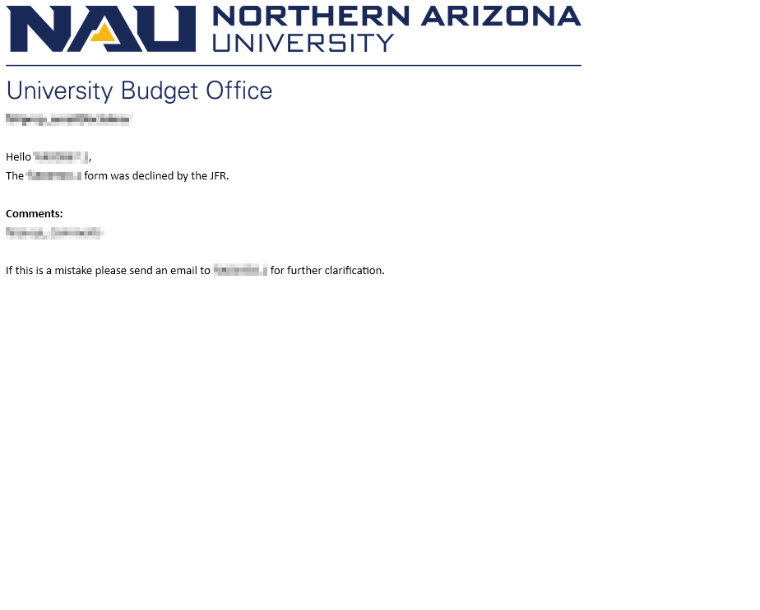

To Submitter – Jurisdictional Financial Representative Requires More Information
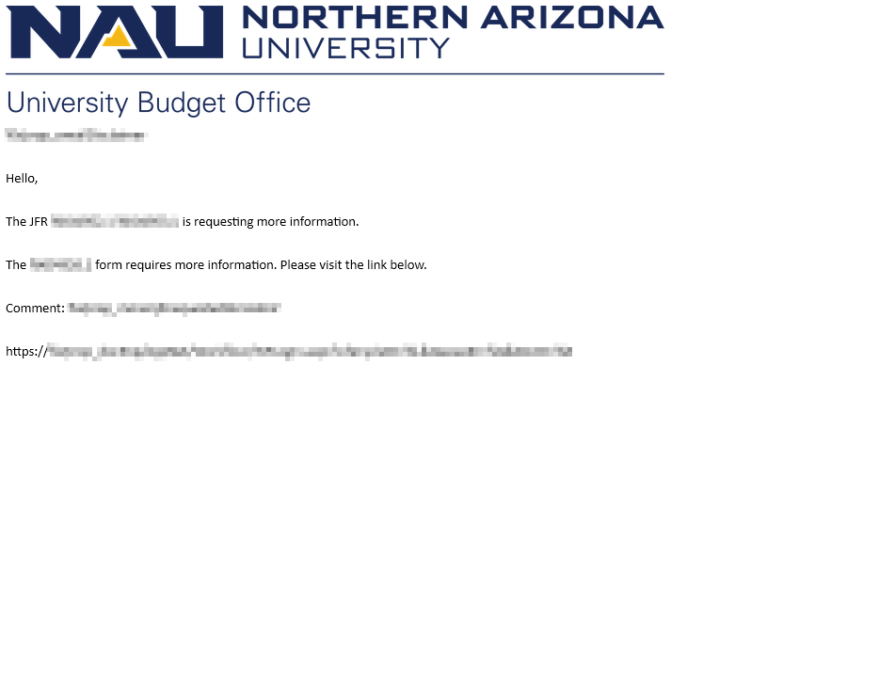

To University Budgeting Office – Review Form
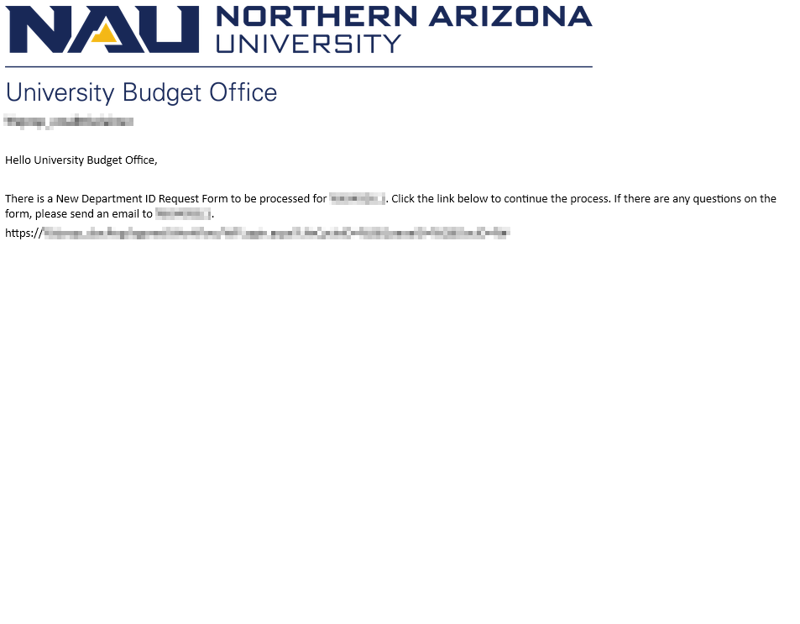
To Submitter – University Budgeting Office Denied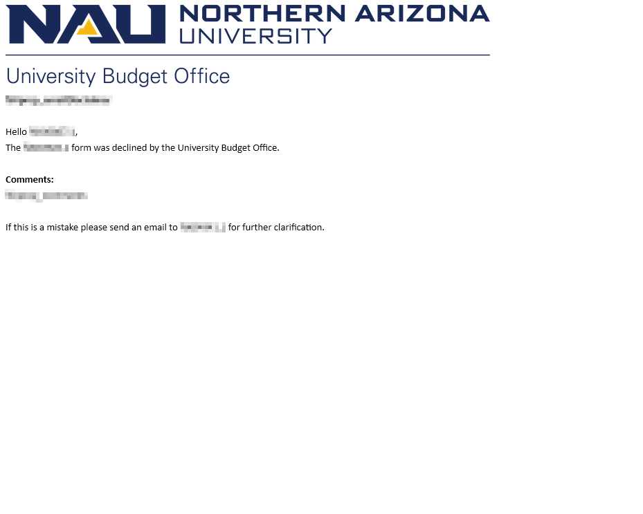

To Submitter – University Budgeting Office Requires More Information
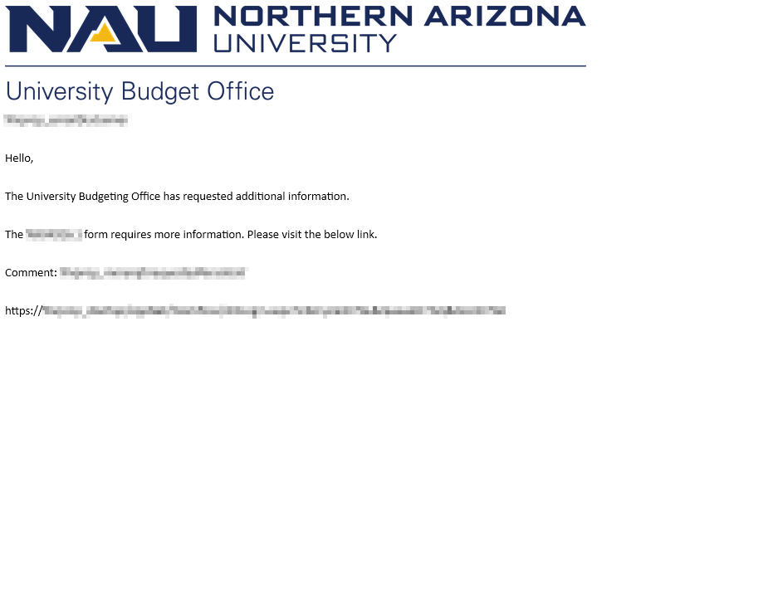

To Comptroller Reviewer – Review Form
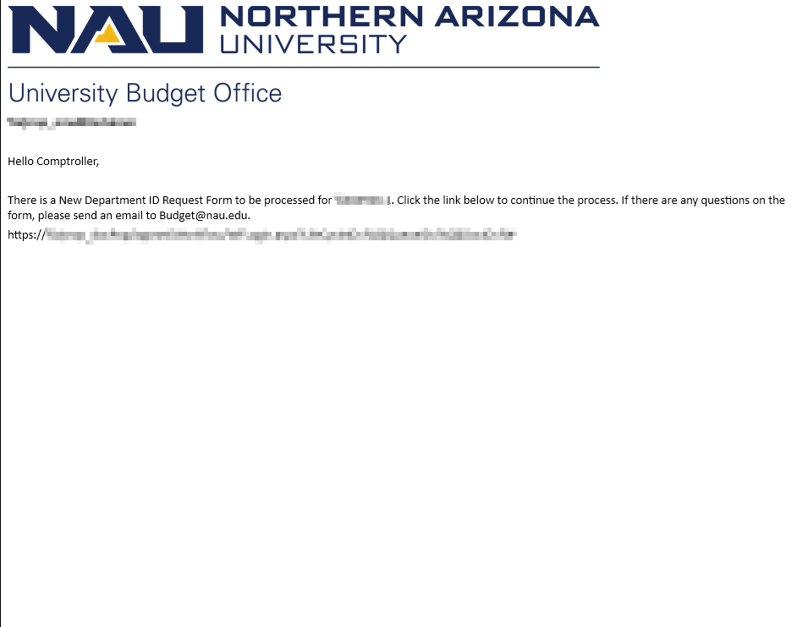

To Submitter – Comptroller Denied
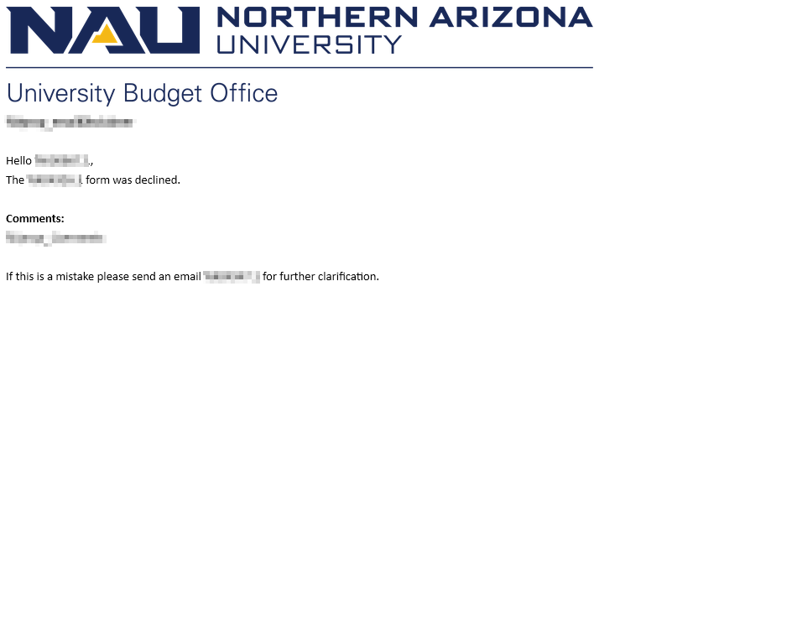

To University Budgeting Office – Comptroller Requires More Information
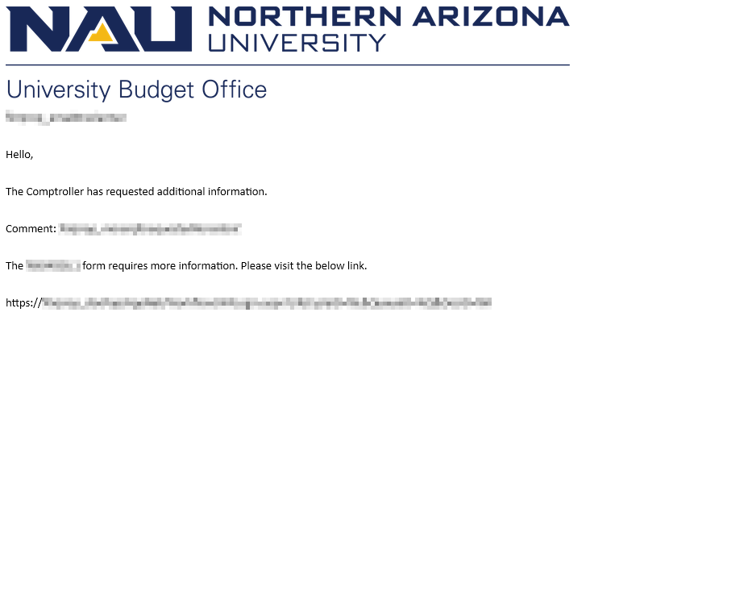

To Comptroller Inputter – Form Requires Inputs
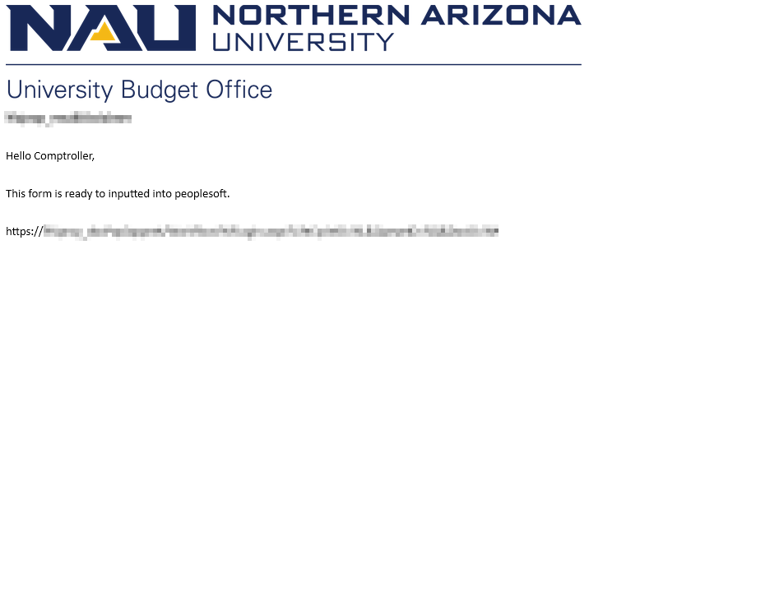

To All – Comptroller Has Completed Inputs
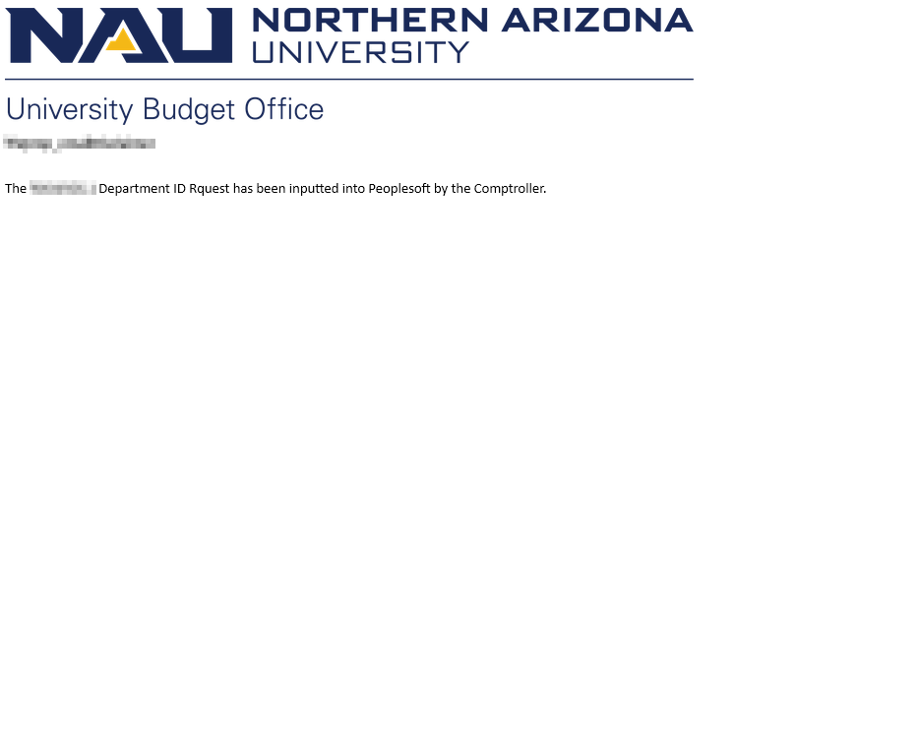

To Budget Analyst – Form Requires Inputs
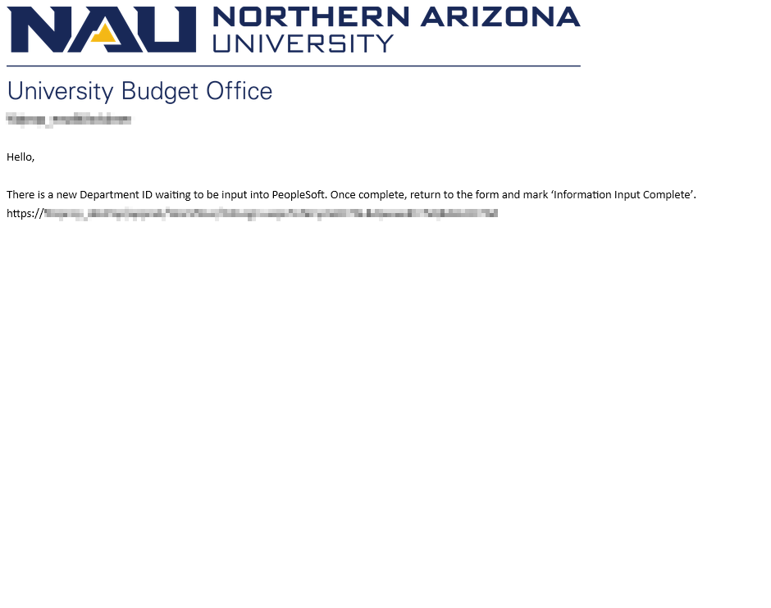

To All – Form Approved
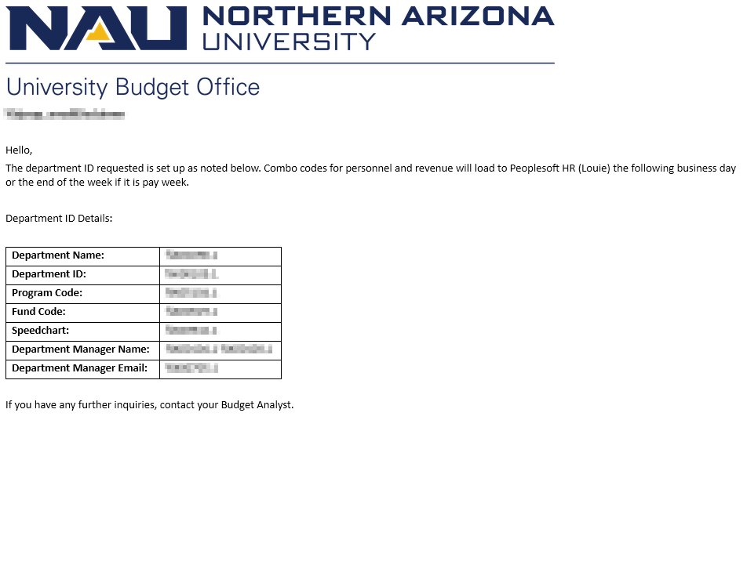

Document Retrieval

Onbase – Retrieving Content – Web Client
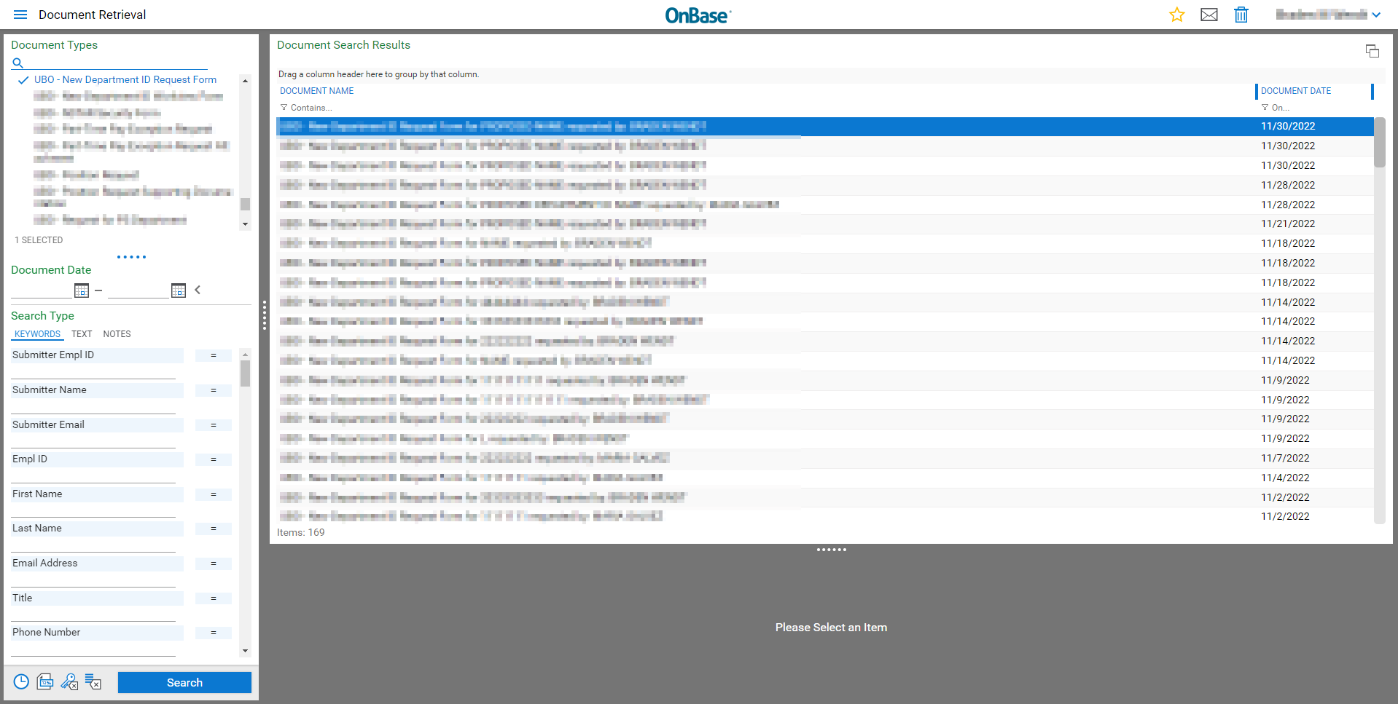
OnBase - Retrieving Content – Unity Client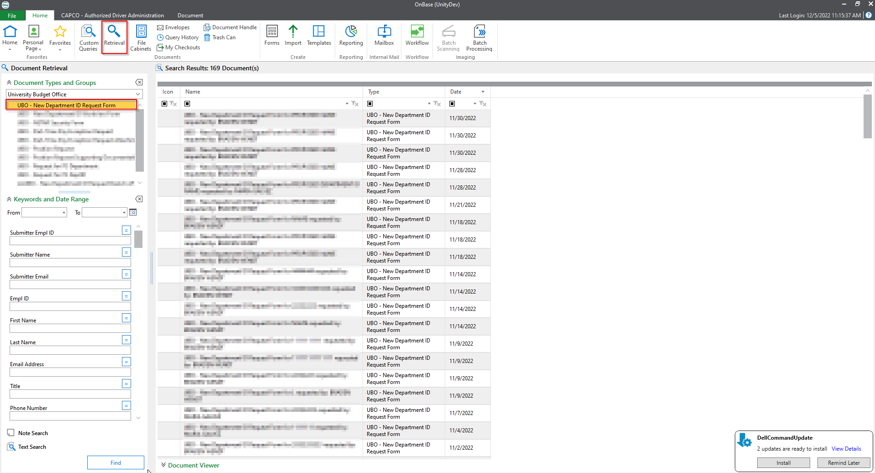

User Group Access

All Faculty and Staff (including Student workers) have access to complete the form. Students do NOT have access to complete the form.
Approvers for the process should request access to the applicable user group through the OnBase Security Request Form.

