WP Aligning Drop Down Menus

Example of aligned right:

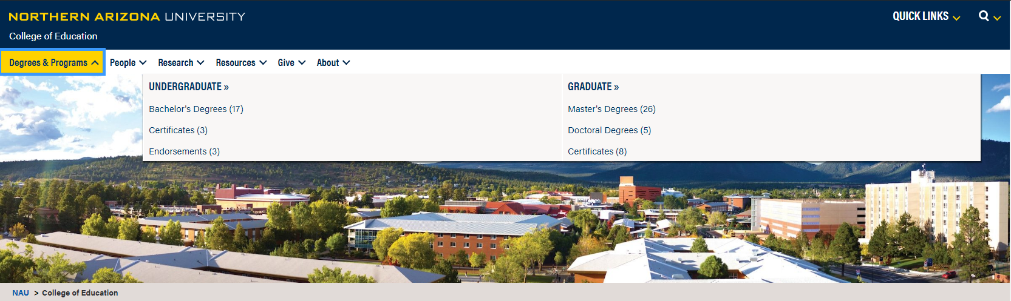

Example of aligned left or default:

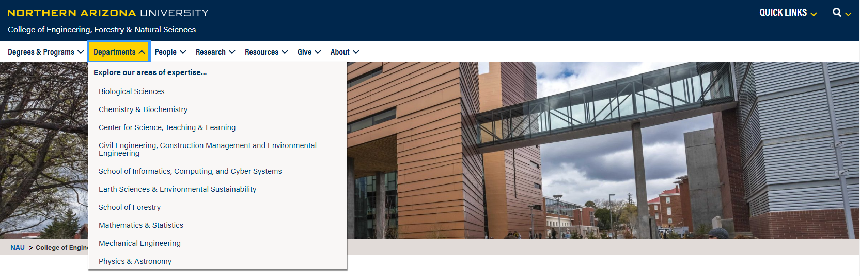

Step 1: Go to Appearance on the leftmost column of your wordpress sandbox.

Step 2: Tap Menus under Appearance options dropdown.
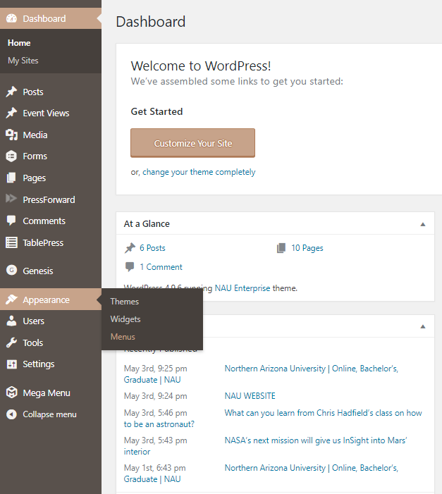

Step 3: Hover the mouse over an item under Menu Structure. You will see the blue icon labeled as Mega Menu. Tap the icon Mega Menu.
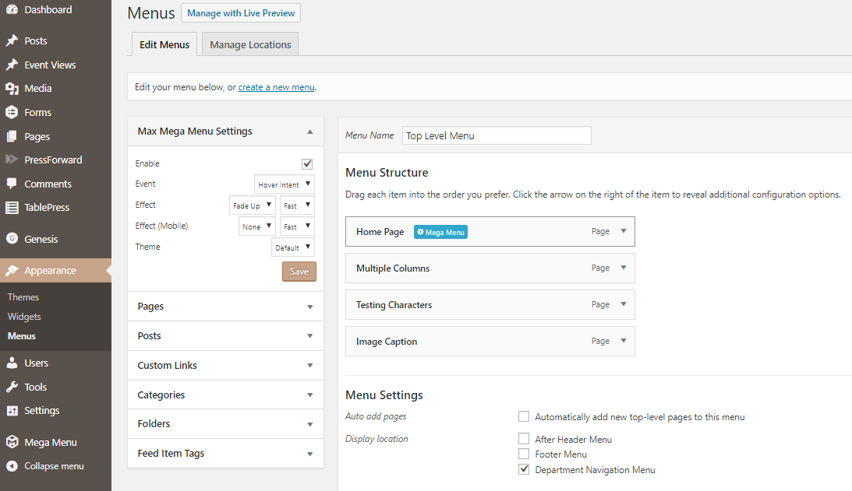

Step 4: Go to Settings, and underneath the Menu Item Align, select either Default or Left
