Clearing the Cache on Google Chrome

To begin, open up google chrome and navigate to a website; e.g. https://nau.edu/?s=education.

- Press “Ctrl + Shift + i” to open up the Developer Tools window as seen below.
Alternatively, you can right click and choose the inspect option to open Developer Tools.
Note that this page may open in your browser window or in a new tab and shall not
be utilized further.
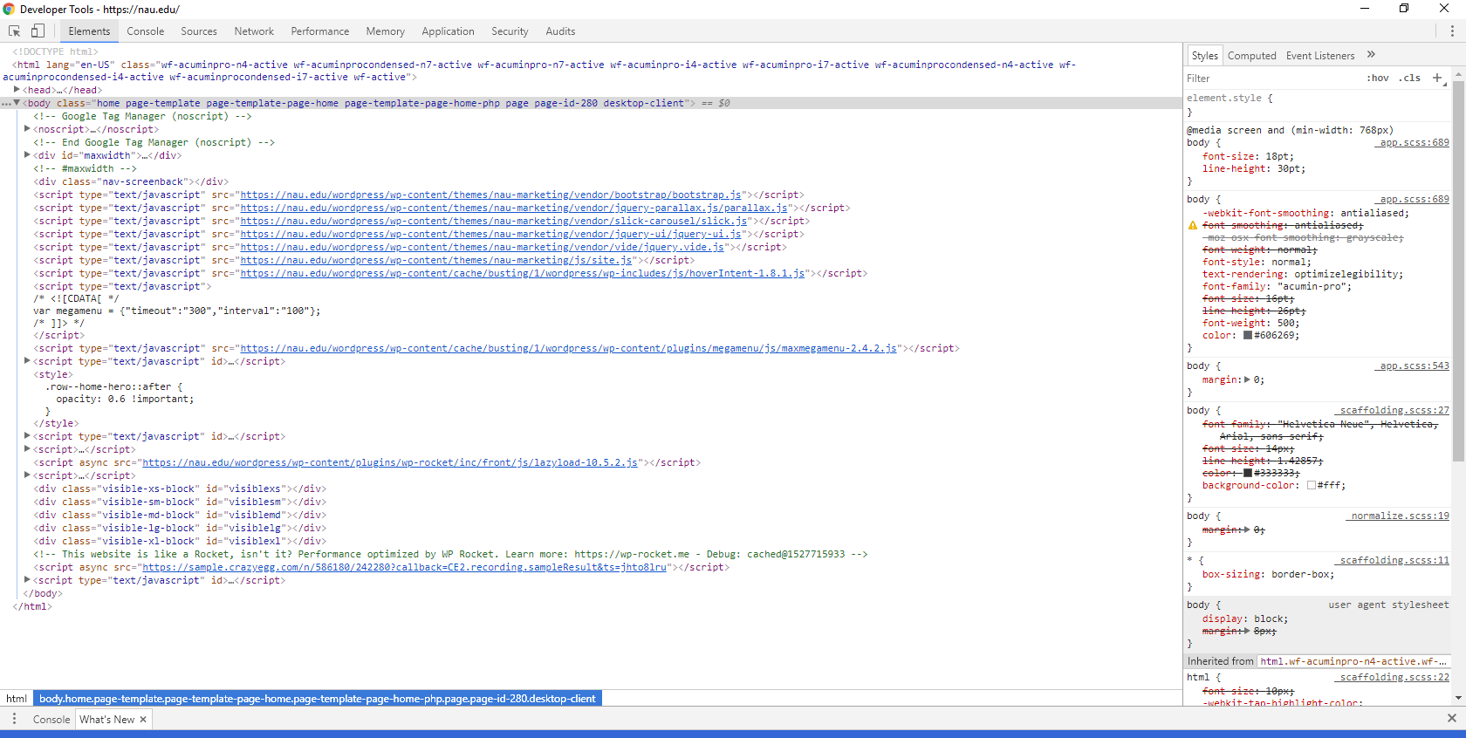

- Return to your previous window.
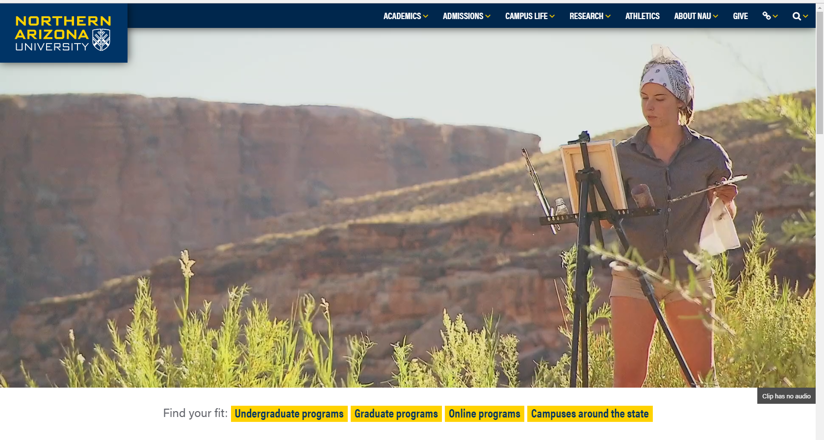
- Right click the reload button, and select “Empty Cache and Hard Reload”
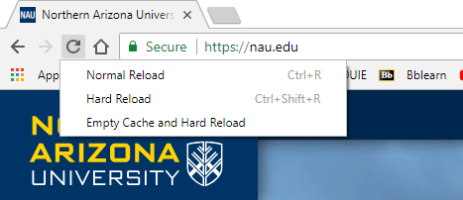
Once the above steps are complete, feel free to close the Developer Tools.

