Adding Tags to an Idea

About Tags
Tags are used to identify ideas that share a theme or other connection. Tags can be added by the idea authors during the submission of an idea, or after an idea is established. Moderators can also add tags to established ideas. To assist idea authors in assigning tags, the system Moderator creates pre-defined tags that can be selected. Otherwise, idea tags can be created by owners and moderators as needed.
Tags should be simple one or two word phrases. Use the dash “-“ character instead of a space to connect tag words. (e.g. “Student-Success”)

Adding Tags

Add a Tag via the idea submission form: Add a tag after an idea has been submitted:
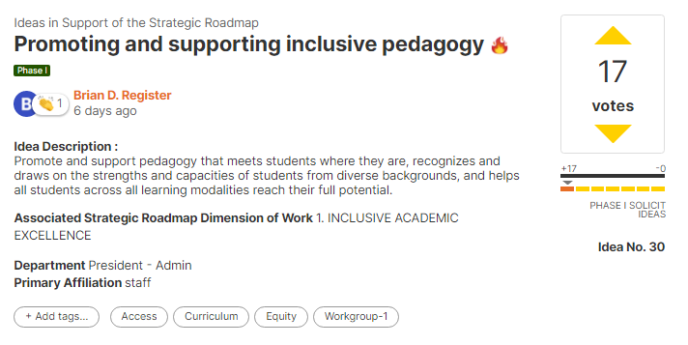
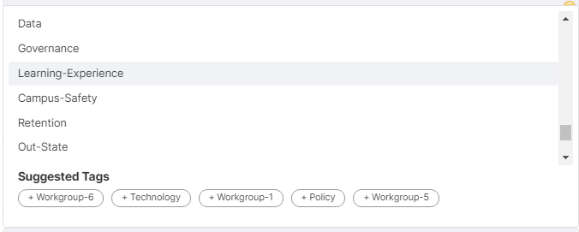
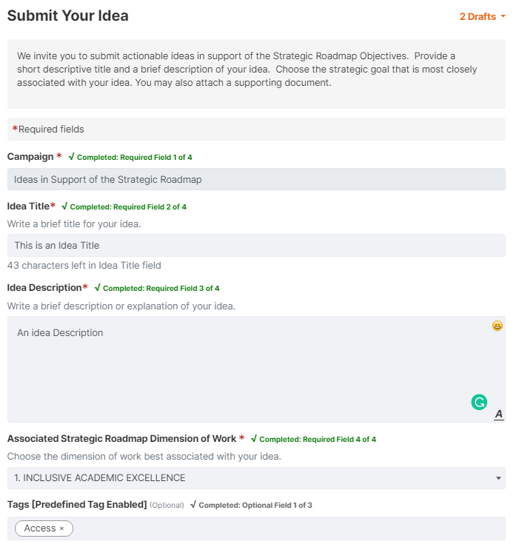

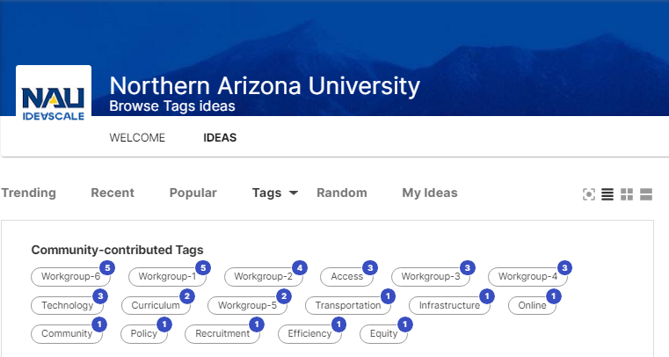

Using Tags to Find Ideas
Tags can then be used when reviewing ideas by selecting TAGS on the ideaScale welcome screen. This can help viewers and collaborators/commenters to find ideas along a particular theme or other connection.

Pre-Defined Tags
The Strategic Roadmap Campaign has identified the following pre-defined tags, arranged below in their associated working group area:

Work Group #1: Inclusive academic excellence
- Workgroup-1
- Learning-Experience
- Atmosphere-Structures
- Careers

Work Group #2: Equitable student access, momentum, graduation, and post-graduation success
- Workgroup-2

Work Group #3 - Impactful research, scholarly, and creative activities
- Workgroup-3

Work Group #4: Enhanced practices for recruiting, retaining, and developing quality, mission-driven, diverse faculty and staff
- Workgroup-4

Work Group #5 - Strong stewardship of place and demonstrated engagement with our communities
- Workgroup-5

Work Group #6 – Effective stewardship of financial, physical, and virtual resources
- Workgroup-6

See https://ideascale.nau.edu/a/pages/goals for latest information on the workgroup goals and pre-defined tags.

