GreenPC Thin Client Support Notes – April 11, 2016
Seymour Joseph

From 2011 through Mid 2014 we recommended the Wyse C10Le client which included one DVI port and PS/2 Style Keyboard and mouse:
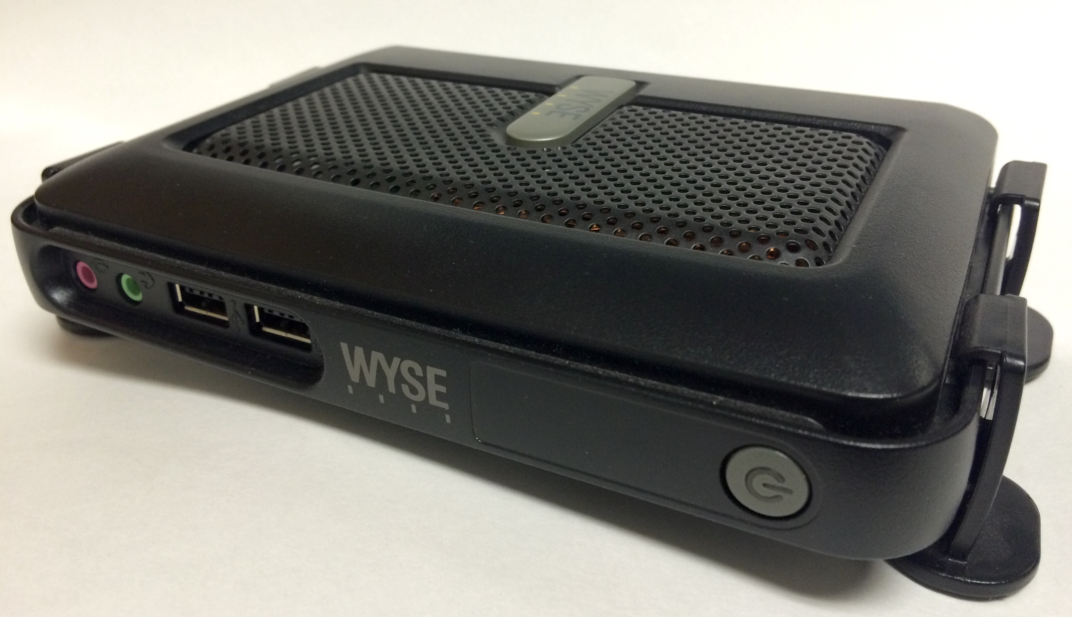

From October 2014 the above model was replaced in the Dell Premier store by the Dell Wyse T10D: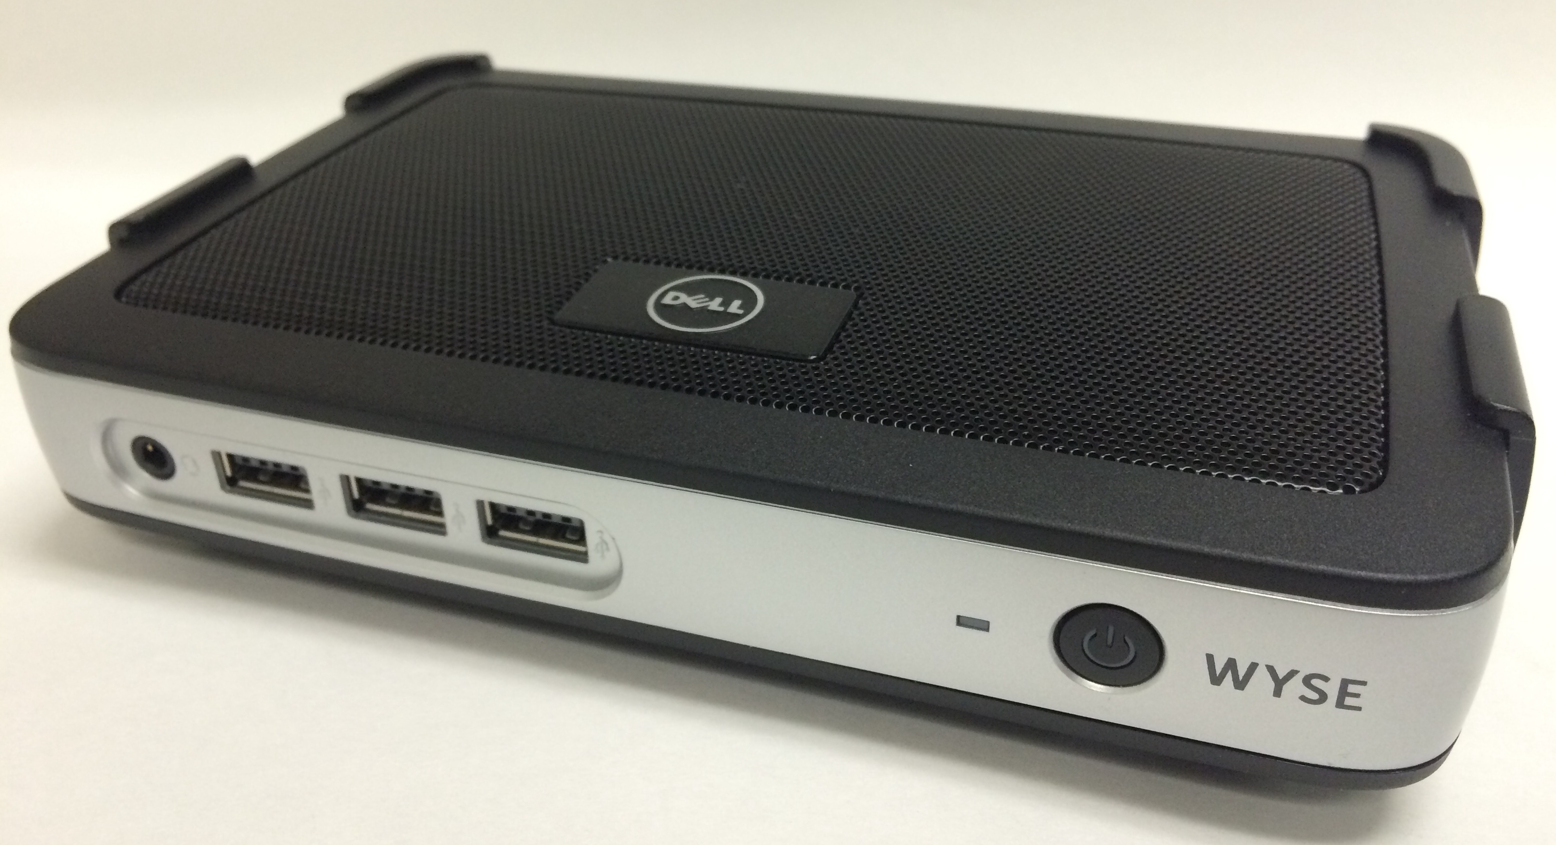

The newer T10D features Dual DVI video ports and all USB peripherals. The Analog audio-in port has been removed on this model.

Initial Setup

GreenPC Thin clients will be asset tagged and given a PCN by Central Purchasing as part of the purchase process.
Thin Clients must be registered in Diamond DNS. We strongly recommend that they be assigned IP’s on a 10.5.x.x subnet for security because they do not need access to any network resources outside NAU. Please enter the word “Wyse” and the serial # of the unit in the Diamond comment field as you register the device with our network.
Thin Clients should auto-configure right out of the box once registered in DNS, connected to the NAU network and powered up. They will contact an NAU FTP server (thinftp.ucc.nau.edu), download the latest OS updates (if any) and update their configuration in a matter of seconds. The GreenPC thin client will typically boot and be ready for client login within 10-15 seconds of powering on after the initial configuration.
If you are adding a group of 10 or more new thin clients, please call the solution center at x1511 and ask them to create an information-only ticket to ITS’ Windows Server team to inform them of how many thin clients you are adding. This will help ITS keep our server capacity ahead of client demand.

Monitor Support

The Wyse C10Le supports both single and dual monitor configurations. The primary monitor should support DVI (or VGA with adapter) with a resolution of up to 2560 x 1600 (see Table 1 below for all supported resolutions). Wide-screen or 4:3 aspect ratio monitors both work fine.
For the Older C10LE Client: A cable adapter allowing you to connect two displays is available. The adapter cable splits the built in DVI-I display connector into one DVI-D and one VGA connector. It is Wyse Part number 920302-02L which existing GreenPC thin client users can purchase as an add-on from computer cable/adapter retailers. (Google: Wyse 920302-02L )
To run dual monitors on your C10Le GreenPC thin client, you will need one DVI and one VGA capable display. The newer T10D GreenPC client has two built-in DVI ports which can support two DVI monitors or one DVI and one VGA with the adapter included in the box.
Most Dell displays sold in the past few years support both standards, with the DVI connector having a white hood and the VGA connector having a blue hood. The Wyse GreenPC thin clients supports a wide range of display resolutions up to 1920 x 1440 for dual monitor use as shown in Table 1.
Table 1: Supported Display Resolutions
640 x 480
800 x 600
1024 x 768
1024 x 768
1152 x 864
1280 x 720
1280 x 768
1280 x 1024
1360 x 768
1368 x 768
1400 x 1050
1440 x 900
1600 x 900
1600 x 1200
1680 x 1050
1920 x 1080
1920 x 1200
1920 x 1440
2560 x 1600
(single monitor only)
You can mix and match monitors of different resolutions and sizes as well as combining rectangular and wide-screen monitors if you wish. The best result will be obtained if the vertical resolutions of the monitors are similar.
The default dual display arrangement is side-by-side. We suggest that if your two displays are different resolutions, that the higher resolution display be connected via DVI (White connector) as display 1 on the left.
Dual Monitor Configuration:
Attach the keyboard, mouse and power cord to your thin client. Make sure the thin client is off. Attach both monitors to the thin client.
For the C10Le: Attach the white connector of the Dual Monitor adapter with the two cables coming out of it to the video port on the rear of the thin client. Attach the white DVI cable from the left-hand monitor to the white DVI connector on the adapter. Attach the blue VGA cable from the right hand monitor to the matching blue VGA plug on the adapter. Power up both monitors and make sure their inputs are set correctly, DVI on the left, and VGA (also called D-Sub) on the right.
For the T10D: The T10D natively supports dual monitor hookups. In dual monitor mode, the right hand plug (looking at the front of the device) is the primary monitor and the left hand DVI plug is the secondary. The left hand DVI socket can be fitted with a DVI to VGA adapter (included with the thin client) to drive an older style VGA monitor.
Remove the network cable from the rear of the thin client chassis by pressing down gently on the clip at the top center and pulling it free from the device. With the network cable disconnected, press the power button and wait for the thin client to start up. You should see the thin client desktop on the leftmost display. (The right hand display may or may not have an image at this point) The thin client will eventually display an error about the lack of a network connection. This is normal.
Click the “Desktop” button on the lower left corner of display 1. Choose “System Setup” and then choose “Display” from the pick-list that appears. The display setup window will open. At the top of the display configuration window, click the tab labeled “Dual Head.” On the screen that appears click the radio button next to “Span.”
With both displays turned on and set to the correct input, click the “Test” button at the bottom of the display setup window. Each monitor should briefly display a bull’s eye pattern with a label in the center of the screen showing the display number, a colon and the resolution automatically detected for that display, something like: “2: 1280 x 1024”. When the display configuration screen reappears, click the “OK” button to save the new settings and restart your GreenPC thin client.
After it restarts you can power it down and reattach the network cable to the rear of unit. The configuration for dual monitors is now complete. When you start up your thin client in the future, it will come up in dual monitor mode, and when you log into GreenPC you will get a merged Windows desktop across both displays. Items dragged off the right side of the main monitor will appear on the secondary display.
The video settings of the GreenPC thin client can be returned to their factory default resolution and single monitor mode by holding down the “v” key on the keyboard as you turn on the unit and keeping it pressed until the display reappears

Audio Out (Sound) Support
GreenPC thin clients have effectively no built in speakers for sound output. If sound is important in your workflow, external powered speakers or headphones can be plugged into the standard audio out port on the front of the unit.

User Migration

If a user is migrating from an existing PC to a thin client, their personal files should be moved to their Bonsai personal share before their PC is decommissioned. That share will be mounted by default on their thin client, so they will retain access to all files copied there.
If a Thin Client user needs to use a departmental share they can mount it in the RDS environment and the drive mapping will be restored automatically every time they login.
Each users Internet Explorer and/or Firefox bookmarks or favorites can be moved into the thin client environment. Both IE and Firefox provide methods for exporting and importing bookmarks. Before their PC is decommissioned, export their bookmarks to a file on their bonsai drive, and then import them into the same web browser in the GreenPC thin client environment.
Outlook in the Thin client environment will auto-configure for the logged-in user, but the outlook first-run setup dialogs may be confusing for less technically savvy users. Use your judgment on whether it would be advisable to do the first run of Outlook with each new thin client user to guide them through the setup dialogs, and get their reading pane set up the way they wish (right, bottom, none).

Boot Sequence

As the Wyse thin client boots, it connects to our network and uses DHCP to obtain an IP address. In its reply to the thin client, NAU’s DHCP server sends the requested IP address and an extra DHCP option tag (#161) containing the hostname “thinftp.ucc.nau.edu”, the hostname of a read-only FTP server that holds the thin client’s configuration files. (Members of ITS’ Windows Server and PC Support teams can access and modify the files on this FTP server via a windows share: \\sourwood.ucc.nau.edu\thinftp$ )
The configuration files for thin clients are stored in the directory Wyse/wnos on the FTP server. Subdirectories include:
- /bitmap – .gif and .jpg images loaded by the wnos.ini for the desktop pattern and the login dialog
- /Docs & Tools – Wyse documentation on the C10Le Thin client hardware, the Wyse Thin OS Version 7, Thin OS INI file syntax, a sample .INI file and a Windows-based WNOS.INI generation tool downloaded from http://www.freewysemonkeys.com/ (a great web resource for user-generated tools and support for Wyse products.)
- /firmware – A library of various versions of the thin client firmware used for testing. This directory is not accessed directly by the thin client. The Wyse C10Le client loads its firmware directly from Wyse/wnos/C10_wnos
- /inc – The “inclusions” directory that holds any custom .ini files referenced as included in the default .ini file

Once the Wyse client has an IP address and knows the hostname of its configuration FTP server, it opens an Anonymous FTP connection to thinftp.ucc.nau.edu and looks in the directory Wyse\wnos for a firmware image. For the Wyse C10Le models we are using, the firmware image is named “C10_wnos” The client first checks if the firmware image is different than the one it currently has loaded. If it is, the client downloads and installs the firmware image from the FTP server (~10 seconds) then restarts.
If the firmware image on the FTP server is the same as image currently running on the client, the client next looks for a general configuration file called “wnos.ini” in the same directory on the FTP server, loads this file and applies the settings contained in it.
Near the end of our wnos.ini, right before the definition of the default RDP session, is an “Include=$mac.ini” statement. This statement will cause the client to next execute any configuration commands from a custom ini file, specific to the MAC address of the booting thin client, if it is found in the directory “Wyse\wnos\inc”. The custom ini file must have as its name the MAC address of the unique workstation to which its config applies (minus the colons, just the six hexadecimal pairs) with the extension “.ini”. If the last line of the included file is “Exit=all” ini processing ends with the custom file, otherwise the client returns to the default wnos.ini and continues processing its initialization with the statement after the “Include.”
The default wnos.ini finishes with a definition of an RDP connection to the host greenpc.nau.edu along with instructions to auto-connect. So after it processes the wnos.ini file, the thin client displays a dialog prompting the user to login with their NAU credentials.

Printing

Our Thin Client environment only supports printers that are directly attached to the network; primarily HP LaserJets, although we have had limited success supporting Dell laser printers and some Konica-Minolta network attached copiers.
Our GreenPC servers use the HP Universal Print Driver to support network attached printers. You can review the table of supported HP network printers by doing a web search for “HP Universal Print Driver Series for Windows - specifications” (the URL as of this document update is http://h20331.www2.hp.com/Hpsub/cache/344305-0-0-225-121.html HP changes the URL frequently, so doing the web search is more reliable.) Scroll down on the specifications page to the table of supported printers.
Supported Konika-Minolta copiers are listed in Section 2 on Page 6 of this Konika-Minolta document:
http://kmbs.konicaminolta.us/supportattachments/Univ_Driver_Admin_Guide_FINAL_10_31.pdf
Printing in the RDS environment is supported via Windows print queues on the host kiwi.ucc.nau.edu. To see a list of already established print queues, go to the start menu and enter the name of the print server “\\kiwi.ucc.nau.edu\” in the search box, then press enter. If the printer the user wants is in the list, just right click it and choose “connect” while logged in as the user. If you have connected multiple printers for a user, you (or they) can then go to the “Devices and Printers” control panel to set a default printer and make other settings.
If a queue for the desired printer doesn’t already exist, please call the solution center at x1511 or create an ServiceNow incident (nau.service-now.com) for the MENSA (Windows Server) team with the following information:
Required Information:
- Printer TCP/IP Address:
- Printer Manufacturer:
- Printer Model #:
Optional Information:
- Printer Location (Bldg / Room):
- Printer Dept:
- Printer Description (ie: Color Printer behind copier) :
- Printing allowed only by members of the following AD Groups (leave blank if no restriction required):
The MENSA team will create a print queue for that printer and will contact you with the queue name. Once the queue is established, each user in the group that will be using that printer should log into their thin client and add that print queue as described in the first paragraph of the printing section above.

Remote Support

Bomgar, our standard remote support tool does not run in the RDS server environment. Remote screen viewing and remote control for support of clients can be established via Lync. The client need only launch Lync, type the technician’s name in the search box, right click them and then choose “Share” to share their screen with a technician. Once remote screen viewing has been established, the client can also use the same method to share mouse/keyboard control.

Document Transfer

Thin clients have no built in removable media drives. If a client needs to move a document out of their server working environment they have a few choices:
- Email the file as an attachment – (the fastest and most secure choice for smaller documents)
- Copy the file to a USB flash drive – FAT 32 formatted Flash drives (we’ve tested up to 16 Gb drives) inserted in the thin client will mount in the server environment to allow file transfer. As always, NAU employees should be cautious of carrying enterprise data unencrypted on removable media.
- Upload the file to your Blackboard Learn Content Collection

Warranty / Repair Service

The Wyse thin clients are purchased with a 5 year return-to-depot warranty. Wyse clients have their manufacture date on a sticker on their bottoms. If it’s less than 5 years from manufacture, it’s covered. More than five years? We need to check with Wyse. If a unit fails while under warranty, Please call the solution center at x1511 or open a work order at nau.service-now.com
Using their supply of service spares, an ITS technician will swap out your broken unit for a working one and ITS will manage returning the unit to Wyse for warranty replacement. Since there is no user data stored on the Wyse devices, the client can resume their work as soon as the replacement unit has been swapped in. It is not economically viable to repair units outside of the warranty period.
Details of the Repair RMA process for Technicians handling repairs are on the Wyse web site at: http://www.wyse.com/serviceandsupport/service/rmaproc.asp

Resetting a thin client

The default configuration file loaded from the network at startup puts the Wyse thin clients in a low privilege mode where clients don’t have access to most of the local thin client interface other than logging in to the RDP server.
If you ever have the need to reset a thin client to factory default settings you have two options:
- Holding the G Key on the keyboard down while you power the unit on causes a reset to factory settings. If it is connected to the network, the client will completely reconfigure itself from the FTP server during the boot process.

- Powering the unit up while it is not connected to the NAU network will boot it in a privileged mode where you have access to more of the interface on the unit, including, in the shutdown menu, an option to reset it to factory settings. Please note that changes you make to the client configuration in privileged mode that conflict with settings made in the wnos.ini configuration file will be reversed the next time the client boots connected to the NAU network.

