QuickTips

Creating a Shortcut
Shortcuts can be used to link to reports in various folders and saved in My Favorites for easy access. Shortcuts insure you always have easy access to the most up-to-date public report including any modifications/updates to the query.
- Select the report that you need the shortcut for (Do NOT double-click or open the report).
- Right click on the report and select Organize drop-down and select Create Shortcut
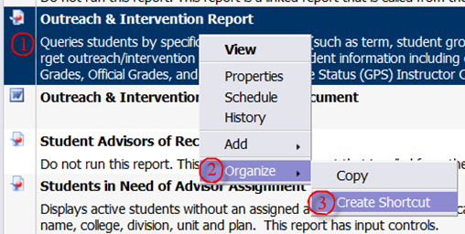
If you choose a copy, be aware that your copy will not reflect future updates or changes to the original report.
- Click on the My Favorites folder to expand it
- Click on Organize then Paste Shortcut

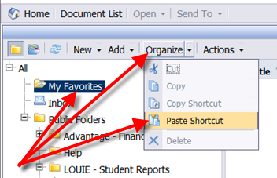
This creates a shortcut to your chosen public report.

