QuickTips

Exporting Your Data
You can easily export your report data to PDF or Excel for further review or manipulation.
- Run your report. Consider using Input Controls to filter your results before exporting.
- Select the dropdown arrow to the right of Document.
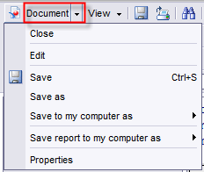
Hover over the arrow to expose the available file types.
- This option saves every tab of your report to the file type you choose. 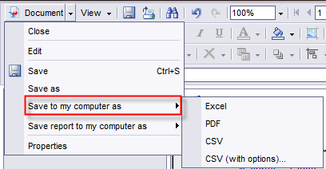
Select the file type you want.
- This option saves ONLY the report tab you are currently on:
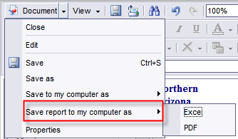
- Depending on your browser, you may be asked whether you want to open or save your file.
- We recommend you open the file then save it to a location of your choosing.

