QuickTips

Using Prompts
The prompt dialog box allows you to specify the data to retrieve and display in the report.
- Run your report.
- Reply to the prompts before running the query. In the example below, you have to select at least one Deptid.
Note: you may select more than one deptid in this example.
- There are several ways to populate prompt values in a prompt.
  - #1 – You may type in your deptid(s) then use the right arrow to move the deptid(s) to the Enter value(s) for Deptid: dialog box.
  - #2 – If you don’t see your deptid(s) in the list of values, use the drop down arrow in #2 to find your range of values.
  - #3 – Select the value(s) from the List of Values then use the right arrow to move the values to the Enter value(s) for Deptid: dialog box.
  - #4 – You can search for a range of values by entering part of the values such as 262* then click on the binoculars icon to return all deptids that begin with 262.
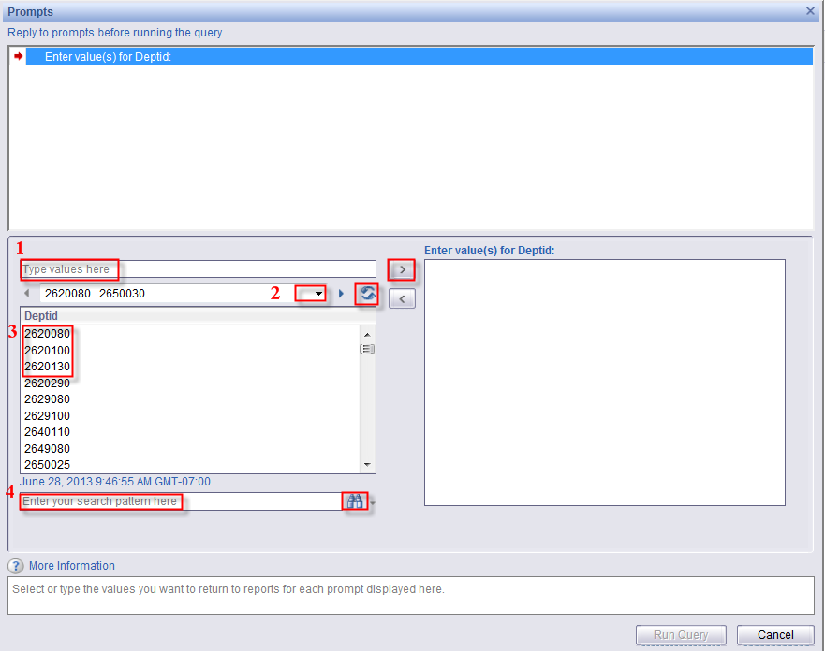
Use the blue arrows icon to refresh the List of Values displayed.
You may pick a range of values by holding the shift key down and selecting the range you want.
OR you may pick select values by holding the control key and selecting multiple values.
Note: The Run Query button above is greyed out until you select values.
- Once your prompt values are selected, you may Run Query.

