QuickTips

Using input controls
You can easily filter data in the report using Input Controls.
- Run your report
- At the bottom left side of your screen you will see several icons. Select the Input Controls icon to change your display. If your left navigation panel is narrow, you may have to click on >> to find it.

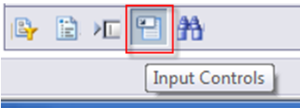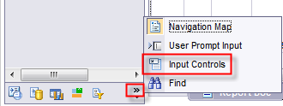

- Use the Input Controls to find the data you need.
- Below is one example of an Input control.
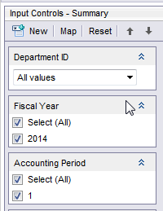
Use the Arrow to select the value you wanted filtered.
Or uncheck /check as needed.
- Input Controls may be reset individually, or use the Reset button to reset all Input Controls on the sub report.
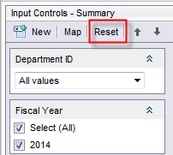

Note: Each sub report may have a different set of input controls.

