QuickTips

Using calculations
Web Intelligence provides standard calculation functions to help you make quick calculations on the data in your reports. These calculations are available from the drop-down list of calculations on the Web Intelligence window toolbar.
You can calculate sums, averages and percentages. You can also calculate the total count, and the minimum and maximum values for a variable.
To organize a report with calculations
- Click a table cell that contains numeric data.

- Click the arrow at the right of the Insert Calculation button and select the calculation you want to insert.

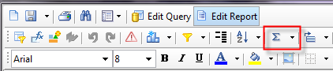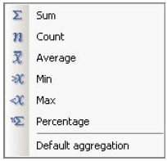

The Insert Calculation button displays a mathematical symbol for the currently selected calculation. This symbol changes depending on the default or the last calculation selected.

- To insert other calculations, click the down arrow next to the Sum icon and select the calculation from the drop down list.
A new row is added at the bottom of the table. The aggregated value appears in the new row cell. You may need to page to the last page of the report to see the aggregated value as it displays on the last row of the table.
The Count calculation defaults to a distinct count of the data in the column you’ve selected. For example, if you performed a count of *Emplids, by default the count is of distinct students. The formula in the cell looks like =Count([*Emplid]). To get a count of all rows, you could update the formula in the cell to =Count([*Emplid];All). As a best practice, it is helpful to label the row with Count or Count All, so the person running the report knows which type of count they are seeing.

