QuickTips

How to search for objects in Query
You have copied a report and now need to know where the Result Objects came from.
- Run your report

- Select Edit Query to access the Query Panel.
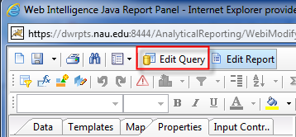
The folder, on the left, expands to display the location of the object selected. Using your arrow key, click through each object in the Results Objects pane, to see where the object resides.
- Click on the first object in the Results Objects pane. 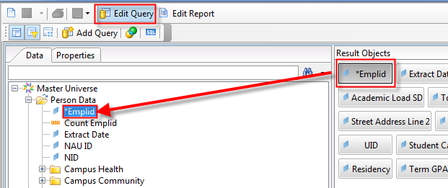
- You can search for an object by typing the object name in the search bar in the upper left hand corner of the navigation panel.
Be aware that some objects have the same or similar names, but are located in various folders. Your search may return the first object name that matches the object name you typed in the search bar. Make sure you have the right object from the right folder before using it.
