QuickTips

How to move a report
When editing a document (Business Objects report), you can move/change the order of your reports (sub reports/tabs). Business Objects terminology refers to the overall report as a document, and each sub-report (or tab) as a Report.
To move a document using Move Report feature
- In the Web Intelligence window, right-click a report tab at the bottom of the document pane and select Move Report.
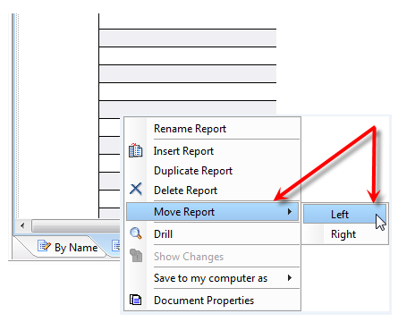
- Using the arrow, select whether you want to move the report Left or Right.
To move a document using Document Properties
- In the Web Intelligence window, right-click a report tab at the bottom of the document pane and select Document Properties. The Document Properties pane will appear to the right of the Report Panel.

- In the Document Properties pane locate Report Order and select the Report you want to move by clicking on a report, then using the arrows move the report up or down.
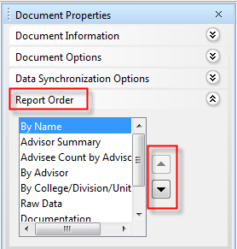
To close the Document Properties pane, click on the X to the right of the Document Properties pane.

