QuickTips

How to Insert, Duplicate, Delete or Rename a Report
When editing a document (Business Objects report), you can insert new reports to a document, and duplicate, delete or rename reports as you like. Business Objects terminology refers to the overall report as a document, and each sub-report (or tab) as a Report.
To insert, duplicate, delete and rename a report within the document
- In the Web Intelligence window, right-click a report tab at the bottom of the document pane and select Insert Report OR Duplicate Report OR Delete Report OR Rename Report.
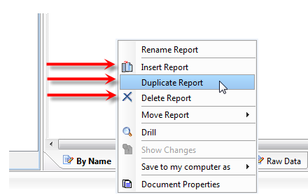
Use Insert Report to insert a blank/unformatted report.

Use Duplicate Report to insert a copy of another report which includes all the formatting of the duplicated report.

- To insert a report, right click on any tab and select Insert Report. A new blank report will appear.
- To duplicate a report, right-click on any tab and select Duplicate Report. A copy of the report you chose to duplicate will appear.

If you’ve duplicated the report, the new report will be located to the far right and (1) will be added to the Duplicated Report name.
If your report has input controls and you want to duplicate a report, the input controls will NOT duplicate. You will need to recreate the input controls on your duplicated report.
- To delete a report, right-click the tab you want deleted and select Delete Report.
- To Rename Report, right-click the tab you want renamed and select Rename Report. The text field on the tab is selected.
- In the text field, type the name you want to give the report and press the Enter key. The report tab displays the new name for the report.

