Arizona energy sources and uses activity (grades: 6-12)

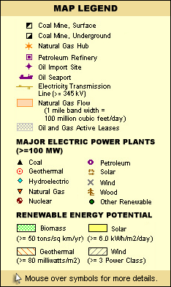
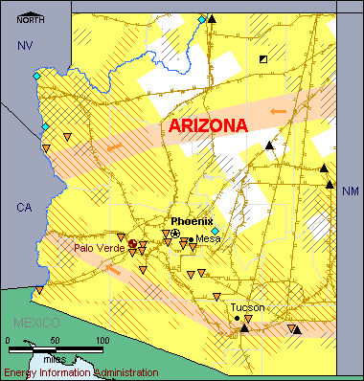
Have students break up into groups or work individually. Each group picks one energy source/type (e.g. nuclear, wind, hydroelectric, natural gas, biodiesel, solar PV, concentrating solar, geothermal, gasoline).

Figure 1. Source: Energy Information Administration State Electric Profiles, 2012.

For each source, the students should perform research that considers the following questions. You can lead them through each area of inquiry as part of a lesson plan, or make this an independent research project that they bring back completed. After the research, students should bring their reports to class for a discussion on the pros and cons of the various energy sources we use.

Alternative methods of presentation:
- Have the students make a poster about their research.
- Have students make a map of Arizona or the region, showing the sources, uses, and impacts of their chosen energy source.
- Have students give a presentation about their research results.

The following page is for you to give to your students.
Each energy source has benefits and drawbacks, or pros and cons. All energy sources have impacts associate with their use – whether these impacts come from mining for raw materials, the construction of power plants, the use of water, or pollutants or waste that may result from their use. Some energy sources have direct and indirect impacts on wildlife and human health.

This activity will help you learn more about the energy sources used in Arizona, and the implications or impacts (direct and indirect) of our use of these energy types.

Answer the following questions to guide your research:

What is the source? What is it used for (e.g. electricity/heating/transportation, burning etc)?

Is there a raw material involved? What? Where does it come from (is it found in Arizona)? How is it extracted? What are the byproducts and impacts of extraction?

Is the raw material processed? How?
Is the raw material transported? How far? Is the final product transported? How far?

How is the energy source used? (e.g. combustion turbine, chemical conversion, etc.)

(For electricity generation sources) How much does it cost to build a plant that uses this source of energy? How much does it cost to operate it (is there a fuel cost)?
(For non-electricity generation sources) Is the source relatively expensive or inexpensive for us to use? What would the alternatives be? Is the source convenient for us to obtain?

When the energy source is used, what are the byproducts? Are there pollutants? How much? Does the process use water? How much?

Are there health impacts on humans of the energy source? What are they?

Are there impacts on the land or living creatures in the environment from the use of this source of energy? What are they?

Is this energy source always available? If not, why not? What happens when it is not available?

How much of the end-use energy (electricity, heating and transportation) that we use in Arizona comes from this source?

Where is this source used in Arizona (make a map)?

Summarize your research with a brief report on this energy source’s pros and cons.

