Table of Contents
Document Management 2
Overview 2
Tutorial 2
Navigate to the Admin Tool 2
Submitting an Admin Drop Request 3
Select a Class for Admin Drop 4
Select Students for Admin Drop 5
Submitting an Admin Add Request 10
Select a Class for Admin Drop 10
Select Students for Admin Add 11
Errors 21
Communications 21
Reference 22
Administrative Drop Policy 22
Administrative Request Deadlines 22
Deadline has Passed 22
Where to find Deadlines 23
Support 25

Document Management
The Office of the Registrar will maintain documentation after initial implementation.
Version | Date | Author | Reason
1.0 | 8/14/25 | Jessica LoCicero | Creation
2.0 | 10/23/25 | Jessica LoCicero | Added Admin Add instructions

Overview
This document will detail the steps involved for an instructor to submit an Administrative Add or Drop Request in PeopleSoft.
Instructors can submit an Administrative Drop Request if the following are true:
- They are listed as a primary instructor for the class
- They have completed the FERPA training and quiz
- The Administrative Request Deadline has not passed for the Term and Session the instructor is attempting to submit a drop for.
  - Note Administrative Requests are not allowed for past terms

Tutorial

Navigate to the Admin Tool
Log into LOUIE/PeopleSoft: peoplesoft.nau.edu
- Navigate to your Faculty Center
  - From Employee Home (Louie) dropdown, select Faculty Advisor Home
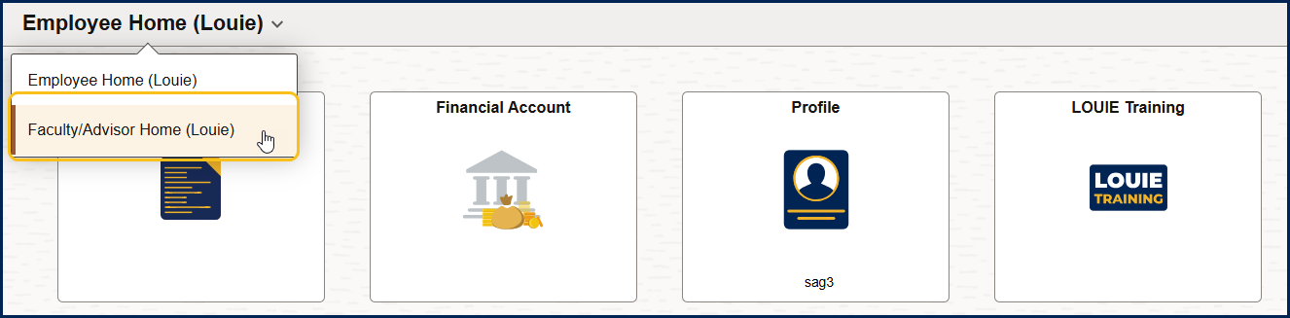
- On the Faculty/Advisor Home page, select the Faculty Center tile
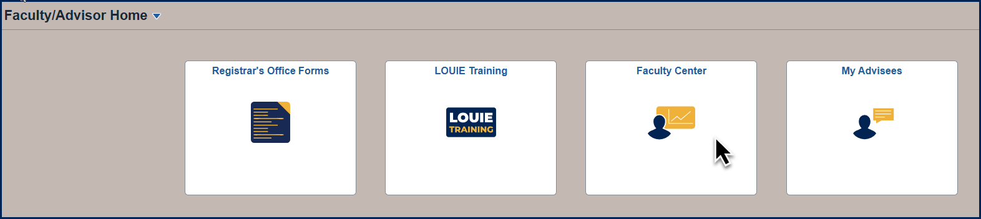

Submitting an Admin Drop Request
- Select Admin Drop from the Left Navigation List
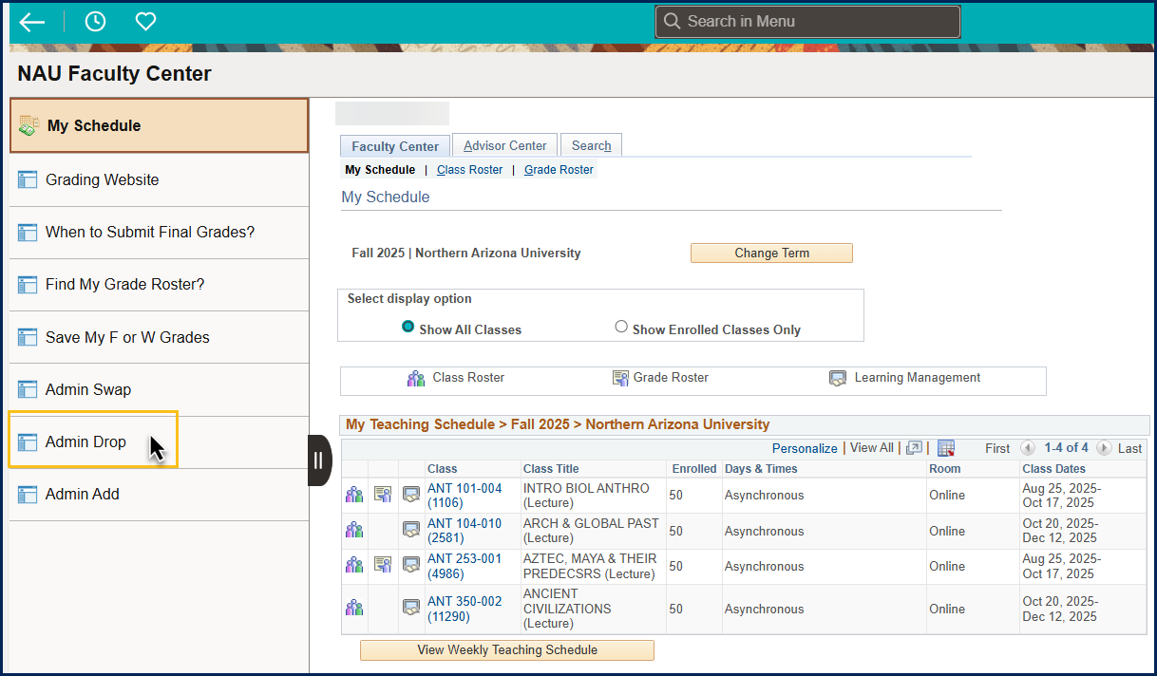

Select a Class for Admin Drop
- The Term should default to the current term, if you want a different term, select it from the Term Dropdown
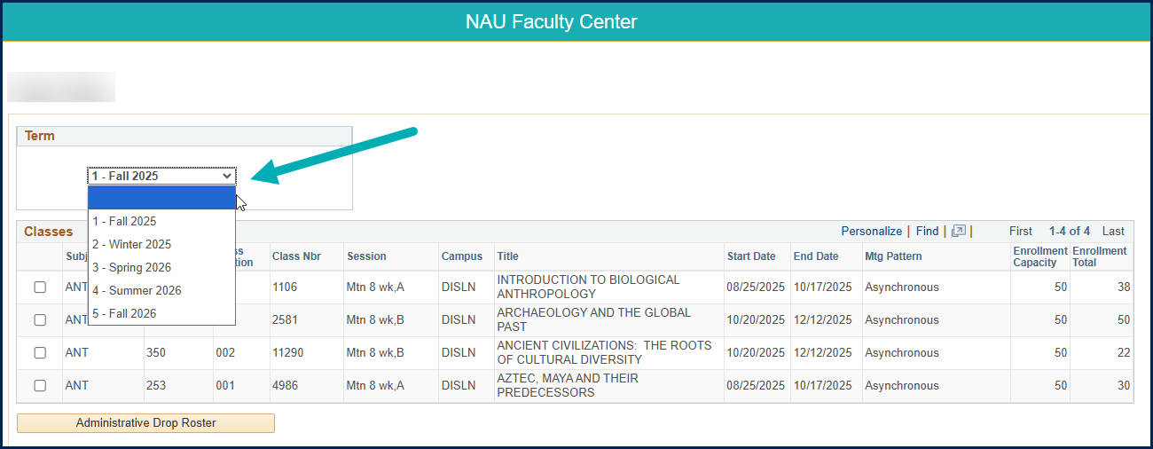
- Select one class from the list to drop students from
- Click the Administrative Drop Roster button
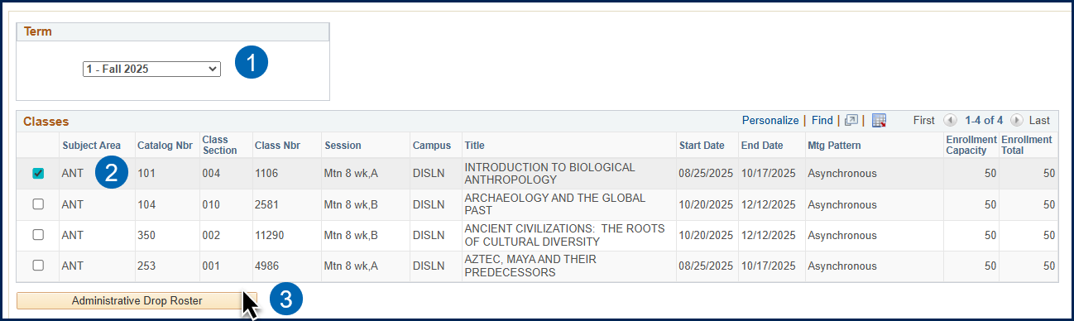

Select Students for Admin Drop
Once on the Admin Drop Roster a user can:
- Display Student Photos
- View Students by Enrollment status
  - Enrolled
  - Dropped
  - Waitlisted
- Select an Admin Drop Reason
  - Poor Attendance
  - Unmet Requisites
- Select students to Drop
- Submit Drop Request(s)

1: Display Student Photos
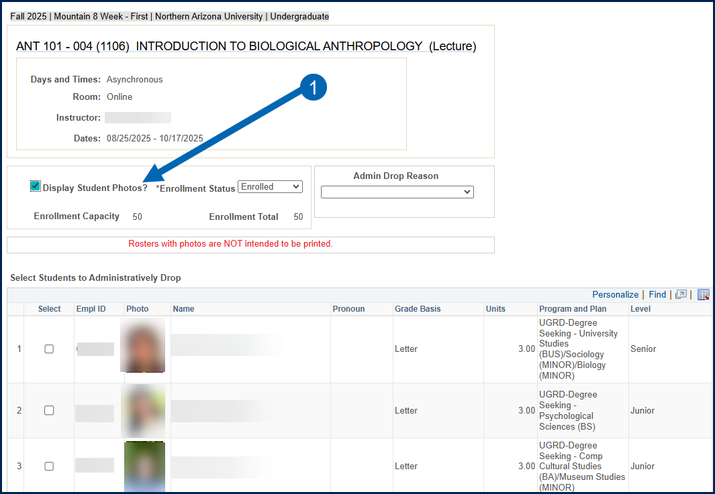

2: View Students by Enrollment Status
- Default status = Enrolled
- Other Options:
  - Waitlisted
  - Dropped
  - All
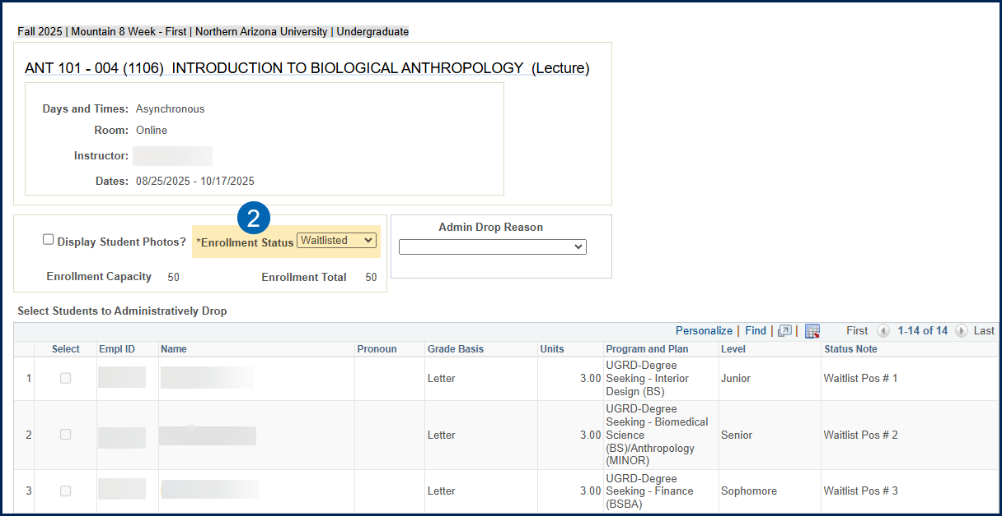

3: Select an Admin Drop Reason
- An Admin Drop Reason is REQUIRED to submit an Admin Drop Request
- If you need to drop students for both Poor Attendance and Unmet Requisites, you will select students for one reason, submit, then select students for the other reason, and submit.
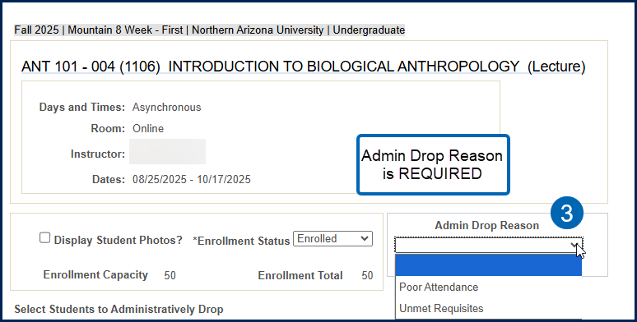

4: Select Students to Drop
- Set Enrollment Status dropdown to “Enrolled” if it is not already
- Select an Admin Drop Reason
- Select one or more students to drop
- Scroll to the bottom of the Roster and Click “Drop the selected student(s)” button
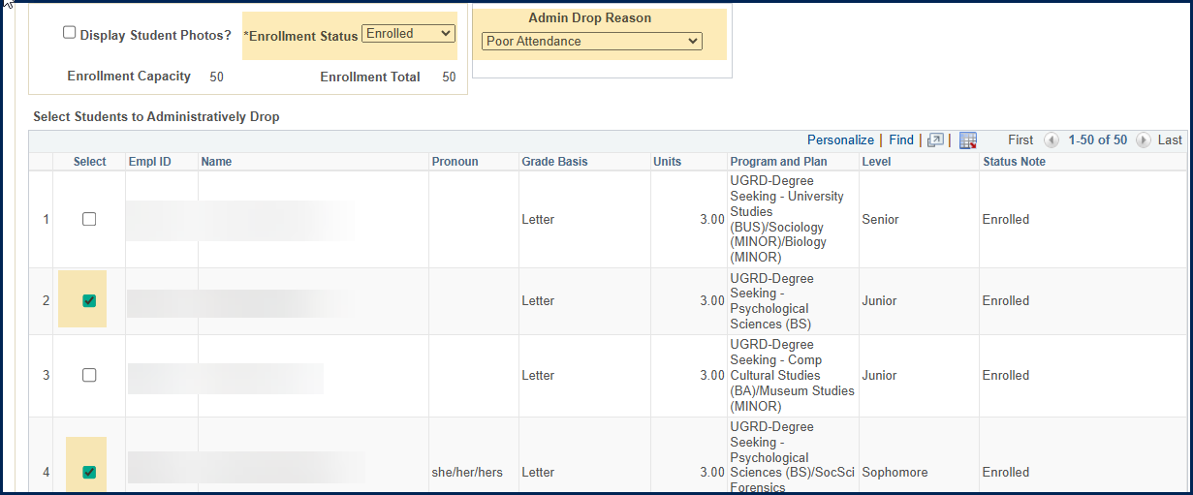
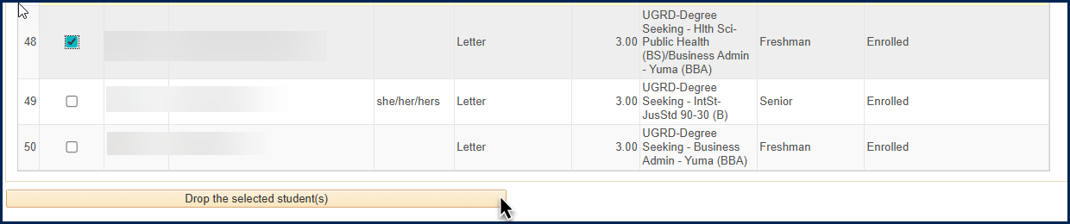

5: Submit Drop request(s)
- You will see a message pop-up for each selected student where you can click
  - Yes to submit the drop for that student
  - No to cancel the drop for that student
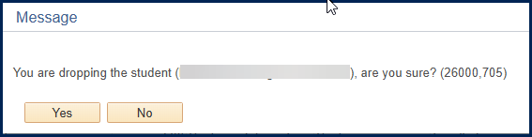
- Clicking Yes and successfully dropping the student will create another pop-up:

- Clicking No will move on to the next student if you selected more than one, or back to the Admin Drop Roster if there are no further students selected

Submitting an Admin Add Request
- Select Admin Add from the Left Navigation List
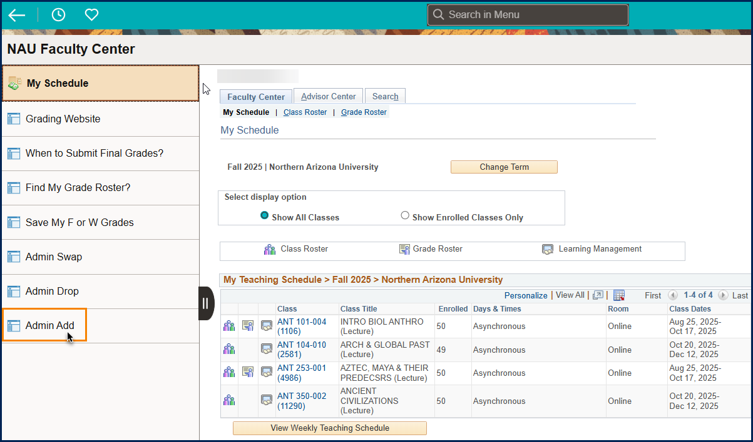

Select a Class for Admin Add
- The Term should default to the current term, if you want a different term, select it from the Term Dropdown
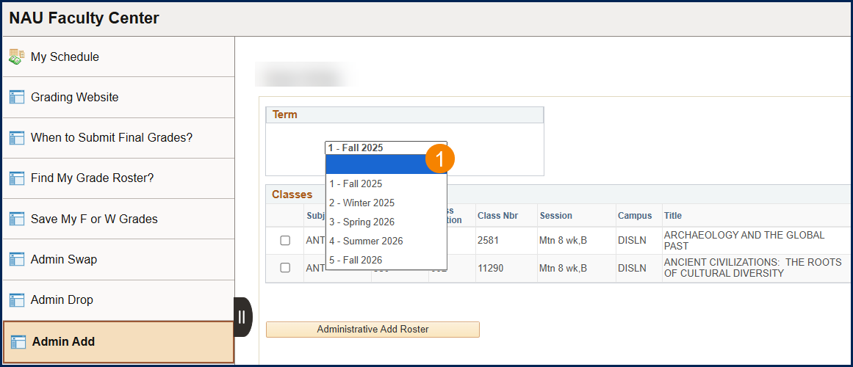
- Select one class from the list to drop students from
- Click the Administrative Add Roster button
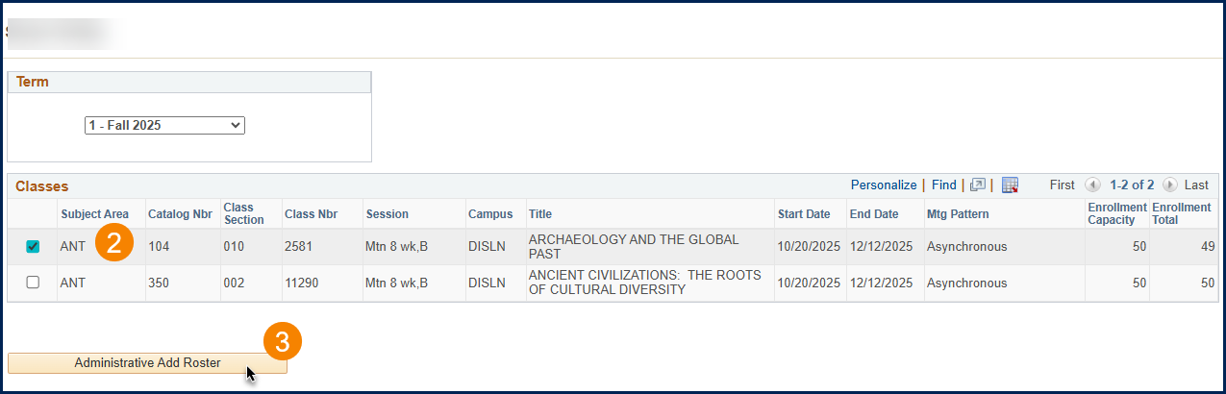

Select Students for Admin Add
Once on the Admin Add Roster a user can:
- Display Student Photos
- Select students to Add by Enrollment Status
  - Dropped
  - Waitlisted
- Search for Students to Add

1: Display Student Photos
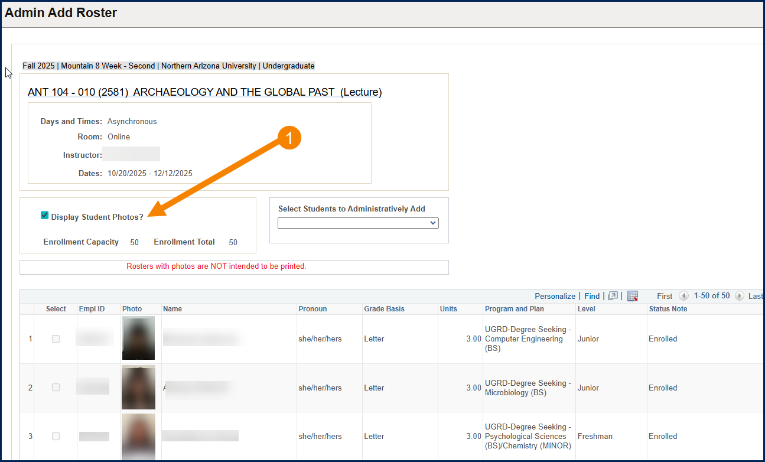

2A: Select Students to Add by Enrollment Status – Waitlisted
- Click on the drop down below “Select Students to Administratively Add” and choose Waitlisted Students
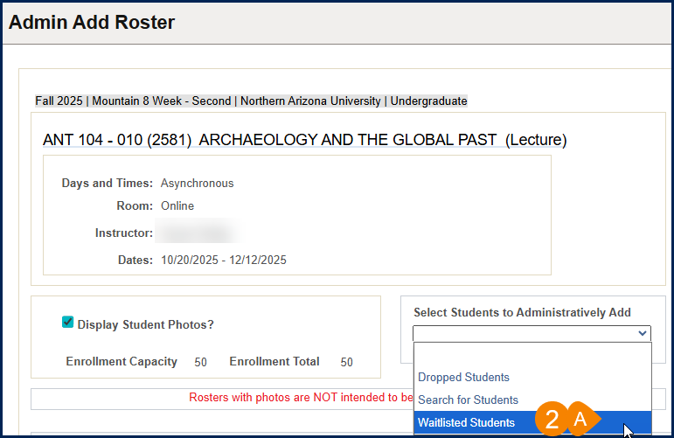
- A Waitlist Roster will open, select one or more students to add
- Click Enroll Student(s) in the Class button
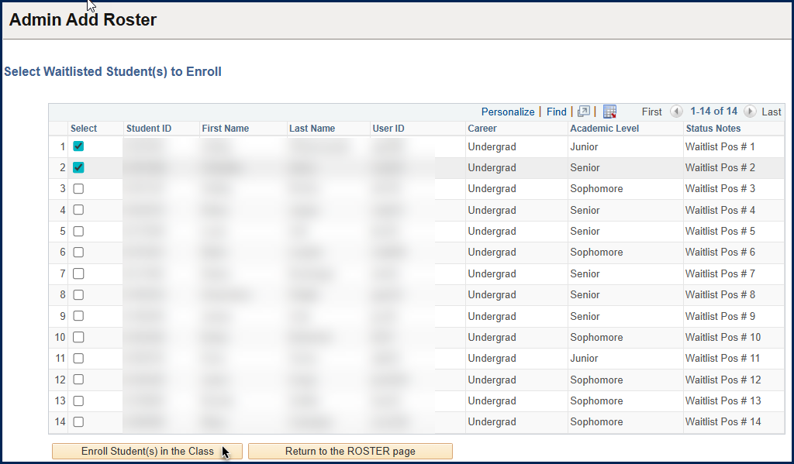
- For each student you will select Yes or No to the message: You are enrolling the student (First Name, Last Name – EMPLID), are you sure?
  - Yes, will submit the enrollment request
  - No, will move on to the next student or return you to the waitlist roster if there are no other students to enroll
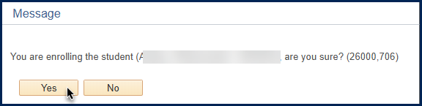
- If the enrollment is successful, you will receive a message:
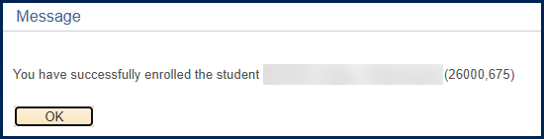
- If the enrollment is NOT successful, an error message will appear. See the Error section for common errors and next steps.

- When you are done adding students from the Waitlist, Click Return to the ROSTER page button


2B: Select Students to Add by Enrollment Status – Dropped
- Click on the drop down below “Select Students to Administratively Add” and choose Dropped Students
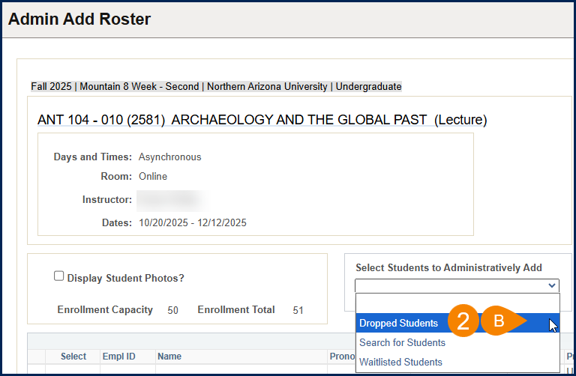
- A Dropped Student Roster will open, select one or more students to add
- Click Enroll Student(s) in the Class button
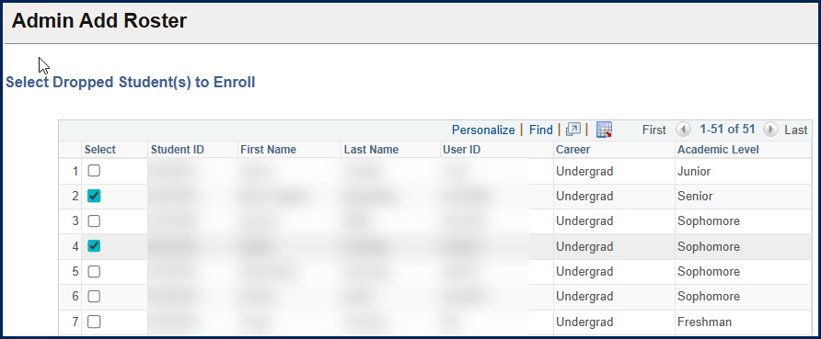
- For each student you will select Yes or No to the message: You are enrolling the student (First Name, Last Name – EMPLID), are you sure?
  - Yes, will submit the enrollment request
  - No, will move on to the next student or return you to the waitlist roster if there are no other students to enroll
- If the enrollment is successful, you will receive a message:
- If the enrollment is NOT successful, an error message will appear. See the Error section for common errors and next steps.

- When you are done adding students from the Dropped Students Roster, Click Return to the ROSTER page button

3: Search for Students to Add
- Click on the drop down below “Select Students to Administratively Add” and choose Search for Students
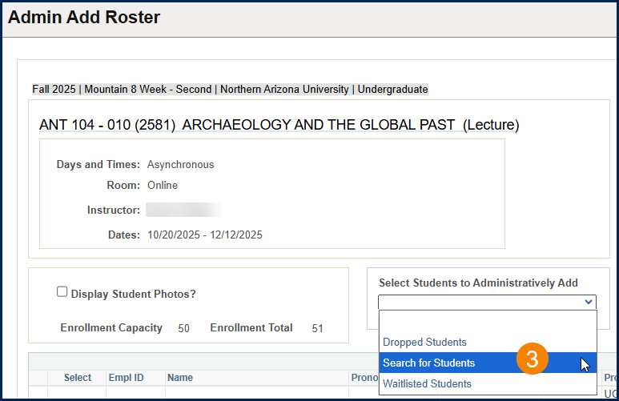
- You will be taken to a Select Student(s) to Enroll Page
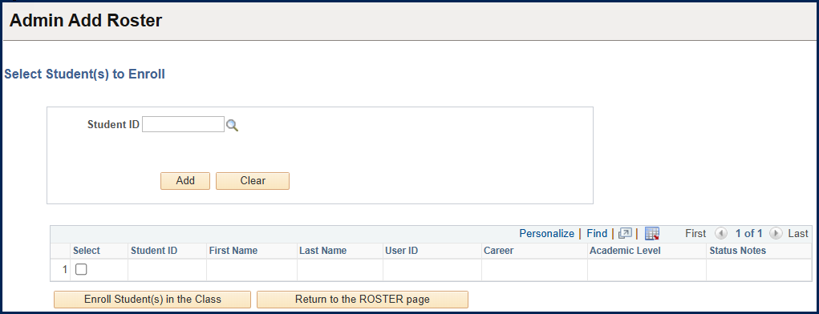
- Enter the student EMPLID into the Student ID box if you know it
- Click the magnifying glass to search by:
  - First Name
  - Last Name
  - User ID
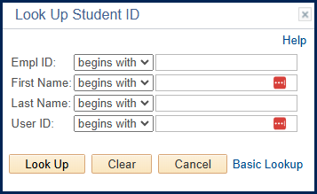
- Once you have selected a student their ID will appear, Click the Add button to add the student to the list
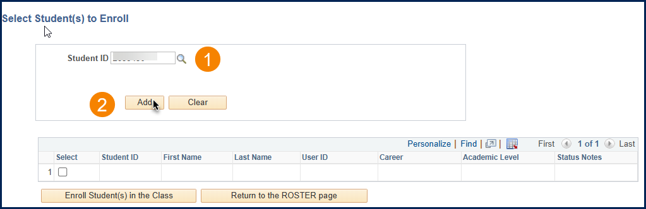
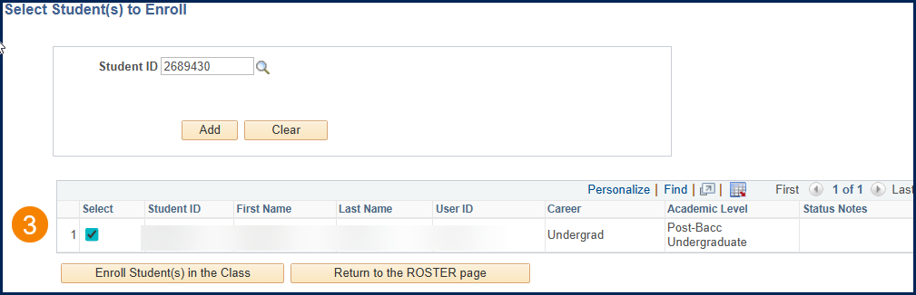
- Follow the same steps above to search for and add additional students in a new line
- The Clear button can be used to clear all students in the list and start over
- Once you have added all students, click the Enroll Student(s)in the Class button
- For each student you will select Yes or No to the message: You are enrolling the student (First Name, Last Name – EMPLID), are you sure?
  - Yes, will submit the enrollment request
  - No, will move on to the next student or return you to the select Student(s) to Enroll Roster if there are no other students to enroll
- If the enrollment is successful, you will receive a message:
- If the enrollment is NOT successful, an error message will appear. See the Error section for common errors and next steps.

- When you are done adding students from the Select Student(s) to Enroll Roster, Click Return to the ROSTER page button

Errors
If there are any issues with dropping or adding a student, you will see an error message to let you know that the student could not be enrolled or dropped.
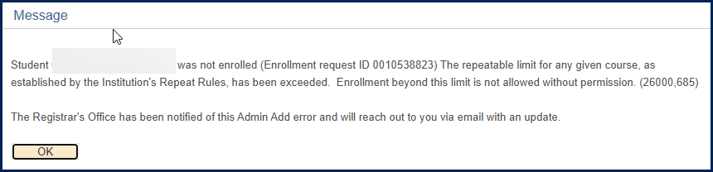
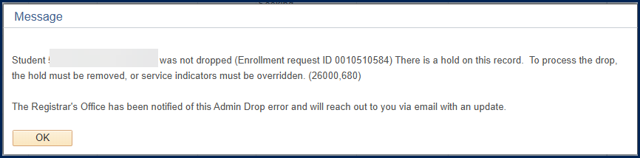
When this happens, an email will be sent to the Registrar’s Office at AdminRequest@nau.edu. The Registrar will review the issue and respond to you via email with further details.

Communications
- An email will be sent to the student to let them know they have been administratively enrolled or dropped from the class
- An email will be sent to the instructor to let them know the student(s) has been administratively enrolled or dropped
- An email will be sent to AdminRequest@nau.edu for any requests that result in an error

Reference

Administrative Drop Policy
The Administrative Drop Policy can be found in the University Policy Library

Administrative Request Deadlines

Deadline has Passed
If the Administrative Request Deadline has passed for the Term and Session you are attempting to use Admin Drop for, you will see the following message:
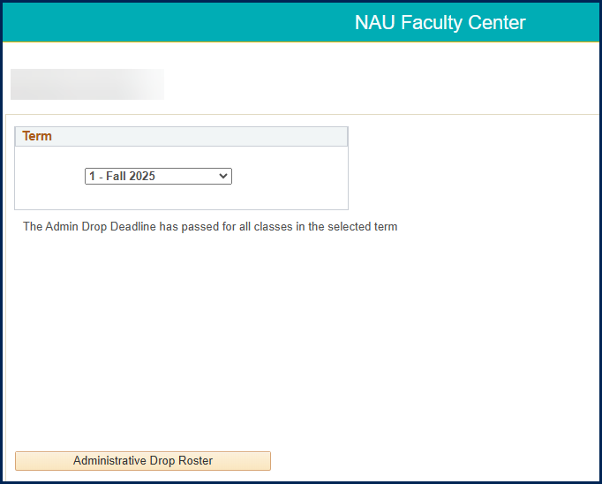

Where to find Deadlines
The Administrative Request Deadline for all sessions can be found on the Registrar’s Office website under the Important Dates and Deadline Section: https://in.nau.edu/registrar/

Once you click on Important Dates & Deadlines, click the Academic Calendar link for the term you want to know the dates for:
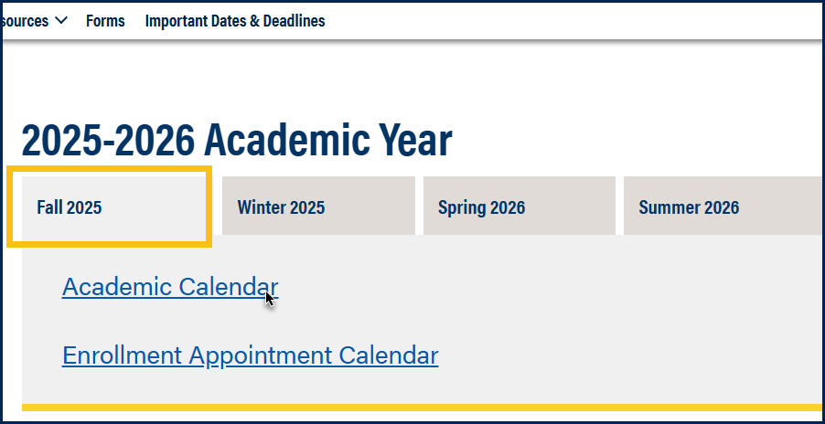
Find the deadline for a under the Administrative Request Deadline Event:
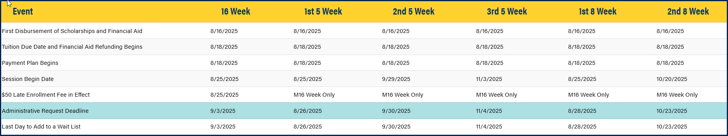

Support
Please contact the Office of the Registrar at AdminRequest@nau.edu with any questions.

