Rolling Up Classes

Condensed Version

Primary Instructional Section

When an instructor teaches multiple sections of the same course, the instructor may ask to roll the sections into one primary instruction section IF the following characteristics are consistent for each section:

Term | Session | Course is the Same  Exception = Approved Combined Sections That Have Been Set Up Appropriately | Units | If there is a Topic, Topic must be the Same | Grading Basis | Mode of Instruction | Instructor | Class  Components / Type  LEC/LEC or LAB/LAB | Instructor Role

This will create one Canvas Learning Management System (LMS) shell, so the instructor will not need to repeat the same class content for each Canvas shell. This is done by using Coursedog’s General Information card then Primary Instr Section field.

TIP: Be sure you understand what the instructor is asking for. Roll-ups are different from Combined Sections (See Helpful Details, below.)

- The process for rolling up sections of a course into one LMS Canvas shell is as follows:
- Change the primary instruction section number/s to match one of the section numbers. For example, if an instructor is teaching sections 001, 002 and 004. Change sections 002 and 004 to 001, so all three numbers are the same.
- When rolling up a zero-unit lab with another zero-unit lab, keep in mind that the section number (letter) is case sensitive. If the section number (letter) is a capital “A”, you must input a capital ”A” in the Primary Instr Section field. If you input a lowercase “a”, the zero-unit labs will not roll into one Canvas shell.
- Remind instructors it is very important for them to notify the academic unit scheduler if any of the rolled-up sections need to be unrolled or if another section is added. Changes to a roll-up need to be completed in Coursedog.
  - In addition, it is important to send an email to lms-faculty-help@nau.edu to advise of any changes, because the initial roll-up feeds to Canvas, but changes do not.
  - The classes will remain rolled up if changes are not made in PeopleSoft and LMS/eLearning is not also notified about the changes.
  - Rolled up sections cannot be changed once the class begins, because student work cannot be moved from the Canvas shell, only content can be moved. Students will lose their work if classes are unrolled after work begins.
Helpful Details

Roll-ups are often confused with other types of course combinations, such as cross-listed or co-convened classes.
- Major differences include:
  - Cross-Listed Classes are combined across prefixes
  - Co-convened classes are combined across grade levels, usually 400 and 500.
  - To qualify as combined sections, the classes involved must be approved in the Course Catalog.
  - (One-time combined sections may be approved by the Office of Curriculum & Assessment.)
  - Cross-listed or co-convened classes must be set up, in Coursedog, to show their relationships. These are reflected in the Combined Sections Table.
  - Since these classes meet together, their combined enrollment relationship helps ensure that they are assigned to a large enough classroom.
- By contrast, roll-ups are used when an instructor teaches more than one section of the same class and wants to manage all the sections in one LMS shell. This saves time because, if a change needs to be made, it only needs to be uploaded once, rather than 2-or-3-or-more times.
- Roll-ups do not require Course Catalog approval BUT requirements do apply. The sections involved must match on these criteria:
Term | Session | Course is the Same  Exception = Approved Combined Sections That Have Been Set Up Appropriately | Units | If there is a Topic, Topic must be the Same | Grading Basis | Mode of Instruction | Instructor | Class  Components / Type  LEC/LEC or LAB/LAB | Instructor Role

Roll-ups are not entered in the Combined Sections Table. Sections of a course are rolled up by changing the primary instructional section’s number to the same section number, sometimes referred to as the “parent” section.
This is done by using Coursedog’s General Information card then Primary Instr Section field.
- Roll-ups may be entered during the Schedule Build phase, but often, instructors do not notify the scheduler until near the start of a term.
- If this happens very close to the beginning of the term, Canvas LMS will be very busy. You will need to send them an email explaining the last-minute change and asking them to expedite.
LMS-faculty-help@nau.edu Ext: 928-523-5554 1-866-802-5256
- If a change to a roll-up happens, such as a change of instructor, cancellation, etc., it’s important for you to advise the LMS team, because the initial roll-up feeds to Canvas LMS, but later changes do not. Remind the instructor and your administrator to notify you of such changes.
- All roll-ups must be set up before the class start date since doing so after the class start date results in lost student work.
- Rolled up sections should not be removed after the class start date. This includes classes that have been cancelled. Contact LMS-faculty-help@nau.edu for guidance.
- Some departments may interpret the enrollment rollup as something that could impact faculty load. For example, there are times when an instructor may be paid for only one of two rolled up sections. If this is the case, it is important that the individual responsible for departmental faculty-load decisions be made aware. Because of their mission, the LMS team may be able to adjust instructor roles “behind the scenes,” if it’s appropriate and if they have a written request from a department chair.
- Roll-ups apply only to the term they’ve been created for. When Schedule of Classes “rolls the schedule forward,” prior to a new build, the Primary Instructor Section field will reset to its natural state. Each section automatically defaults to itself as its own Primary Instructional Section. For example, if you had set sections 002 and 003 to reflect a Primary Instr Section of 001, when the schedule rolls, they will be reset so that 002 reflects a Primary Instr Section of 002 for the new term—and 003 will reflect 003. If the roll-up is needed for the new term, you will need to do the roll-ups afresh.

Sample Situation

Situation: Your instructor is asking that you “roll up” two sections of the same class so that they can be managed in one Canvas LMS shell.

The following criteria must be equal when using the Primary Instructional Section to roll up multiple sections:

Term | Session | Course is the Same  Exception = Approved Combined Sections That Have Been Set Up Appropriately | Units | If there is a Topic, Topic must be the Same | Grading Basis | Mode of Instruction | Instructor | Class  Components / Type  LEC/LEC or LAB/LAB | Instructor Role

If the criteria are equal, you can proceed. To do so, you must choose one of the sections as the “parent” (AKA Primary Instruction section).

You will use the general Information card in Coursedog to do this. Field = Primary Instr Section

Suppose we have two sections, number 003 and 004, taught by this instructor.
You determine that the primary instructor section will be 003.
- To roll up section 004, go to the section editor for 004.
- As shown below, change the Primary Instr Section from 004 to 003.
- Save and exit.
- You must make this change for each of the sections you are rolling up. The example uses two sections, but an instructor could theoretically be teaching 3, 4, 5, or more.

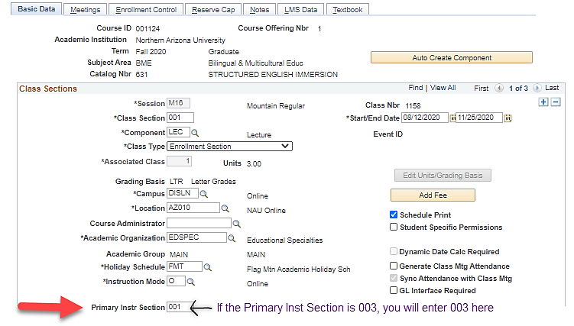.
- Remind instructors it is very important for them to notify you if any of the rolled-up sections need to be unrolled or if another section is to be added. Changes to a roll-up need to be completed in Coursedog.
  - In addition, it is important to send an email to lms-faculty-help@nau.edu to advise of any changes to a roll-up, because the initial roll-up feeds to Canvas LMS, but later changes do not..
  - The classes will remain rolled up for the term if changes are not made in PeopleSoft and if the LMS team is not also notified about the changes.
  - Rolled up sections cannot be changed once the class begins, because any student work cannot be moved from the Canvas LMS shell---only content can be moved. Students will lose their work if classes are unrolled after work begins.

