Schedule of Classes/Coursedog
Reference Guide

Table of Contents
Introduction 2
What is Coursedog? 2
Access & Login 2
Golden Rule for Coursedog Use 3
Scheduling Management/Dashboard 4
Home 4
Section Editor 6
Section Editor Cards with Data Fields 13
General Information Card 14
Units Card 19
Meeting Patterns Card 22
Preferred Room Features Card 27
Instructor Detail Deep Link Card (Instructor ID, Instructor Role, Designer Access, Print, Grade Access, Eval and EC Pay Info in Peoplesoft) 31
Enrollment Settings Card (Class Status, Add Consent, etc.) 39
Relationships Card 41
Combined Sections Table Deep Link Card (Combined Sections Table in PeopleSoft) 44
Reserve Capacity Link Card (Reserves in PeopleSoft) 45
Notes Card 48
Preference Forms 49
Requests 49
Rooms 53
Buildings 53
Reports 53
Permission Numbers in PeopleSoft 54
Course Catalog 60
Help & Contact Information 61
Reference and Assistance 61
Appendix A Rollups, Combined Sections, and (LMS) Blackboard Learn 62

Introduction
- This document will cover scheduling requirements and processes, as well as how class detail input is completed in Coursedog.
- Academic units plan and build each academic year’s schedule of classes. Classes roll forward from each like-term (fall to fall, spring to spring...). Academic units plan the schedule of classes that will be offered, considering major and minor requirements, electives, topic classes, as well as instruction modes (in person, online…), session (M16, 7.5A…), units (if variable), grading basis (if BTH/BIP), meeting pattern/s, instructor/s, capacity, etc. Planning a schedule build is time and thought-intensive. Considerations need to be made to ensure conflicts aren’t created between required courses, meeting patterns and instructors, as well as spreading classes across standard meeting times and providing balances for blended- and short- session classes to ensure students can maximize their schedules and classroom space is optimized.
- Once planning is finalized, the schedule is input into Coursedog, which feeds to PeopleSoft, the system of record for NAU. Schedule of Classes (SoC) completes data integrity checks and assigns general-use classrooms, which is followed by publication of the schedule of classes and enrollment of students.
- Academic units will move from a build phase to a request phase once the schedule of classes is published. At that point, requests are submitted via Coursedog for changes that may be required, due to funding, student demand, etc. Changes should be limited because they likely will impact student schedules.
- Once complete, this cycle repeats itself. Planning the schedule of classes for the next academic year begins, followed by building classes, etc.

What is Coursedog?
- Coursedog is a scheduling interface that is used to build classes for future fall, winter, spring, and summer schedule builds. It is also used to request changes for published terms.
- Coursedog allows workflow, when appropriate. In addition, rules are built into the system to effectuate scheduling requirements. These rules are triggered in real time to help identify errors of class builds. They prompt error messages, called Warnings.
- The system provides direction for warnings that require action that must be taken before submitting schedule builds or submitting new class/change requests. This ensures schedule builds are accurate.

Access & Login
- Coursedog works with most browsers, but Google Chrome is recommended.
- Log into Coursedog at https://app.coursedog.com/#/login/nau.
- Hit the Click To Sign In button, which directs you to the NAU CAS login page— and enter your NAU credentials.
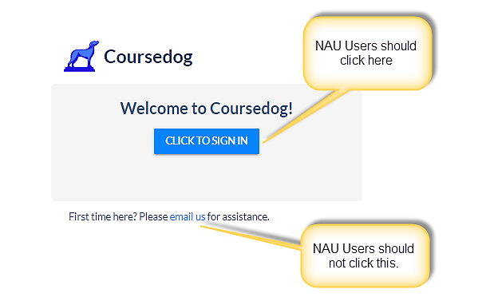

Golden Rule for Coursedog Use
Do not enter data if you see a spinning circle “Synching section with SIS” at the top of the opened section. Otherwise, it’s possible to create a conflict between data that is feeding to PeopleSoft and data entered in Coursedog.

Schedule Edit Stages
When it comes to scheduling in Coursedog, there are two stages:
  - Building stage (open build)
  - Request stage (post build)
Actions will differ depending on whether the build is in progress (building stage) or finalized (request stage).
  - Building stage (open build)
    - The building stage refers to an open build. The schedule rolled forward from the previous like term (fall to fall, spring to spring), and a timeline is established for schedulers to complete any edits/additions to the classes that rolled forward.
    - Schedulers have open access to make changes directly in the Section Editor for all the class data fields.
    - As data is entered in Coursedog during the building stage, all warnings should be cleared, and all rule exception requests should be submitted.
  - ***Rule Exception Requests are ONLY submitted during the building stage.
  - Request stage (post build)
    - Once the building stage is over, the build is submitted and is final. Schedulers who need to submit changes due to extenuating circumstances can then submit them only via Requests. Schedulers will no longer enter changes directly in the Section Editor, except for the fields that schedulers always have access to edit in the Section Editor (see below for the specific fields that remain editable). Instead, schedulers will submit a Request for all changes, other than those that are always accessible, to be reviewed and approved by the Schedule of Classes team.

Scheduling Management/Dashboard
This is located on the left side of the Home page, which is where you are directed after signing into Coursedog. Scheduling Management and Dashboard are used interchangeably and consist of eight clickable fields:
- Home
- Section Editor
- Preference Forms (currently not utilizing)
- Requests
- Rooms
- Buildings
- Reports

*Regardless of your location in Coursedog, you can select the three parallel lines in the upper-left corner to view the Dashboard.

Home
Once logged in, you will default to the Home page. It consists of:
- Departmental Status
- Scheduling Timeline
- Help Center
- Product Updates
- Notifications
- Profile

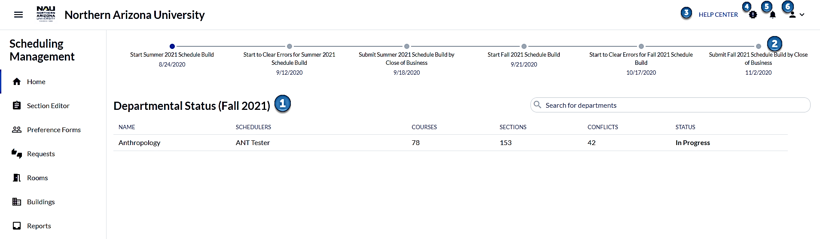

Departmental Status (1)
Provides a high-level overview of your department’s schedule build, including:
- Name of department
- Name of the scheduler/s
- Number of courses offered for the current scheduling term
- Number of sections of courses offered for the current scheduling term
- Number of scheduling conflicts (conflicts refer to the warnings that were triggered due to a rule being violated - the number of conflicts reflects how many warnings exist for the current scheduling term)
- Schedule status for the current schedule build term will state either In Progress or Submitted.
- In Progress populates once the build begins, regardless of the actual status.
- Once the schedule build has been finalized, warnings are cleared, and rule exception requests have been submitted and addressed, the schedule build can be submitted. Once submitted, the schedule status will state Submitted.

Sections By Course (navigating through Departmental Status vs. Section Editor)
Navigate to Sections By Course by clicking on a department. This provides a list of all courses and sections of courses offered by your department for the current scheduling term. This is where the following tasks are completed:
- Add Course
- Add a newly approved course or a course that is offered every other year and did not roll forward.
- Click Course, and the Add Course window will populate. Choose Add Course From Curriculum Inventory and start typing a course into the block. Select the course from the drop-down menu, and then hit Add Course.
- Validate schedule
- Hit Validate Schedule as you build. Each rule that has been violated will be viewable, with all sections violating the rule listed below. There are two categories of warnings:
- Section warnings list all rule violations.
- Meeting pattern warnings list over-utilization of meeting pattern violations.
- All warnings must be resolved prior to submitting the schedule build for a term.

- Submit schedule
- As you build, train yourself to periodically hit Submit Schedule to view:
  - a list of warnings that need to be cleared,
  - rule exception requests that need to be submitted.
- If a rule exception request needs to be submitted, a link titled Submit Rule Exception Request will be included in the message. Click the link and fill out the reason for request. The field expands, so you have room to explain clearly. The request will then be submitted to SoC.
- Only one request can be submitted at a time. Please do not wait until you are finished building your schedule to hit Submit. Rule exception requests are not instantaneous. They need to be reviewed and responded to by SoC, as well as addressed/cleared by academic units before schedule builds are submitted.
- The Submit Schedule button will be grayed-out until all warnings have been cleared and all rule exception requests have been submitted.
- After all conflicts/warnings have been resolved, the Submit Schedule button will be clickable. At this point, the schedule build should be as complete and accurate as possible, with all warnings cleared, and all rule exception requests submitted. Once the Submit Schedule button has been clicked, the schedule build is submitted and finalized.
*Validate Schedule and Submit Schedule are also located in Section Editor; however, only one department is represented at a time in Section Editor, so it is not possible to validate and submit the schedule build from Section Editor if you build for multiple departments.

Scheduling Timeline (2)
- Contains key dates for scheduling terms, such as when the schedule build for a term begins, when warnings must be cleared, and when schedule builds are submitted.
- The line between dates will change to blue once a timeline date passes.

Help Center (3)
- This is for SoC administrator use only.

Product Updates (4)
- This is for SoC administrator use only.

Notifications (5)
- Displays notifications regarding request status, such as confirmation a request was submitted, moved to suspended status (“Suspended” is the Coursedog term that indicates SoC is working on the request), and whether the request was approved or not. Click on the notification to return to the request.
- New notifications are indicated by a red dot that appears in the top right corner of the bell icon.

Profile (6)
- Navigate to Account Settings to change your name, if necessary. Feature Requests is for SoC administrator use only. You may also navigate to Profile and click Log Out.

Section Editor
- There are two ways to navigate to Section Editor. Each provides different functionality.
- Click on the department on Home to:
- Build a new course.
- Validate your schedule.
- Submit your schedule.
- If scheduling for multiple departments, you may validate/submit/add course for all departments through this navigation.
- Click Section Editor on the Scheduling Management/Dashboard
- View the same information as navigating through Home/Department, but do not validate/submit a schedule or build a new course in this navigation.
- View and edit classes for the current schedule build term in the Section Editor. This is where the schedule lives.
- Click Section Editor on the Scheduling Management/Dashboard to open Sections By Course, which provides a list of your department’s courses and sections of courses offered for the current schedule build term.
- Click the course to open a list of offered sections.
- Hover over the section number and click the Open Section Editor button to open a section to view/edit class details.
- View course catalog information by clicking the Course Info button. View Course Title, Course Description, Departments, Course Attributes, and Course Status.
- Build a new section by clicking the + Section button.
- View scheduling rule violations. A yellow triangle appears next to a course if a section or sections of the course violate a rule.
- Open a course to see the list of sections. A yellow triangle appears next to a section of a course if a section violates a rule. Click on the section to view the rule that has been violated and identify how to fix it.

Sections by Course

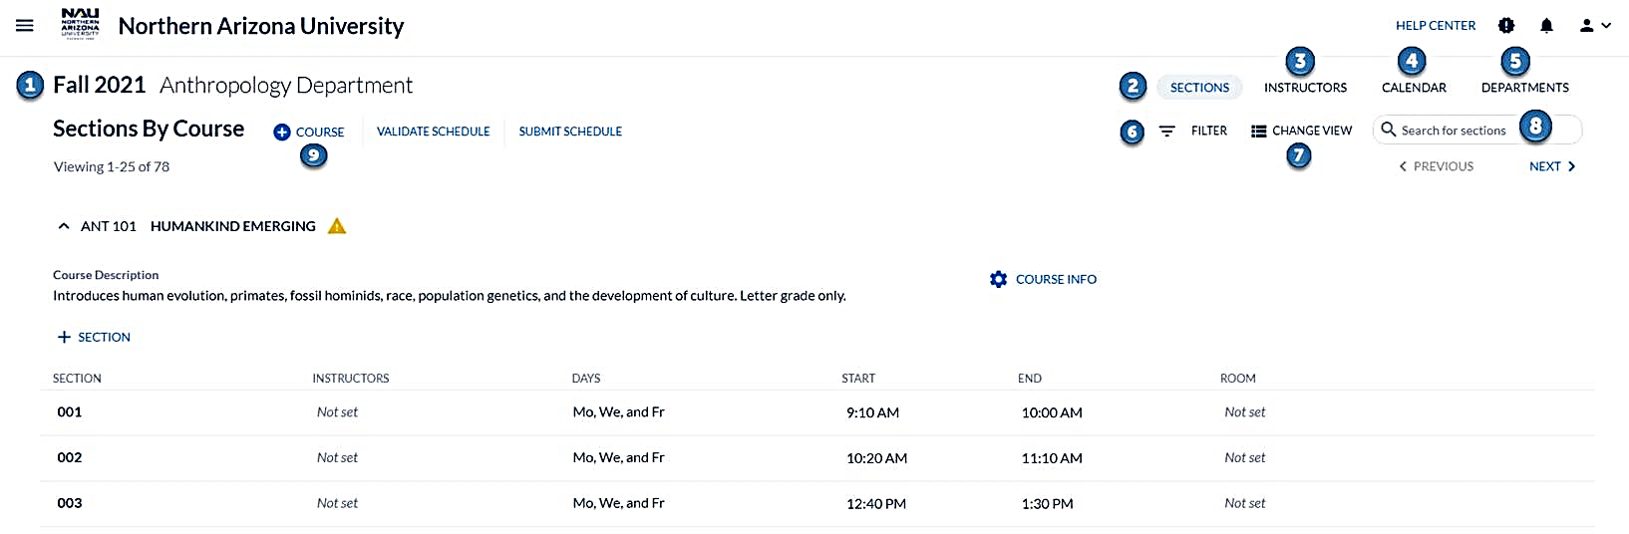
Term (1)
Defaults to the current scheduling term. To view a different term, click on Term and select the term from the drop down.

Sections (2)
Provides a list of offered courses and sections of courses for the current schedule build term.

Instructors (3)
- List view of all instructors assigned to the department.
- Click on the instructor name to view instructor section assignments and instructor profiles (if added by the unit).

Calendar (4)
Click on Calendar to view your department schedule of classes in one of three different views - calendar, list, or room.
- Calendar view
Displays how a department’s classes are being spread out across meeting patterns, broken up by days and times.
- Hover over a class on the calendar to see the meeting pattern and assigned instructor.
- Within the Calendar view, you can select Color by Section and Color by Day.
  - Color by Section provides a view of classes colored based on the day/s of the week the classes meet. A class that meets on M/W will be the same color on Monday and Wednesday. Another section of the same course that meets on T/R, will be a different color.
  - Color by Day provides a view of the classes colored by day. All classes listed on Monday will be the same color, all classes listed on Tuesday will be the same color, etc.
- List view
- Displays a list of a department’s classes scheduled on any given day, separated with breaks for different days and times. The list will begin with classes scheduled on the earliest day of the week, followed by the earliest start time on that day. For example, Monday, 8:00 AM classes will be listed first.
- Room view
- Displays a list of a department’s classes with details, including meeting patterns categorized based on the Facility ID.
- Only courses with approved pre-assignments will be viewable on the calendar during schedule builds.
Once the builds are submitted and classrooms are assigned, all classes assigned to classrooms will be present on the room view.

Departments (5)
- List view of the departments for which you schedule.
- Click on the name of the department to open Section Editor.

Filter (6)

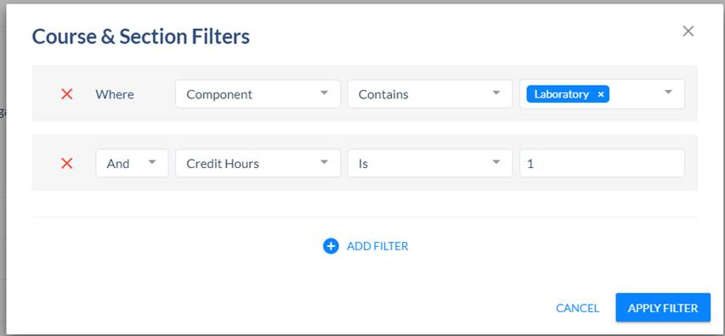

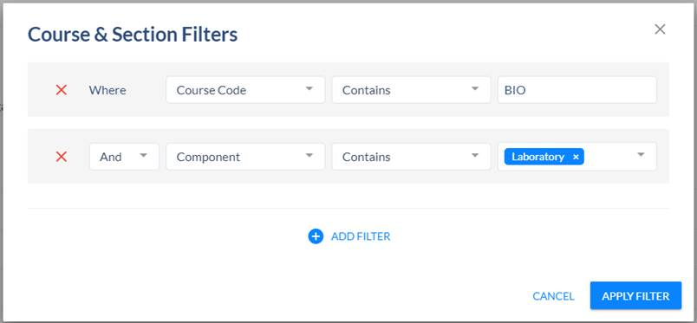

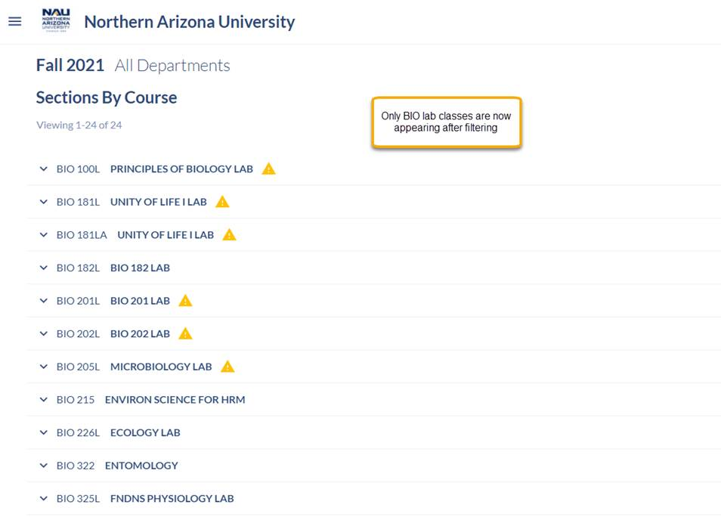

- Apply customizable parameters for a selective schedule view. This allows you to see specific types of classes.
- Filter for Course Title, Grading Basis, Class Status, Campus, etc.
- In the first screenshot, filters are added to search for a Lab component and lab classes approved as 1-unit courses, which will limit the search to 1-unit lab classes.
- In the second screenshot, a filter is added to search for Biology lab classes. Once Apply Filter is selected, only BIO lab classes will appear in the list to the left.

Change View (7)
Two options are available to view Sections By Course, either View By Sections or View Another Term.
- View By Sections
- Click Change View and View By Sections to view all sections, rather than first clicking on the course to open the list of sections of a course.
- Classes will be listed in alphabetical and numerical order.
- To flip back to View By Course, click Change View and then View By Course.
- View Another Term
- Click View Another Term to change the term. You may change the term by clicking on the term on the upper-left corner.

Search (8)
- Search for courses, sections of courses, or instructors (note that to search for instructors you must be on the Instructors tab).
- The search function is space sensitive. If looking for a class, you must input the prefix (space) catalog number. Input PSY 250, not PSY250.

+ Course (9)
- This should be completed using the navigation Home>Departmental Status, and then clicking on the department, if scheduling for multiple departments.
- Add a newly approved course or a course that is offered every other year and did not roll forward.
- Click +Course and the Add Course window will populate. Choose Add Course From Curriculum Inventory. Add New Course is not an available selection. Start typing the course into the block. Select the course from the drop-down menu, then hit Add Course.
- when a new course is added, click +Section. If more than one option is available, select the section number. Proceed to fill out the new class information. (Covered under Section Editor Cards with Data Fields).
- As you input the class details, warnings will appear in real time if a rule is violated.
- The class number will not populate for a new section. Click Add Section at the bottom of the Section Editor, exit and return to the section to verify that the class number populated. If it still has not populated, exit the section and return again. Once the class number populates, you may click on deep links to access instructor, reserve cap, and the combined section table (to input total enrollment for combinations and to view classes in the combination), if applicable.

How to Read and Understand Warnings
- A warning is generated when a rule is violated. A yellow triangle indicates warnings and will appear on Sections By Course, next to the course title.
- 
- Click on the course to open the sections. Hover over the yellow alert triangle next to the section number to view the warning/s. Warnings can also be viewed by opening the specific section.
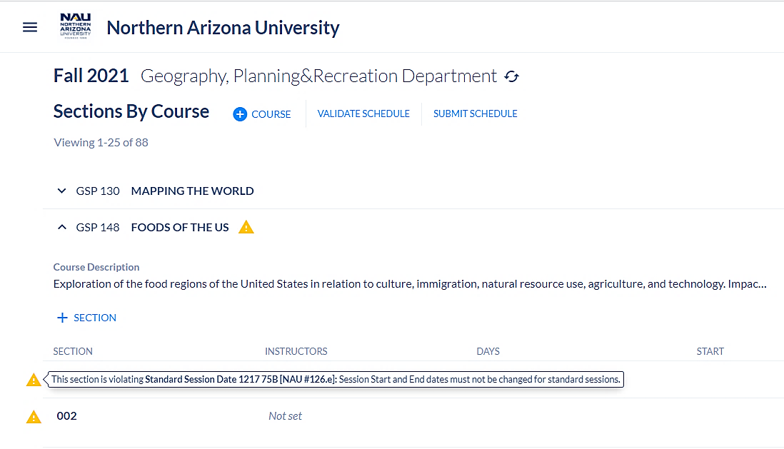

- When a section is opened, warnings will also appear at the top of the section in real time if a rule is violated.
- Wait to review the warnings until you have input the class details and saved. Once you add all the class details, some or all warnings may disappear.
- A section can be saved with warnings, but you will not be able to submit the schedule build unless warnings that require action are cleared.
  - *Validate your schedule as you build to view which warnings must be cleared before submission. Home>Department Status>Validate Schedule.
  - *Submit Rule Exception Requests as you build. Home>Department Status>Submit Schedule.

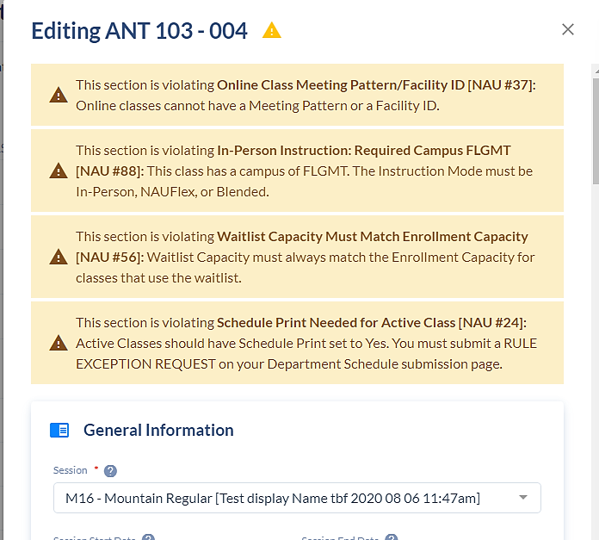

- To clear a warning, return to the section in Section Editor and correct the rule violation. The warning message will state what actions need to be taken to fix the violation. Once fixed, the yellow warning message will clear from the top of the section.
- Other warnings will, instead, require a rule exception request. A warning message will state “You must submit a Rule Exception Request on your Department Schedule submission page”.
- A rule exception request allows the opportunity to request an exception to a rule in certain cases.
  - An example is a request to build an active, in-person class that does not utilize a meeting pattern. If an in-person course is not approved to be offered without a meeting pattern (individualized course lines, supervised teaching, etc.), a warning will trigger advising that your class requires a meeting pattern.
  - If the class is not an approved exception, you will submit a rule exception request. The request will be reviewed by the SoC team.

Section Editor Cards with Data Fields
The Section Editor is opened by hovering over the section number on Sections By Course and clicking the box with the arrow. Once clicked, a window will display blocks that contain class details. The blocks are referred to as Cards.
- Most of the cards correlate with the tabs in Peoplesoft (Basic Data, Meetings, Enrollment Cntrl, etc.).
- There are thirteen cards:
  - General Information (includes Session, Session Start/End Date, etc.)
  - Link to Set Variable Units
  - Units (view only)
  - Meeting Patterns & Rooms
  - Balancing Sections
  - Preferred Room Features
  - Instructor (view only)
  - Link to Instructor Details in Peoplesoft
  - Enrollment Settings (Class Status, Add Consent, etc.)
  - Relationships
  - Combined Sections Table Link (to view your Combined Sections in Peoplesoft- view only)
  - Reserve Capacity Link
  - Notes

General Information Card
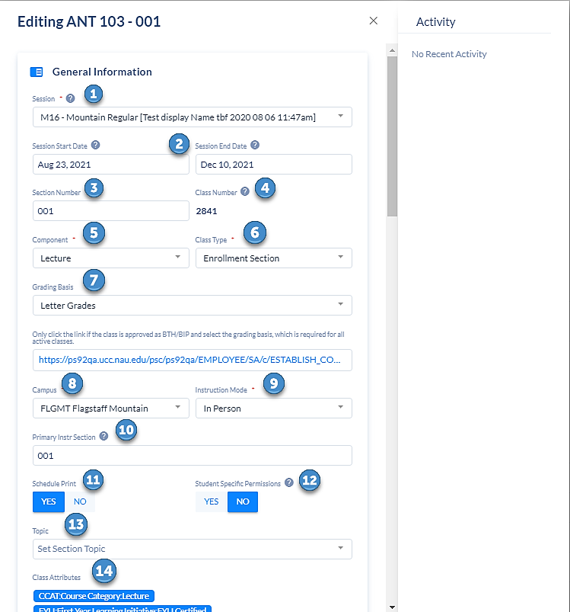

Session (1)
    - Session and session start/end dates are listed on the SoC webpage at https://in.nau.edu/registrar/schedule-of-classes-maintenance/. Additional information about terms and sessions can found on the Registrar webpage, https://in.nau.edu/registrar/important-dates/.

Session Start/End Date (2)
    - The start and end date will populate once the session has been chosen.
    - For dynamically dated (DD) classes, you must change the start and end date to the actual class start and end dates. If a class begins within the first week of a regular session start date and ends within the last week of the regular session end date (M16, 7.5A, 7.5B, M5A, etc.), the class is not a DD session. It should be scheduled as a regular session.
    - The SoC team will calculate the rule for add/drop/withdraw based on the actual session start and ends dates, and add the rule to the class.
    - A class note will populate once the class feeds to PeopleSoft. It will inform students about the add/drop/withdraw dates. These dates will differ from add/drop/withdraw dates for regular sessions.
    - Standard Sessions are less confusing to students than Dynamically Dated sessions.

Section Number (3)
    - Section numbers will populate with the next consecutive number when building a new section. Section numbers may be changed until the schedule build has ended. If you change a section number, it is important to remember to change the primary instructional section number to match the new section number, or it may result in two classes inadvertently rolled into one Canvas LMS shell, because the primary instructional number doesn’t automatically change to the new section number.
    - All section numbers will be three digits, with the exception of lecture/zero-unit labs. (001, 035, 100)
- Lab sections of lecture/zero-unit lab component classes are identified by using a letter as the section number. For zero-unit lab sections, change the section number to a letter, e.g., A, B, C. The letter alerts eLearning that the class is zero-unit, which requires an opt out of enrollment when combining a zero-unit lab/s with the associated lecture/s.
- Stand-alone labs, which are designated as L, e.g., 251L, will be labeled as 3-digit numbers.
- Do not change section numbers after the build is final, especially after the classes have fed to Canvas LMS. This will result in different section numbers in PeopleSoft and in Canvas LMS.

Class Number (4)
- Class numbers are present for existing sections.
- Class numbers are not present for new sections. Once a new section is added and saved in Coursedog, PeopleSoft assigns the class number, which feeds back to Coursedog.
  - Click Add Section at the bottom of the Section Editor. The Section Editor will automatically exit after clicking Add Section. Return to the newly added section to verify that the class number populated. If it still has not populated, exit the section and return again. Once the class number populates, you may click on deep links to access instructor, reserve cap, and the combined section table (to input total enrollment for combinations and to view classes in the combination), if applicable.
- Do not proceed with further changes until the class number is present. Coursedog will not retain further information until the class number is assigned.
- Please note that deep links will not work until a class number is generated. You must wait for a class number to be generated in order to use the deep links.
- If you attempt to edit/use deep links for classes that have not fed to PS and resulted in the population of a class number, a merge error will occur.

Component (5)
- Courses approved with one component (lecture, lab, research, etc.) will only display the approved component as a selection in the drop-down menu.
- Courses approved with both a lecture and lab component require the selection of the LAB component for the zero-unit lab class.

Class Type (6)
- Click on the field and there will be two options in the drop-down menu, Enrollment or Non-Enrollment. Non-Enrollment should only be selected for zero-unit lab sections.

Grading Basis (7)
- BTH/BIP (Both and Both In-Progress) grading basis classes require a selection of the appropriate grading basis, such as Letter or Pass/Fail. The class will remain tentative until a grading basis is selected. Once published, and not after enrollment, the grading basis should not be changed, so the selection of a grading basis should be thoughtfully determined.
- The drop-down list of grading basis options will be limited to what is approved at the course level. If approved for BTH at the course level, you will see “Both: Letter or Pass Fail” as the option in the drop down. Select that option from the drop down. This does not mean you have selected your grading basis. You must take one more step to set your grading basis if BTH/BIP. Click on the deep link, which opens the Basic Data page in PeopleSoft. Click the Edit Units/Grading Basis button, which opens Class Associations. Set the grading basis in the Grading Basis box and hit OK.

Campus (8)
- Select the appropriate campus. Examples of campus are DISLN - Online,
FLGMT - Flagstaff Mountain, PHBIO - Phoenix Biomedical, YUMA - Yuma, etc.
- Online classes will be assigned to DISLN campus.
- All campuses other than DISLN will be assigned to In Person, NAUFlex: Full Remote, and Blended Learning instruction modes.

Instruction Mode (9)
- In Person (P)
  - Delivered synchronously and in-person and requires some in-person participation at assigned physical locations, at specific times.
  - Includes all face-to-face classes.
    - Course lines, such as independent studies, internships, practicums, and fieldwork experience are considered in-person (unless the class is delivered as a part of an exclusively online degree program, in which case the class instruction mode will be Online).
- Blended (BL) -
  - Blended classes meet at a regularly scheduled time, but twenty-five percent or more of the conventional class time is replaced with out-of-class activities, which may include use of technology.
    - Only the class meeting time will be input, not the replaced conventional class time. For example, if a W meeting pattern is replaced with out-of-class activities for a standard M/W meeting pattern, only the M in person portion of the class will be scheduled.
- NAUFlex – In Person and Remote (FL) *Fall 2020 only
  - This class is delivered synchronously with a mix of in-person and remote class sessions. Students and faculty meet at specific times, with some students participating in-person at assigned physical locations and other students participating remotely.
  - FL classes should show the campus that reflects the campus for which the class is being built, such as FLGMT, PHBIO or a statewide campus such as SCTSD or YUMA
- Online (O)
  - Delivered asynchronously
  - Online classes are delivered via the Internet. There will be no meeting pattern identified for online classes.
- NAUFlex – Full Remote (FR)
  - This class is delivered synchronously and remotely. Students and faculty simultaneously participate in class sessions remotely at specific times. The class syllabus will provide details.
  - Classes require real-time meetings and must include these meeting times in the schedule of classes. A time and day(s) should be selected.
  - The facility ID is CS1074-SYN.
  - Prior to 2020, this pattern would have been designated as “Online Synchronous.” Full Remote is now the appropriate mode to request for such classes.
  - Instead of showing campus DISLN, the campus should reflect the campus for which the class is being built, such as FLGMT, PHBIO or a statewide campus such as SCTSD or YUMA.
- Further information about instruction modes can be found on the SoC webpage under the Additional Resources accordion, or here.

Primary Instructional Section (10)
- When an instructor teaches multiple sections of the same course, and the session, units, grading basis, mode of instruction, and topic are consistent for each section, the instructor may roll the sections into one primary instruction section. This will create one Learning Management System (LMS) Canvas LMS shell, so the instructor will not need to repeat the same class content for each Canvas LMS shell.
- The process for rolling up sections of a course into one Canvas LMS shell is as follows:
- Change the primary instruction section number/s to match one of the section numbers. For example, if an instructor is teaching sections 001, 002 and 004. Change sections 002 and 004 to 001, so all three numbers are the same.
- When rolling up a zero-unit lab with another zero-unit lab, keep in mind that the section number (letter) is case sensitive. If the section number (letter) is a capital “A”, you must input a capital ”A” in the Primary Instr Section field. If you input a lowercase “a”, the zero-unit labs will not roll into one Canvas LMS shell.
- Remind instructors it is very important for them to notify the academic unit scheduler if any of the rolled-up sections need to be unrolled or if another section is added. Changes to a rollup needs to be completed in Coursedog.
  - In addition, it is important to send an email to lms-faculty-help@nau.edu to advise of any changes, because the initial rollup feeds to Canvas LMS, but changes do not.
  - The classes will remain rolled up if changes are not made in PeopleSoft and eLearning is not also notified about the changes.
  - Rolled up sections cannot be changed once the class begins, because student work cannot be moved from the Canvas LMS shell, only content can be moved. Students will lose their work if classes are unrolled after work begins.

Schedule Print (11)
- Only switch Schedule Print to “No” if a class should not be viewable in the class search. Advisors will still see the class; however, students and guests will not. For example, departments may prefer to not print an Independent Study class in the class search, since these classes are individualized study classes.
- Schedule print should not be checked “No” for the purpose of placing a class in a tentative status. Instead, move the class to tentative status.

Student Specific Permissions (12)
- Check “Yes” for student specific permissions if the instructor prefers to assign permission numbers to specific students, using their ID number, rather than generating generic permission numbers to give to students as needed.
- Permission numbers will be generated in PeopleSoft. (Covered in detail under Permission Numbers)

Topic (13)
- If a class requires a topic, select the topic ID and topic description from the drop-down menu. The topic will print in class search and on the student’s transcript.
- Copy and paste the topic description into the Notes card in the free format note box. This will provide students with a better understanding as to what the class will encompass, which has the added benefit of increasing interest and enrollment.
- Original New Topic Request forms, with the Chair/Director signature, should be saved and filed by academic units. When reusing a topic, refer to the New Topic Request form and copy and paste the topic description into the class notes.
- If the topic needed is not present in the drop-down menu, this means it does not exist at the course catalog level—and that you must request it be created. Submit a New Topic Request form to SoC. The form is found on the Schedule of Classes webpage under the Forms heading. https://in.nau.edu/wp-content/uploads/sites/153/2020/04/New-Topic-Title-Request-Form-May2020_tiger.doc

Class Attributes (14)
- Informative field that displays the course attributes, for example, CNVN (co-convened) and CLST (cross-listed). Courses with these attributes are approved to be combined.

Link to Set Variable Units

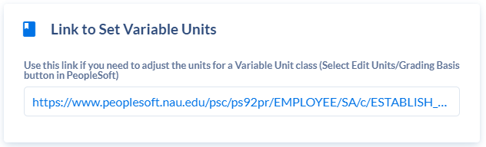

- If a course is approved to be variable units in the course catalog, it will automatically populate with the variable units in the Units card.
- If a variable unit class requires a set number of units (most topic and graduate seminar classes), a warning will appear stating that the class requires a set number of units.
- If a course is approved to be offered with variable units and the class needs to be set to a single unit or to variable units within the parameters of the approved minimum and maximum variable units, use the Link to Set Variable Unit in the Section Editor to set the units. It is located under the General Information card.
- The deep link will bring you to the Basic Data page in Peoplesoft. Click the Edit Units/Grading Basis button to change the units.
- During the building stage, units are not editable on the Units card—the units either populate from the catalog, or the units are changed for variable unit classes, via the deep link.
  - *Remember- deep links cannot be clicked until a class number has been generated. When building a new section during the building stage, a class number will not appear. Once you enter the class information, hit save. The Section Editor window will automatically minimize. Return to the section you just created, and the class number should be present. If it has not populated, exit the window and go back in. Once the class number has populated, you can use the deep link to set the units for the class.
- During the request stage, if requesting a new section be built, remember that you cannot click on the deep link until the class number is generated, because a class number will not be generated until the request is approved. Please provide the required units in the textbox at the time of your request. If the class is approved as variable units and requires a set unit or different variable units, within the parameters of the approved units at the course level, the units will be changed by SoC after the request is approved and the class number is generated.
- Once the build is final, during the request stage, a request does not need to be submitted to set units for variable unit classes for existing sections. The deep link is accessible in the section editor and can be clicked without submitting a request.

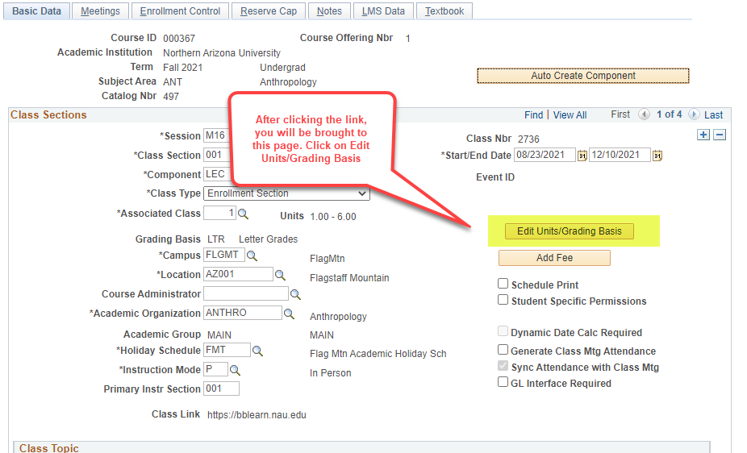
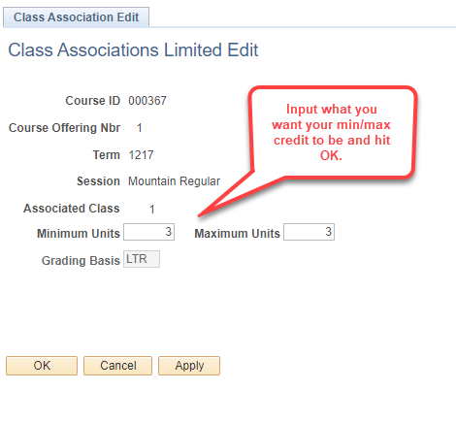

Units Card (view only)

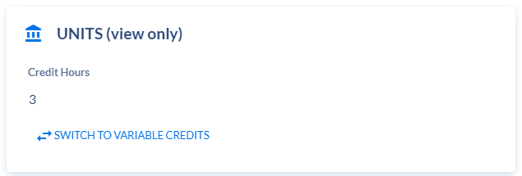

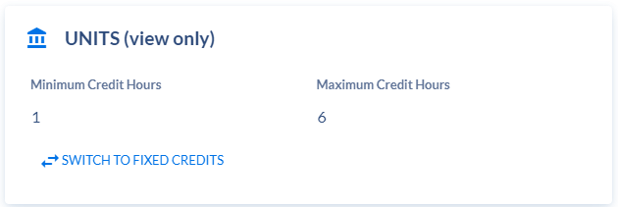

- Units will populate in the credit hours field as approved at the course level. For example, if the course is approved as 3 units, one box with 3 credit hours will populate. If the course is approved with variable units of 1-6, a box with 1 credit hour next to another box with 6 credit hours will populate.
- This card is view only. No edits can be made to this card. You will use the deep link on the Link to Set Variable Units card in the Section Editor to set the units (located right above this card).
- If a course is approved as variable units, but the class needs to be changed to a single unit, you must click the deep link to set variable units and select a fixed unit within the approved parameters of the course.
- If a course is approved as variable units, but the class needs to be changed to a different set of units within the approved parameters of the course, click Switch to Variable Credits. Set Minimum Credit Hours and Set Maximum Credit Hours boxes will populate. Enter in the minimum and maximum value and hit save.
- Units need to be set at the time of the class build and should not be changed once the class is published and not after students enroll.
- Topic, contemporary development, graduate seminar, and other similar classes approved at the course level as variable units, should generally be offered for a set unit.
- Note #108 should be added to the Notes card for variable unit classes, reminding students they need to select the number of units or the units will revert to 1.

Meeting Patterns & Rooms Card
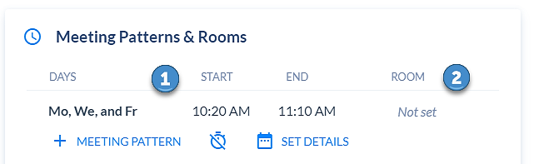

Meeting Patterns (1)
- There are two possible types of meeting patterns:
- Standard Meeting Patterns
- Approved meeting times/days that allow students to maximize schedules and FLGMT campus to maximize room utilization. Failure to schedule during standard meeting times impacts passing time, final exams, room availability, etc.
- To view all standard meeting pattern options, click on the icon between + Meeting Pattern and Set Dates. Hover over the icon and it should read Use Custom Meeting Patterns. A drop-down menu of pre-defined meeting patterns will populate in the order of usage by all academic units, with the least-used meeting patterns populating first. This gives you an idea of the least used and most used meeting patterns.

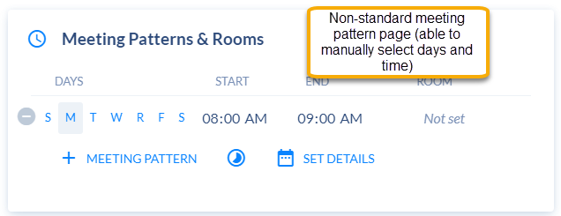
- Non-Standard Meeting Patterns
- If the course has been approved to schedule using non-standard meeting patterns, toggle to Custom Meeting Patterns by clicking the clock icon in between + Meeting Pattern and Set Dates. Custom day/s and time/s may be selected.
- One-unit classes must select custom meeting patterns.
- Classes should start at a standard meeting time.
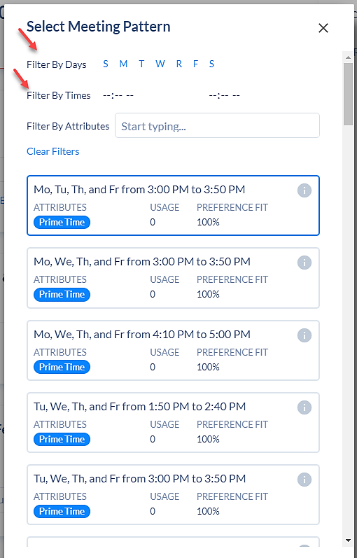
- Input a Standard Meeting Pattern
- Select + Meeting Pattern and the standard meeting pattern selections will populate. If looking for only a MW meeting pattern option, select M and W on the Filter By Days row at the top of the Select Meeting Pattern editor. Only the MW meeting patterns will show at the top. As you scroll, all other M/W meeting patterns will appear.
  - *If a standard meeting pattern is selected and you toggle to the Custom Meeting Patterns page, the selected standard meeting pattern will get wiped out. You will receive an error message advising that switching to standard meeting patterns will erase your custom meeting pattern.
  - If the standard meeting pattern is removed due to switching to the Custom Meeting Patterns page, return to the Standard Meeting Patterns page and reselect the meeting pattern.
- Select Filter By Days and Filter By Times to find specific types of meeting patterns. To filter for certain times, enter in the desired start and end time in Filter By Times. The meeting patterns with the selected start and end time will appear first, then others will appear as you scroll further. You may filter by both days and times to find a specific meeting pattern.
- You may add multiple meeting patterns to a section. *If using a standard and a non-standard meeting pattern for the same class, they must both be entered in Custom Meeting Patterns.
- Input a Standard Meeting Pattern
- To input a non-standard meeting pattern, toggle to Custom Meeting Pattern. To do so, select the clock icon located between the + Meeting Pattern and Set Details buttons. A new screen will populate where the day/s and time can be entered.
- Hover over the icon between the + Meeting Pattern and Set Details buttons to identify if you are in standard or custom meeting patterns.
- Each meeting pattern provides the university usage and a percent fit. This information can be used to avoid time and room bottlenecks.
  - Usage refers to how many sections across every department have selected the meeting pattern. If the usage reads 126, it means 126 sections of the university is utilizing that meeting pattern. The higher the usage, the more competition there may be to find a classroom during the meeting pattern.
- Percent fit identifies the usage as a percentage. The lower the percentage, the more difficult it may be to find an available classroom for the meeting pattern.

Rooms (2)

- Approved pre-assignments are selected by clicking Room. All other room assignments will be optimized and added once the build is complete.
- Not Set populates under Room when no room is assigned. Click Not Set to view approved pre-assigned room/s for the course in the Assign Room Editor. Then click the room to assign it to the class.

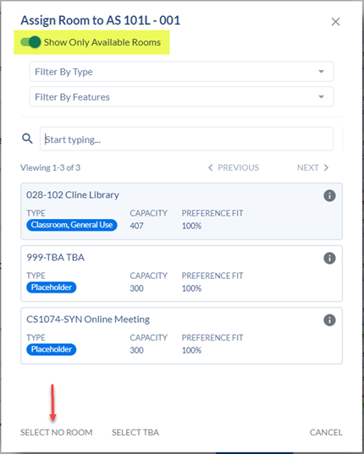

If the class you are building has an approved pre-assignment, you are expected to enter it at the time of the build..

  - As seen in the screenshot, only Facility ID of 028-102 has populated because it is the only approved pre-assignment for AS 101L.
    - 999-TBA and CS1074-SYN will populate for every class as they are both place holders and can be selected when appropriate.
    - If the pre-assigned room is not listed as an option, it may be because there is already a class assigned to the classroom at the same time. Coursedog only shows available rooms. To view all rooms, toggle the “Show Only Available Rooms” and this will list all approved classrooms for pre-assignments, even if a class is scheduled in the room at that time (keep this in mind to prevent conflicts!).
      - If you toggle and still do not see a pre-assigned room that you know has been approved, please communicate with your program coordinator.
- The Assign Room page provides details such as room name, room capacity and preference fit (preference fit takes into account if the room capacity can accommodate the enrollment capacity).
  - Hover over the (i) icon in the upper-right corner of the Facility ID for additional room details, such as room features, room type, and building.
  - If a room is selected by mistake, open the Assign Room page and click Select No Room on the bottom left. This will remove the room.
  - *DO NOT use Select TBA. This is not the same as 999-TBA. Use the search bar to assign 999-TBA.

Note Regarding Approved Pre-Assigned Rooms

NOTE: Pre-assignments are authorized for just two main reasons: (1) ADA needs and (2) Specialized equipment needs (such as spectrum analyzer, dental operatory, gas lines, pianos, etc.)

Any "Other" reason requires compelling justification and time for review/vetting via a petition form and the Classroom Review Committee. "Other" reason does not include: instructor preference, historic usage, instructor office location, or back-to-back scheduling,

The petition-for pre-assignment form may be found on the SoC website. The Classroom Review Team process may take up to one month. The process is not intended to take place during an active build.

Balancing Sections Card

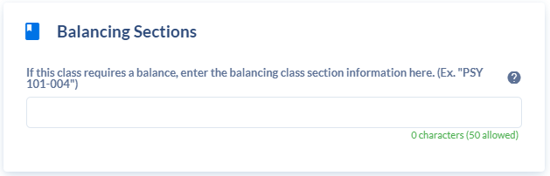

- A balance of classes is required for shorter session, blended instruction mode and 1-unit classes, that fit within one standard meeting pattern classes. This ensures classroom space utilization is optimal.
  - Balancing classes should be entered the time of the build. To do so requires that planning takes into account classes that need a balance.
  - Example of a Blended balance - A blended MW class that replaces the Monday class with outside activities is balanced with another MW blended class that uses Wednesday for outside activities. This is required for blended classes scheduled during peak hours.
    - a blended class with a meeting pattern of M 2:20-3:35pm, is balanced with class with a meeting pattern of W 2:20-3:35pm
  - Example of a shorter session balance - A short-session class needs to be matched with another short-session class, if scheduled during Peak Hours. A 7.5A-session class needs to be balanced with another 7.5B-session class.
    - a 7.5A class with a meeting pattern of MW 12:45-2:00pm, is balanced with a 7.5B class with a meeting pattern of MW 12:45-2:00pm
- To indicate balanced classes, input each class on the Balancing Sections card of each section.
  - EX: if balancing ACC 205-001 with ACC 255-001, enter ACC 255-001 on the Balancing Sections card for ACC 205-001 (on the Section Editor of the balancing class), and enter ACC 205-001 on the Balancing Sections card for ACC 255-001 (on the Section Editor of the balancing class).
- Always check to see if the class provides a balance before making changes, because changes will likely be required for both classes, since they are balanced.
- The enrollment capacities for balanced classes should not differ more than 30% of one another and the classroom needs should be comparable. Balanced classes will be manually pre-assigned to a suitable classroom to ensure they are placed in the same classroom.

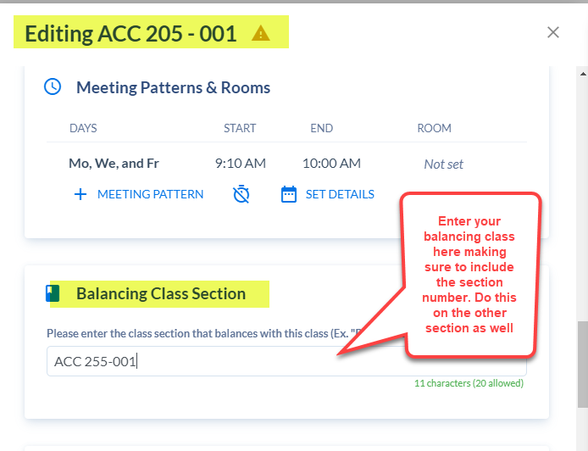
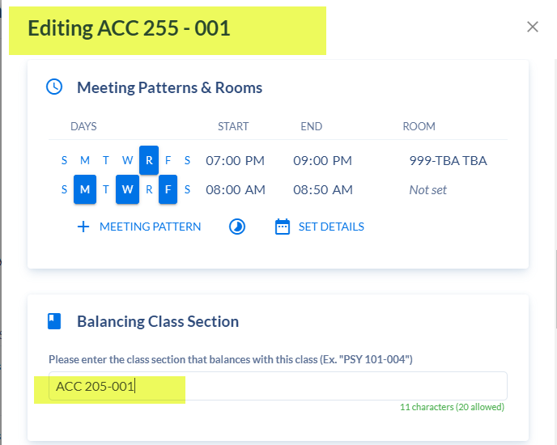

Preferred Room Features Card

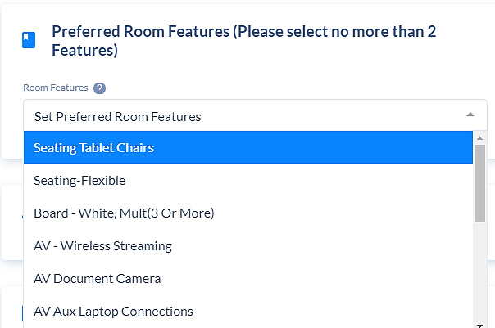

- A maximum of two room features may be selected. Room features are useful for courses that require certain features, but do not have an approved pre-assigned classroom. For example, a statistics class may require three or more white boards.
- Only select a feature if it is required. There is a limited inventory of rooms with specific features. If a feature is selected because the instructor prefers to have a feature, rather than because it is a true need, and there are not a sufficient number of classrooms with required features available for a requested meeting pattern, some classes may not be scheduled in the classrooms with features they truly need.
- Every feature selected reduces the number of choices available and increases the likelihood that no classroom will be available with the selected feature. When this occurs, the class will be left without an assignment, and a meeting pattern change will be required.

Instructor Card (view only)
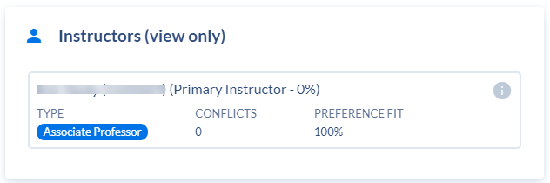

- View only. It will list the instructors that are added in PeopleSoft via the deep link shown below.
- This card is view only. No edits can be made to this card. You must use the deep link on the Link to Instructor Details in Peoplesoft card in the Section Editor to set the instructor details (located right below this card).

Instructor Detail Deep Link Card (Instructor ID, Instructor Role,
Designer Access, Print, Grade Access, Eval and EC Pay Info in Peoplesoft)

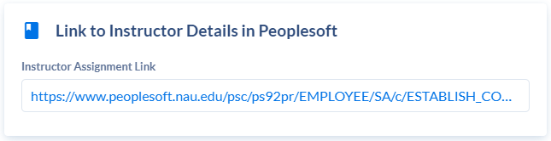

Instructor Details Link
- Due to Instructor Pay Info implications, instructor information will be completed in PeopleSoft, via the instructor information deep link in Coursedog.
- If building a new section, the class number must be populated before the deep link is clickable. If the class number has not yet populated after adding the section, exit, then return to the section. Repeat until the class number populates.
- The fields highlighted in yellow are required to be completed for each instructor assigned to a class, with the exception of EC Pay Info, which is only required for Summer, Winter, Online and Statewide classes. The fields in green are informational and require action—the instructor needs to complete a tutorial or certification prior to the accessing student information or teaching the class.
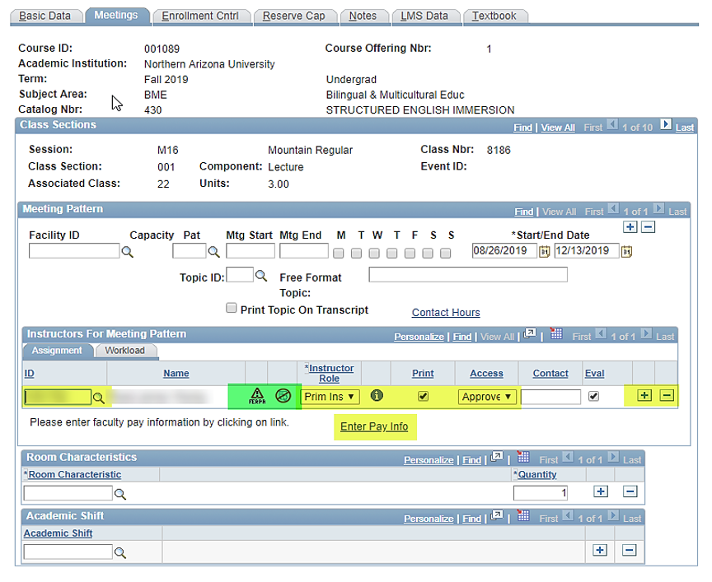
Instructor ID
- Input the instructor ID or click on the magnifying glass to look up an instructor’s name. Once the instructor ID populates, hit the tab key and the instructor’s name will appear. It is not uncommon to have the same or similar instructor names, so be certain to select the correct ID and, if necessary, verify this information with the instructor.
- Click View All whenever adding multiple instructors for a meeting pattern. This will avoid duplicating instructors and ensure all the instructors have been added. Click the (+) button to add another instructor.

Instructor Role
It is very important this information is correct for reporting purposes. The roles, as well as how they correspond to roles in LMS (Canvas LMS) are defined below. Hovering over the icon next to the instructor role will populate the definition for each instructor role.
- Primary Instructor
- There must be at least one Primary Instructor assigned to each class prior to the class start date. Input instructor information as soon as the instructor is identified.
- The primary instructor is the instructor of record who is ultimately responsible for providing instruction and grading for the class. Use this role to indicate the instructor with primary responsibility for the class even when this instructor is a Graduate Teaching Assistant.
- The primary instructor may have no grading access (i.e., 699 and 799 classes), grade access, or approve access. At least one instructor listed on a class must have approve access.
- They may also be checked to print in the class search and show as the contact person for the class. Students should be provided with one contact for each class.
- The check mark will automatically populate in the EVAL check box for all primary instructors and may be removed at the discretion of the department.
- In LMS (Canvas LMS), the primary instructor may view the grade center, grade assignments, add assessments and discussions, use messages and discussions, and change tool and course properties. They may add/delete/change course content, which differentiates a primary instructor role in LMS (Canvas LMS) from all other roles.
- Instructor workloads may be adjusted/overridden by the Chair/Director in FAAR.
- Secondary Instructor
    - The secondary instructor role should be used if a class has an instructor or faculty member who is not ultimately responsible for providing instruction and grading for the class, but they co-teach the class. Teaching assistants should never be placed in this role. They will either be primary instructors if they are responsible for the class or identified as TA. Planning and institutional Research (PAIR) can only pull TA information from the primary and TA roles.
    - The secondary instructor may have no grading access, grade access, or approve access.
    - They may also be checked to print in the class search and show as a contact person for the class if appropriate.
    - The check mark will not populate in the EVAL check box for secondary instructors but may be checked at the discretion of the department.
    - In LMS (Canvas LMS), the secondary instructor may view the grade center, grade assignments and discussions, use messages and create/reply to discussions, and change tool and course properties. They may not add/delete/change course content; however, designer access may be requested, which will allow them this option.
    - The instructor workloads may be adjusted/overridden by the Chair/Director in FAAR
  - Teaching Assistant
    - The teaching assistant role should be used to indicate a Graduate Teaching Assistant (GTA) or undergraduate student who is assisting a primary or secondary instructor
    - If a TA is the primary instructor, they should be placed in that role, rather than the TA role.
    - Anyone other than a primary or secondary instructor who determines a valuation of performance of assignments in terms of grading, should be placed in the TA role.
    - The teaching assistant may have no grading access, grade access, or approve access.
    - They may also be checked to print in the class search and show as a contact for the class.
    - The check mark will not populate in the EVAL check box for teaching assistant but may be checked at the discretion of the department.
    - In LMS (Canvas LMS), the teaching assistant may view the grade center, grade assignments and discussions, use messages and create/reply to discussions, and change tool and course properties. They may not add/delete/change course content; however, designer access may be requested, which will allow them this option.
    - Teaching assistants should not have instructor workloads reported to FAAR.
  - Steward
    - The steward role should be used by anyone who needs to be identified as having an association with the class and does not fit into the roles of primary instructor, secondary instructor, TA, or grader. Examples are supervisors, coaches, administrators, etc.
    - Steward should not be grading student work in terms of determining a valuation of performance of assignments, but may access the grade book to assist the instructor or department. If they are not teaching a class but are determining a valuation of performance, enter them as a TA.
    - Steward may have no grade access or approve access.
    - They should not be checked to print in the class search and show as a contact for the class.
    - The check mark will not populate in the EVAL check box for steward. There should not be a reason to evaluate a steward; however, it may be checked at the discretion of the department.
    - In LMS (Canvas LMS), the steward may view the grade center, grade assignments and discussions use messages and create/reply to discussions, and change tool and course properties. They may not add/delete/change course content; however, designer access may be requested, which will allow them this option.
    - Stewards should not have instructor workloads reported to FAAR.
  - Grader
    - The grader role should only be used to indicate an individual who is responsible for the data entry of student grades into LOUIE.
    - Grader may have grade access or approve access.
    - Grader has no responsibility for the administration of the class or for determining a valuation of performance of assignments and should never be given any other role.
    - They should never be checked to print in the class search and show as a contact for the class.
    - The check mark will not populate in the EVAL check box for grader and they should never be checked to receive an evaluation.

FERPA Icon
- The FERPA (Family Educational Rights and Privacy Act) icon displays to the right of an instructor’s name if the tutorial has not been completed. Ask the instructor to promptly complete the FERPA tutorial. Instructors, as well as anyone associated with a class who has access to student information, must complete FERPA prior to the class start date. Run the Enterprise Report Scheduled Instructors Who Need FERPA Training several weeks prior to the start of the term to verify all instructors have completed the tutorial.

Online Certification icon
- This icon populates if an instructor has not completed the online certification. Click on the icon to connect to the eLearning link that provides further details.

Instructor Role (i) icon
- Hovering over the (i) icon next to the instructor role will populate the definitions for each instructor role.
Designer Access
- If appropriate, click on the same (i) icon that is used to view the instructor definitions, to request designer build access for secondary, teaching assistant, or steward instructor roles in LMS (Canvas LMS). Access can be requested once classes have fed to Canvas LMS. Click the link, http://tinyurl.com/nau-bb-designer. The class link displays the URL on the Basic Data page when content exists in the LMS (Canvas LMS) shell.

Print
- Print populates if the primary instructor role is selected. If the instructor is checked to print, they will be viewable in Class Search as the contact for the class. If the primary instructor should not be the contact, uncheck Print and then check Print for the appropriate instructor.

Access
- Select Approve or Grade access from the drop-down box. Access controls mid-term and final Grade Roster access.
- Approve access will allow the instructor to both input grades and approve the grades to be sent to Registrar Grades.
- Grade access will only allow the ability to enter grades.
- Prior to the start of the class, there must be one instructor assigned with approve access.
- 699 and 799 classes will be built with Graduate College personnel as graders with approve access. The primary instructor will have no grade access. These classes are exceptions.

Eval
- The Eval checkbox is used to map an instructor to receive a student evaluation. Be sure to map evaluations prior to the start of the term or as soon as an instructor is identified. This will ensure instructor evaluations are set up prior to the date the data is batched and sent to CoursEval.
  - All primary instructors are automatically checked to be evaluated. If a primary instructor should not be evaluated, uncheck the box.
  - Secondary instructors and TAs are not automatically checked to be evaluated. Check the Eval box if they should receive an evaluation.
  - A steward should most likely not be checked to be evaluated.
  - A grader should never be checked to be evaluated.

Enter Pay Info
- This hyperlink will display for all summer, winter, online, or statewide classes under the heading, Instructors for Meeting Pattern.

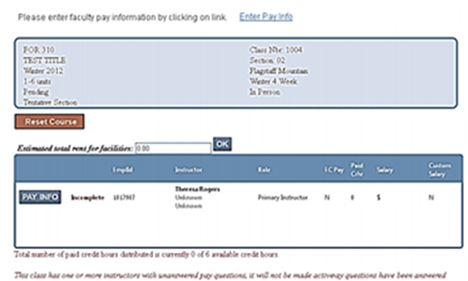

- Instructions are as follows:
  - Select the hyperlink Enter Pay Info to enter compensation information for instructors of the class.
  - Select Pay Info and enter the instructor’s primary affiliation, as well as how the instructor will be paid and the credit hours for which they will be compensated.
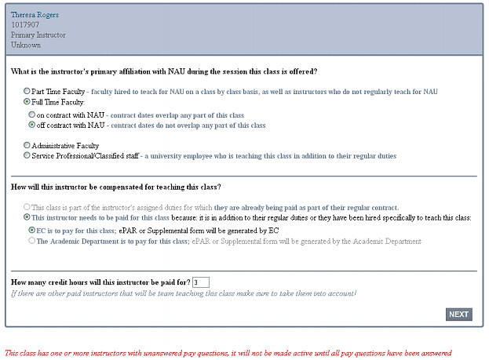

  - Click Next to enter suggested salary, if any. When all pay information has been entered, the instructor will show as Complete. The red text at the bottom provides information on progress toward pay setup completion.
  - Once pay information is complete for all the class instructors, the class will move from tentative to active by a process that runs hourly. Check on the hour to be sure the class changed to active status.

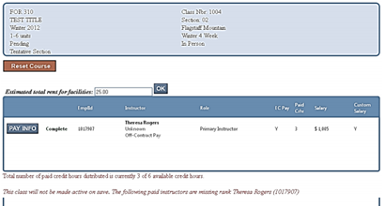

  - Click the Reset Course button to erase all pay answers if necessary.
  - Department Chairs/Directors should refer to the EC Instructor Approval page, https://admin.extended.nau.edu, if the message states Missing Rank.

Enrollment Settings Card (Class Status, Add Consent, etc.)

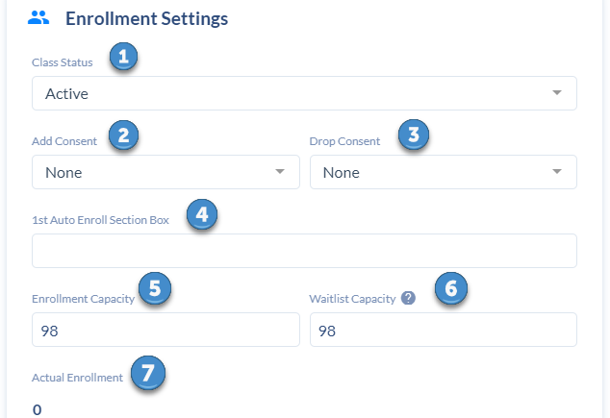

Class Status (1)
- Active
- Cancelled
- Tentative
  - Tentative Section may be selected if, for example, it is questionable whether funding will be available to hire an instructor, but the meeting pattern has been carefully planned, and so there is a desire to preserve it in case the class can be offered. Classes in tentative status can retain the meeting pattern, but the room assignment is removed. *Please note the class will not be viewable in class search, to advisors, etc.
  - The class may move to tentative if more information is needed for instructor EC pay. Remember after pay information is input, the class will not change to active status until the top of the hour. Always follow up to ensure the class status changed from tentative to active.
  - Classes with BTH or BIP grading basis will remain in tentative status until a grading basis is selected.
  - Prior to the publish date, and at selected intervals through the start of the term, check all classes with a tentative status to verify if EC pay information or the grading basis are the reason the class is in tentative status.

Add Consent (2)
- If the class is approved at the course level to add consent, select Instructor Consent or Department Consent in the Add Consent drop down box.
  - A note should be added to the Notes card, providing a department contact to students, along with details about how to receive consent to add the class.
  - Do not use consent to abridge the add deadline. Remember that classes should allow enrollment until the add deadline. An academic unit must receive approval from the Vice Provost of Academic Operations before a class can shorten the add deadline date. SoC needs to be copied on email requests because the approval documentation is monitored by this office.

Drop Consent (3)
- Only a handful of classes are approved for Drop Consent, such as CCC to NAU classes.

1st Auto Enroll Section (4)
- This may be used if students in a zero-unit lab section should be enrolled in a matching lecture section of a lecture/zero-unit lab component course. If the lab section number (letter) is added to the lecture 1st Auto Enroll Section box, the students will be enrolled into both sections - the lecture and the matching zero-unit lab.
- When cancelling lab classes, be sure to check first and verify the section number (letter) was not added to the 1st Auto Enroll Section box. If so, remove the letter, or students will not be able to enroll in the lecture.

Enrollment Capacity (5)
- The enrollment capacity should be thoughtfully assessed and reflect the anticipated enrollment in the class. If the enrollment capacity is not input correctly and a facility ID is required, the class may be assigned to a classroom that isn’t sufficiently sized. Likewise, if the enrollment capacity is not input and a facility ID is required, no room will be assigned because a room can’t be assigned to a class with no capacity.
- Refer to the Course Demand and Projections Report at https://in.nau.edu/academic-affairs/course-scheduling/. The report will serve as a guide for the number of seats required for courses. This will help to determine if you need to reduce or increase capacity or the number of sections offered.
- The enrollment capacity should never be changed to zero. It should also never be adjusted to a number below the actual enrollment capacity.
- The enrollment capacity should never be increased beyond the layout capacity of the classroom, even if you feel the room can accommodate more students. Hover over the room on the Meetings card to see the layout capacity of the classroom.
- If a class has a reserve capacity, the enrollment capacity should never be lower than a reserve capacity. This will create an error message and must be resolved. When changing an enrollment capacity, be sure to verify the class doesn’t have a reserve, and if so, make necessary changes to the reserve capacity.
- If there is a need to view the Class Roster, navigate to Curriculum Management>Class Roster>Class Roster and input the class details. Find the correct section, click on Enrollment Status, and select Enrollment.

Wait List Capacity (6)
- Wait list capacity and enrollment capacity should always be the same.
- Do not set up wait list for the following classes:
  - dynamically dated
  - lecture/zero-unit lab
  - co-requisites
  - combined sections, with the exception of a regular class combined with an honors class with an enrollment of 1 or 2 students
- If there is a need to view the Wait List Roster, navigate to Curriculum Management>Class Roster>Class Roster and input the class details. Find the correct section, click on Enrollment Status, and select Wait List.

Actual Enrollment (7)
- Displays the actual number of students currently enrolled in the class. If no students are enrolled, it will state 0.

Preferred Room Capacity (8)
- This field should not be used. Never change or request to change this field as it does not feed to anything and will create a merge error.

Relationships Card

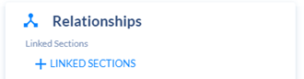

Combined Sections
- There are two different types of Combined Sections-
- Co-convened classes - the same class offered as an undergraduate class and a graduate class within the same subject, with additional work required for the graduate students, i.e., CST 424 & CST 524
- Cross-listed classes - the same class offered with different prefixes to meet requirements for each major, i.e., WGS 191 & ES 191

Co-convene/Cross-listed Approvals
- Combined sections must be either permanently approved at the course level or have received a one-time approval.
- Permanent Combination
- The courses have received a curriculum committee approval to be combined. This can be verified by viewing the course attributes on the Section Editor of the General Information card. The course attribute will state CNVN (co-convened) or CLST (cross-listed), and the course attribute values will state the courses.
- One-time approval policy
- Any combination, other than one that includes an honors class, which hasn’t received approval to be combined at the course level, needs to receive a one-time approval prior to scheduling the classes to meet together. Refer to the policy for cross-listing and co-convening courses.
- Topic classes, “99” course lines and regularized topic classes require a one-time approval for each topic, unless the same topic/combination was approved within the last two terms. Once a topic has been used 3 times, it should be submitted to the College Curriculum Committee to be approved as a new course.
- Combinations that require approvals should not be scheduled to meet together until they have received approval to be combined.

- In Coursedog, Linked Sections are used for approved Combined Sections (in the Course Catalog via Curriculum approvals). To add Combined Sections, select + Linked Sections on the Relationship card.

Edit Relationship

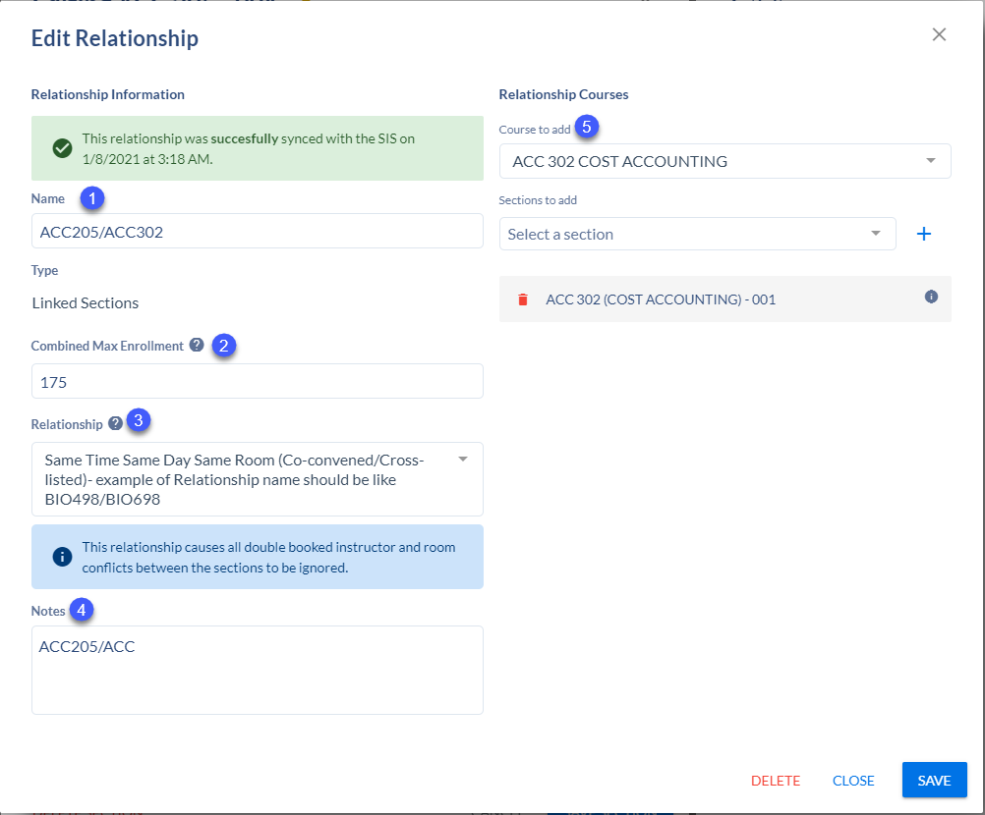

- To link sections, click + Linked Sections. An Edit Relationship card will populate with four fields:
  - Name (1)
    - Add the courses included in the combined section in the Name field.
      - EX: ACC 205/ACC 302
  - Combined Max Enrollment (2)
    - This field will automatically populate with sum of the enrollment capacities of the sections linked the relationship. Once you save the linked sections, the total enrollment will automatically be calculated and will populate.
    - When you change the enrollment capacity to one of the sections in the relationship, the combined max enrollment field will remain with the original combined enrollment. Hover over the “tool tip” to see the new adjusted combined max enrollment. Update the field with the new sum.
      - This step is very important. If the new total combined max enrollment is not updated after changing an enrollment capacity to one of the sections, the system will only pay attention to what is entered in the combined max enrollment field. If you increased the enrollment capacity on one section but did not update the combined max enrollment, the system will only allow students to enroll until the combined max enrollment is hit, even if there are more seats open on an individual section.

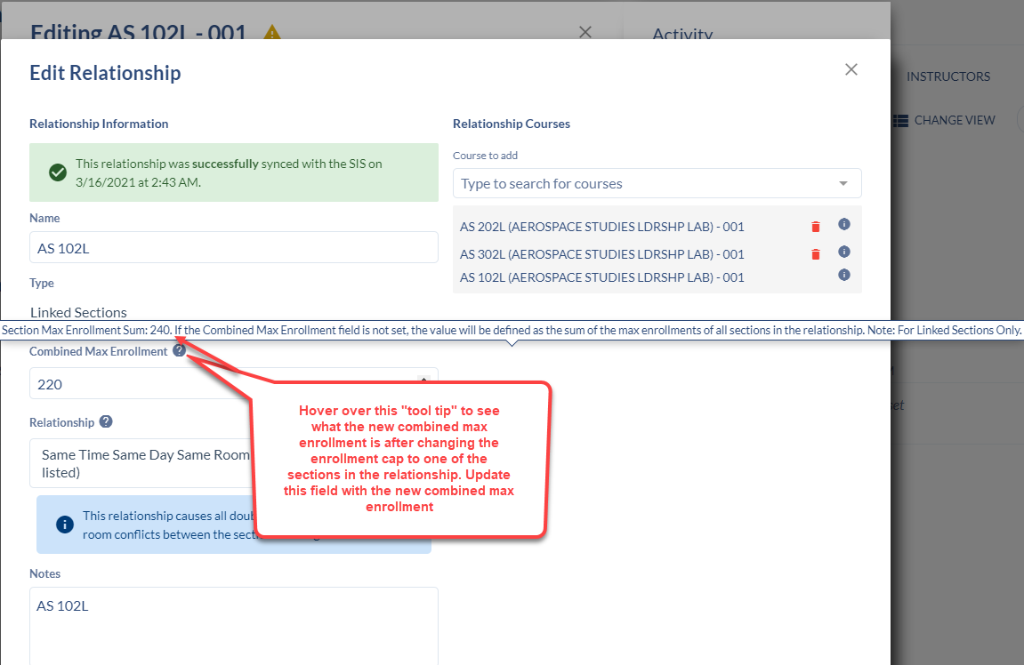
    - When changing an enrollment capacity to a section in a relationship, you will see a warning generate at the top of the section reminding you to update the combined max enrollment field.

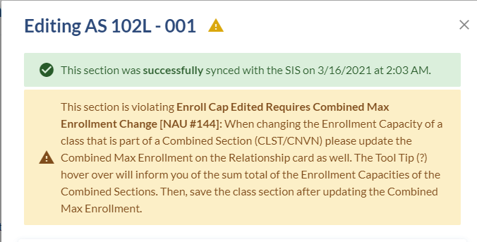

  - Relationship (3)
    - Select the relationship option of Same Time Same Day Same Room.
  - Notes (4)
    - This field does not feed to anything in Peoplesoft and should never be edited. It will populate extraneous data into the Combined Sections Table.
  - Courses to add (5)
- Start typing the course you are combining with in the Course to Add box. Select the course from the drop down.
- Select which section of the course you are wanting to combine from the Sections to Add drop down.
- Click the + sign to finish adding the linked sections.
  - The combination cannot be saved if the (+) sign is not selected.
- Click Save in the bottom right to save your linked section.
- If adding multiple classes to the combination, type over the first course you added in the Course to Add box and follow the above steps.

Combined Sections Table Link Card (to view only the Combined Sections Table in PeopleSoft)
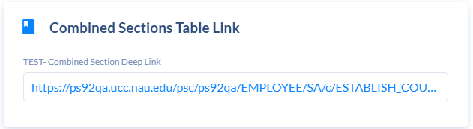
- This link is only used to view the Identify Combined Sections page in Peoplesoft. After linking co-convened or cross-listed classes on the Relationships card, click this link to ensure they fed to the table in Peoplesoft, however, no action is required.
  - Before making changes to a class, check to verify if the class is combined. If so, make required changes to fields for the other classes in the combination, such as session, grading basis, units, campus, instruction mode, topic, meeting pattern, enrollment capacity, reserves…
- *DO NOT combine sections in PeopleSoft. This can result in inconsistent data between Coursedog and PeopleSoft.

Identify Combined Sections
- Defines the combination type, enrollment capacity, class numbers of the combined classes, the enrollment capacity for each class and the actual enrollment. This page is view only and requires no action.

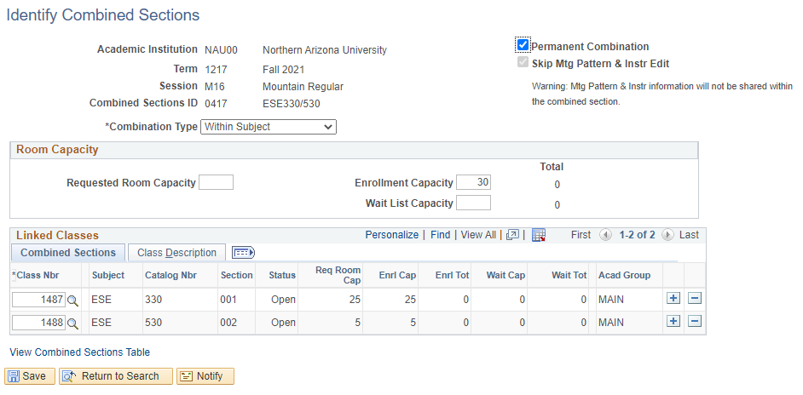

Reserve Capacity Link Card (Reserves in PeopleSoft)

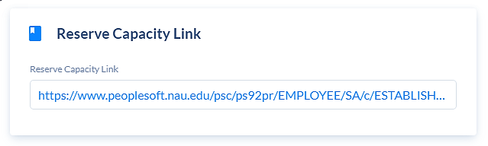
Defines any number of reserve capacity groups for a class.
Academic units have access to the entire page. The snapshot below highlights the details on the Enrollment Control page:
- Yellow designates class details that academic units have access to input.
- Green designates details that are informative
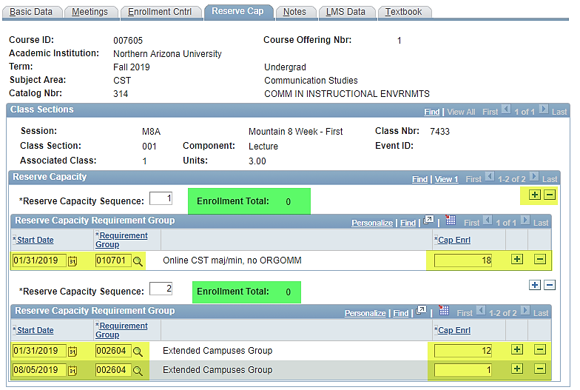

- View All
- The Class Sections heading provides the ability for schedulers to View All sections, Find a section number and to scroll through sections by clicking the arrow. These options are also available in the Reserve Capacity heading.

- Release Reserve
- The second Reserve Capacity Sequence provides an example of how to release a reserve, using the number 1. Most Reserves are released a few weeks before a session starts.

- Reserves that should be released are asked to be released three weeks prior to the start of the session.

- Start Date
- Insert the start date for the reserve requirement group (generally the day it is entered).

- Requirement Group
- Input the requirement group. Refer to the list of the most commonly used requirement groups, which is found under the heading, Additional Resources, on the Schedule of Classes webpage.

- Capacity Enrollment
- Insert the capacity enrollment (the number of students for whom seats will be reserved).
  - If the enrollment capacity needs to be changed or if a release date needs to be added, click on the plus (+) button to add another row. Input the effective date for the change or release, using the identical reserve requirement group number. Input the new capacity enrollment. If releasing a reserve, input the number 1. All changes to the capacity enrollment for a specific requirement group will be made within the same reserve capacity sequence.
- If a class has multiple reserve groups, click the plus (+) button in the reserve capacity heading to add another requirement group number. Each requirement group that is added has a different reserve capacity sequence number.
- When a student enrollment request is processed, the system automatically searches through the reserve capacities in sequential order and places the student in the first group with an available spot for which the student qualifies, based on the reserve capacity group rules.

- Enrollment Total
- The Enrollment Total found in the Reserve Capacity block tracks the students who have met the reserve requirement and enrolled in the class.

Notes Card
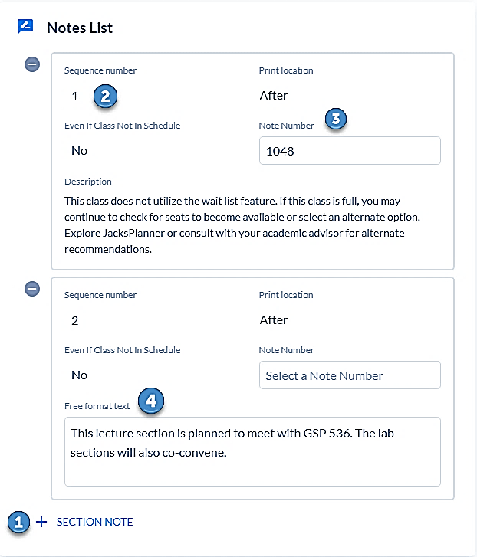

- + Section Note (1)
  - Select this to add a class note. Once clicked, a Note Entry box will pop up.
- If notes rolled over from the previous term, they will already be displayed on the Notes card.
- Sequence Number (2)
- Each class note is assigned to a different sequence number. A pre-defined note and a free format note will not share the same sequence number.
- To add multiple notes, a new sequence must be added by clicking the + Section Note button
- Note Number (3)
- Click the Note Number box to add a pre-defined note. A list of all pre-defined notes and Note Numbers will appear. Click on the desired note. The Note Number and Description will populate.
- You may also search for a pre-defined note to prevent scrolling. Search a key word. For example, input “wait list” to search for the note that explains a class does not utilize wait list. Depending on how precise the search is, one note or a list of notes will populate. Select the note desired. It will appear at the top of the screen.
- Pre-defined notes populate for Dynamically Dated, Blended, NAUFlex: In Person and Remote, NAUFlex: Full Remote, and Online classes once the class is saved and exited. Do not remove these class notes.
- Free Format Text (4)
- Type the Free Format note in the Free Format Text box.
- If a free format note is used on a regular basis, request a permanent, pre-defined, note. Once built, select the note ID number, rather than typing the note for each applicable class.

Preference Forms
- This field is currently not being utilized

Requests
- This field allows you to:
- Create and submit a Section Change request after a schedule build for a term has been finalized and changes due to extenuating circumstances may be submitted.
- View previously submitted requests.
- View the current status of submitted requests.

Request Page Features
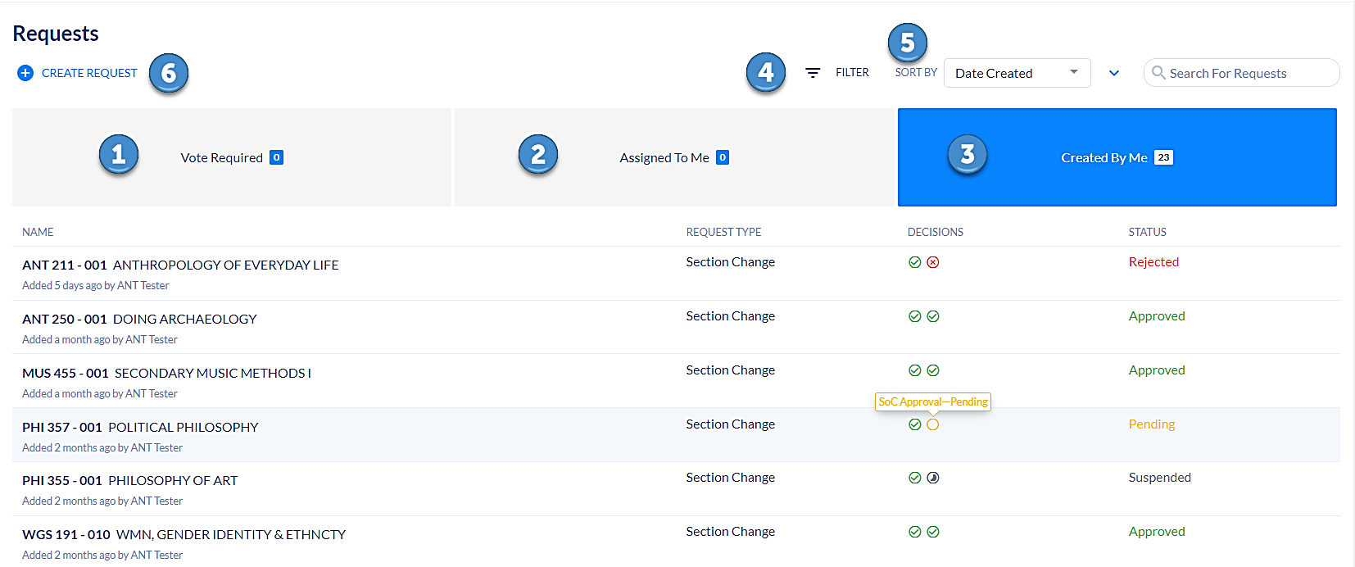

Vote Required (1)
- Not utilized

Assigned To Me (2)
- Not utilized

Created By Me (3)
- View all submitted requests on the Created By Me tab. There are four columns on this tab:
  - Name
    - Name column lists the class for which the request was submitted.
  - Request Type
    - Request Type column identifies if the change was a Section Change or Rule Exception Request
  - Decisions
    - Decisions column gives a quick glance at the approval step. You will see two circles. The first circle is green with a check mark for all requests. This means the request was successfully submitted by the scheduler. The second circle shows the next step in the approval process. Hover over the circle to see the status of the request.
- If the circle is yellow, this represents Pending. The request has been submitted and SoC has not reviewed it.
- If the circle is gray with a half moon, this represents Suspended. SoC is working on this request.
- If the circle is green with the check mark the request has been approved and the changes were made.
- If the circle is red with an x, the request was rejected, and the requested changes could not be made.

  - Status
    - The Status column identifies where the request is in the approval process. There are four different status types.
      - Pending, which means the request has been submitted and is awaiting SoC review.
      - Suspended, which means SoC is working on the request.
      - Approved, which means the request has been reviewed and the requested changes have been made.
      - Rejected, which means the requested changes could not be made due to an error, because further clarification is needed, or the request does not comply with scheduling requirements and is denied.

Filter (4)
- Utilize the filter to view only certain types of requests. Filter by status, type, department, and term.

Sort By (5)
- Sort by the date the request was created or the request type.

Create Request (6)
- Fill out and submit a Section Change after the build has been completed and the window of time for changes due to extenuating circumstances has opened.

How to Create Request
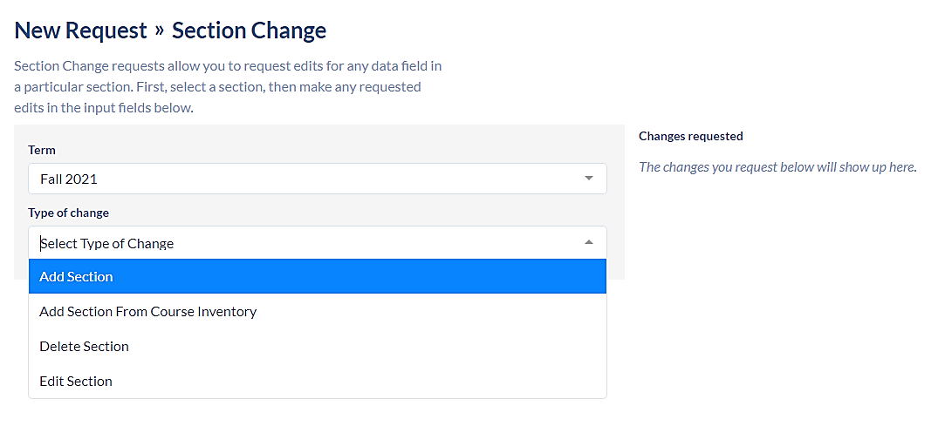
- Only submit a section change request after the schedule build has been completed and the window for allowed changes has been opened. When adding new sections or edit existing sections:
- Select + Create Request. Select Section Change or Rule Exception.
- The Section Change request form will populate. Choose the term. Select the type of change:
- Add Section
- Select this option to add a new section of a course that already exists for the current scheduling term.
  - Add Section From Course Inventory
- Select this option to add a new section of a course that does not exist for the current scheduling term, such as a class that did not roll forward because it was not offered in the past like-term or is a newly approved course.
  - Delete Section
- Select this option if a course is inactive or will never be offered again in the term, such as a class that will no longer be taught in spring term.
  - Edit Section
- Select this option when a class detail has changed and the schedule needs to reflect that change.
- Do not submit a rule exception request via the Requests field on the Scheduling Management/Dashboard. This type of request is only submitted during the schedule building, via the Submit Schedule button.
- There are certain fields that always remain editable to units and do not require a request to be submitted once builds are final. These fields include-
  - enrollment/wait list capacity (not editable during classroom assignments, but becomes editable once classroom assignments completed)
  - schedule print
  - student specific permissions
  - primary instructional section
  - reserve caps
  - instructor information (adding/editing/removing an instructor)
  - add consent
  - notes
  - deep links (BTH/BIP grading basis, variable units, instructor information, reserve caps)

Rooms
- View detailed room information:
  - Room Name
  - Building
  - Room Type
  - Capacity
- Click on the Room Name to view more details, such as capacity, features, etc. The Room Profile will be present on the left side of the page, along with four options:
  - Settings
  - Courses - list view of scheduled courses in the selected Facility ID.
  - Calendar - calendar view of scheduled classes in the selected Facility ID.
  - Blocked Out Times - showcases block out times for the selected Facility ID.

Buildings
- For SoC administrator use.

Reports
- View different types of useful reports and charts to help with class scheduling, preventing conflicts, spreading out meeting patterns, maximizing room utilization, etc.
- View reports/charts for all academic units or filter to see reports for selected departments.
- Ten categories of reports and charts are available on the left side task bar:
  - Sections
  - Conflicts
  - Instructors
  - Times
  - Departments
  - Rooms
  - Bottlenecks
  - Enrollment
  - Export
- There are additional reports under the Exports tab on the left-side task bar. All of these reports may be exported to Microsoft Excel.

Useful Reports and Charts
- Most Popular Meeting Pattern
    - Displays over-utilized meeting patterns. Navigate to the Times tab and scroll until you see the chart called Most Popular Meeting Patterns. Hover over the graph to see how many sections are scheduled during the over-utilized meeting patterns.
- Instructor Assignments List
    - Report showing instructors and their assigned classes. Navigate to the Export tab and scroll to the report called Instructor Assignments List.

Permission Numbers in PeopleSoft
LOUIE Navigation: Records and Enrollment > Term Processing > Class Permissions > Class Permissions
NOTE: Class Permissions is one of the few areas where you will work directly in LOUIE (vs. Coursedog—with one tint exception for Student-Specific Permissions).

Class permissions are numbers or authorizations that you can associate with a class and assign to students to use at enrollment time. You can create general or student-specific add permissions. You can also create student-specific drop permissions.
Class permissions can override conditions such as pre-requisites, co-requisites, and limits. Permissions allow a student to add or drop a class, as long as the student uses the permission by the expiration date and does not violate overall student limitation rules (such as maximum number of units).

Generic Permissions | Student-Specific Permissions
For generic permissions, you will go straight to LOUIE, using the navigation above. | For student-specific permissions,  - Start with Coursedog,  - Go to the desired class in Section Editor.  - On the General Information Card, click the Student-Specific Permissions toggle box to “yes.” Save.  - You must do this step before going to LOUIE  - Then, navigate to LOUIE using the navigation above.

You may wish to choose generic permissions if:
- A class requires consent-to-add and experience tells you will need to issue permission to many students.
- A class has pre-requisites, but history shows they have been waived if qualification has been demonstrated.
- You want to have the permissions ready-and-waiting for peak enrollment periods.
- You do not have student-specific info, such as Student ID.

The PeopleSoft Permissions area differentiates between undergraduate/graduate permissions. Choices vary depending upon whether the class is an undergraduate- or graduate-level class. These pages are dynamic.
- If the class is undergraduate, then the option to override the course career is not available.
- If the class is graduate level, then it is possible to override the student’s career.

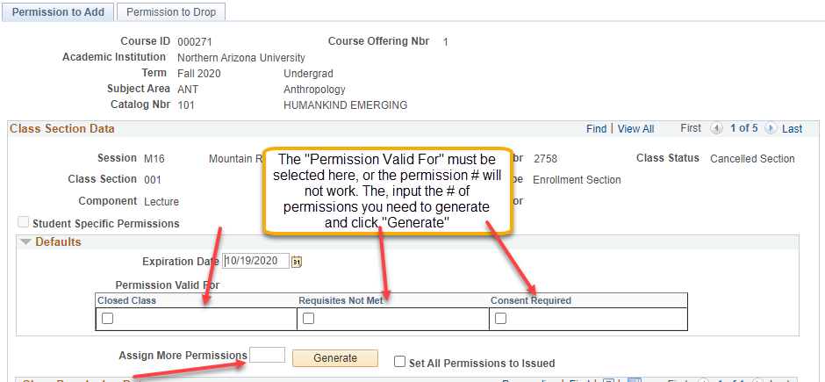

The snapshot above shows the three types of permissions that may be requested for undergraduates.

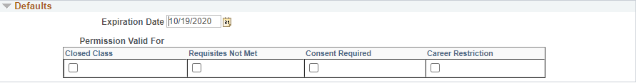

The snapshot above shows the four types of permissions that may be requested for graduates.

- Permission numbers
- Generated to allow a student to add a class section that they are not able to enroll in for various reasons. They allow the department and/or instructor to set permissions that are valid for: closed class, requisites not met, consent required, career restrictions, or any combination of these five values.
  - Permissions allow a student to add a class, as long as the student uses the permission by the expiration date and does not violate overall student limitation rules (such as maximum number of units).
- Wait List Permission Numbers
  - Permission numbers work the same for enrollment and wait list. A student must have a permission number in order to enroll in class when one of the restrictions identified applies. A student must also have a permission number to wait list for a class when one of the restrictions identified applies.

- Correct section number
  - It is important to navigate to the appropriate class section for which permission numbers are to be generated (arrow to the correct page to find the section).
- Expiration Date
  - The expiration date is the date after which the permission number is no longer valid. The system will default to the deadline to drop date for the session.
- Permission Valid For
  - Select the reason for which the permission number is valid. The reason MUST be checked under the Defaults heading or the number/s will not work. Permission Numbers are valid for:
- Closed Class
    - By selecting this checkbox, the student will be able to enroll in the class if is closed.
- Requisites Not Met
    - By selecting this checkbox, the student will be able to enroll in the class if they do not meet requisite requirements.
- Consent Required
    - By selecting this checkbox, the student will be able to enroll in the class if it requires Instructor or Department Consent.
- Career Restriction
    - If this checkbox is selected, the student will be able to enroll in the class if it is outside her/his undergraduate academic career. Note: this not available for undergraduate classes.
- Assign More Permission Numbers
- Enter a numeric value. This number controls how many permission numbers are generated. This feature can be used as many times as necessary.
- Generate
  - Press Generate and the permission numbers will populate below.
- Set All Permission to Issued
  - You may check Set All Permissions to Issued to mark all permission numbers as issued. When the page is saved, the Issued By and Date Issued will be updated with the user ID of the individual saving the page and the current date.
- Wait List Class Restrictions
  - If students choose to wait list a class with restrictions, they must obtain a permission number prior to adding themselves to wait list. Closed class will override students directly into a class before others on the wait list, so it should not be selected unless it has been determined there is a valid reason, such as a student who will not have the ability to remain on track and graduate on time.

Icon
  - By pressing this icon , the sub-tab navigations disappear and a horizontal scroll bar is presented, which provides additional information as shown below

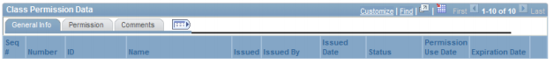

  - If the arrow icon is selected, you may check additional reasons for a permission number for an individual student. For example, if the permission numbers are generated for Consent Required and a student also has not met requisites, the Requisites Not Met box can also be checked.

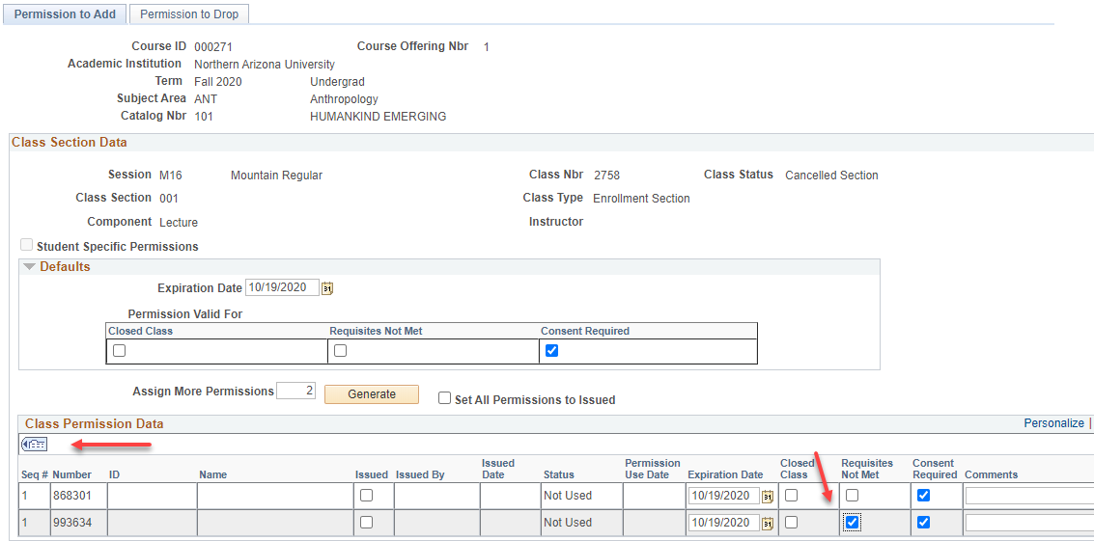

- Comments
  - This is an optional field.

- Save
  - Always press Save when finished or the Permission Number/s will not work.
- Issued
  - Issue the permission number to the student/s and select the Issued checkbox.

Student-Specific Permission

Use the same process as generic permissions, with one difference—input the student’s ID. When the student attempts to enroll, the system checks to see if the ID exists on the class permissions record. If the ID does exist, then the system will process the enrollment request based on the override granted.

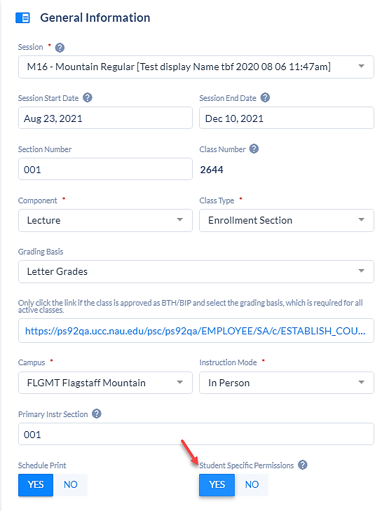

- In order to use student-specific permissions, the Student-Specific Permissions box must be toggled to “Yes” on the General Information card in Coursedog.
- Use the same process as generic permissions, with one difference—input the student’s ID. When the student attempts to enroll, the system checks to see if the ID exists on the class permissions record. If the ID does exist, then the system will process the enrollment request based on the override granted.
- Student-specific permissions do not generate a number.

Icon
- This icon downloads the information in the grid to Excel. Depending on the browser, Ctrl – click may be required for Excel to open. To download all three (3) tabs to Excel, use the expand/collapse icon before clicking on the Excel icon.
Miscellaneous Information Regarding Permission Numbers
- Find
- Clicking Find, as shown in the snapshot above, opens a text box that is used to search the data in the grid.
- Customize
- Select Customize to change the column order in which the fields are displayed.

Course Catalog
Navigation: Curriculum Management > Course Catalog > Course Catalog

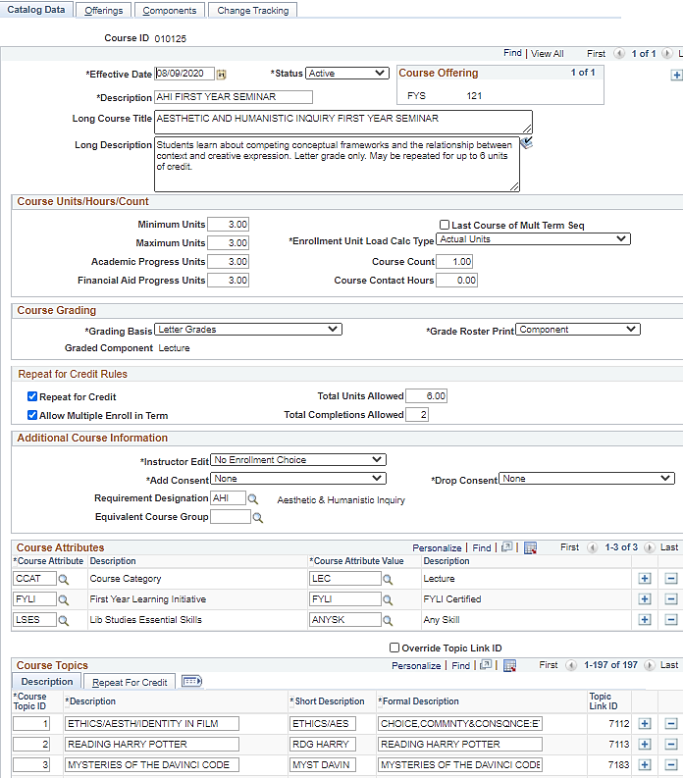

Defines effective date, status, minimum/maximum units, grading basis, repeat for credit rules, course topics (if applicable), topic repeat for credit rules and components.
- Course versus Class
- The word "course" is used to identify a common topic or subject area. Each course will have class sections built that will share the course number (i.e., BIO 181). The word "class" is used to identify the days/times that a specific course meets. Class details are limited to the parameters set at the course level.
- Course Catalog Pages
- Catalog Data
- Offerings
- Components
- Catalog Data page
- Effective Date
- Status
- Min/Max Units
- Grading Basis
- Repeat for Credit Rules
- Course Attributes
- Course Topics
- Course Topic Repeat for Credit
- Click Repeat for Credit to see if a topic may be repeated. The repeats must fit within the parameters set at the course level. For example, the course allows 6 total units and 6 total completions, including multiple enrollments in a term. Topic repeat rules cannot exceed these limits.

Help & Contact Information
- Please reach out to your Schedule of Classes contact for help with troubleshooting, schedule building, room assignments and Coursedog related questions/concerns.
  - Rebecca Brewer Associate Registrar 928-523-9318
  - Salwani (Wani) Jaafar 928-523-7289
  - Marilyn McDonald 928-523-8869
  - Camila Serpas-Shorter 928-523-3890
  - Jeanine S Horio 928-523-6203
Reference and Assistance
It makes a difference where to look/ask for help.
- Fall, spring, Flagstaff Mountain or Phoenix Biomedical in-person and blended classes, as well as online, summer, and winter classes built by Flagstaff Mountain schedulers: Registrar.ScheduleofClasses@nau.edu
- Summer, winter, online or statewide classes: Info.Statewide@nau.edu
- Information regarding SoC business procedures, policies, and forms: http://nau.edu/Registrar/Faculty-Resources/Schedule-of-Classes-Maintenance/
Appendix A
Rollups, Combined Sections, and Canvas LMS

Canvas LMS is a program for managing class content on the web, within our Learning Management System (LMS). It can be used like a virtual classroom where students can access class content, submit assignments, and interact with other students. Information from the Schedule of Classes is used to manage some aspects of Blackboard Learn.

Schedule of Classes data will be used to:
- Store the class URL in the class link field.
- Manage the level of access instructors have to the class content.

Note: In order to access a Canvas LMS web shell, instructors must have submitted all new hire paperwork and have received an employee ID from Human Resources as well as been issued a user ID and password from ITS.
- Allow management of content for multiple class sections provided the course, term, session, topic, instructor, and instructor role are the same for all sections.
- The Canvas LMS URL is: Canvas Support | Teaching and Learning Center
- Students enrolled in classes taught in Canvas LMS access their class at Learning Management System | Northern Arizona University and log in with their user ID and password.
- Canvas LMS shells are created for every class regardless of instruction mode. Consequently, an instructor teaching an in-person class will have the option of offering elements, such as the class syllabus and other handouts, including the electronic reserves, online. NAU policy states that online components for in person classes are a supplement to the ABOR required in-person contact hours, NOT a replacement.
- If an online class is not being taught in Canvas LMS, please have the instructor contact E-Learning.

Example: An instructor may choose to teach his/her online class using a Jan account instead of the Canvas LMS shell.
Note: Cline Library Electronic Reserve materials will only be provided through the Canvas LMS shell.
- Teaching Assistants should never be entered as Primary Instructors in order to obtain designer access. Schedulers can request designer access for instructors, other than primary instructors (schedulers now have an Add Designer site they can use to add TAs and Secondary Instructors as designers).
- There should never be more than one Primary Instructor assigned to a class for the sole sake of the Canvas LMS Design role.
- If the instructor role in the Schedule of Classes does not reflect the role required in Canvas LMS, the department may email e-Learning Center at Lms-faculty-help@nau.edu to request the desired Canvas LMS shell access.
Example: Department requests that a Teaching Assistant have Designer Access along with the Primary Instructor.
- Departments should keep work load reporting in mind when making these decisions. Departments are responsible for making sure anyone with access to the Grade Book or Roster completed the FERPA tutorial.

Instructor Shell Access: Approximately Two – Three Weeks prior to Early Enrollment
Instructor has access to view and design Canvas LMS Shells

Instructors who would like to access their Canvas LMS shell prior to the above timeline should request a shell by emailing: elc-help@nau.edu
- Instructors not utilizing a Canvas LMS shell are encouraged to notify e-Learning Center at lms-faculty-help@nau.edu two weeks prior to early enrollment so that the e-Learning Center and ITS may prevent enrollment from loading to the Canvas LMS shell. (Courses utilizing Cline Library Electronic Reserves are not eligible.)
  - When enrolled students attempt to log into a class containing no online content, they will receive a message that “no content is available”.
- The class start date determines when a class will become accessible to enrolled students. Students are NOT able to access the class until the start date, which begins at 12:01 am.

Notes Regarding Enrollment
- Students enrolled in LOUIE will also be enrolled in Canvas LMS. Canvas LMS receives an update from LOUIE every five hours.
- If a student drops a class taught in Canvas LMS, his/her Canvas LMS work will not be deleted in case the student re-enrolls.
- Students may continue to log into a Canvas LMS class for two weeks after the end date.

Help Desks for Technical Web Issues
- Students should contact the Academic Computing Help Desk (ACHD): 928-523-9294 or 888-520-7215
- Faculty should contact ELC-Help: 928-523-5554 or 1-866-802-5256 or email lms-faculty-help@nau.edu

Revised 4/11/2025

