Table of Contents
Document Management 2
Overview 2
Tutorial 2
Submit an Administrative (Admin) Drop 2
Navigate to the Admin Drop Tool 2
Select a Class for Admin Drop 3
Select Students for Admin Drop 4
Errors 9
Communications 9
Reference 10
Administrative Drop Policy 10
Administrative Request Deadlines 10
Support 11

Document Management
The Office of the Registrar will maintain documentation after initial implementation.
Version | Date | Author | Reason
1.0 | 8/14/25 | Jessica LoCicero | Creation

Overview
This document will detail the steps involved for an instructor to submit an Administrative Drop Request in PeopleSoft.
Instructors can submit an Administrative Drop Request if the following are true:
- They are listed as a primary instructor for the class
- They have completed the FERPA training and quiz
- The Administrative Request Deadline has not passed for the Term and Session the instructor is attempting to submit a drop for.

Tutorial

Submit an Administrative (Admin) Drop

Navigate to the Admin Drop Tool
Log into LOUIE/PeopleSoft: peoplesoft.nau.edu
- Navigate to your Faculty Center
  - From HR Home (LOUIE) dropdown, select Faculty Advisor Home
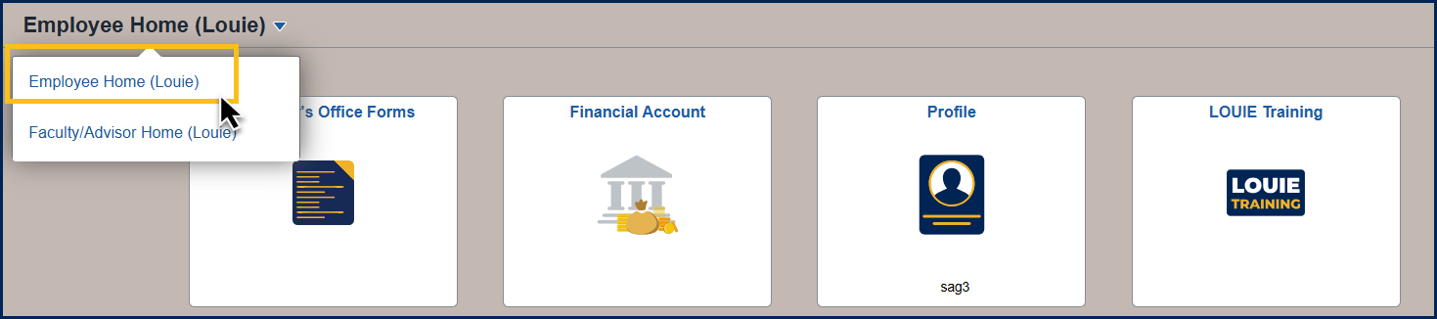
- On the Faculty/Advisor Home page, select the Faculty Center tile
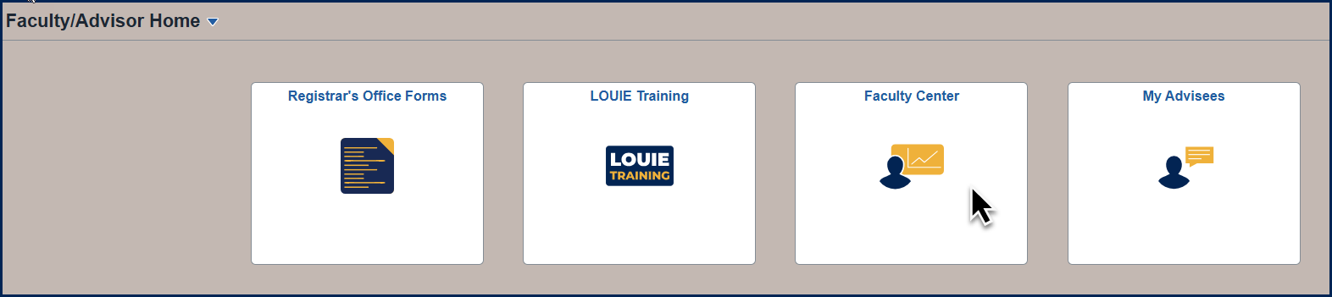
- Select Admin Drop from the Left Navigation List
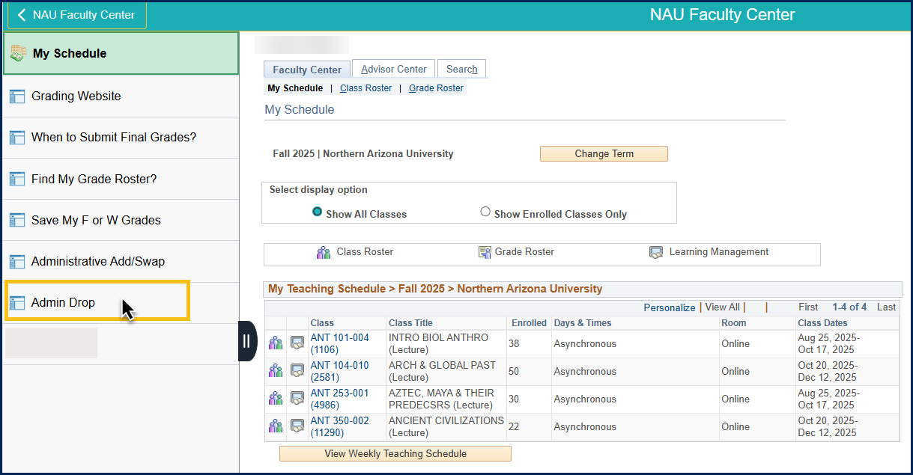

Select a Class for Admin Drop
- The Term should default to the current term, if you want a different term, select it from the Term Dropdown
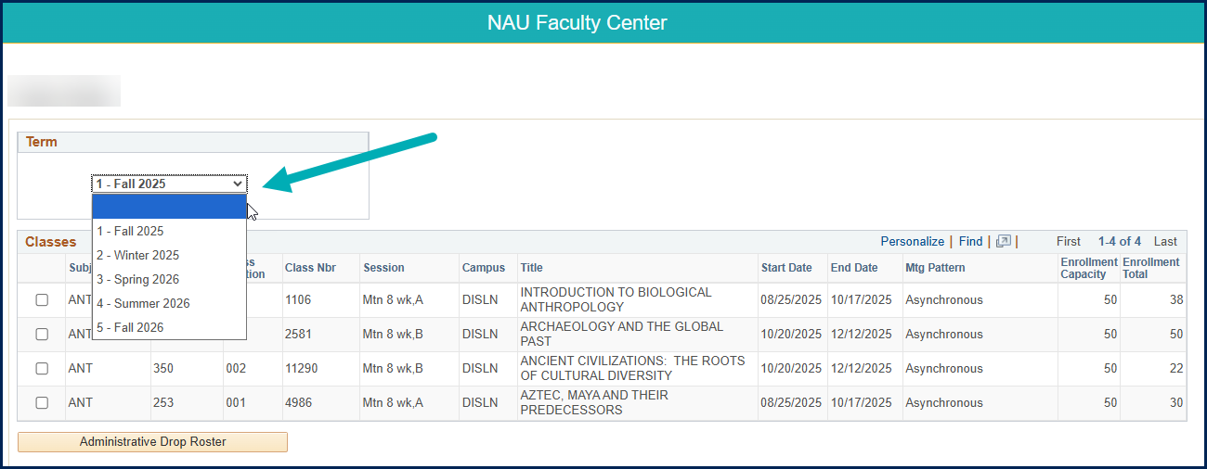
- Select one class from the list to drop students from
- Click the Administrative Drop Roster button
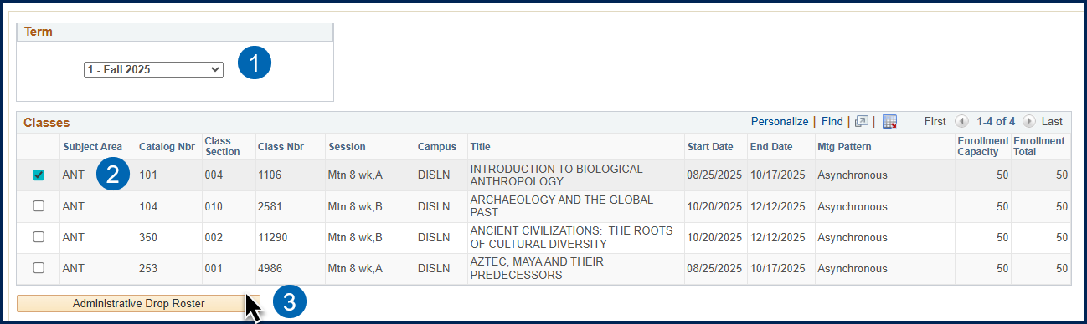

Select Students for Admin Drop
Once on the Admin Drop Roster a user can:
- Display Student Photos
- View Students by Enrollment status
  - Enrolled
  - Dropped
  - Waitlisted
- Select an Admin Drop Reason
  - Poor Attendance
  - Unmet Requisites
- Select students to Drop
- Submit Drop Request(s)

1: Display Student Photos
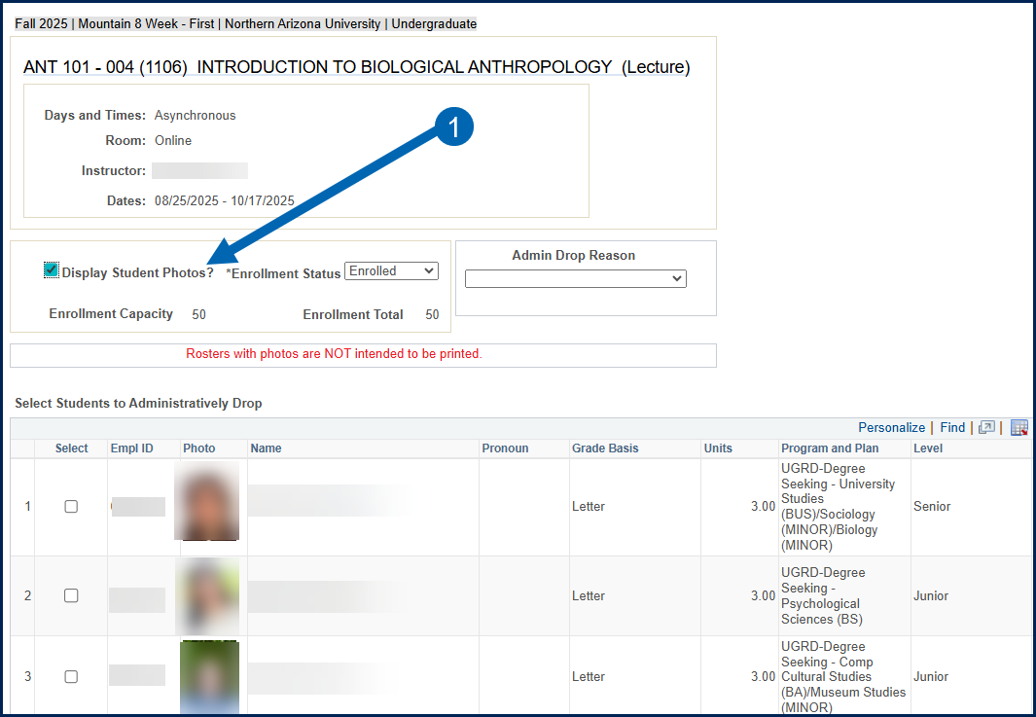

2: View Students by Enrollment Status
- Default status = Enrolled
- Other Options:
  - Waitlisted
  - Dropped
  - All
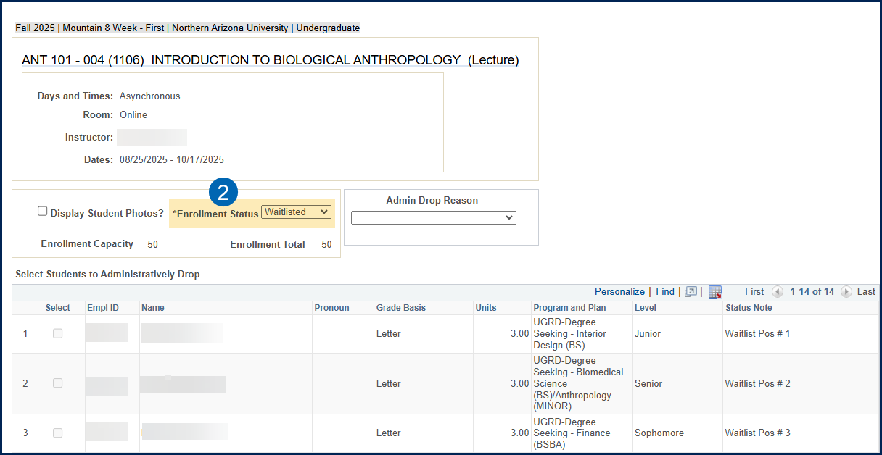

3: Select an Admin Drop Reason
- An Admin Drop Reason is REQUIRED to submit an Admin Drop Request
- If you need to drop students for both Poor Attendance and Unmet Requisites, you will select students for one reason, submit, then select students for the other reason, and submit.
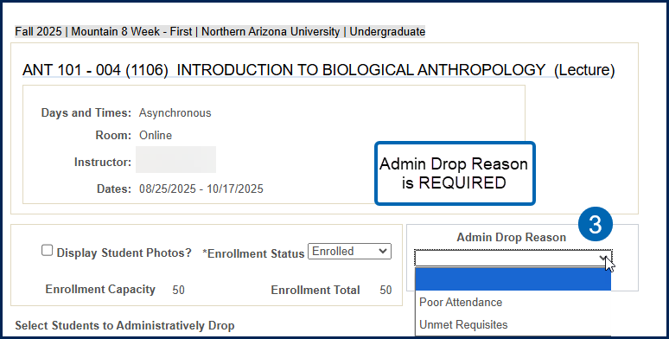

4: Select Students to Drop
- Set Enrollment Status dropdown to “Enrolled” if it is not already
- Select an Admin Drop Reason
- Select one or more students to drop
- Scroll to the bottom of the Roster and Click “Drop the selected student(s)” button
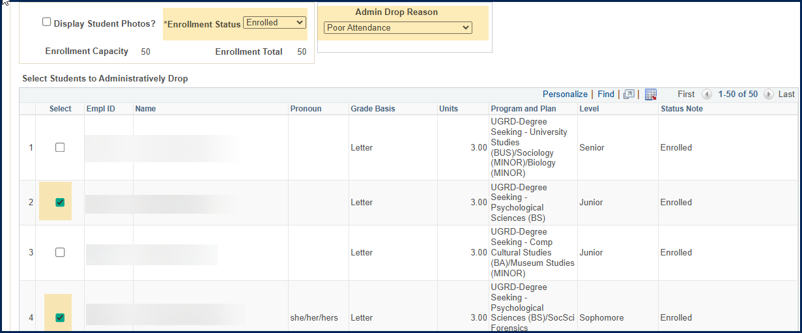
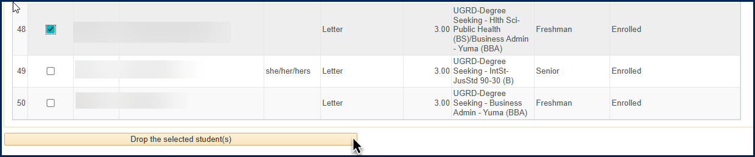

5: Submit Drop request(s)
- You will see a message pop-up for each selected student where you can click
  - Yes to submit the drop for that student
  - No to cancel the drop for that student
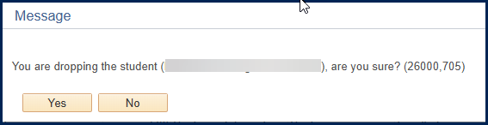
- Clicking Yes and successfully dropping the student will create another pop-up:
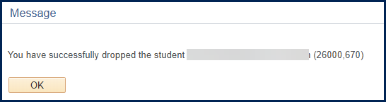
- Clicking No will move on to the next student if you selected more than one, or back to the Admin Drop Roster if there are no further students selected

Errors
If there are any issues with dropping a student, you will see an error message to let you know that the student could not be dropped.
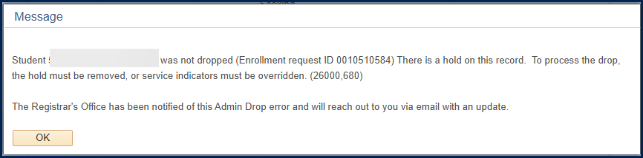
When this happens, an email will be sent to the Registrar’s Office at AdminRequest@nau.edu. The Registrar will review the issue and respond to you via email with further details.

Communications
- An email will be sent to the student to let them know they have been administratively dropped from the class
- An email will be sent to the instructor to let them know the student(s) has been administratively dropped
- An email will be sent to AdminRequest@nau.edu for any requests that result in an error

Reference

Administrative Drop Policy
The Administrative Drop Policy can be found in the University Policy Library

Administrative Request Deadlines
The Administrative Request Deadline for all sessions can be found on the Registrar’s Office website under the Important Dates and Deadline Section: https://in.nau.edu/registrar/

Once you click on Important Dates & Deadlines, click the Academic Calendar link for the term you want to know the dates for:
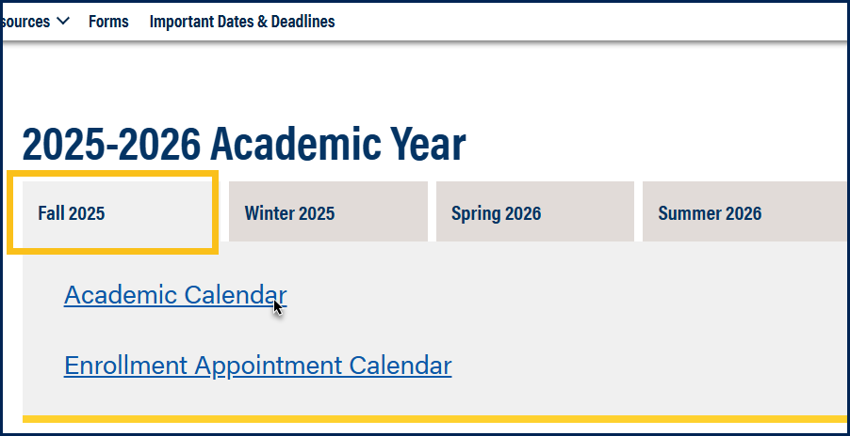
Find the deadline for a under the Administrative Request Deadline Event:
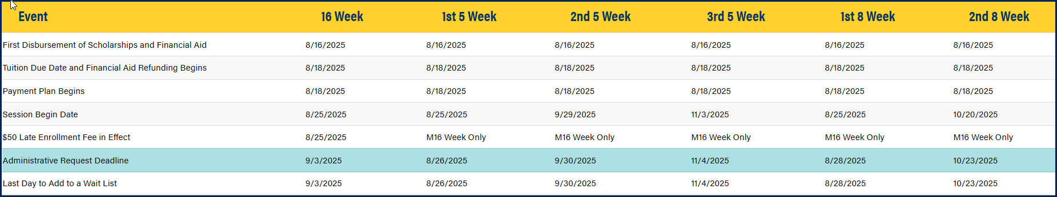

Support
Please contact the Office of the Registrar at AdminRequest@nau.edu with any questions.

