If a student would like to Update Connection, (meaning they would like to add and/or delete certain access to view in The Lumberjack Family Hub),

1. Student will need to log into The Lumberjack Family Hub
2. Student will see Active Connection, click on the person to whom you would like to change access for

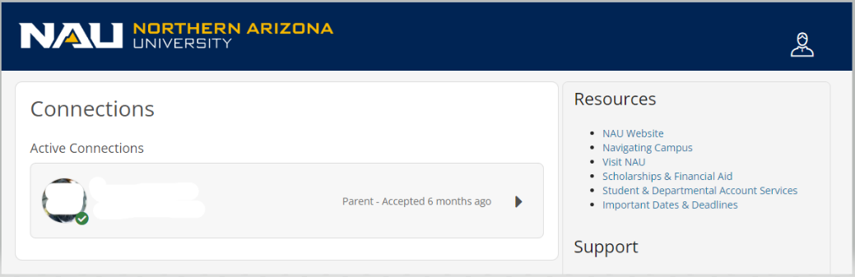

1. Select or unselect the checkmarks for the different records you wish to share or unshare

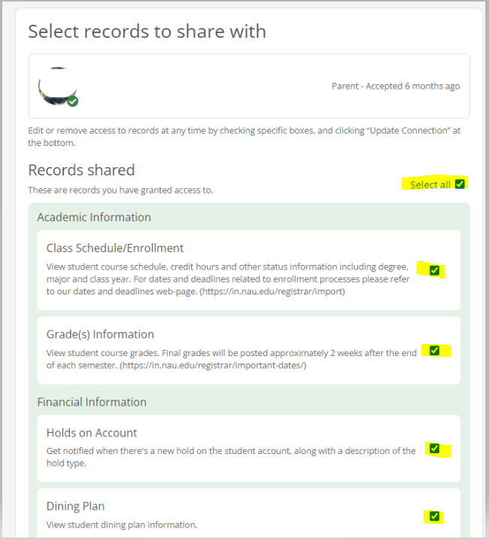

1. Click “Update Connection”

