If a student would like to revoke the FERPA access they have given within The Lumberjack Family Hub,

1. Student will need to log into The Lumberjack Family Hub
2. Student will see Active Connection, click on the person to whom you would like to revoke access from

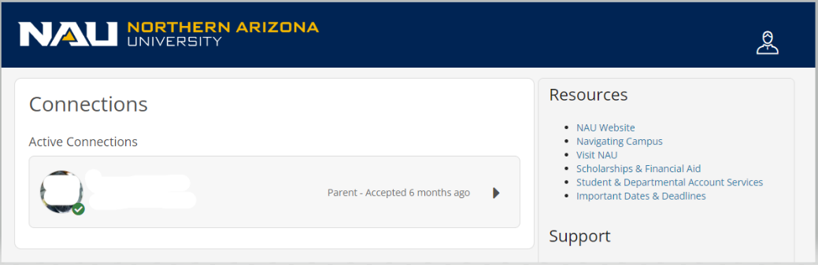

1. Scroll on the bottom of the “Select records to share with…” page, and click “Cancel Connection”

