Table of Contents
Overview 2
Tutorial 2
Reference 8

Overview
The Registrar’s Office now offers an online grade change form through LOUIE. The initiation and approvals are all completed online through LOUIE.

Tutorial
To access the grade change form, you will want to log into your LOUIE account. From the Home (LOUIE) page click on Manager/Department Dashboard.

Click on Registrar’s Office Forms. This will take you to the landing page for all Academic Unit Forms available
From here you will click on “add”:
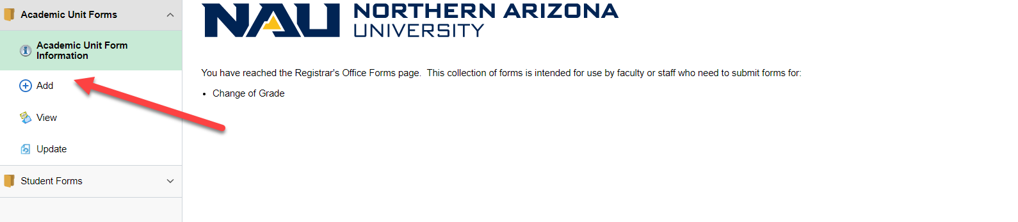
Select the term a grade change needs to be processed for:
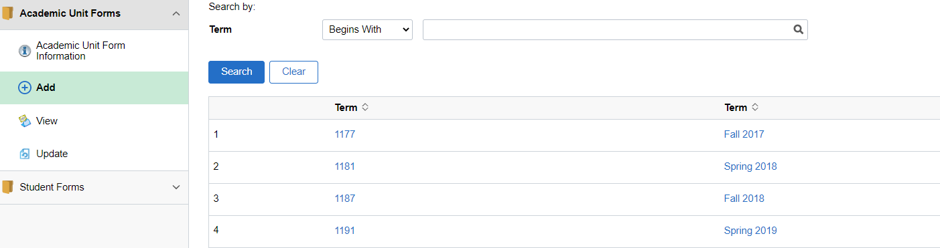

Select or enter the course number that needs the grade change:
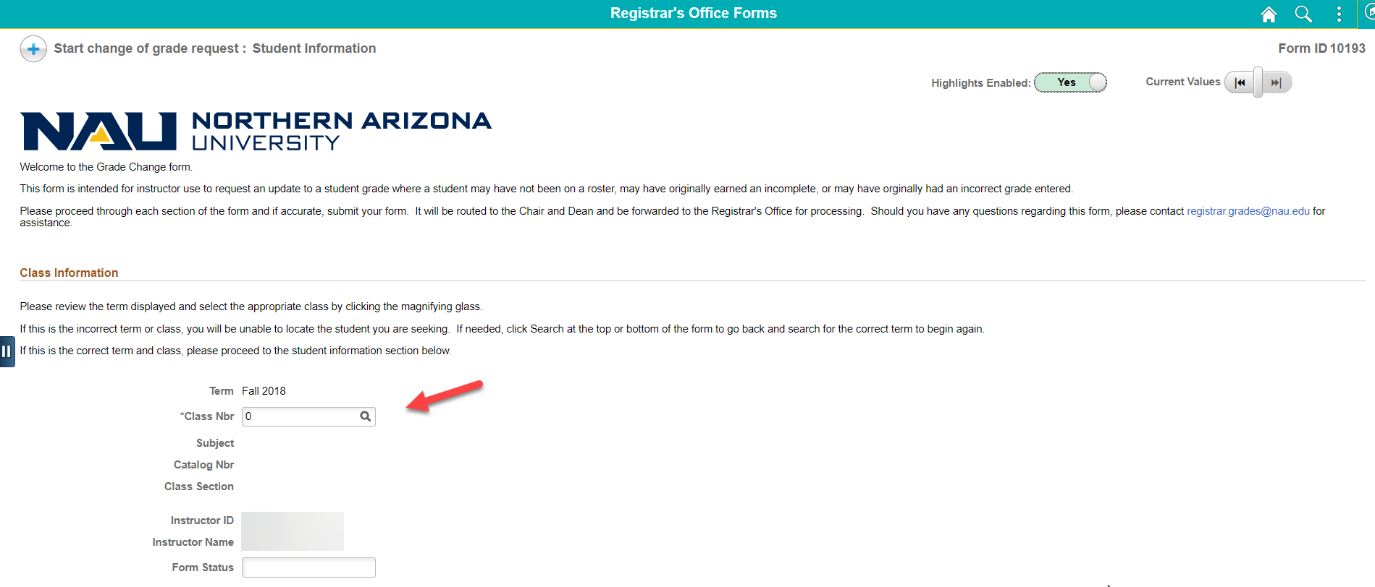
Select or enter the student’s information:
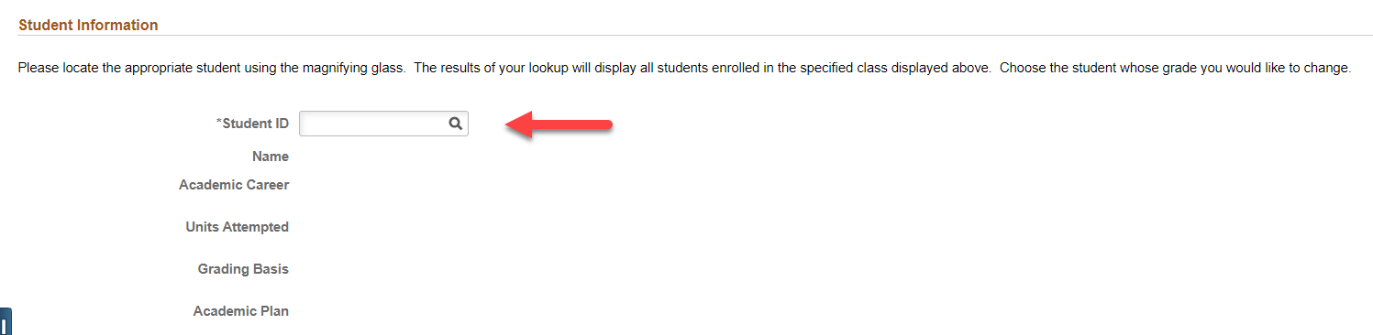
Next, you will need to select, and provide a reason, if applicable, for the grade change:
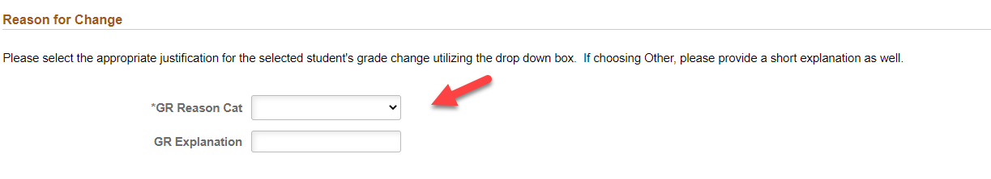

Lastly, you will need to provide the new grade and click submit:
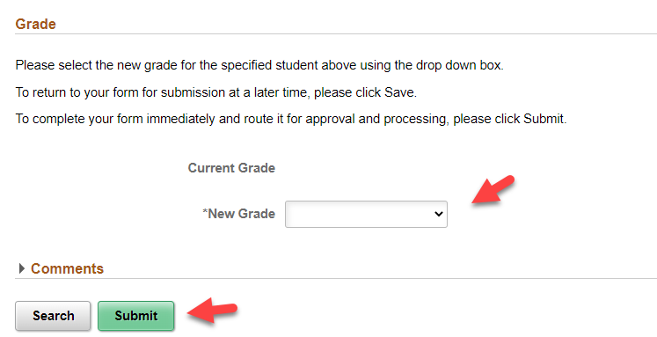
Once you submit the grade change form, an email will be sent to the Chair and Dean requesting their approvals. After the approvals are obtained the grade change form will be forwarded to the Registrar’s Office for processing.
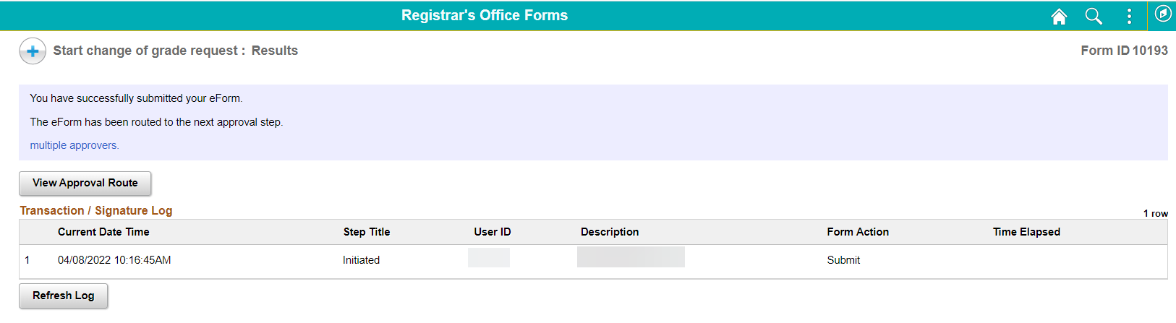
Click “update” and then “search” to make edits after the form has been submitted and before it has been processed by the Registrar’s Office:
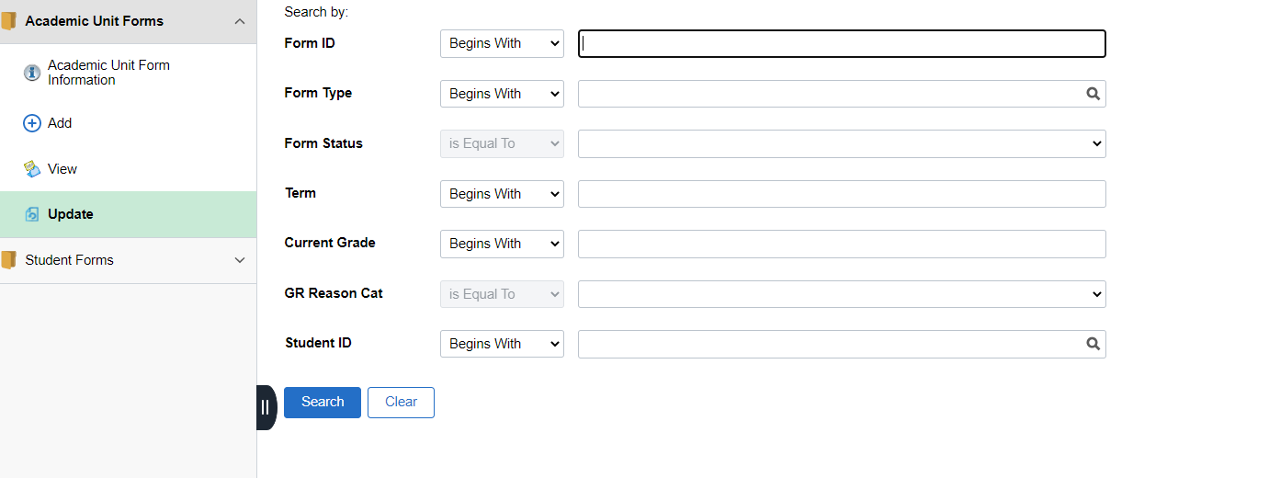
Choose the grade change form you need to update. Once the changes are made you will want to click “submit” again. If you are needing to withdraw the grade change form, you will want to click “withdraw”.
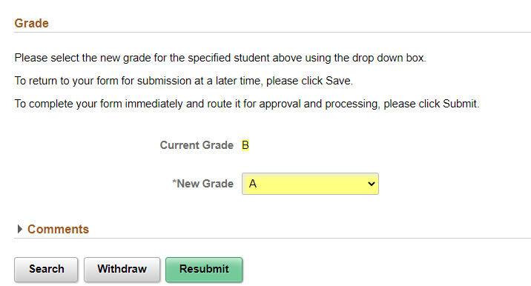
For Chair and Dean’s approvals you will receive the email below:
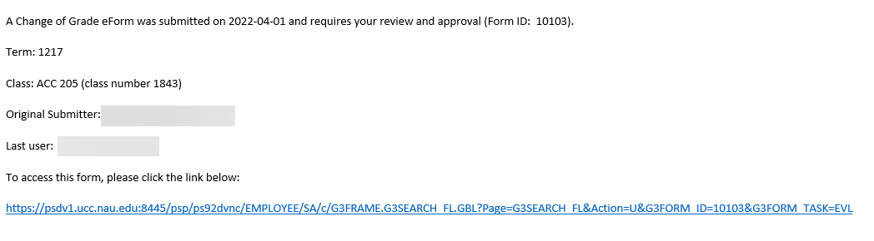
Click on the link or log into LOUIE to access the Registrar’s Office Forms. Once there click “evaluate”. Change of grade forms that require your approval will be in blue towards the bottom. Click on the link to evaluate and approve the grade change form.
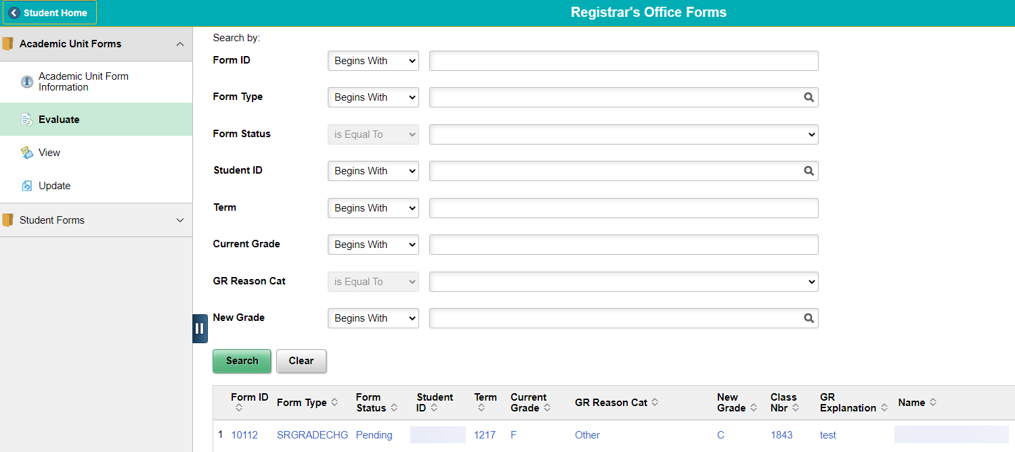
Chairs and Deans will have the option to “deny”, “recycle”, or “approve” the grade change form:
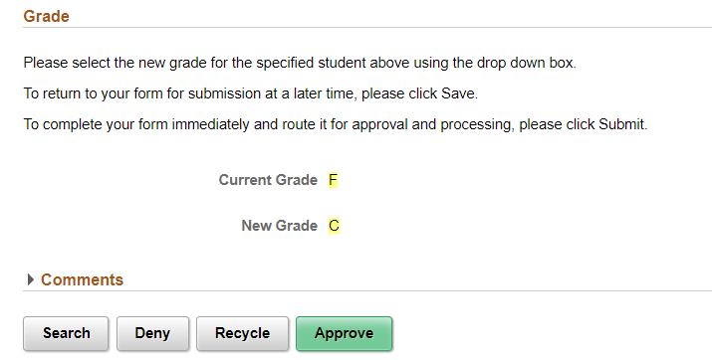

Reference
If assistance is needed, you can contact the Grading area at Registrar.Grades@nau.edu.

