Timely Tips
Timely Tips

(As you plan and enter your Schedule of Classes Build)

To refresh your memory, please review the Scheduling Requirements document, which may also be found on the Schedule of Classes Maintenance webpage.
Meanwhile, here are eleven basic questions to ask yourselves. There are certainly others, but these are the most common issues that cause delay.
- Have you used Standard Meeting Patterns wherever possible?
  - Non-standard meeting patterns make it harder for students to plan their schedules, since such classes stretch across multiple class times or shrink the standard 20-minute passing time. Using non-standard meetings times may make it impossible to find an available room.
  - We recommend that you keep a copy of this document handy: Standard Class Meeting Times. Requesting exceptions takes extra time for you and individual processing by SoC.
  - Using non-standard meeting times can cause problems during Finals Week.
  - Using non-standard meeting times may require you to schedule a “balancing class.”
  - Standard meeting patterns improve room utilization because rooms become available at the same predictable time—so the next scheduled class can use the room.
- Have you assigned the approved pre-assigned room for any of your classes that have one?
  - In Coursedog, you’ll access the area for approved pre-assigned rooms via the Meeting Patterns & Rooms Card.
  - Make sure your Enroll Cap does not exceed the Room Capacity of the pre-assigned room.
  - If you need a list of your unit’s Approved Pre-Assignments, you may request it from SoC.
  - If you neglect to assign a pre-assigned room to your class that has one, it will be placed by the Optimizer in a general-use classroom that will likely not be usable for your class.
- Have you pre-assigned the rooms for those instructors who have been given an ADA plan/ accommodation through NAU Disability Services?
  - Check with your Chair/Director for current list.
  - It’s very important these rooms be assigned before the all-campus room assignments begin, or the class will be placed in a room that will not be usable for your instructor with an accommodation.
  - You will need to submit a request for this room since it will not be available on the drop down list of pre-assigned rooms

Have you entered Combined Sections information via the Relationships Card in Coursedog?
  - Is this combination approved by the Course Catalog to be co-convened or cross-listed?
  - If not approved in the Catalog, have you requested one-time approval?
  - Have you verified that the combined classes have the same meeting pattern structure, delivery mode, grading, units, topic, dates, instructor, etc.?
  - If your class is cross-listed with another Prefix, have you touched base with their scheduler to be sure the classes are planned to combine for this term? Agree on who will enter in CD.
- If a class has a Grading Basis option of BTH/BIP, have you selected LTR or P/F? (Most cases need a decision, or the class will not become Active.)
  - It is difficult to change the Grading Basis after students have seen published classes and enrolled.
  - Correcting such a situation often requires that you request a new section and then petition Registrar Enrollment to “swap” students from the old section to the new section—and involve Advising personnel. It can also hamper student progress if they need a LTR grade for graduation or scholarships and did not realize they would receive a P/F grade.

- Have you balanced Blended, Shorter Session, and One-Unit Classes that occur during peak hours?
- Enter Balancing section detail via the Balancing Sections Card.
- Balancing classes are needed for classes that meet in Peak times (that have a start time of 9:00 AM through 5:00 PM). If you want to schedule before 9:00am or from 5:00pm forward, you do not need a balancer.
  - An exception is if you schedule using one of the “any single night” patterns, such as 4:00 PM to 6:30 PM (single-night) or 4:30 to 7:00 PM (single-night).
  - Some Friday-only patterns can also be accepted since rooms are less of an issue, and balancing is not as required.
- Balanced Sections:
- Example: shorter session: a 7.5A class with a meeting pattern of MW 12:45-2:00pm, is balanced with a 7.5B class with a meeting pattern of MW 12:45-2:00pm
- Example: blended class: a blended class with a meeting pattern of M 2:20-3:35pm, is balanced with a class with a meeting pattern of W 2:20-3:35pm
- Example: A 1-unit class will normally meet just once per week. Balance with another 1-unit.
  - To identify balanced classes, input each class on the Balancing Sections card of each section.
  - Example: if balancing ACC 205-001 with ACC 300-001, enter ACC 300-001 on the Balancing Sections card for ACC 205, and enter ACC 205-001 on the Balancing Sections card for ACC 300-001
  - If you have a very long class that needs balancing, you can sometimes balance it with two shorter classes.
  - Before making changes, always check to see if the class has a balancer, because, if so, you will need to make changes for both classes, since they are balanced.
- If your class has a meeting pattern but will meet in a non-classroom space, have you entered 999-TBA AND entered a Free-Format Note advising students what to do for Day One? (Or a contact for this info.)
  - 999-TBA does not mean “we do not know yet” or “I don’t see the room I’d like in the pull-down menu.”—so please don’t use it as a placeholder. 999-TBA means the class will not meet in an assignable classroom space. This could be a professor’s office, a research lab, a conference room, a forest, a canyon, etc.
  - Enter a Free-format note that explains to students Where/What to do on Day One.
- If your class has the option of Variable Units, have you set the units to a fixed number in most cases?
  - If variable units are not set properly before students begin enrolling—and you then later change the units, students may be negatively affected. Examples: unexpected tuition increase or being enrolled for too few units for scholarship eligibility or graduation. Either way, it can seriously impact students’ financial aid, degree progress, and more.
  - Some classes (notably Course Line classes), which are usually offered as individualized study, may use variable units. This generally includes: 389, 279, 408, 466, 485, 497, 566, 593, 608, 685, 689, 697, 699, and 799—and some 208s.
  - But most classes, including 199, 299, 399, 499, and 599, need fixed units because they are seldom individualized—though there are some rare exceptions.
  - Classes that are allowed to configure with variable units should also use/add Note #0108, which will populate to tell the student:

“This is a variable unit class. Please check with your advisor to enroll in the correct number of units for this class. In addition, if you do not select a fixed number of units, you will automatically be enrolled in the lowest number of units offered (i.e., if no units are selected for a variable unit class offered for 1-3 units, you will be enrolled in 1 unit).”
- Have you distributed your classes across different meeting patterns (days and times of day)?
- Over-emphasizing a popular peak meeting pattern often results in “No classroom available” situations, forcing you to look for an alternate time, later in the process.
- Scheduling required classes in the same blocks of times makes it harder for students to schedule and make progress toward their decree.
- Have you entered any instructors who are teaching back-to-back and requested to stay in the same room (or one nearby)?
- Our optimizer will attempt to schedule the same (or nearby) room but can only do so if the instructors are entered during the build and before optimization. If you wait to enter instructor information after rooms have been assigned, we cannot shift room assignments to accommodate back-to-back situations.
- Have you entered the precise dates for any Dynamically Dated (DD) classes you may have?
And done so in TWO places?
  - Dynamically dated (DD) classes have different Start/End dates than standard sessions. They also have different Drop/Add and Payment dates, which can be confusing to students, so their use is limited.
    - In-person/blended DD classes will generally not fit within a standard meeting time, which impacts student schedules, passing time, final exam schedules, and classroom utilization.
    - DD classes require manual work on the part of units and SoC. This means DD classes scheduled by Academic Units on the Flagstaff campus require approval. Only classes that must align with an outside entities’ schedule or that cannot legitimately fit within a standard session should be scheduled as DD.
  - Choose your DD session based on when it ends.
    - Example: Your DD class must meet from 9/20/22 to 10/18/22
    - Looking at your End Date, and comparing it to the published generic session dates, you will learn this is a DD1 class, since it ends before the generic DD1 End Date of 10/23/22.
    - This means you must be aware of the generic session dates AND your DD class’s particular dates.

Session | Start Date (First day of session) | End Date (Last day of session
DD1 | 8/29/22 | 10/23/22
DD2 | 10/24/2022 | 12/16/2022

  - Although there are generic DD session dates, units must enter the precise dates for each DD class. Example. If the DD session starts on Monday the 10th, but the particular class starts on Tuesday, the unit must enter Tuesday, the 11th as the precise start date.
WHERE to enter:
❶ General Information card and
❷ Meeting Patterns & Rooms card Meeting Pattern Additional Information
❶
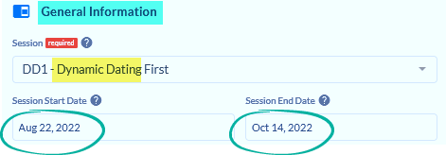
❷
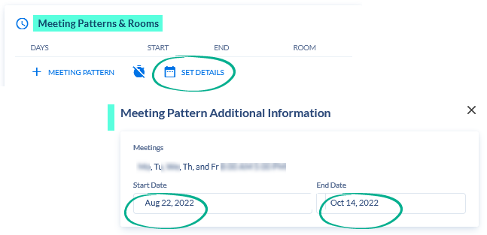

The Schedule of Classes Maintenance webpage has further training that includes screenshots and more step-by-step directions. Please use those as a resource beyond this Timely Tips document.

