Table of Contents
Overview 2
Tutorial 2
Reference 5

Overview
This document provides documentation for how to access an Academic Advisement Reports (AAR) from the Advisor Center in the LOUIE Self-Service pages, in the FLUID operating system.

Tutorial
Only Northern Arizona University (NAU) faculty or staff who have the appropriate ePASS securities will be able to access AARs. These securities include the completion of the NAU FERPA Tutorial, as well as the LOUIE security request form with the NAU_SR Student Records Viewer role or an advisor security role.
To access AARs in LOUIE, complete the CAS-login into LOUIE:
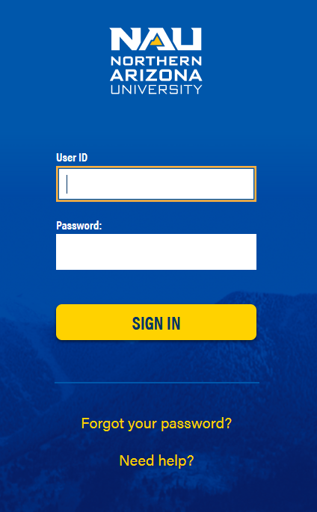
In the new FLUID system, go to the “Faculty/Advisor Home” menu at the top of the screen:
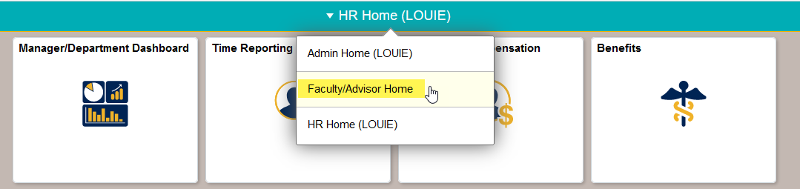
Once on that Home Page, click on the “My Advisees” tile:
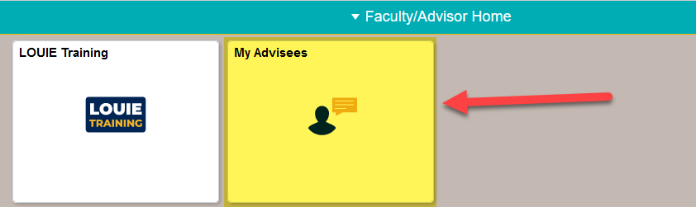
If assigned as an advisor to students, search through the list to identify the student that needs their Academic Advisement Report (AAR) ran. If not currently assigned as advisor to any students, then click on the “View Other Student” button:
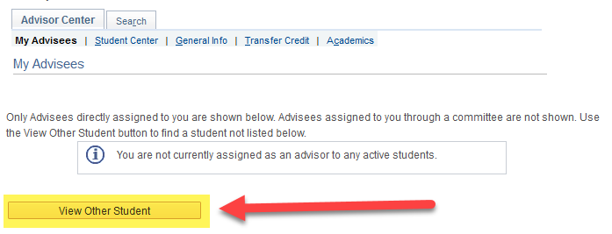
In the next screen, identify information to be able to view the student’s academic progress in their AAR. An EMPL ID or their user ID (i.e., abc123) are excellent identifiers:
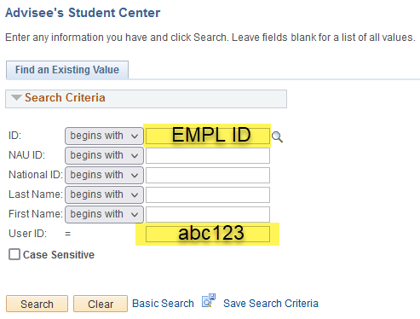

Completion of this information will take you to the student’s Student Center. From their Drop-Down-Menu that currently indicates “other academic . . “, choose “Academic Requirements” and click on the >> button to view the student’s AAR.
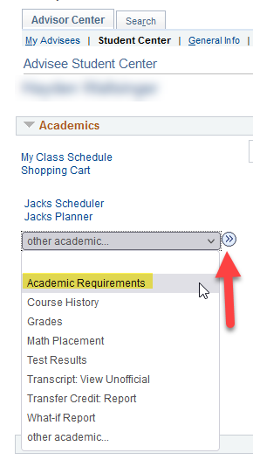
The next page to populate will be the student’s Academic Advisement Report (AAR).

Reference
Any additional questions regarding accessing AARs, please reach out to the AAR Team at Registrar.AdvisementReport@nau.edu.

