Generic DD Session Dates for FALL 2022
Choose your DD session based on when it ends.
Your dates must be exact, not the generic dates.

 | Generic DD Session Dates for Summer 2022
 | DD1 | DD2
Start Date (First day of session) | 8/29/22 | 10/24/2022
End Date (Last day of session) | 10/23/22 | 12/16/2022

Links to Other Resources on the SoC Website
Calculator for Contact Hours
Thumbnail: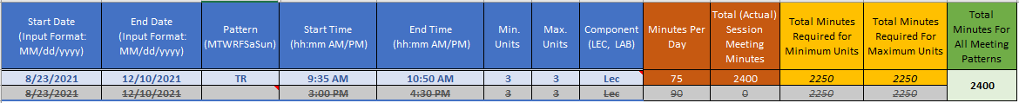
Calculator for Dynamically Dated Classes
Thumbnail: 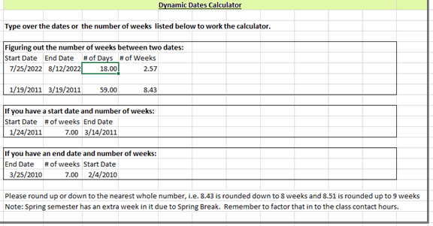

Policy for Contact Hours (Arizona Board of Regents)
