Table of Contents
Overview 2
Tutorial 2
Reference 4

Overview
This document provides the simple step-by-step guide on how to request a student’s initial advisement report.

Tutorial
There is an overnight process within PeopleSoft that will automatically run a student’s initial advisement report (AAR). This allows the student and/or the advisor to pull their AAR from their SalesForce account.
There are a handful of times each semester in which the overnight process does not run for individual students. This has been researched extensively and the AAR Team is unable to determine the cause for these students to not be ran in the overnight process. Thus, sometimes, the initial AAR Report needs to be ran on a manual basis in order for it to be seen by the student and/or the advisor.
Academic Advisement -> Student Advisement -> Request Advisement Report
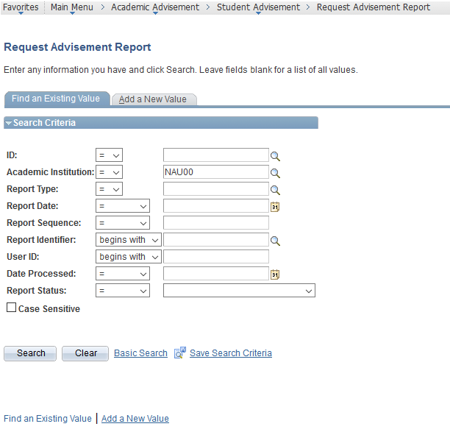
Focus on the “Add a New Value” tab.
Enter the student’s EMPL ID, leave the Academic Institution as NAU00.

Identify type of report: Current
- Current: ADVIP
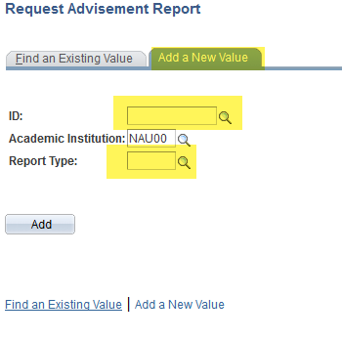
Click on the “Add” button.
If only wanting to see the student’s current AAR (ADVIP), click on the “Process Request” button on the Report Request Page (screenshot below). This will provide the initial advisement report.
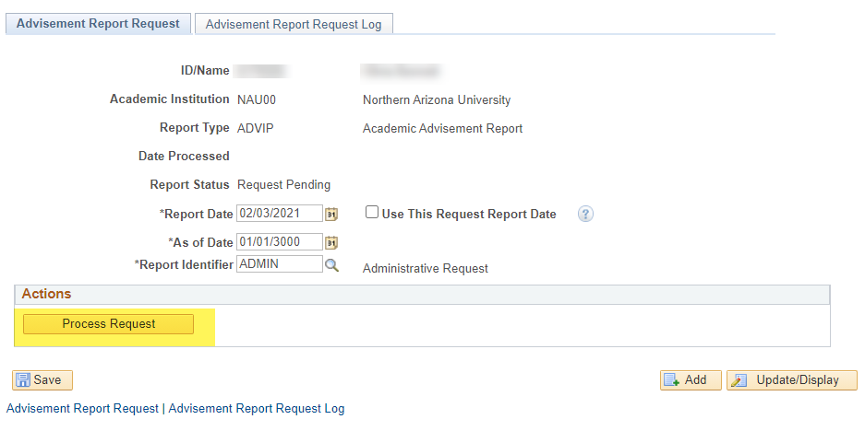

Reference
If additional assistance is needed, please reach out to the Advisement Report (AAR) Team at Registrar.AdvisementReport@nau.edu for additional troubleshooting.

