Table of Contents
Overview 2
Tutorial 2
Reference 9

Overview
The Administer Student Exceptions role is an extension of the Authorize Student Exceptions role. This is a result that the Administer Student Exceptions page is the “queue” of all of the submitted student exceptions that have been submitted by advisors across the University. Users must have the Exception Processor Role (NAU_AI AAR Exception Processor) in order to actually process the exceptions from the Administer Student Exceptions page for them to be visible in the student’s AAR.

Tutorial
Processing Exceptions is an extremely powerful role. Exceptions can make it so a student’s AAR collapses and the student can graduate – and if done incorrectly, a degree can be erroneously awarded. Thus, users without the Exception Processor Role security participate in this two step-process of submitting the exception, and a user reviews it and processes the exception to then have it appear in the student’s AAR.
Again, the Administer Student Exceptions page is similar to a “queue” where all of the submitted exceptions for major, minor, certificate, and emphasis requirements wait until they are processed by the Exception Processors for individual colleges. All Liberal Studies, Diversity, and University Requirements exceptions are processed by the AAR Team.

Academic Advisement -> Student Advisement -> Administer Student Exceptions
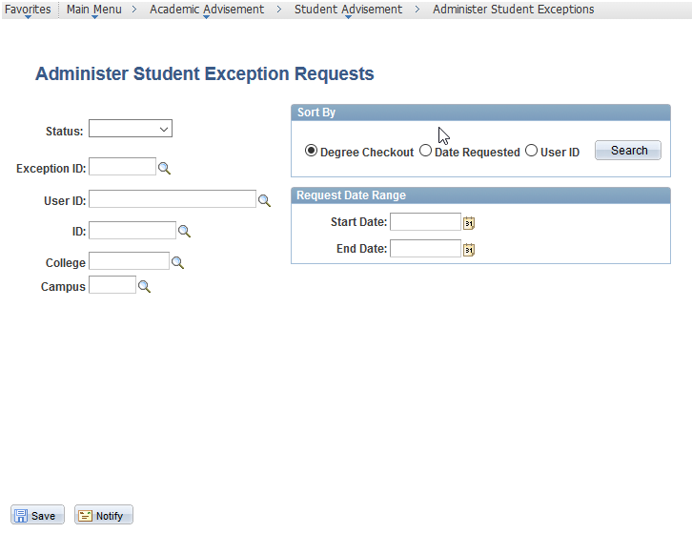
This page notifies users of what exceptions have been submitted, cancelled or completed. This can also be filtered to each individual college, date range, campus location, etc.
Advisors will need to filter their exceptions to their own college and exceptions that have been submitted:

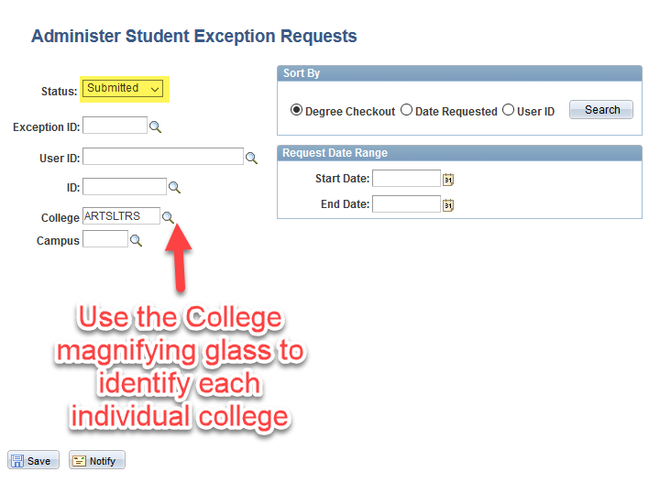
When utilizing the magnifying glass to identify an individual college click on the “Look Up” button to obtain a listing of all of the Colleges and their codes:
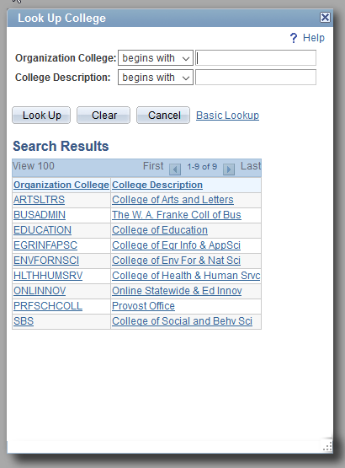

Once the status has been changed to “Submitted” and the College has been identified, click on the “Search” button to obtain a list of all of the exceptions that have been submitted for that college:
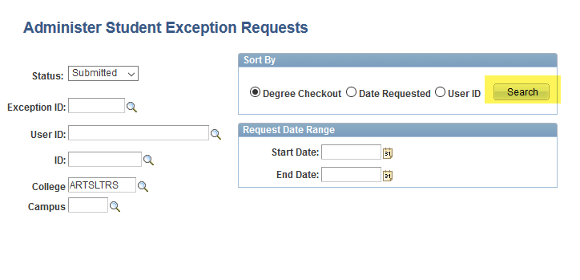
This will bring up the list of all of the exceptions that have been submitted for that college, but not actually processed/visible in the student’s AAR:
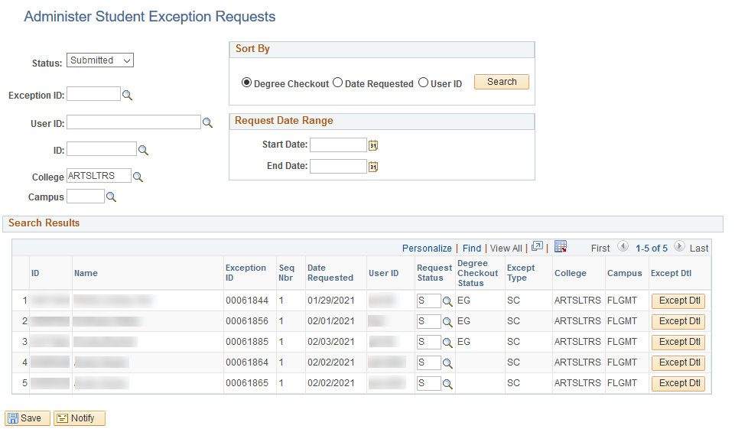
- The ID Column is the EMPL ID for the student that had an exception submitted for them.
- The Exception ID Column is the ID assigned from the exception request form submitted – this will be different than the Authorization Override (AO) number that is assigned when the exception is processed.
- The Seq Nbr Column is the number of the exception submitted. This number should always be 1 because there should be a new exception submitted for each exception. You cannot stack exceptions on top of each other on different rows in PeopleSoft..
- The Date Requested Column is the column indicating the date that the exception submitted.
- The User ID Column is the user ID of the individual who submitted the exception. Thus, if there are any questions about the exception, the processor can ask the person who submitted it.
- The Request Status Column should all say “S” for Submitted. Otherwise, it is “C” for Completed, and “X” for Cancelled.
- The Degree Checkout Status Column indicates if the student is eligible to apply to graduate (EG), or if they have applied to graduate (AG). Students who have the AG status should be prioritized and their exceptions processed first. Then those with EG status should be prioritized next.
- The Except Type Column will mostly indicate “SC” for Substitute Course. It can also indicate “SIP” for Student Individualized Plan (RARELY, if EVER, USED) or “CRL” for Change Requirement Line.
- The College Column is the college that houses the plan that is getting an exception to it.
- The Campus Column is the campus for the student that needs the exception.
- The Except Dtl Column is the Exception Detail Column. Clicking on the “Except Dtl” button will bring up what advisors have submitted for the exception. This is basically the “meat” of the exception for the processor to follow.
Below is a screen shot of the “Except Dlt.” It is essentially the information that the advisor fills out on the Student Exception Request form:
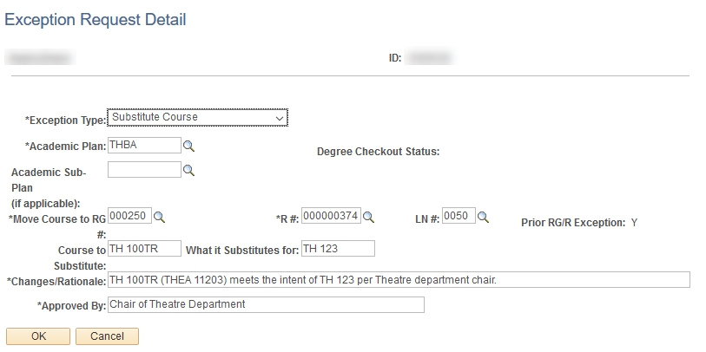This page will indicate what the academic plan is for the student that needs the exception, what the RG, RQ, and Line is for where the course will need to go in the AAR.
This page will also indicate what the messaging will need to be in the wording of the exception processing, as well as who has approved it. Most often, processors will have two tabs open during the processing stage: 1 for the Administer Exceptions Page and 1 for the Authorize Student Exceptions Page. It is handy to be able to copy the wording from this submitted exception to put into the processing exception page.
When the exception has been processed and saved, change the Request Status from “S” (Submitted) to “C” for Completed. This will gray out the “Except Dtl” button. If someone ever needs to see the detail of the exception submission again, then they will need to change the Request Status from “C” back to “S” and do a search for submitted exceptions again.

It is always encouraged that processors run an Advisement Report prior to completing the exception, as well as after completing the exception. This is just to ensure that all of the coursework appears as needed, and nothing different occurs outside of what is being processed.

Reference
If additional assistance is needed, please reach out to the Advisement Report (AAR) Team at Registrar.AdvisementReport@nau.edu for additional troubleshooting.

