Table of Contents
student group overview 2
understanding the student groups page 2
adding/activating a student group 5
inactivating a student group 6
managing a group – assessing which students require inactivations 9
effective dating guidelines 11
assistance and bulk uploads 14

student group overview

Student groups categorize students for certain types of processing in LOUIE (tuition charges, enrollment limits, enrollment appointments, requisite processing, etc.). As such, when a new student group is created, an owning department is also identified. That department assumes responsibility for maintaining their student group data. Maintenance includes adding students to the group initially and maintaining the student group status (i.e., activation/inactivation) of individual students over time.

Because many offices rely on student group data, yet all offices use the same page to maintain student groups, all departments must follow the same rules and processes. Departments should never make changes for a group they don’t own (i.e., by assigning the group to a student or by inserting/editing effective dated rows in the bottom portion of the student group page).
Further, departments should never use the button on the student group page (which will delete historical data). If you make a mistake when updating a student’s record, please contact Registrar.DataIntegrity@nau.edu immediately. Failure to follow these rules may result in security access being revoked.

understanding the student groups page

Navigation: Main Menu > Records and Enrollment > Career and Program Information > Student Groups

Enter EMPLID, click “include history”, and click “search”.

NEVER click “correct history”. Also, never alter a previous student group entry. If you feel a change is needed, reach out to the individual who added the row/entry. Users found to have corrected/altered history on the student groups page will have their access immediately revoked. This is especially important for groups which assess program fees.

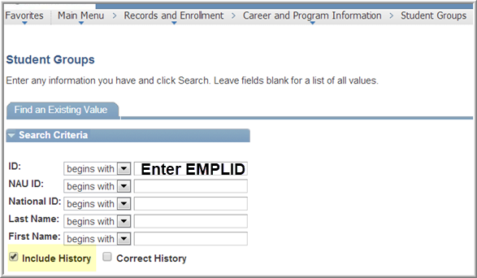

This will bring you to the student’s student groups. By navigating left and right with the arrows of the parent rows (the top rows), you can see each of the student groups a student is in. For instance, the student below is in 7 student groups, the first of which is “ATN1”. The student group entries are alphabetized.

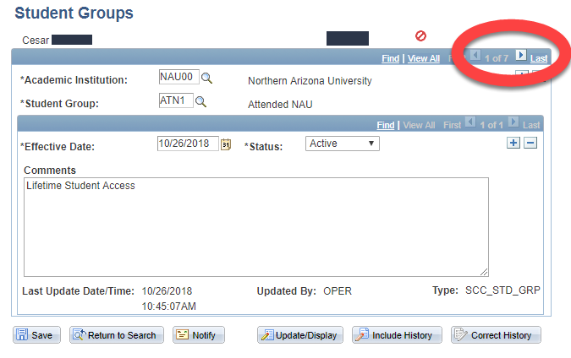

The child rows (the lower set of arrows and +/- signs) will show the changes over time for each group. For instance, as you can see in the red circled area below, we can see that this student has 2 rows of history for their #007 group:
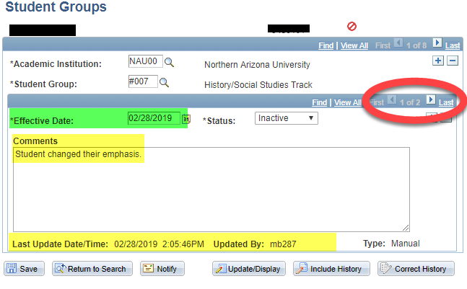
It will always show us the most recent row first. Therefore, we know that this student is currently INactive in student group #007 as of 2/28/19. We can also see some other information such as the explanatory comment that was left when the group was inactivated as well as the user ID and date/time stamp of when the action occurred.

If we were to click the > arrow in the child rows, we would see the previous entry for this student group. In this case, if I click the > arrow to go to record 2, we could see that this student was initially activated in the #007 group on 1/1/2018:
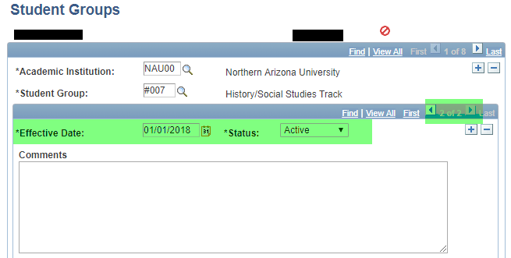

adding/activating a student group

First, check to make sure that the student doesn’t already have an entry for the student group you are adding. If they don’t, follow these instructions to add an active student group to a student’s record.

First, use the parent (top) + to add a new entry.

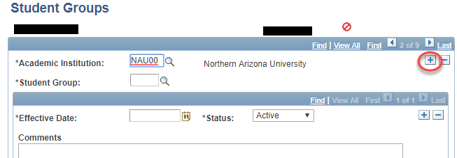

The new entry will be blank except for Academic Institution and Status. You will want to fill in each of the sections highlighted.
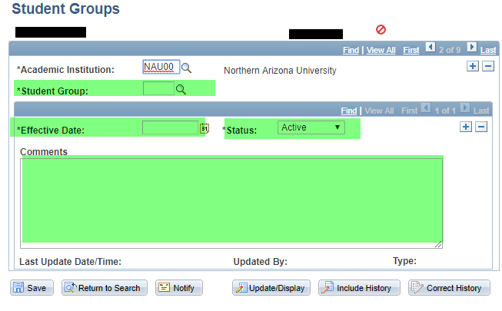

- Enter your Student Group by typing it in or using the “look up” option.
- Enter an Effective Date
  - Effective date will vary depending on the group. See “Effective Dating” section for an overview.
- Leave the status as “Active”, assuming you want the student to be active in the group
- Enter an explanatory comment (optional, but highly encouraged)
- Click “Save”

After hitting Save, you will see your own user ID as well as the date/time stamp for when you made the change. Note – the date/time stamp will reflect the date that you actually took the action in the student group; this might be different than the effective date.

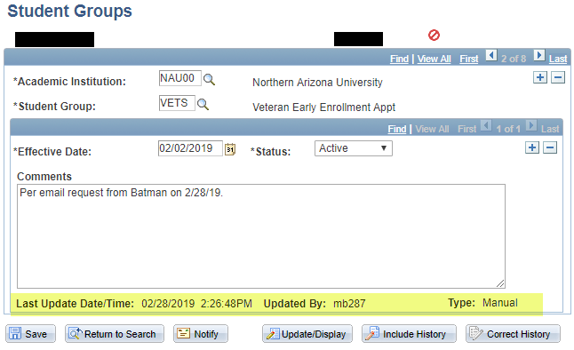

inactivating a student group
Students are frequently inactivated from student groups as well. Remember: even though the language “remove a student from a student group” is often used, you should never use the button. We are only ever INACTIVATING students from a group – never, ever removing the group entirely.
To inactivate a group,
- pull up a student’s student group page and use the parent (top) rows to navigate to the student group you want to inactivate. In this example, I navigated to the NSRC group (group 4 of 8), which we can see was activated on 2/14/19 as part of an automatic process:
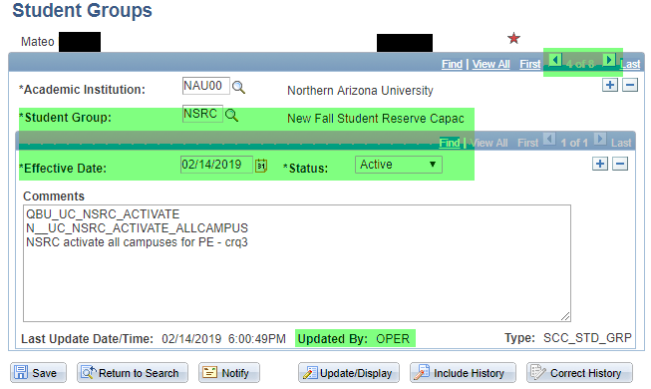

- To inactivate, you need to ADD A NEW CHILD ROW by clicking the + sign in the child (bottom) row, since we are adding a change to an already-existing group
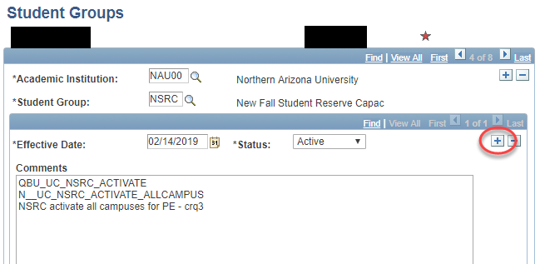

Once you hit the +, you will see that it now says “1 of 2” records within that group. Also, a new effective date will populate (of today)
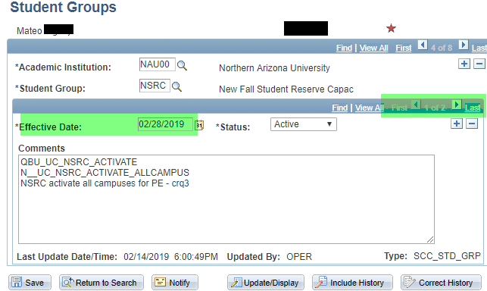
- Change your effective date if needed
  - Effective dates will vary depending on the group. See “Effective Dating” section for an overview.
- Change the “STATUS” drop down to say “Inactive”
- Delete the old comment and add a new comment (optional, but highly encouraged)
  - Comments will vary depending on the student group you are working with. Commonly, comments will include who a request came from, or why the student is being inactivated.
- Click “Save”
You will see your new (inactive) record now shows up first, as record 1 of 2 within that group. You will also see your comment and the stamp with your user ID and the date/time:
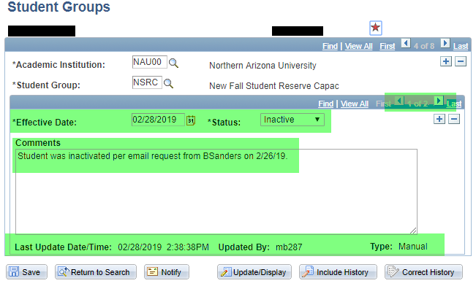

managing a group – assessing which students require inactivations

Departments must consistently maintain their student groups, including the inactivation of students who no longer should be in the group, have graduated, etc. Here are some examples of why this maintenance is so important:
- Certain students receive Priority Enrollment Appointments (e.g. Athletes)
- Departments and the university pursue current and/or historical membership records in particular groups
- Can affects student tuition, fees, and financial aid
- Can identify eligibility and participation in certain university programs
- ABOR, NCAA, and other reports
The “View Student Groups by Student” page in Peoplesoft allows you to see all students who are currently active or inactive in a specific student group.
Navigation: Main Menu > Records and Enrollment > Career and Program Information > View Student Groups by Student
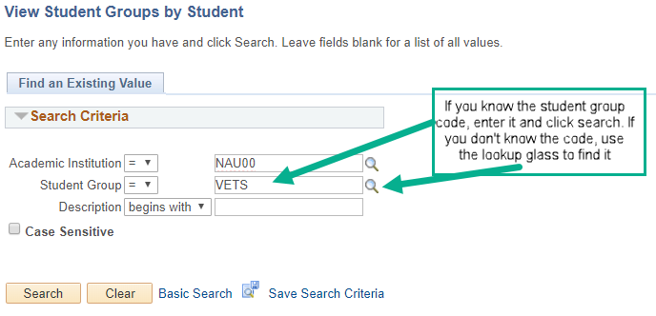
When using the magnifying class, filter your options to make finding your group easier. For instance, you could say that you know your student group “starts with” a specific character or “contains” a particular character, etc.
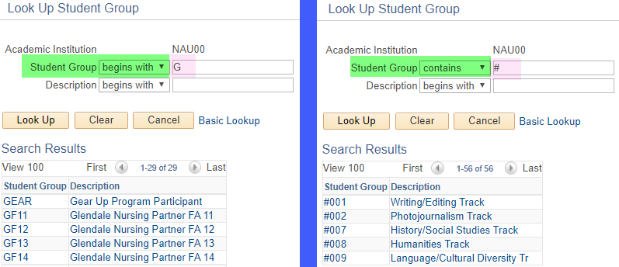
Click the appropriate group. You can then tailor your results using the options in the pull-down menu.
You can search for most current active or inactive students, all students, and other criteria.
In this example, the user would view the most current active selection, with no range selection:
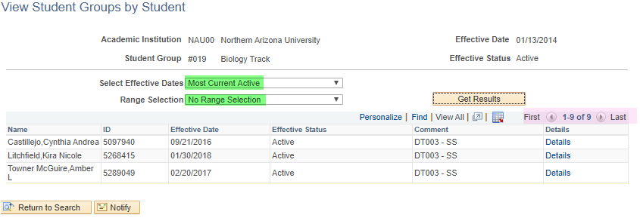
Caution: Some student groups are quite large. If you don’t limit your selection criteria, it could take several minutes for the results to be displayed. Also note that on the top right (highlighted in pink above), there may be multiple pages of results.
You may click the column headers to organize by, for example, effective date. You can also export your list to Excel by clicking this icon:

Clicking the “Details” link will take you to the specific student group page for that student.

effective dating guidelines
If your department requests that a student group be created and you are trained to maintain a student group for your department, you are responsible for the accurate effective dating and maintenance of the group. Your 1:1 training from the Registrar’s Office will touch more specifically on accurate effective dating for the specific groups you will maintain. Here are some basic, general guidelines and timelines:
- You cannot activate and inactivate a student group with an effective date of the same day.
  - If you need to change the active status in the same day (for example, due to mistakenly activating the wrong student in a group), you can future-date your (in)activation by one day if this won’t have negative repercussions.
  - If it’s important that the student be (in)activated immediately (e.g. their tuition will post incorrectly), please email Registrar.DataIntegrity@nau.edu and we can remove the erroneous (in)active row

- Activating students using correct effective dates (for student groups that DON’T relate to tuition or fees)
  - If you are manually adding students to your student group, you should make sure that the date you are using is within the term you want them to be active

- Inactivating students in a group NOT tied to tuition or program fee
  - When they complete their program/plan (graduate) – inactivate using the day after the degree confer/ degree complete date
  - When they leave the university – use current date
  - When they no longer meet the requirements for your student group – use current date

- Activating in a group that IS tied to tuition or fees
  - It is up to the department that owns/manages a group to ensure accuracy of activations, effective dates, and student group comments
  - Registrar.DataIntegrity@nau.edu or SDAS can assist in identifying the proper effective date as needed, prior to any student group updates
  - The general rule of thumb is that any program fees should be viewable to students by the time their tuition is calc’ing for the relevant term. This is so that students don’t see a TUIT/fee charge that then increases once the fee is applied
    - SDAS’ goal is to post tuition charges 6+ weeks prior to the beginning of the term:
      - Fall term tuition target date is first week of July
      - Winter term tuition target date is end-of-September
      - Spring term tuition target date is mid-November
      - Summer term tuition target date is end-of-March
    - Therefore, manual in/activations for fee-related groups should be completed in time for tuition calc for the appropriate term
      - Care should be taken to use an activation effective date that is early enough to apply fees at the time of tuition posting but also late enough that it won’t erroneously apply fees to any prior terms
    - Requests for bulk activation into a student group should be sent within that timeline as well
    - If you will be unable to adhere to this timeline for any reason, contact SDAS and RO Data Integrity as soon as possible in advance of tuition posting to discuss
    - Once the first census date has passed for a given term, it is difficult and sometimes impossible to add program fees for that term
      - If census for the relevant term has already passed, contact SDAS or Data Integrity prior to proceeding
    - Once a term has concluded, it is generally not possible to retroactively apply a fee to that term.
      - If this situation arises, contact SDAS and/or Data Integrity prior to making any changes
      - Exceptions can be made in very rare situations
    - Any time that a program fee is being added after-term-start, contact the student before making the change and ensure they are expecting the charge and are aware of why it’s being added after-the-fact.

- Inactivating a group that IS tied to tuition/fees
  - Remember: the first step for any inactivation is to add a new child row. If you change the pull-down menu to “inactive” without adding a new child row, there can be very serious repercussions, especially with fee-related groups.
    - Any person working with a fee-related group who changes a row to “inactive” without adding a new effective-dated child row will have their student group access removed immediately
  - If you are maintaining a Program Fee student group, auditing program fees is the responsibility of student group managers
    - Any student who graduates, leaves the relevant program, or for any other reason no longer requires the program fee must be monitored and inactivated by the department owning the group
    - If a student has enrollment and drops all courses, the program fee will also be removed. However, if a student leaves your program but remains enrolled in other courses, they will still be charged the program fee until you inactivate the student group
  - For tuition-related or financial-aid-related student groups, you can work with SDAS and/or Registrar.DataIntegrity@nau.edu to identify a proper inactivation effective date
  - This chart can assist you in correct INACTIVATION effective dating for groups that relate specifically to Program Fees:
Student Leaves Program: | Refund Program Fee? | Add inactive row with:
On or before term begin date | Yes | Any date that is on or before the start of the term that the fee is charged
In the middle of a term if approved by the department | Work with SDAS to see if a refund is appropriate | Any date that is on or before the start of the term that the fee is charged
In the middle of a term typically program fees are not refunded for the term unless approved by the department | No | Any date after the term begin date to  1 day after the term ends – work with SDAS/RO as needed
At the end of a term – doesn’t finish program OR completes program | No | Date 1 day after term end date

assistance and bulk uploads
- If you have a large group of students that you would like to be activated or inactivated in bulk, please email a list of EMPLIDS to Registrar.DataIntegrity@nau.edu with your request. Please include the effective date I should use for the activation/inactivation as well as any comment you’d like included.

- If you make a mistake but haven’t hit save yet, simply navigate away from the page. Say “no” when it asks if you want to save your changes.

- If you make an error and have already clicked “save”, please do NOT try to fix the error yourself. Contact Registrar.DataIntegrity@nau.edu and we will assist you to fix the error

- Michele Beier and Anora Tillman are the contacts for Student Group questions. The best place to reach them is Registrar.DataIntegrity@nau.edu

