Table of Contents
Milestones – definition and responsibilities 2
Accessing the milestone page 2
Adding a student’s first milestone 2
Adding a milestone to a student with an existing milestone 4
Inactivating a Milestone for a student with Only one milestone 6
inactivating a milestone for a student with multiple milestones 7
Additional notes 11

Milestones – definition and responsibilities
A milestone is a non-course requirement, tracked in LOUIE. Examples include major status, work experience, proficiency exams, doctoral candidacy, and more. Once a student has completed a milestone, it will appear on the student’s unofficial transcript (undergraduate milestones) and/or official transcript (graduate milestones). Milestones also can be used to satisfy requisite checking for course enrollment and can be used to fill AAR requirements. Milestones also appear in students’ LOUIE Student Center.

The department using the milestone is the “owner” of that milestone and is responsible for maintaining it. Maintenance means assigning milestones to students, and inactivating milestones following the training guidelines provided.

Because many offices rely on student milestones data, yet all offices use the same administrative pages to maintain student milestones, all departments must follow the same rules and processes. Departments also should never activate or inactivate a milestone they don’t own. Further, departments should never use the button on the student milestones pages (which will delete historical data). If you need assistance or if you make a mistake when updating a student’s record, email Registrar.DataIntegrity@nau.edu immediately. An individual with Milestone access who makes continuing and/or egregious errors in the Milestone page will have their access to Milestones revoked.

Accessing the milestone page
- Main Menu > records and enrollment > enroll students > student milestones
  - Click “Add to Favorites” on the right to add the Milestone page to your favorites
- From this page, enter the EMPLID of the student
- Click “Include History”
- Click “Search”

Adding a student’s first milestone
Once you’ve clicked “include history” and “search”, if it says “No matching values were found”, that means this student has no Milestones. To add a new one, click on “Add a New Value”. DOUBLE CHECK THAT THE CORRECT EMPLID IS LISTED ON THE NEXT PAGE (it will always default to your last student, so it almost always needs to be changed). Then enter the Academic Career and Academic Program for the student (see details below screenshot). Click “Add”.
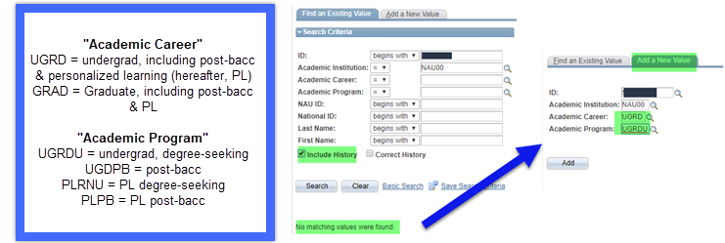

On the resulting Milestones page,
- Ensure you’re looking at the correct student.
- Enter an appropriate effective date.
  - Most of the time, the day you are adding the milestone will be fine, assuming you are entering the milestone once the student has completed the milestone requirements.
  - Don’t future-date milestones
- Enter your Milestone by typing it in or using the lookup function
  - You will see that some information auto-populates. Don’t change the auto-populated information.
  - If your department instructs you to ADD information in a non-auto-populated field (e.g. in the “comment” section), that is fine
- At the bottom, enter “completed” under “Milestone Complete” and add a “Date Attempted”
  - The screenshot below highlights each of the four areas explained here, which you must fill in for every milestone addition
- Click “Save”
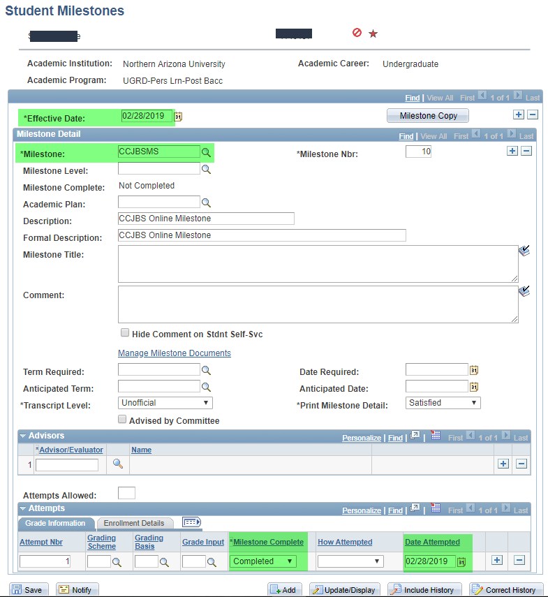

Adding a milestone to a student with an existing milestone
When you search an EMPLID and it brings you straight to their Milestones (rather than saying “no matching values found”), this means the student already has one or more existing milestones. Do not make any changes to the existing milestone(s).
To add an additional milestone, follow these steps:
- Click the parent (top-most) + sign to add a new row
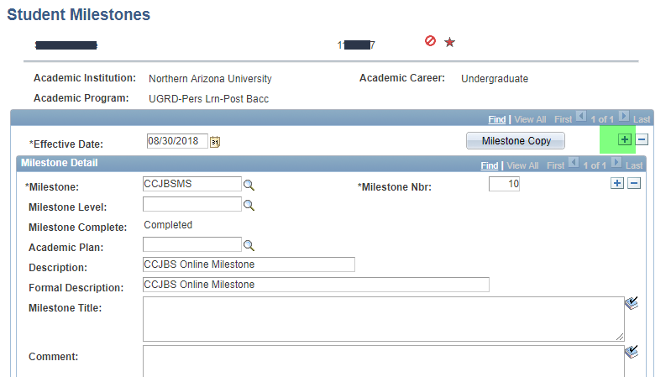

- Add a new effective date, or keep the auto-suggested “today” date. You will see that the parent rows now say “1 of 2” instead of “1 of 1” (see screenshot)
  - Most of the time, the day you are adding the milestone will be fine for an effective date, assuming you are entering the milestone once the student has completed the milestone requirements.
  - Don’t future-date milestones
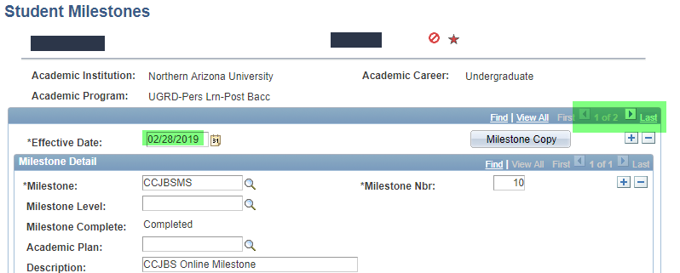

- After entering your effective date, click the child (lower) + sign to add a new Milestone entry. Again – do NOT overwrite any existing milestones. You must add a new child row to add a new milestone.
  - You will see that the child rows also show “2 of 2” now, instead of “1 of 1”
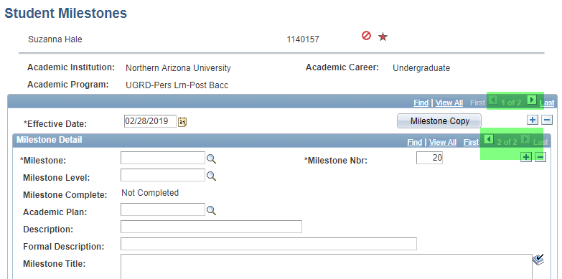

- Enter your Milestone by typing it in or using the lookup function
  - You will see that some information auto-populates. Don’t change the auto-populated information.

- At the bottom, enter “completed” under “Milestone Complete” and add a “Date Attempted”
  - The screenshot below highlights each of the four areas explained here, which you must fill in for every milestone addition
  - If your department instructs you to ADD information in a non-auto-populated field (e.g. in the “comment” section), that is fine

- Click “Save”
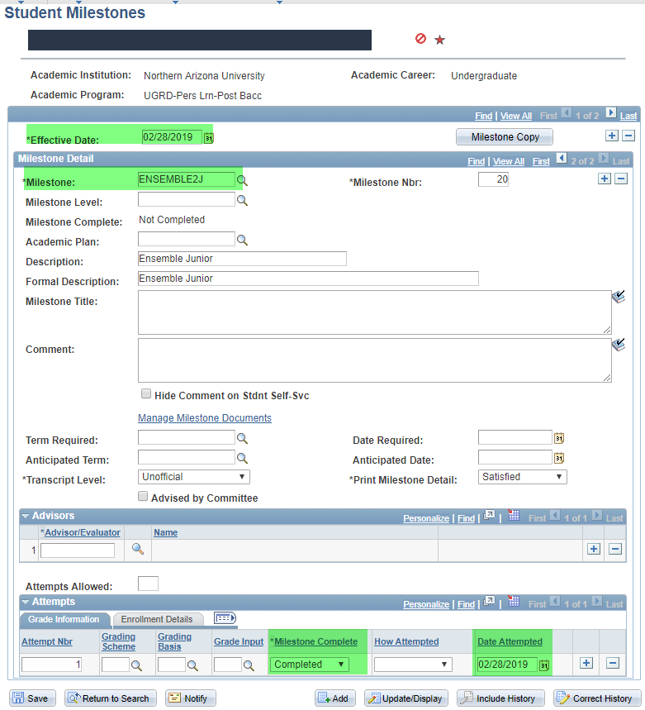
You have now added the student’s second milestone. If you were to search for this student again from the Milestones page, and then scroll through the parent rows, you would see on record 1 of 2 that they’d had an active milestone on a past date. On record 2 of 2, you’d see that they now have 2 active milestones (by scrolling through the child rows) – 1 is the one that existed previously, and the other is the one you just added.

Inactivating a Milestone for a student with Only one milestone
Use the following steps to inactivate a Milestone on a student’s record. Do not EVER use the button on the student milestones page. You are always inactivating, never removing.
On the student’s milestone page, click the parent (top) + sign to add a new effective date. You will see that it now says “1 of 2” in the parent rows. Today’s date will auto-populate, and this is generally an appropriate date to use.
ONLY ONCE YOU HAVE ADDED A NEW EFFECTIVE DATE, overwrite the milestone with the word “INACTIVE” (or use the look up option to select “inactive”).
Click save.
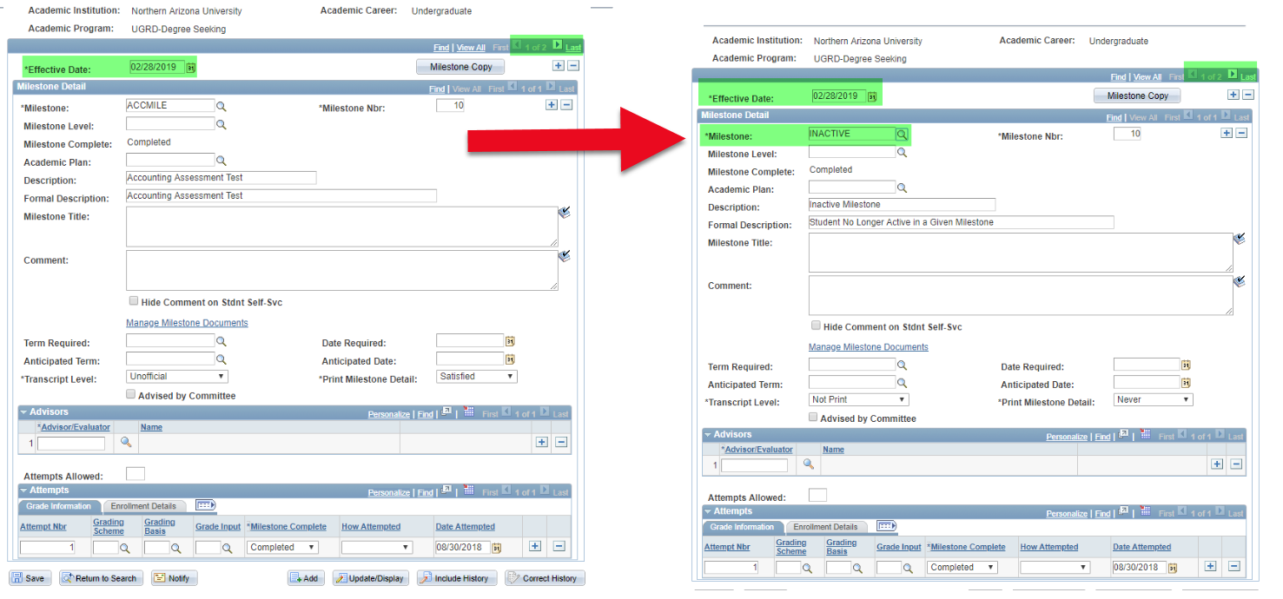

inactivating a milestone for a student with multiple milestones

Use the following steps to inactivate a Milestone on a student’s record. Do not EVER use the button on the student milestones page! You are always inactivating, never removing.

This student, Roxane, has two Milestones; Business Professional Program and Accounting Assessment. For this example, we are going to “Inactivate” the Business Professional Program Milestone.
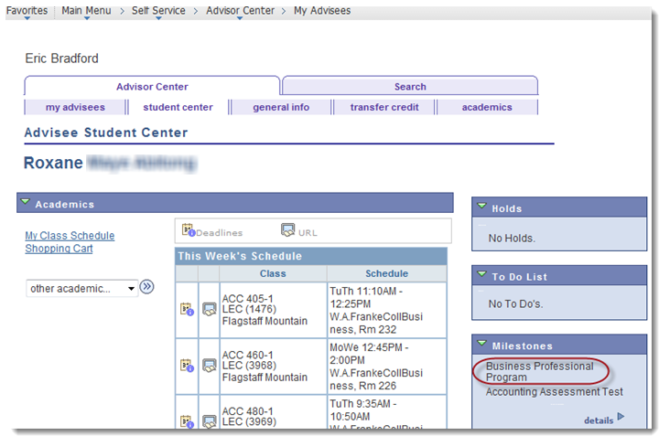

Search in the Milestones page for the student you wish to inactivate the Milestone for.
Here, we searched for Roxane and can see her two Milestones. 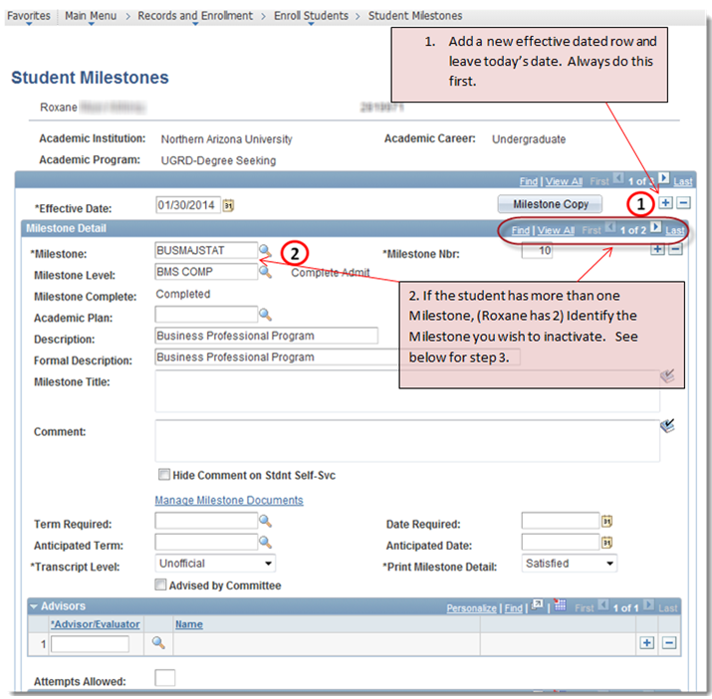

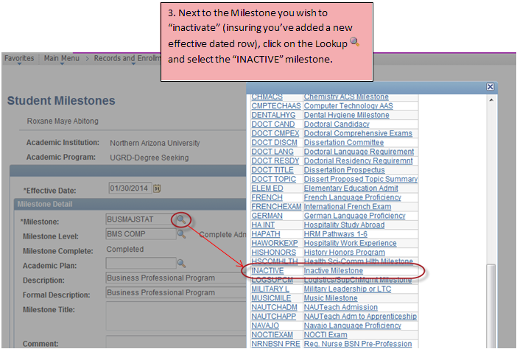
In other words, once you’ve added your new parent row / effective date, and navigated to the Milestone you want to inactivate, overwrite the milestone you are inactivating with the word “inactive”.
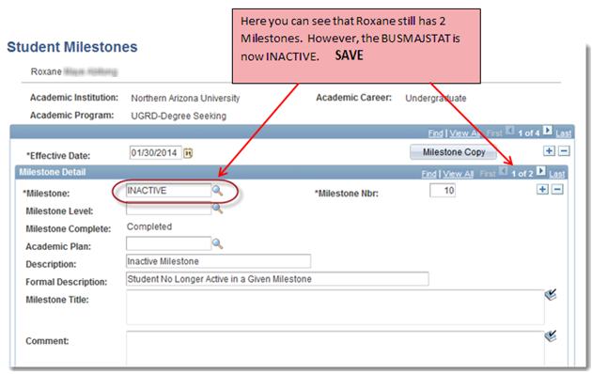
Returning to the Advisor Center you can see that Roxane now only has one Milestone listed. Note – She still has two Milestones. However, the Inactive Milestone is not displayed.
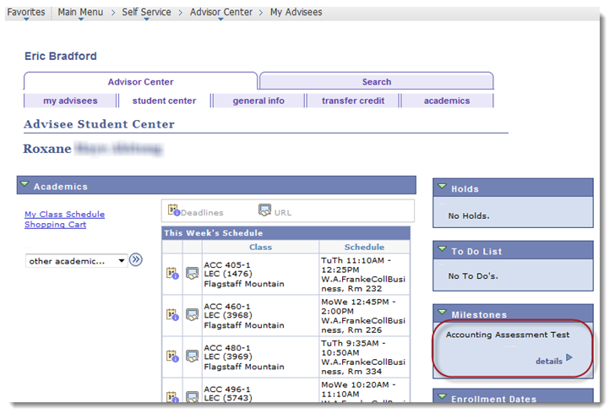

Additional notes
- If you are concerned you have made an error but haven’t saved yet, just navigate away from the page. Say “no” when it asks to save your changes
- If you make an error and have already clicked “save”, do NOT try to fix the error yourself. Instead, email Registrar.DataIntegrity@nau.edu and explain the error as clearly as possible. We will fix the error.
- Michele Beier and Anora Tillman are the contacts for Milestone questions or concerns and Registrar.DataIntegrity@nau.edu is the best place to reach them

