Table of Contents
OVERVIEW 1
WHERE AND WHAT TO LOOK FOR 2
Generic Permissions 2
Student-Specific Permissions 6
Miscellaneous Information Regarding Permission Numbers 7

OVERVIEW

LOUIE Navigation: Records and Enrollment > Term Processing > Class Permissions > Class Permissions
NOTE: Class Permissions is one of the few areas where you will work directly in LOUIE (vs. Coursedog).

Class permissions are numbers or authorizations that you can associate with a class and assign to students to use at enrollment time. You can create general or student-specific add permissions. You can also create student-specific drop permissions.
Class permissions can override conditions such as pre-requisites, co-requisites, and limits. Permissions allow a student to add or drop a class, as long as the student uses the permission by the expiration date and does not violate overall student limitation rules (such as maximum number of units).

Generic Permissions | Student-Specific Permissions
For generic permissions, you will go straight to LOUIE, using the navigation above. | For student-specific permissions,  - Start with Coursedog,  - Go to the desired class in Section Editor  - On the General Information Card, click the Student-Specific Permissions toggle box to “yes.” Save.  - You must do this step before going to LOUIE  - Then, navigate to LOUIE using the navigation above.

You may wish to choose generic permissions if:
- A class requires consent-to-add… and experience tells you will need to issue permission to many students.
- A class has pre-requisites, but history shows they have been waived if qualification has been demonstrated.
- You want to have the permissions ready-and-waiting for peak enrollment periods.
- You do not have student-specific info, such as Student ID.

The PeopleSoft Permissions area differentiates between undergraduate/graduate permissions. Choices vary depending upon whether the class is an undergraduate- or graduate-level class.
- If the class is undergraduate, then the option to override the course career is not available.
- If the class is graduate level, then it is possible to override the student’s career.

WHERE AND WHAT TO LOOK FOR

Generic Permissions
(Student-Specific directions follow. Quite similar. Details begin on Page 6.)
Academic units have access to the entire page, though some fields are informational only. The snapshots below highlight fields and details on the Class Permissions page:
The Class Section Data heading (mid-page) provides schedulers with the ability to “View All” sections.
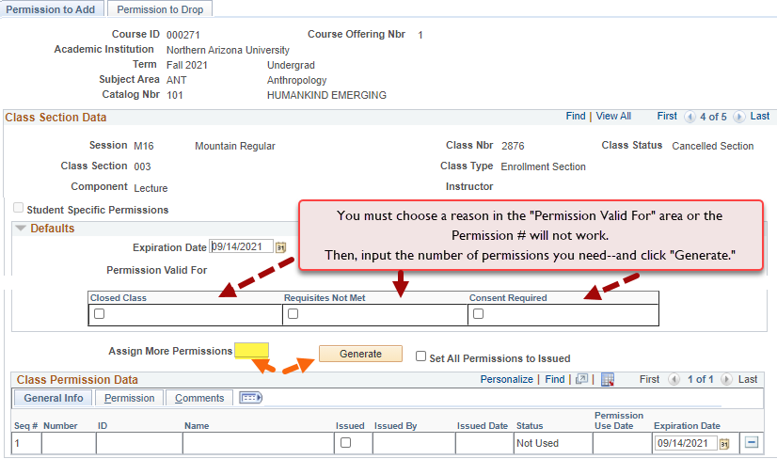
The snapshot above shows the three types of permissions that may be requested for undergraduates (Closed Class, Requisites Not Met, and Consent Required).

The snapshot below shows the four types of permissions that may be requested for graduates.
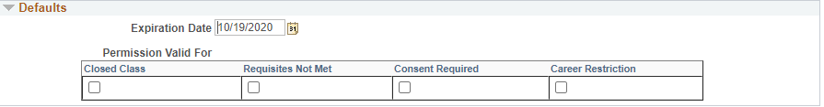
- Permission numbers
- Generated to allow a student to add a class section that they are not able to enroll in for various reasons. They allow the department and/or instructor to set permissions that are valid for: closed class, requisites not met, consent required, career restrictions, or any combination of these four values.
  - Permissions allow a student to add a class, as long as the student uses the permission by the expiration date and does not violate overall student limitation rules (such as maximum number of units).
- Wait List Permission Numbers
- Permission numbers work the same for enrollment and wait list. A student must have a permission number in order to enroll in class when one of the restrictions identified applies. A student must also have a permission number to wait list for a class when one of the restrictions identified applies.
- Correct section number
- It is important that you navigate to the appropriate class section for which permission numbers are to be generated (use arrow to the correct page to find the section).
- Expiration Date
- The expiration date is the date after which the permission number is no longer valid. The system will default to the deadline-to-drop date for the session.
- Permission Valid For
  - Select the reason for which the permission number is valid. The reason MUST be checked under the Defaults heading or the number/s will not work. Permission Numbers are valid for:
- Closed Class
    - When you select this checkbox, the student will be able to enroll in the class if is closed.
- Requisites Not Met
    - When you select this checkbox, the student will be able to enroll in the class even if they do not meet requisite requirements.
- Consent Required
    - When you select this checkbox, the student will be able to enroll in the class if it requires Instructor or Department Consent.
- Career Restriction
    - If this checkbox is selected, the graduate student will be able to enroll in the class if it is outside her/his undergraduate academic career. Note: this not available for undergraduate classes.
- Assign More Permission Numbers
- Enter a numeric value. This number controls how many permission numbers are generated. This feature can be used as many times as necessary.

- Generate
  - Press Generate and the permission numbers will populate below.
- Set All Permissions to Issued
  - You may check Set All Permissions to Issued to mark all permission numbers as issued. When the page is saved, the Issued By and Date Issued will be updated with the user ID of the individual saving the page and the current date.
- Wait List Class Restrictions
  - If students choose to wait list a class with restrictions, they must obtain a permission number prior to adding themselves to wait list. Closed Class will override students directly into a class before others on the wait list, so it should not be selected unless it has been determined there is a valid reason, such as a student who will not have the ability to remain on track and graduate on time.
Arrow Icon
- By pressing this icon , the sub-tab navigations disappear and a horizontal scroll bar is presented, which provides additional information as shown below
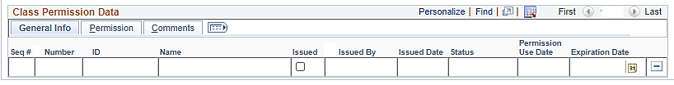
- If the arrow icon is selected, you may check additional reasons for a permission number for an individual student. For example, if the permission numbers are generated for Consent Required and a student also has not met requisites, the Requisites Not Met box can also be checked.

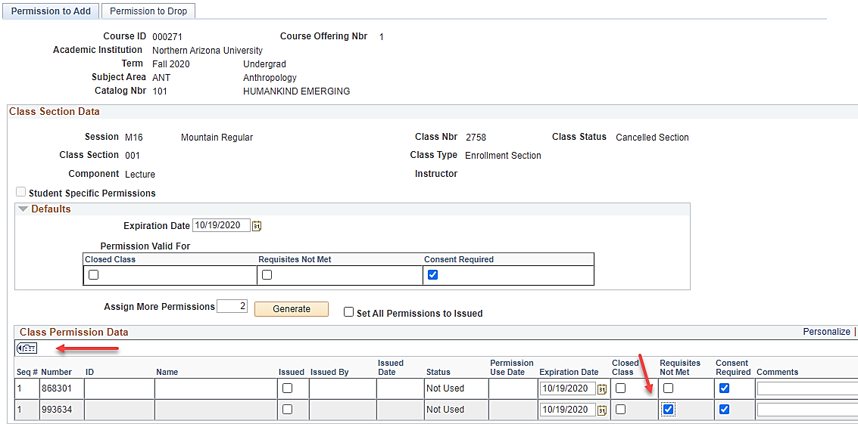

- Comments
  - This is an optional field.
- Save
  - Always press Save when finished or the Permission Number/s will not work.
- Issued
  - Issue the permission number to the student/s and select the Issued checkbox.

Student-Specific Permissions

- Use the same process as generic permissions, with one difference—input the student’s ID. When the student attempts to enroll, the system checks to see if the ID exists on the class permissions record. If the ID does exist, then the system will process the enrollment request based on the override granted.
- Student-specific permissions do not generate a permission number.
Student-Specific Permissions
For student-specific permissions,
- Start with Coursedog,
- Go to the desired class in Section Editor
- On the General Information Card, click the Student-Specific Permissions toggle box to “yes.” Save.
  - You must do this step before going to LOUIE
- Then, navigate to LOUIE using this navigation.
LOUIE Navigation: Records and Enrollment > Term Processing > Class Permissions > Class Permissions
Start with Coursedog. Toggle the Student-Specific Permissions toggle box to “yes.”
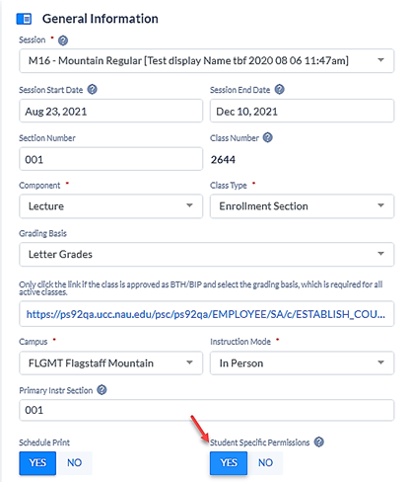

- In order to use student-specific permissions, the Student-Specific Permissions box must be toggled to “Yes” on the General Information card.

In PeopleSoft, be sure you navigate to the appropriate section.
Your screen should resemble this one.
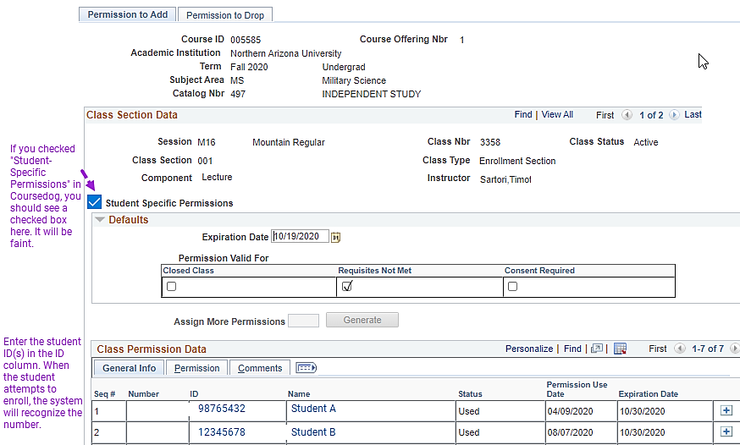

POSSIBLY OF INTEREST “Excel” Icon
- This icon allows you to download the information in the grid to Excel. Depending on the browser, Ctrl – click may be required for Excel to open. To download all three (3) tabs to Excel, use the expand/collapse icon before clicking on the Excel icon.

Miscellaneous Information Regarding Permission Numbers
- Find
- Clicking Find, as shown in the snapshot above, opens a text box that is used to search the data in the grid.
- Customize
- If you are a heavy user of permissions, you may want to customize the order in which columns display. To do so, select “Customize/Personalize” to arrange the columns as they best suit you
