Table of Contents
OVERVIEW 1
WHERE AND WHAT TO LOOK FOR 1
Course versus Class 2
Course Catalog Pages (These appear as tabs near the top of the PeopleSoft page.) 2
Catalog Data —Areas of Interest 2
Offerings —Areas of Interest 2
Components —Areas of Interest 2
Catalog Data Screen 3
Catalog Data Screen Showing History and Effective Dates 4
Catalog Data Screen Showing If a Class May Be Combined (Cross-listed or Co-convened) 5
Catalog Data Screen Showing If a Class May Be Repeated for Credit 6
Catalog Data Screen Showing If a Class Has Pre-Requisites or Co-requisites 7
Catalog Component Screen 8
Catalog Data Screen—Details Related to History and Effective Dates 9

OVERVIEW
The Course Catalog defines data such as effective date, status (Active/Inactive), minimum/maximum units, grading basis, repeat-for-credit rules, course topics (if applicable), topic-repeatability-for-credit rules, and components.

Most units do not make changes to the Course Catalog, but they do consult it to find out important details.

WHERE AND WHAT TO LOOK FOR

PeopleSoft navigation: Main Menu Curriculum Management Course Catalog Course Catalog

Course versus Class
TIP: Terminology Matters
To help you distinguish between Course and Class … the hierarchy is Course, then Class, then Section. Course refers to curriculum and is approved by committee. Think of it as the production plan that defines options. If we were speaking of Toyotas, for example, the Course Catalog entry might represent the parameters for a Prius. How many doors might it have; how big Area a battery; what fabric choices; what standards it must meet… Once the parameters are set, a specific Prius can be built (parallel to a Class at NAU). Example: a blue, 4-door hatchback with leather seats. You can only select options that are approved in the Catalog’s “production plan.” You can only choose options after they are available (Effective Date).

- The word "course" is used to identify a common topic or subject area. Each course will have class sections built that will share the course number (i.e., BIO 181). The word "class" is used to identify the days/times that a specific course meets during a term. Class details are limited to the parameters set at the course level.

Course Catalog Pages (These appear as tabs near the top of the PeopleSoft page.)
- Catalog Data page
- Offerings page
- Components page

Catalog Data —Areas of Interest
  - Effective Date
  - Status
  - Min/Max Units
  - Grading Basis
  - Repeat-for-Credit Rules
  - Course Attributes
    - Includes whether the class is permitted to be cross-listed or co-convened. This is important if you are planning a combined section.
- Course Topics
  - Repeat for Credit
Click Repeat for Credit to see if a topic may be repeated. The repeats must fit within the parameters set at the course level. For example, if the course allows 6 total units and 6 total completions, including multiple enrollments in a term, then the Topic Repeat rules cannot exceed these limits.

Offerings —Areas of Interest
  - Prerequisites and Co-requisites
  - Campus
  - Term typically offered

Components —Areas of Interest
  - Lists components of a course, such as:
      - Lecture
      - Zero-unit labs and fieldwork

Catalog Data Screen

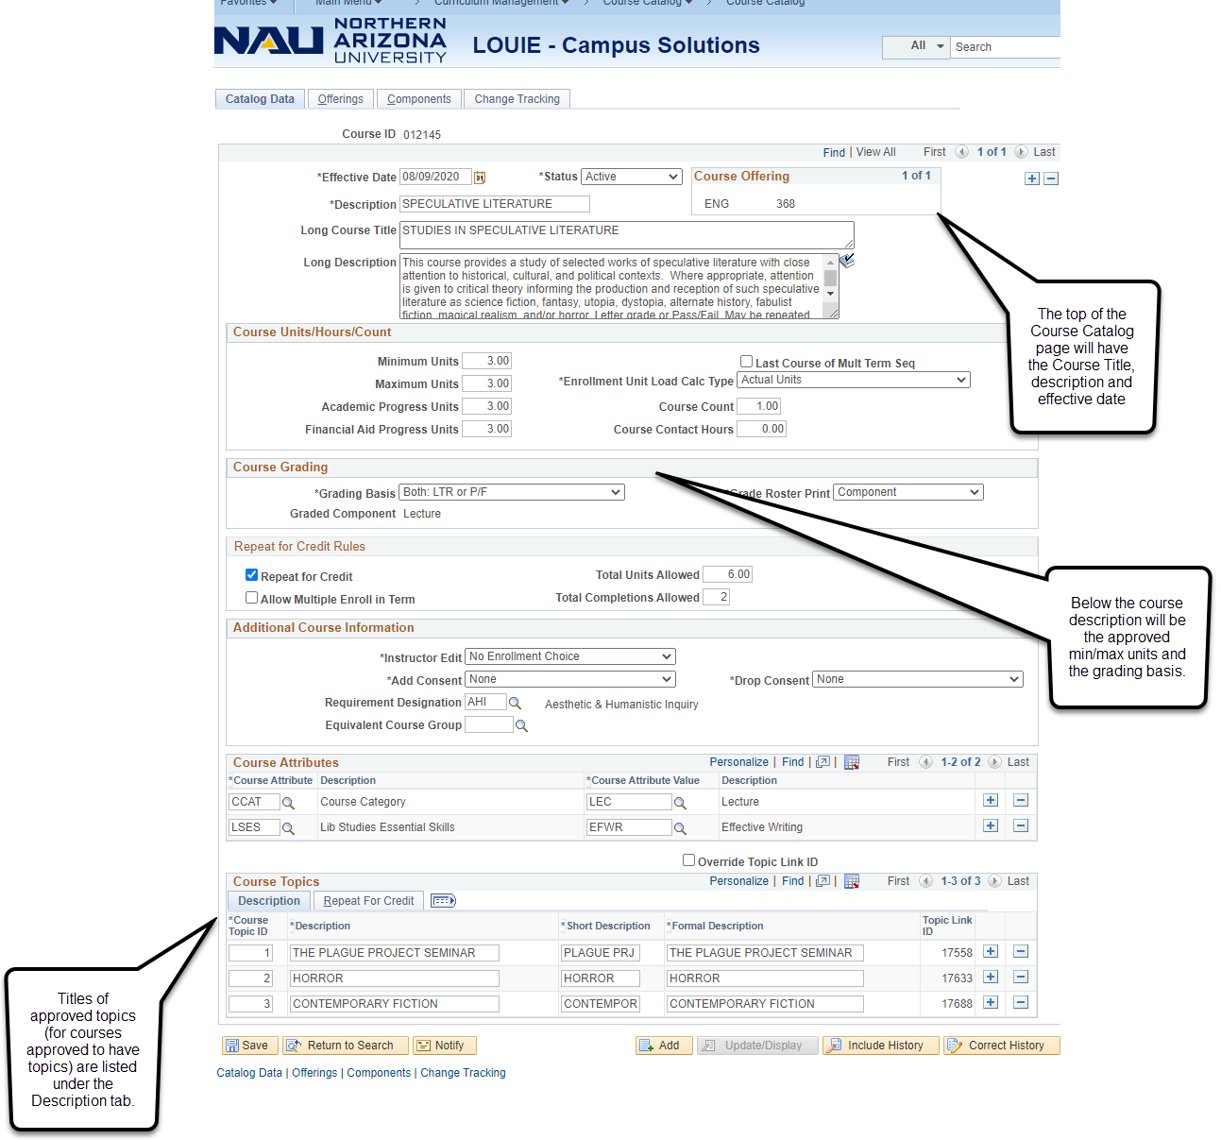

Catalog Data Screen Showing History and Effective Dates

When you click Include History or Correct History you can see all the Catalog changes made to a course, since NAU deployed PeopleSoft. These might include a change of Prefix, Course Number, Grading Basis, Active/Inactive, Number of Units...and more.

You can specify Include History or Correct History from either
the main Course Catalog Search area…or from inside your search result.
From the Main Course Catalog Search Area
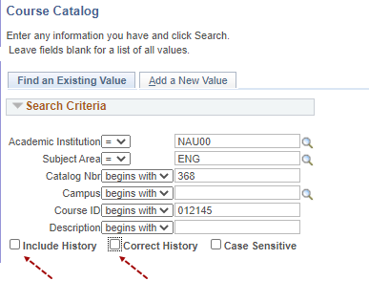
From Inside Your Search Result
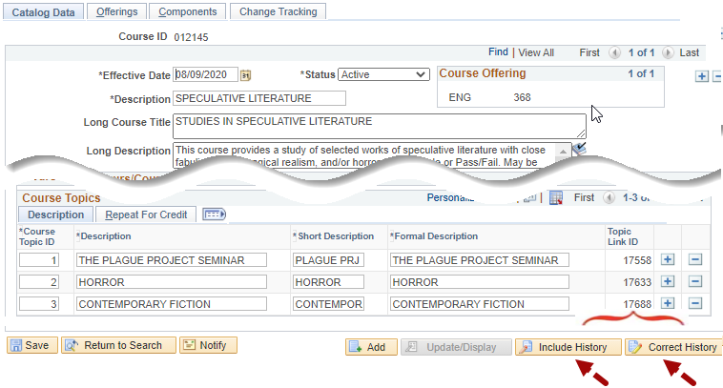

The Effective Date (found at left) tells you when that change(s) became effective.
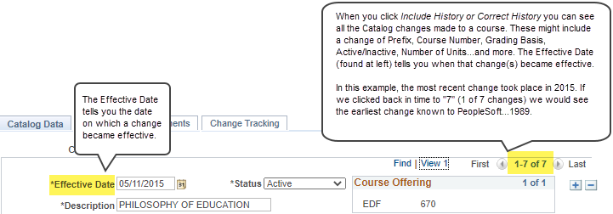
Not all users will need to research past changes. For more details about this feature, see Catalog Data Screen—Details Related to History and Effective Dates, at the end of this document.

Catalog Data Screen Showing If a Class May Be Combined (Cross-listed or Co-convened)

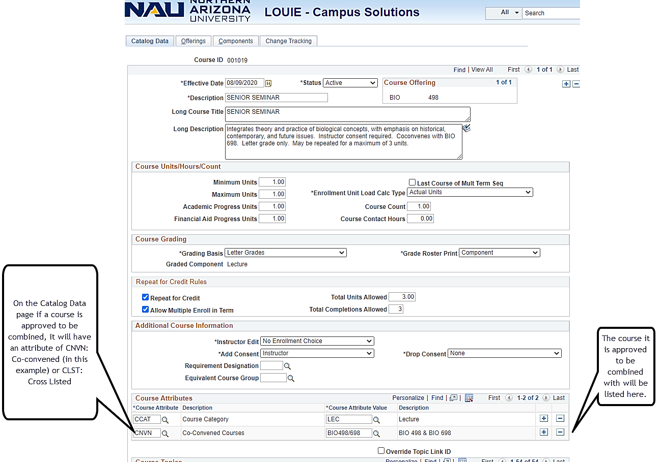

Catalog Data Screen Showing If a Class May Be Repeated for Credit

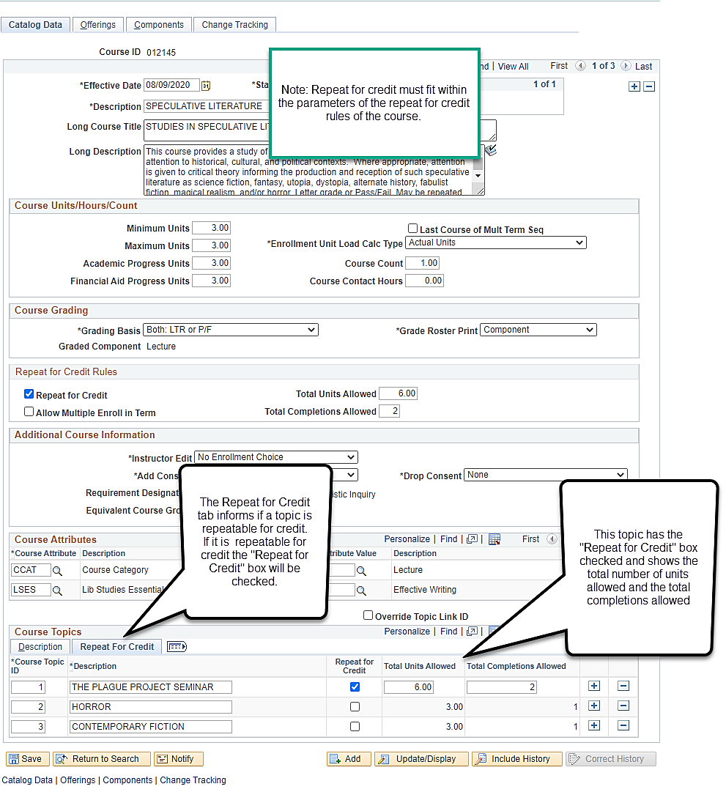

Catalog Data Screen Showing If a Class Has Pre-Requisites or Co-requisites

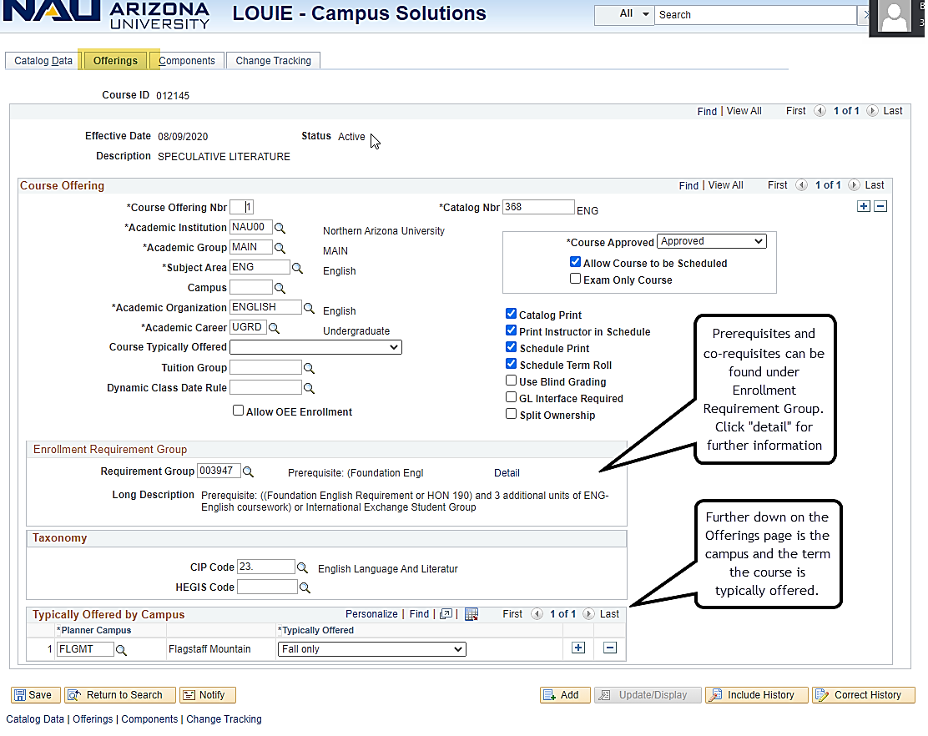

Catalog Component Screen

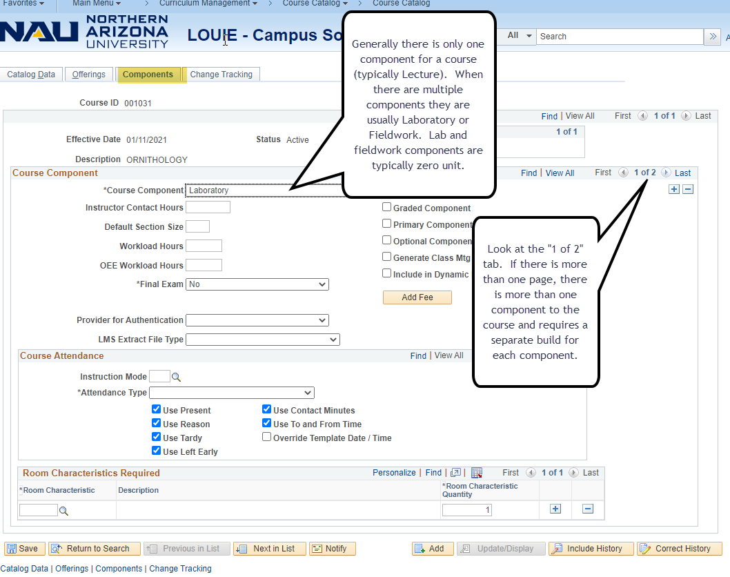

Catalog Data Screen—Details Related to History and Effective Dates

