Table of Contents
OVERVIEW 1
WHERE AND WHAT TO LOOK FOR 2
Administrative Class Search & Student Class Search 2
Sample View for Administrative Users 3
Additional Search Criteria Screen 3
Search Results 4
Class Details Screen 5
Campus Address or Campus Location/Address 6

OVERVIEW

In version 9.2 of PeopleSoft, the Class Search and Browse Course Catalog functions have been separated into two distinct navigations to meet the specific and often differing needs of instructors, advisors, staff, students, and guests. This change in functionality allows individuals to be given access to the appropriate LOUIE data based on their roles at NAU.

WHERE AND WHAT TO LOOK FOR

Administrative Class Search & Student Class Search

Administrative Class Search (for Staff and Administrators)

Navigation: Self Service > Faculty/Advisor Center Search > Class Search
OR
Navigation: Curriculum Management > Schedule of Classes > Class Search

These administrative navigations show suppressed classes, classes not shown. The class search criteria drop-downs now contain only subjects that have classes scheduled in the term selected, a campus search with additional functionality to find nearby campuses, ability to search for online classes quickly, help text to provide further explanation of complex items, and a new starting month search capability.

Student Class Search (for Student Users)

Navigation: Self Service > Class Search
OR
Navigation: Self Service > Student Center > Search for Classes

The student class search function is like the faculty/advisor and administrative class search function with the major difference being the student search does not display suppressed classes. Additionally, there are date controls which would allow the terms to become available to faculty/advisors and administration before students could search for classes in those terms.

NAU Students should access Class Search through the Registrar’s website under Student Resources https://in.nau.edu/registrar/louie-training/ > search for classes in LOUIE. Also, the link below is a video instruction guide for students on how to complete a class search: https://www.youtube.com/watch?v=i7ua-m2pmc0

Sample View for Administrative Users

Use the Term drop-down menu to select the term you wish to access.

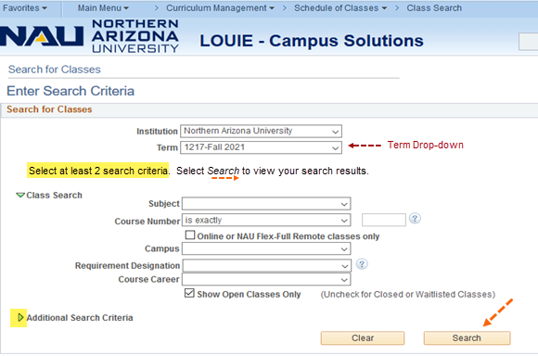

Additional Search Criteria Screen

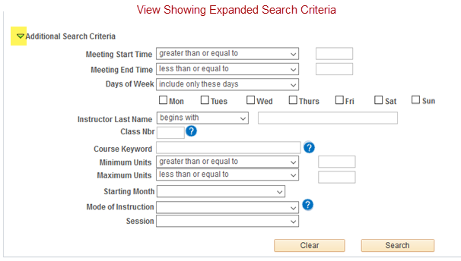

Clicking the information icon brings up further information to describe our modes of instruction. (For those unfamiliar with our instruction mode terminology, this can be particularly useful.)

Search Results
Select the Search button to begin a class search using at least two criteria.
Your Search Results will display.

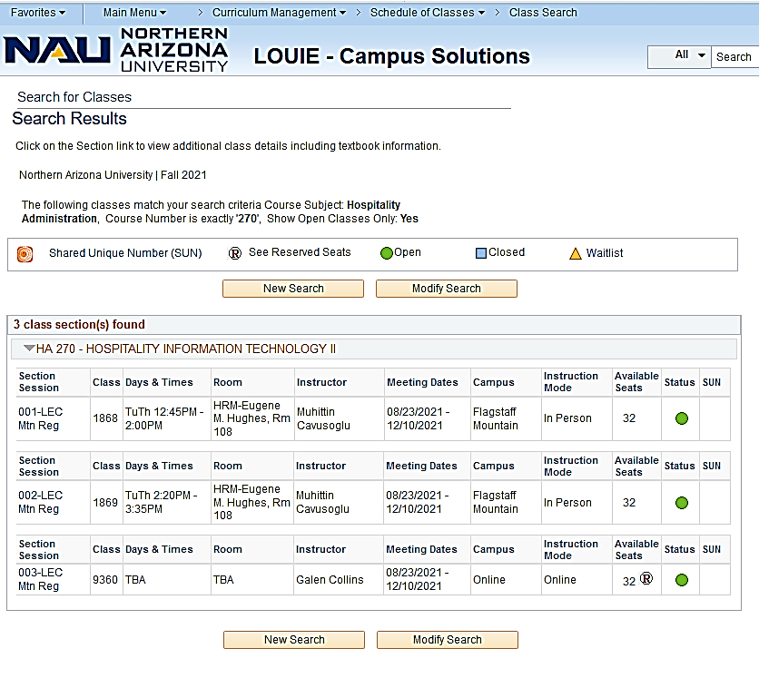

Results will sort such that sections with the highest number of seats available show first. In PeopleSoft 9.2, available seats are now displayed on this initial page. (In earlier versions, this was not visible without having to drill deeper into a specific class section.)

To see Class Details, click on the section number; for instance, section 002-LEC, to see the text associated with this specific class.

Class Details Screen

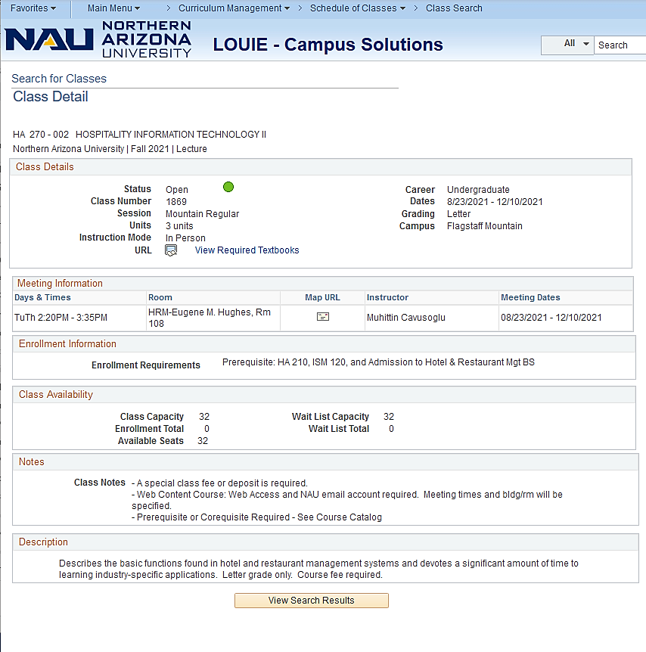

Campus Address or Campus Location/Address

For the Flagstaff Mountain campus, the campus map will be displayed. All other campus locations/addresses will be displayed. Note: Online classes do not have this icon.
Flagstaff Mountain Campus:

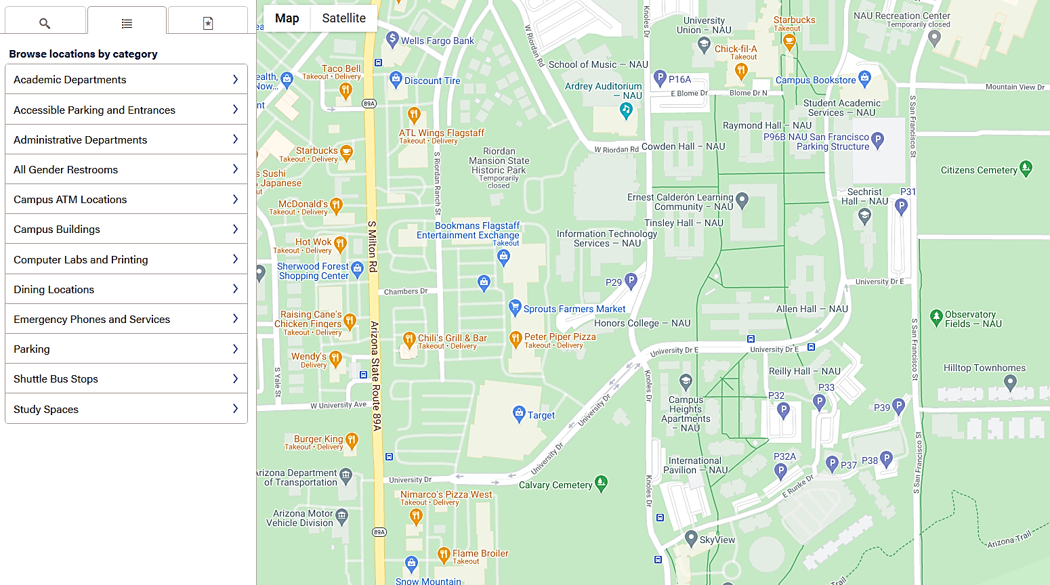

Other Campuses:
