Contents
Overview 1
What to Look for and Where 1
Screenshots and Tips 2
Course Details 4
View Class Sections Column 5
SUN Courses 5
A Quick Way to Look at Active Sections, Meeting Times, and More 7

Overview
In version 9.2 of PeopleSoft, the Class Search and Browse Course Catalog functions have been separated into two distinct navigations to meet the specific and often differing needs of instructors, advisors, staff, students, and guests. This change in functionality allows individuals to be given access to the appropriate LOUIE data based on their roles at NAU.

What to Look for and Where
While Class Search will display the classes that are scheduled in a specific term, Browse Course Catalog will display all active courses that could be scheduled in a specific term, whether they are scheduled that term or not.
User security determines which navigation an individual will see.

Navigation: Self Service > Faculty/Advisor Center Search > Browse Course Catalog
OR
Navigation: Self Service > Student Center > Search > Browse Course Catalog
OR
Navigation: Self Service > Class Search/Browse Catalog > Browse Course Catalog
OR
Navigation: Curriculum Management > Course Catalog > Browse Catalog

Screenshots and Tips
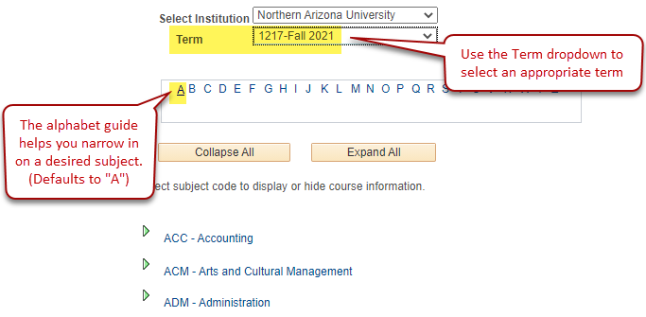
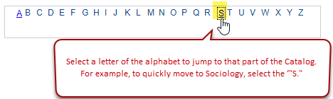

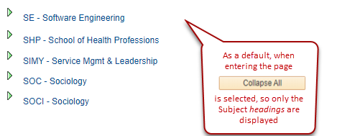

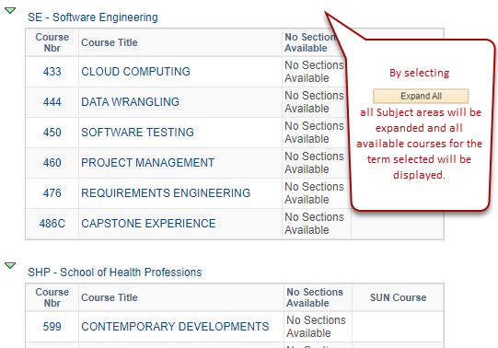

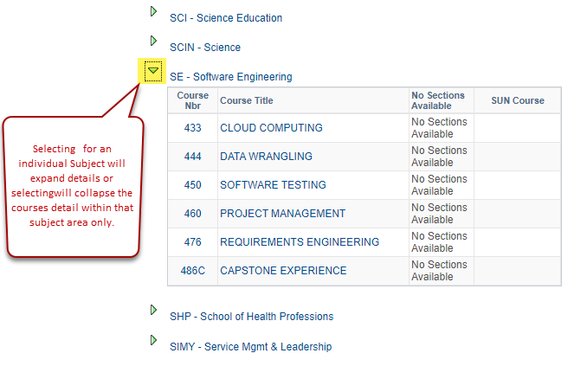

Course Details
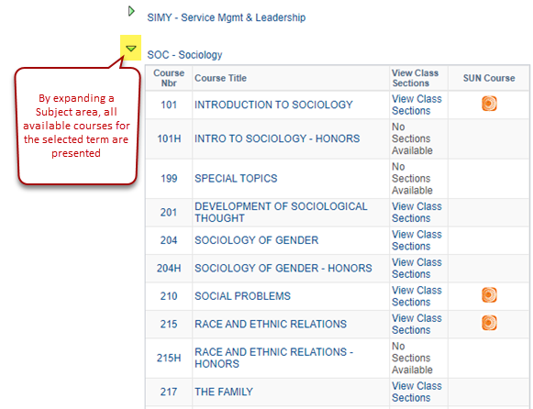

View Class Sections Column
- If the course is already scheduled in the selected term, “View Class Sections” will be displayed.
- If the course is scheduled but all sections are suppressed, “Contact Department for Class Sections” will display for the Student and Guest navigations.
- Otherwise, you will see “No Sections Available.”

SUN Courses
If the course is part of the Arizona Shared Unique Number System, will be displayed in the SUN Course column.
- SUN Courses transfer directly among Arizona’s public community colleges and three state universities. Additional information on SUN Courses can be found at: https://www.aztransfer.com/sun/
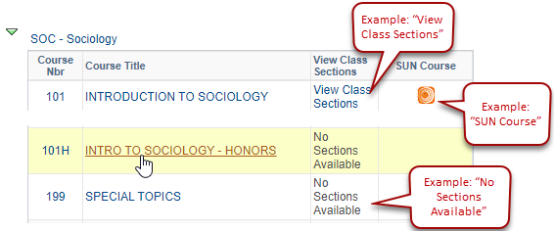

If you click on the Course Number or the Course Title, the system will display a detailed description of the course.
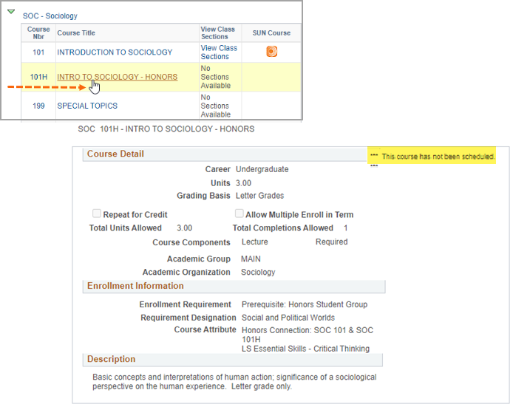

A Quick Way to Look at Active Sections, Meeting Times, and More
By clicking on Vew Class Sections, a new window opens up, listing the current class sections.

This close-up view of SOC 201 for Fall 2021, provides a lot of information in one view. You can see that there are four scheduled sections—three of which are Mountain Regular session and in-person, and one of which is both online and session 7.5B. You can see that instructors have been assigned as well as rooms, where applicable. You can also see how many seats are available—and if there are students on the wait list. The red R (Reserved Seats) icon will display if the remaining seats are reserve-group only. If there are other seats available, the red R will not display.
