**Coursedog Pain Points**

**Table of Contents**

Schedule Edit Stages ……………………………………………………………………………………………………………………………… 2

Section Change Requests …………………………………………………………………………………………………………………….... 2

Fields Always Editable in Section Editor ………………………………………………………………………………………………… 4

Section Editor ……………………………………………………………………………………………………………………………………….. 4

How to Set Variable Units …………………………………………………………………………………………………………………… 4

How to Set Grading Basis if BTH/BIP …………………………………………………………………………………………………… 7

Session Start/End Dates ……………………………………………………………………………………………………………………. 10

Primary Instructional Section Roll Ups ……………………………………………………………………………………………... 10

Instructors ……………………………………………………………………………………………………………………………………….. 10

Enrollment Capacity …………………………………………………………………………………………………………………………. 11

Co-convened/Cross-listed (Combined Sections) vs. Balanced Sections ……………………………………………… 12

Activity Feed ………………………………………………………………………………………………………………………….…………. 16

Synch Message ………………………………………………………………………………………………………………………….…….. 16

Room Capacity ………………………………………………………………………………………………………………………………... 18

Room (999-TBA) ……………………………………………………………………………………………………………………………….. 18

Room (Pre-Assignments) ………………………………………………………………………………………………………………….. 19

Warnings …………………………………………………………………………………………………………………………………………….. 21

Miscellaneous …………………………………………………………………………………………………………………………………….. 22

**Schedule Edit Stages-**

* When it comes to scheduling in Coursedog, there are two stages:
  + Building stage (open build)
  + Request stage (post build)

Both stages are mentioned throughout this document. Actions will differ depending on whether the build is in progress (building stage) or finished (request stage).

* + Building stage (open build)
    - The building stage refers to an open build. The schedule rolled forward from the previous like term (fall to fall, spring to spring), and a timeline is established for schedulers to complete any edits/additions to the classes that rolled forward.
    - Schedulers have open access to make changes directly in the Section Editor for all the class data fields.
    - As data is entered in Coursedog during the building stage, all warnings should be cleared and all Rule Exception Request.
  + ***Rule Exception requests are ONLY submitted during the building stage.
  + Request stage (post build)
    - Once the building stage is over, the build is submitted and is final. Schedulers will then submit changes via Requests. Schedulers will no longer enter changes directly in the Section Editor, excluding the fields that schedulers always have access to edit in the Section Editor (see below for the specific fields that remain editable). Instead, schedulers will submit a Request to be reviewed and approved by the Schedule of Classes team.

**Section Change Requests (Request Stage)-**

* When to submit a request-
* Section Change Requests should be submitted when a class detail needs to be changed AFTER the schedule has been built and submitted. This is the request stage.
* Section Change Requests should not be submitted during the building stage. If the build is open to build classes for a specific term, do not submit a request. You have open reign for any and all changes during the building stage.
* After the build, requests need to be submitted when changing a field other than what is listed below under “Fields always editable in Section Editor”. If the field is mentioned below, a request does not need to be submitted and the change can be made directly in the section editor.
  + Always ensure thorough detail when providing the reason for request – details that specify why a change is being made after the schedule has been completed and/or after students have enrolled.
* When submitting a request through the Requests field on the Dashboard, ONLY Section Change should be selected. You should never submit a Rule Exception request through the Requests field on the Dashboard.
  + Rule Exception requests are only submitted during the building stage via the “Submit Schedule” page. If prompted to choose from a list of rule exceptions, you are in the wrong place and the request cannot be fulfilled.
* If your request has been rejected, you will receive an automated email from Coursedog. Click the link in the email to return to your request. Click the “Activity” button in the upper right and scroll to view our comments as to why the request has been rejected.

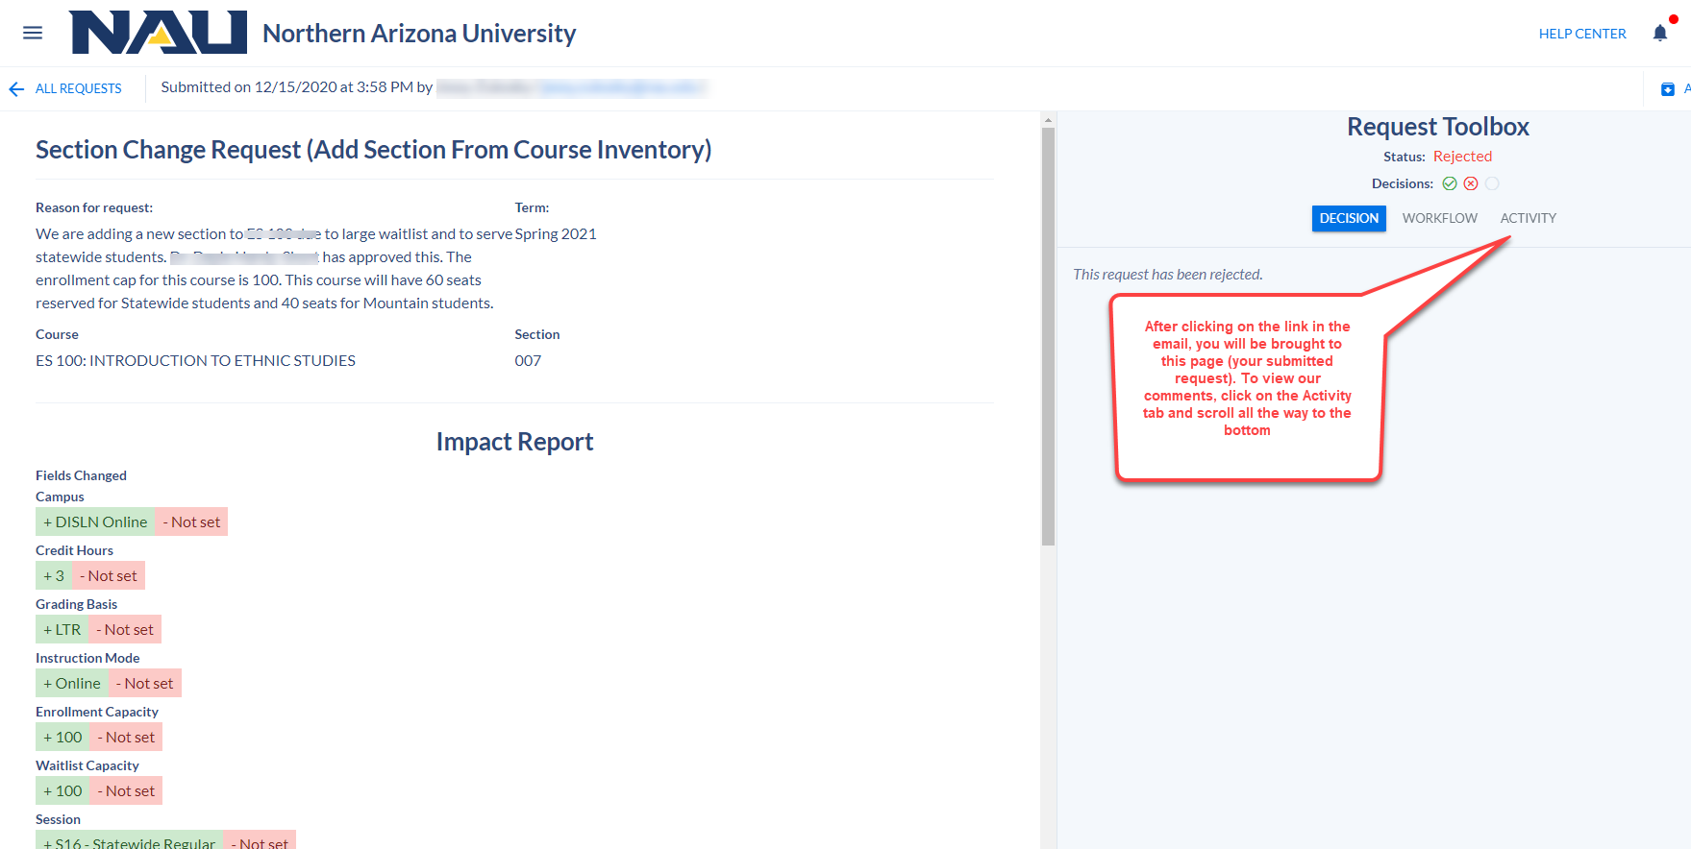

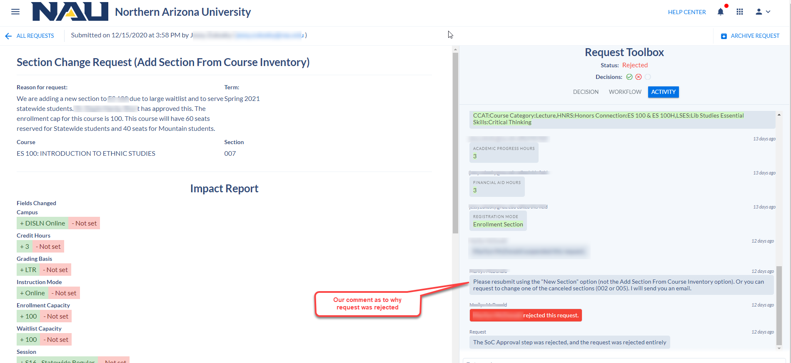

**Fields always editable in section editor (Request Stage)-**

* Certain fields always remain editable in the section editor during the request stage. These fields do NOT require a request to be submitted:
* enrollment/wait list capacity (not editable during classroom assignments, but becomes editable once classroom assignments completed)
* schedule print
* student specific permissions
* primary instructional section
* reserve caps
* instructor information (adding/editing/removing an instructor)
* add consent
* notes
* deep links

**Section Editor-**

* Class numbers when building a new section during the building stage:
* When adding a new section, a class number will not appear in the Section Editor until the class information is completed and “Add Section” is selected. After the window minimizes, go back into the section that was just created to verify the class number appears.
* If the class number isn’t viewable, exit the Section Editor and return until the class number appears.
* Users need to ensure the class has a class number before attempting to make additional changes to the section or before using a deep link.
  + ***Deep links will not work until a class number is populated.
* If you attempt to edit/use deep links for classes that have not fed to PS yet and a class number was not yet populated, a merge error will occur. It requires time intensive work to resolve merge errors, so avoid creating these type of errors.
* How to set variable units:
* If a variable unit class requires a set number of units (most topic and graduate seminar classes), a warning will appear stating that the class requires a set number of units.
* During the building stage and request stage, if a course has *variable units* and the class needs to be set to a single unit or to different variable units, within the parameters of the approved units at the course level, use the deep link in the Section Editor to set the units. It is located under the General Information card.
* The deep link will bring you to the Basic Data page in Peoplesoft. Click the Edit Units/Grading Basis button to change the units.
* During the building stage, units are **not** editable on the Units card—the units either populate from the catalog, or the units are changed for *variable unit* classes, via the deep link.
  + *Remember- during the building stage the deep links cannot be clicked until a class number has been generated. When building a new section during this stage, a class number will not appear. You will fill out your class information, then hit save. The Section Editor window will automatically minimize. Go back into the section you just created, and you should now see a class number. If you do not, exit the window and go back in. Once you see the class number, you can now use the deep link to set your units.
* During the request stage, if requesting a new section be built, remember that you cannot click on the deep link until the class number is generated. Because a class number will not be generated until the request is approved, please provide the required units in the textbox at the time of your request, if the class is approved as variable unit and requires a set unit or different variable units, within the parameters of the approved units at the course level. The units will be changed by SoC after the request is approved and the class number is generated.
* Once the build is final, during the request stage, a request does not need to be submitted to set units for *variable unit* classes for existing sections. The deep link is accessible in the section editor and can be clicked without submitting a request.

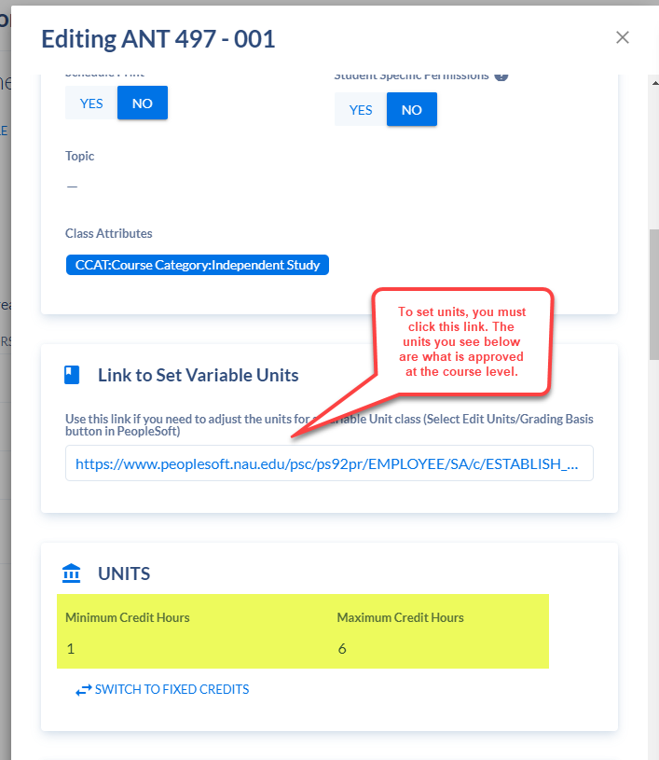

Variable units:

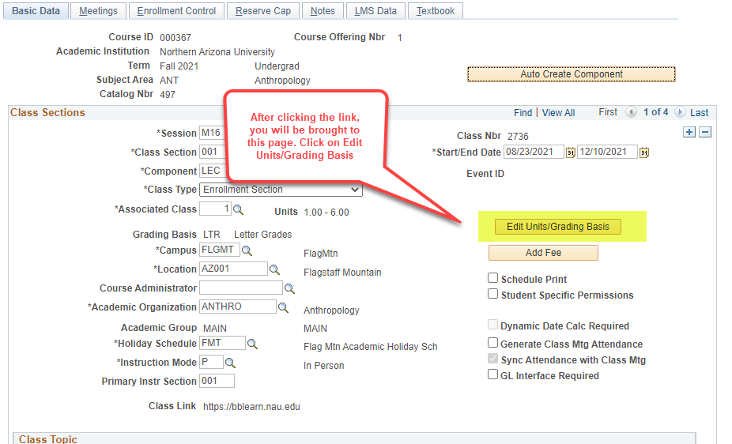

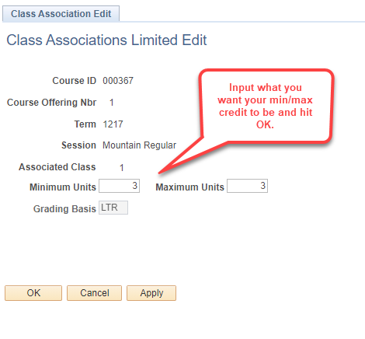

* How to set grading basis if BTH/BIP:
* If the class grading basis is either BIP or BTH at the course level, it must be set to a specific grading basis: LTR, P/F, etc.
* If a grading basis isn’t selected for a dual grading basis class, a warning will appear stating that the class requires a set grading basis.
* Classes with a BTH/BIP grading basis will be in tentative status, which means the class will not be viewable to students.
* To set the grading basis during both the building stage and request stage, use the deep link directly under the Grading Basis field on the General Information card.
  + *Remember- during the building stage the deep links cannot be clicked until a class number has been generated. When building a new section during this stage, a class number will not appear. You will fill out your class information, then hit save. The Section Editor window will automatically minimize. Go back into the section you just created, and you should now see a class number. If you do not, exit the window and go back in. Once you see the class number, you can now use the deep link to set your units.
* The link will bring you to the Basic Data page in Peoplesoft. Click the Edit Units/Grading Basis button to set the grading basis for one of the approved selections.
* **Do not simply choose the option of BTH or BIP from the drop down**. Set the grading basis using the link for all classes with a dual grading basis.
* During the request stage (once the build is final), do not submit a request to set the grading basis for existing sections. The deep link is accessible in the section editor and can be clicked without submitting a request.
* During the request stage, if requesting a new section be built, remember that you cannot click on the deep link until the class number is generated. Because a class number will not be generated until the request is approved, please provide the required grading basis in the textbox at the time of your request, within the parameters of the approved grading basis at the course level. The grading basis will be changed by SoC after the request is approved and the class number is generated.

Grading Basis:

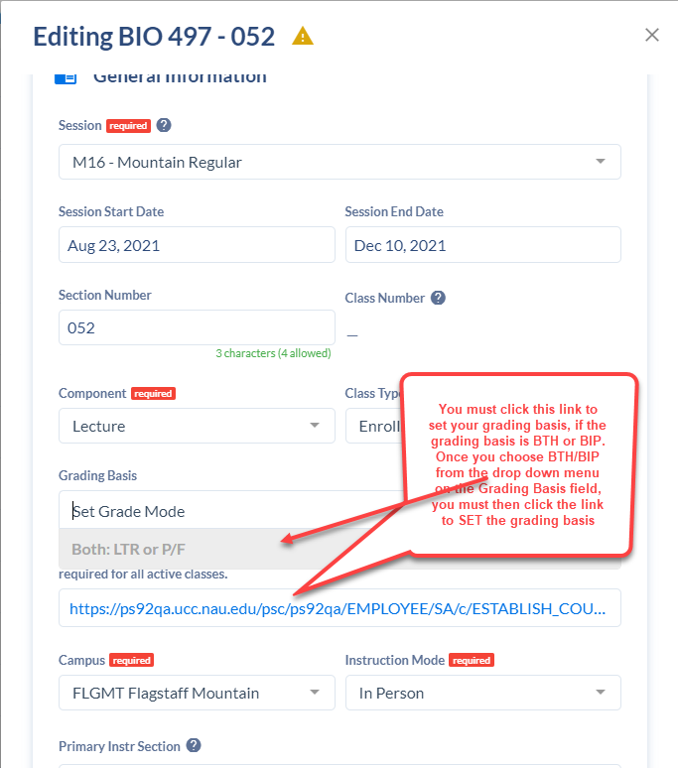

Grading Basis:



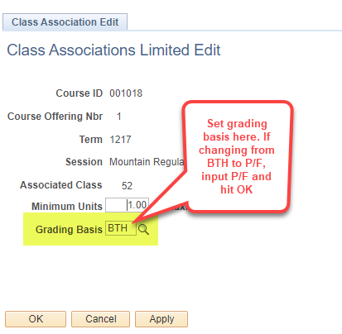

* Session Start/End Dates:
  + If the class meeting pattern start/end dates differ from the session start/end dates, keep in mind that the meeting pattern dates must be within range of session dates.
  + If a class is Dynamically Dated (DD), the meeting pattern dates MUST be changed in addition to the session dates. If the session start/end dates change, remember to also change the meeting pattern start/end date.
    - **session dates should ONLY be changed if the class session is DD, never for a standard session.
* Primary Instructional Section Roll-ups:
  + When rolling up a zero-unit lab with another zero-unit lab, keep in mind that the section number (letter) is case sensitive. If the section number (letter) is a capital A, you must input a capital A in the Primary Instr Section field. If you input a lowercase a, it will not roll the zero-unit labs into one BbLearn shell.
* Instructors:
  + Affiliate/non-NAU faculty will not feed back to Coursedog once entered via the deep link. It will state instructor not found. The instructor, however, will be listed in PeopleSoft and viewable when the link is clicked. This is fine because PeopleSoft is the system of record.
  + Please be aware that during the request stage, you must set your instructors using the deep link. There are two instructor cards- one labeled “Instructors” and one labeled “Link to Instructor Details in Peoplesoft”. On the first card you will see a “+ Instructor” and “Set Instructor roles & Details” button. THIS IS NOT HOW YOU ADD INSTRUCTORS. You must ALWAYS use the deep link to add instructors.
    - You do not need to submit a request to add instructors. Units always have access to instructor information and should utilize the deep link without the need to submit a request.
  + The “Instructor” card acts as a view only card. Once you have added instructors in Peoplesoft using the deep link, they will be visible on the “Instructors” card.

Instructors:

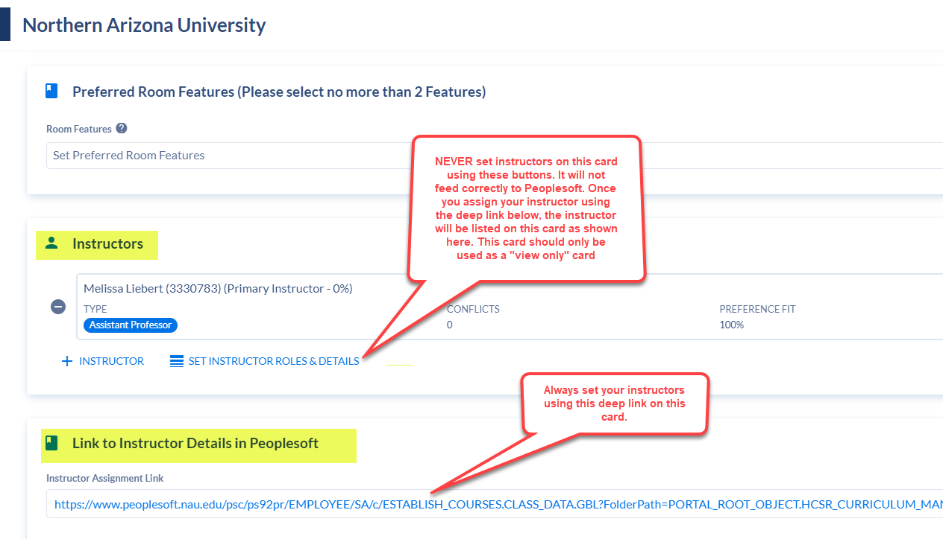

* Enrollment Capacity:
  + Before adjusting the enrollment cap, check to see if there is a reserve cap on the class by clicking the Reserve Capacity Link. The reserve cap cannot be greater than the enrollment capacity of the class, so if changing the enrollment capacity, the reserve cap will likely need to be changed as well.
    - EX: if the reserve cap is 20, and the enrollment cap is 40, and the enrollment cap is being changed to 5, adjust the reserve cap to 5 or less before changing enrollment cap.
  + Do not drop the enrollment cap below the current enrollment. This causes a merge error which is time intensive to identify and correct.
    - If the class is in the process of being cancelled and students should not enroll in the section, use Schedule Print OFF, add consent and input a class note that states the class is in the process of being cancelled and no further enrollment should occur. Once cancelled, the class should be changed to schedule print, remove consent and remove the note. This will ensure the class rolls forward for the next schedule build without restrictions.
* Co-convened/Cross-listed (Combined Sections) vs. Balanced Sections:
* Co-convened/cross-listed Sections:
* Co-convene/cross-listed sections have either been approved to be taught together at the course level or have received a one-time approval to share a syllabus and meet together.
  + Co-convene (upper division and lower division, BIO 580/BIO 480)
  + Cross-listed (same course, but different prefix, BIO 507/FOR 507)
* To enter your approved combinations, link them on the Relationships card.
* A section can only be combined in ONE relationship. You cannot link the same class more than once.
* You may combine multiple classes in the same relationship (ensuring none of the classes are already linked with something else as the above bullet mentions). To link multiple classes, you follow the normal process of linking sections. Once you have linked your first class by selecting the course, section and clicking the + button, start typing the other course you need in the Courses to Add field just as you did with the first one. The original course name will still show- simply click on it and start typing the new course.
* Leave the Combined Max Enrollment field blank. Once you save your linked sections, the total enrollment will automatically be calculated for you. After saving your linked section, open it back up to view the Combined Max Enrollment.
* Click on the Combined Sections Table Deep Link to ensure your linked sections fed into the Combined Sections Table in Peoplesoft. No action is required other than confirming your classes are there and are correct, as well as the total enrollment.
* Name the relationship appropriately. The naming convention should be the class you are editing, backslash, and the class/es it is combined with. Do not use any other naming convention.
* EX: BIO 507/FOR 507
* Always check to see if the class is co-convened/cross-listed before making edits, because changes will be required for both classes since they are balanced.

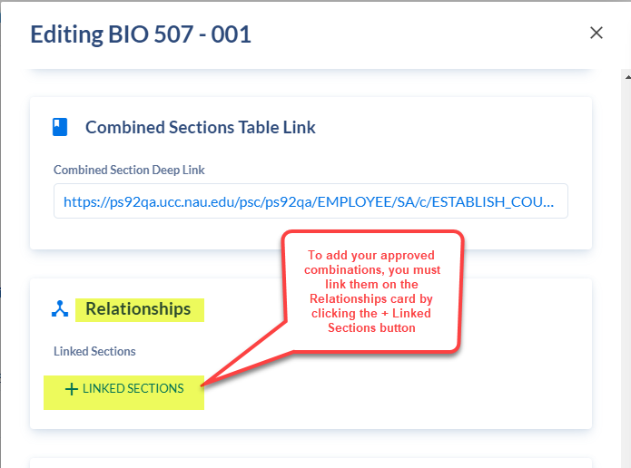

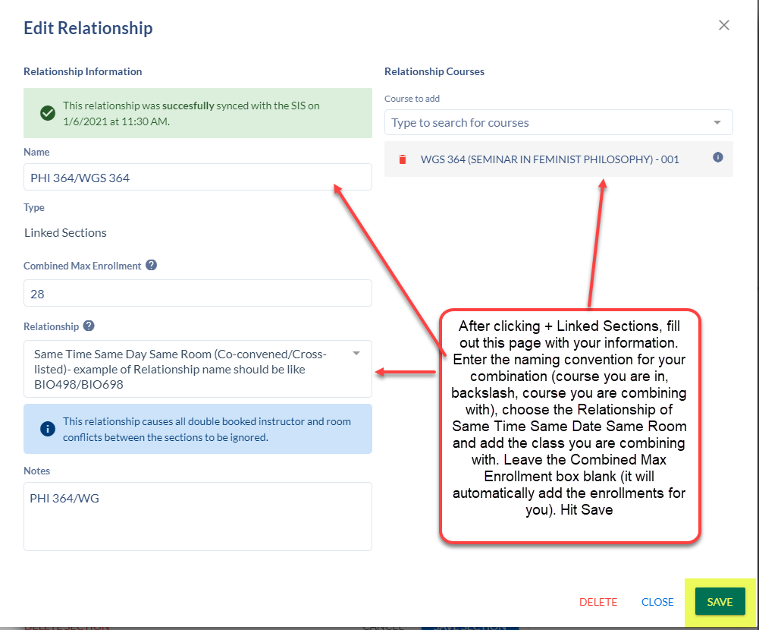

Co-convened/Cross-listed- linking multiple classes in the same relationship

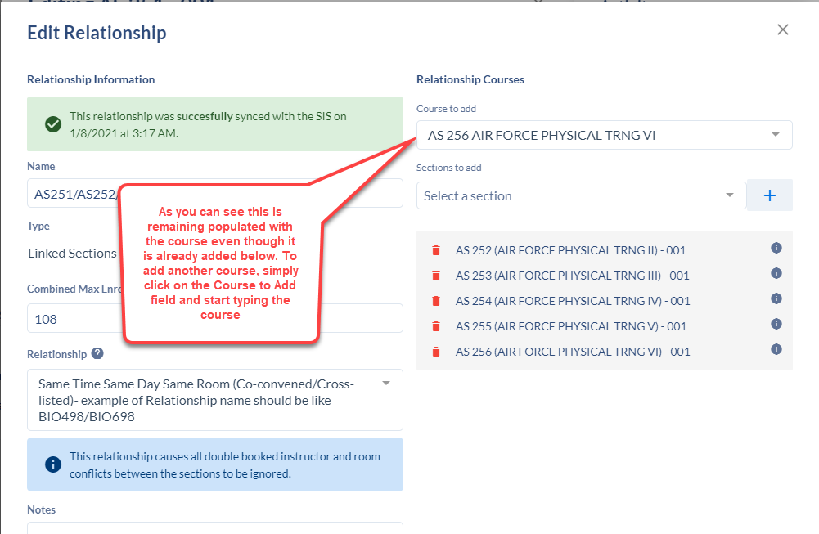

* Balanced Sections:
* A balance of classes is required for shorter session, blended instruction mode and 1-unit classes, that fit within one standard meeting pattern classes. This ensures classroom space utilization is optimal.
* EX - shorter session: a 7.5A class with a meeting pattern of MW 12:45-2:00pm, is balanced with a 7.5B class with a meeting pattern of MW 12:45-2:00pm
* EX - blended class: a blended class with a meeting pattern of M 2:20-3:35pm, is balanced with class with a meeting pattern of W 2:20-3:35pm
* To identify balanced classes, input each class on the Balancing Sections card of each section.
  + EX: if balancing ACC 205-001 with ACC 255-001, enter ACC 255-001 on the Balancing Sections card for ACC 205, and enter ACC 205-001 on the Balancing Sections card for ACC 255-001
* Always check to see if the class provides a balance before making changes, because changes will be required for both classes since they are balanced.

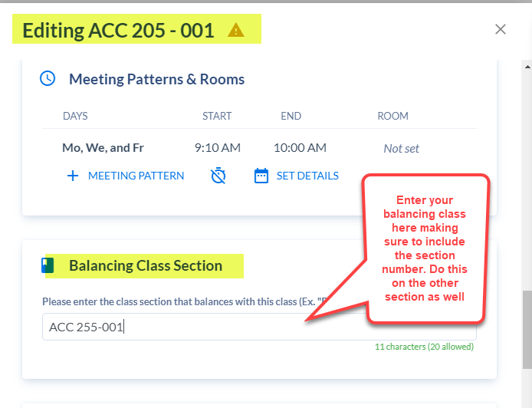

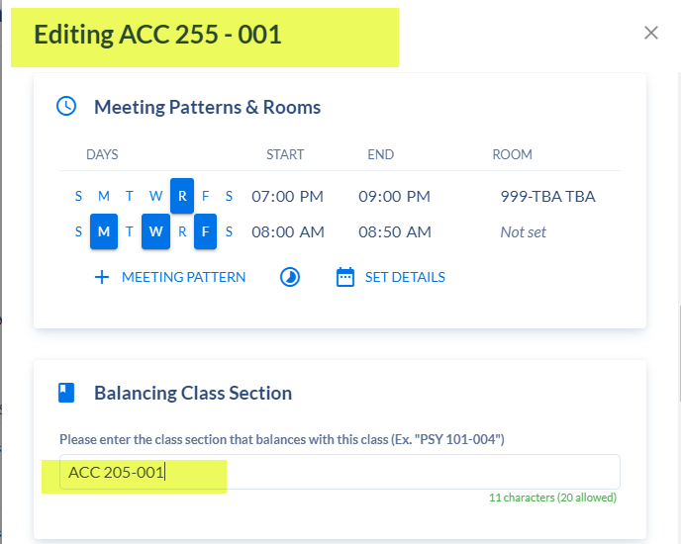

* Activity Feed:
* Please note the activity feed in section editor of a class does NOT notify SoC about any comments made. It may be used for internal notes and will identify every change that occurs to a class.

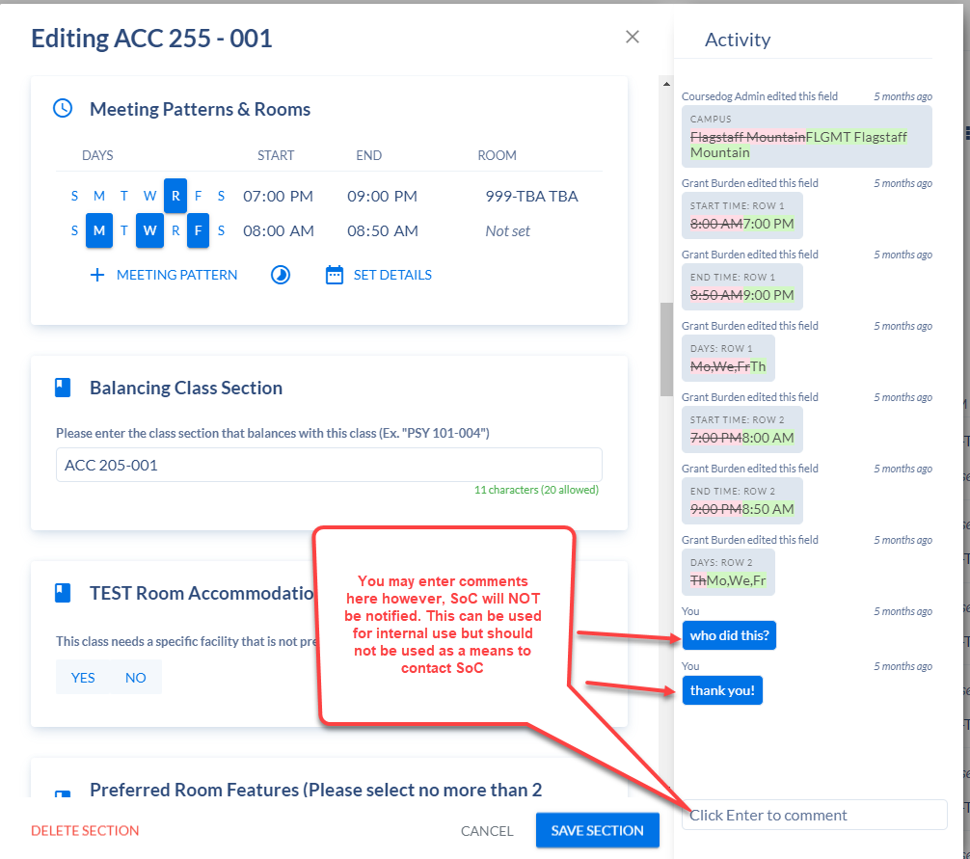

* Synch Message:
* It is important to read the synch message at the top of the section editor after changes have been made to a class or a new class has been entered. The message informs if the class was successful in merging over to Peoplesoft (in which case no action is required), or if it was unsuccessful. If unsuccessful, open the message to find out why. Make the necessary change according to the message. Exit the section and return to the section to verify the merge was successful after addressing the issue. If you do not understand the message, reach out to Schedule of Classes.
  + In the below screenshot, once the synch message is opened, it states the reason for the error is that the Meeting Pattern Start Date was set to an earlier date than the Session Start Date. To fix this, you would adjust the Meeting Pattern Start Date to a date after 10/18/2021.

Synch Message:

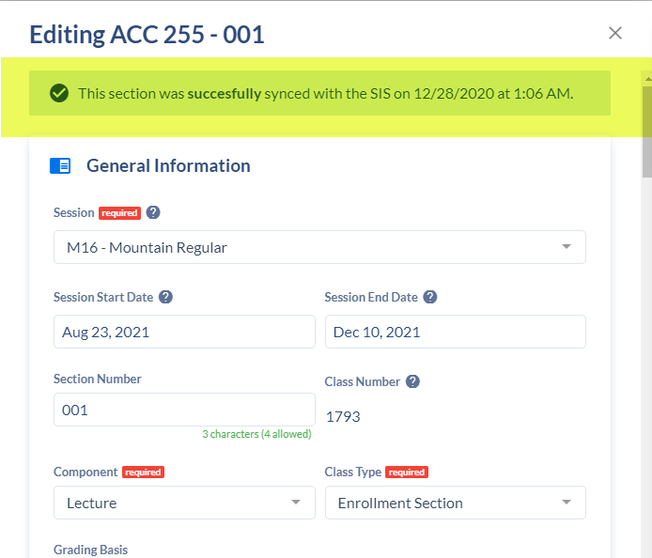

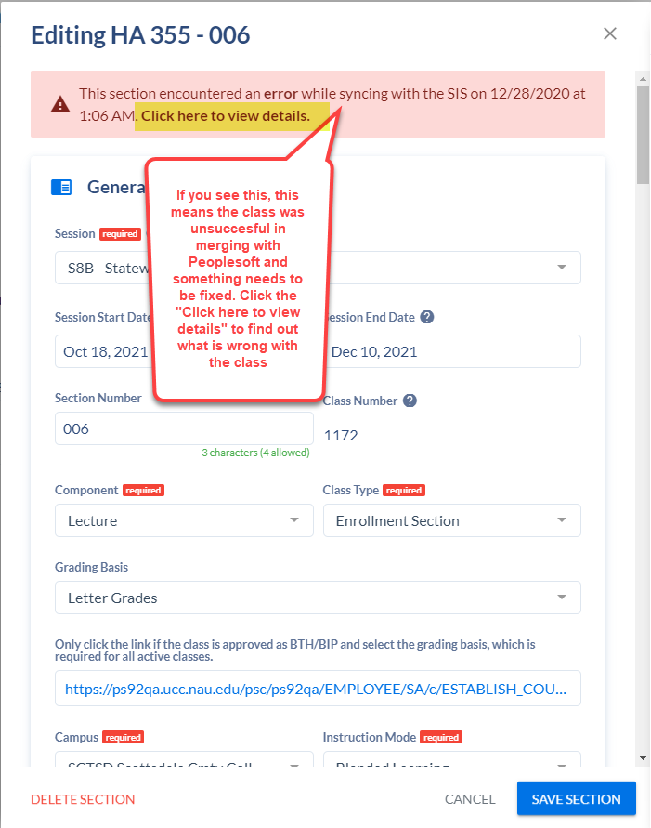

Synch Message:

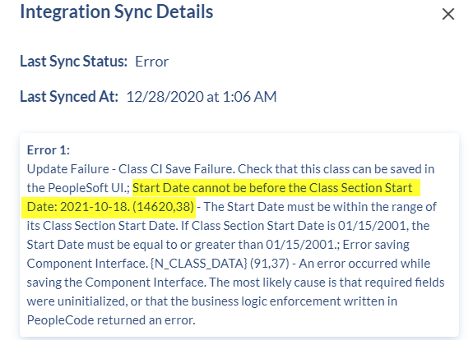

* Room Capacity:
* This field is not editable during the building stage. During the request stage it is editable (there is a notation next to Room Capacity during this stage that states it should not be edited). Please do not request to change the preferred room capacity.
* Room (999-TBA):
* STW Scheduling Only: The TBA facility ID is specific to the STW campus, 999-TBA is used for FLGMT and PBM only.
* Classes with 999-TBA require a class note stating where students will meet or providing instructions regarding the meeting place.
* Room (Pre-assignment):
* It is the responsibility of the unit to input approved pre-assignments/ADA accommodations at the time of the build. Input your pre-assignment on the Meeting Pattern and Rooms card. Click “Not Set” and an “Assign Room” window will pop open that will list the approved pre-assigned classrooms. Click on the classroom to add it to the class. Save the section. Reach out to your SoC contact to add a classroom for an approved ADA accommodation.
* If the pre-assigned room is not listed as an option, it may be because there is already a class assigned to the classroom at the same time. Coursedog only shows available rooms. To view all rooms, toggle the “Show Only Available Rooms” and this will list all approved classrooms for pre-assignments, even if a class scheduled in the room at that time (keep this in mind to prevent conflicts!).
* If offering back-to-back classes, the instructor must be identified and assigned to the classes before the end of the schedule build. The optimizer will only recognize back-to-back classes and assign them the same room if the instructor is assigned.
  + The enrollment capacities of back-to-back classes must be similar. If there is a vast difference in enrollment capacities, the optimizer will not place the classes in the same room.
  + Back-to-back scheduling is only available to classes with instructors listed before classrooms are assigned.

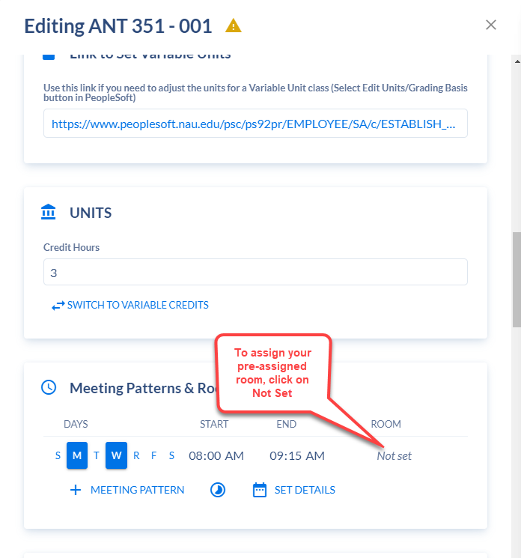

Room (Pre-assignment)

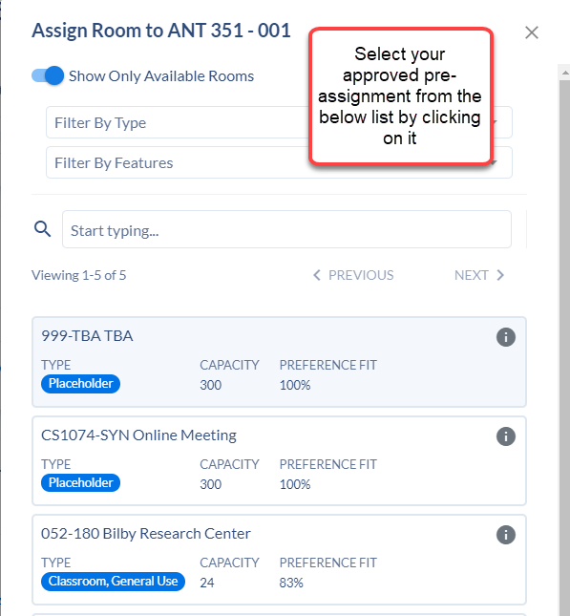

Room (Pre-assignment):

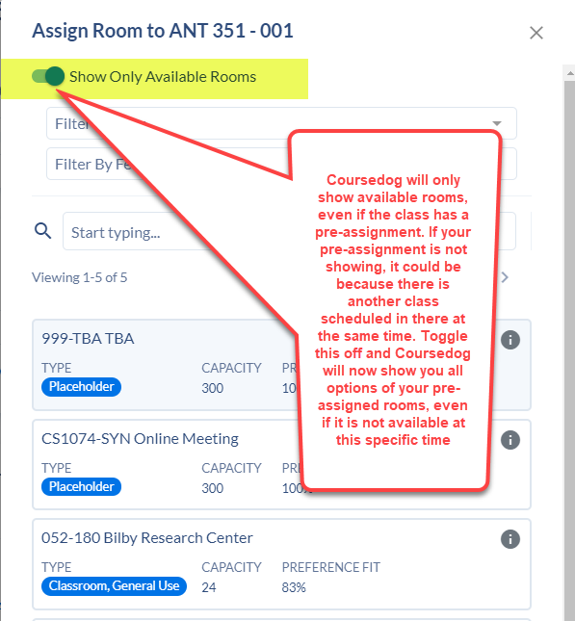

**Warnings-**

* When building a schedule (building stage), always check to see if a warning appeared at the top of the section editor after completing changes to a class in the section editor.
  + After every change made, scroll to the top of the section editor to see if a warning appeared. If a warning appears, take the necessary action to clear it immediately (look for the yellow triangle).
* Warnings should also be checked and cleared before submitting a request after schedule has been submitted (request stage).
  + After making a change on the request form, check to see if a warning appears. Do not submit a request with a warning. Take the necessary action prior to submitting the request. It will not be approved if there is a warning present.

**Miscellaneous-**

* Never submit anything through the Help Center in Coursedog. SoC will not receive the message. Contact SoC directly with any questions or concerns.