Contents
Adding a Service Indicator 1
Removing a Service Indicator 3

Adding a Service Indicator
In this version of Louie, Service Indicators have an end term. This functionality allows service indicators, generally holds, to be placed on a student’s record for a specific term. In the earlier version of Louie, once a service indicator was placed on the student’s record it was in effect until it was removed.
Note: NAU setup is currently term based only; start and end dates will not be recognized.
Navigation: Campus Community > Service Indicators > Person > Manage Service Indicators
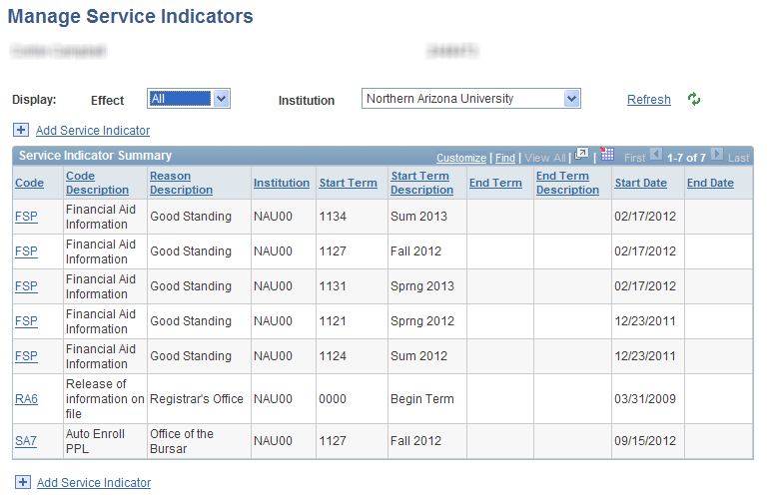
- Click .
Note: Service Indicator security controls which service indicators you can place and remove.
- Select a Service Indicator Code and associated Reason Code.
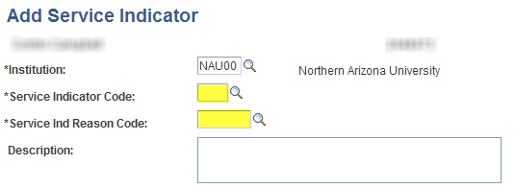
- Determine the Effective Period.
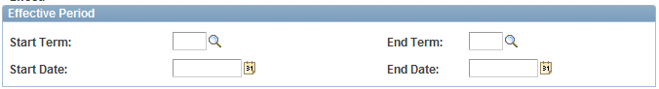
Start Term/End Term: Enter the term during which the service indicator should become valid for the ID, and enter the term during which it should cease to be valid for the ID. An End Term must be entered.

EX: if you want to place an advising hold for Fall 2014 enrollment – you would use the start term of 1147 and an end term of 1147 as you are only placing the hold on enrollment for that term.

Start Date/End Date: Current NAU configuration does not support Start Date/End Date functionality. The page will allow you to enter an End date but it will have no effect since this function is not enabled. DO NOT USE for RAA Service Indicators
The Start Date will auto populate with the first day of the term that you enter, but it has no effect on the hold.
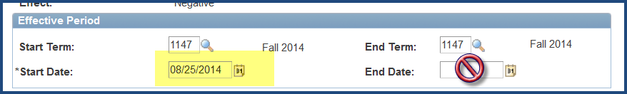

- Update Department (optional)

*Department: Many service indicators are set up to automatically add the department code. For example the RAA – Academic Advising Required has the Registrar set up as the default department. If you are adding the hold, however, you have the option to change to your department by using the lookup glass or entering your department code if you know it:
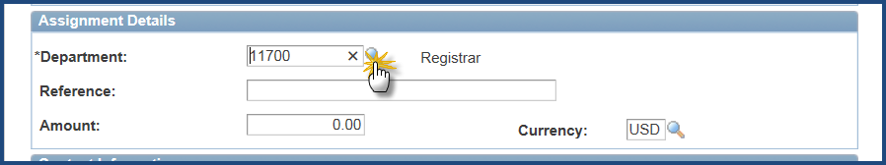

Choose your department:

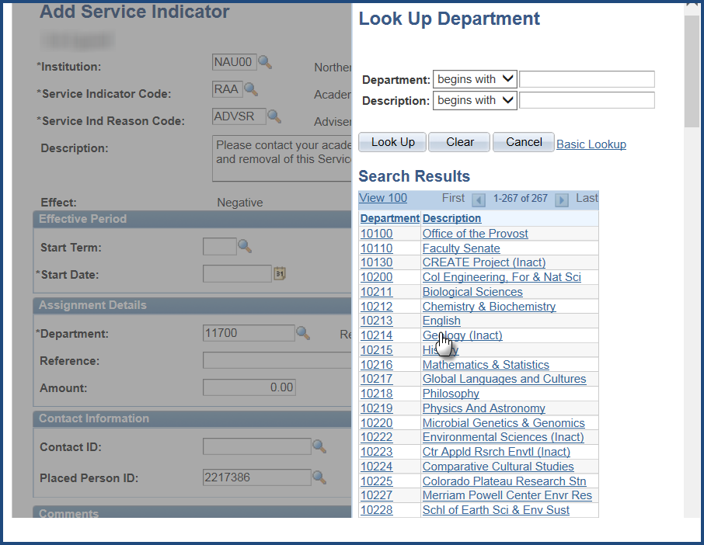

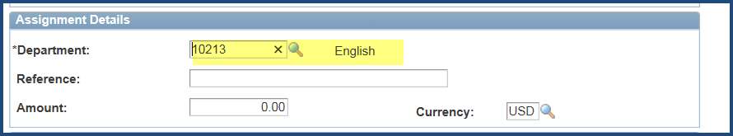

- Save the component by selecting.

Removing a Service Indicator
Navigation: Campus Community > Service Indicators > Person > Manage Service Indicators
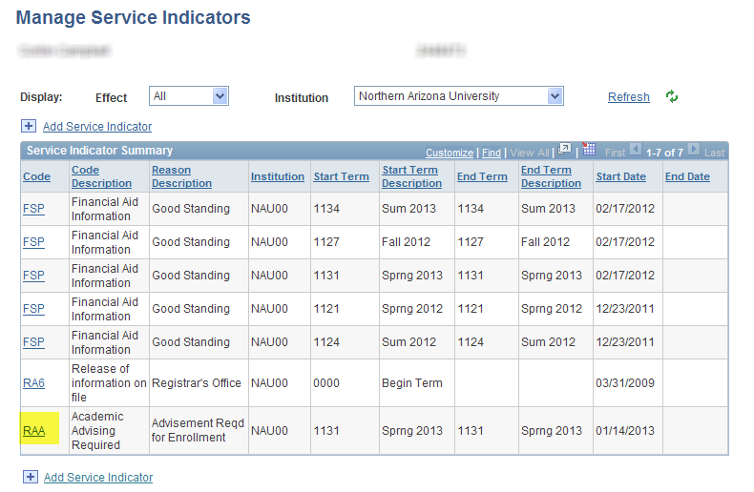
- Select the Service Indicator to be released and click on the hyperlink. Security determines which service indicators you can add and which you can remove.
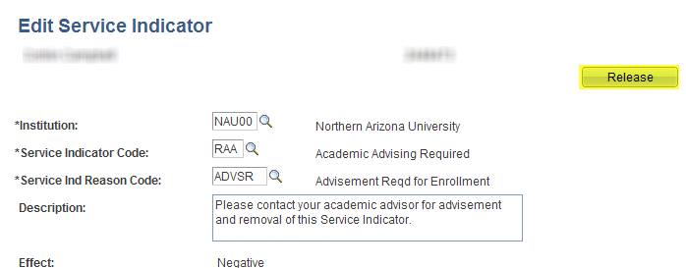
Press the Release button. If you do not have the authority to release this type of service indicator, the Release button will not be visible.
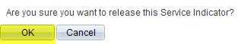
- Press OK. The Service Indicator is now removed.

