Office of Registrar – Schedule of Classes
Northern Arizona University
Registrar.ScheduleofClasses@nau.edu
Revised August 30, 2018
Instructions: How to Access Enterprise Reporting “Schedule of Classes” and Input for New Schedule Build

Contents
Navigation and Search Criteria 2
Saving a Report to Excel 3
Changes in Processes for Two Types of Classes Specific to Fall ’19, Spring ‘20 4
Data Fields or Links that are Available to Academic Units 5
Data Fields That Are Not Available to Academic Units and May Require Input 6
Examples - How to Input Changes on Fall 2019/Spring 2020 ERS SoC Spreadsheets 11
Adding Rows to Excel Spreadsheet 15

Navigation and Search Criteria

The navigation for the Enterprise Reporting “Schedule of Classes” report is:
Public Folders > LOUIE - Student Reports > Course and Class Information > Schedule of Classes

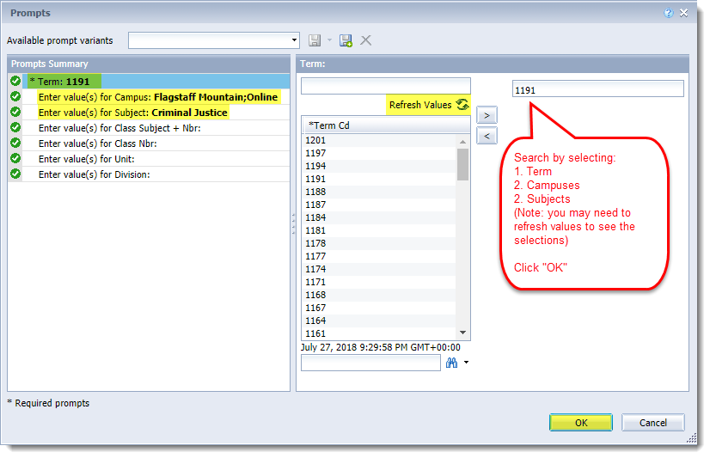
- Avoid using Internet Explorer as the browser.
- Enterprise Reporting “Schedule of Classes” spreadsheets are referred to as “ERS SoC spreadsheets”.
- Run reports for the term that applies, for example: AY 19/20 ERS SoC reports should be run for 1197 (Fall 2019) and 1201 (Spring 2020).
- Select the campus that applies, for example: FLGMT campus schedulers will only select Flagstaff Mountain or Online for campus, unless you also schedule some Statewide classes.

Saving a Report to Excel

Once the report is saved to your computer as an Excel document, changes to classes that will be offered may be input.
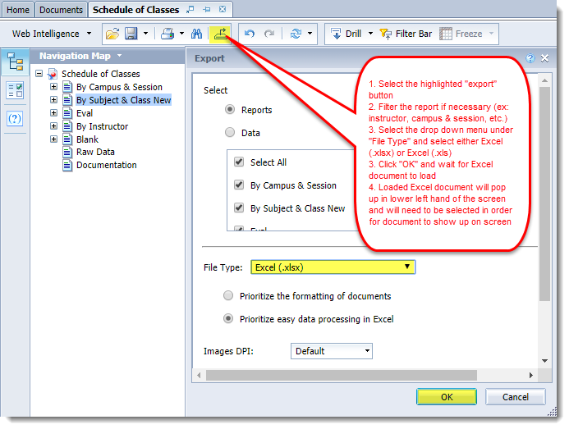

Changes in Processes for Two Types of Classes Specific to Fall ’19, Spring ‘20

- Topics:
- Topics will not need to be identified in the AY 19/20 spreadsheets. A block of time between October 31 and December 14, 2018 will be opened for academic units to request topics to be added to existing/built classes via the “SoC Build and Change Request Form”. We ask that you not wait until close to December 14, or until December 14, to request all the needed topics. This will create a bottleneck. SoC processes have to move from building classes to data integrity reviews and preparation for room assignments, followed by 25Live runs, clean up, and reviews, etc. …easy to see why it’s important to not wait until the deadline to send in the topic requests.
- IMPORTANT NOTE: Topics for classes that will be combined must be requested no later than November 13 and added to the combined sections table by the time they are requested.
- Academic units will request any needed topic classes in the AY 19/20 spreadsheets and strike through existing topics that will not be offered. Since both the 1197 and 1201 schedules will be viewable by February 4, followed by early enrollment appointments a few weeks later, please ask faculty to think ahead to Spring 2020.
- An option for Spring 2020 classes is: Units may create slightly “generic” topics for the Spring 2020 classes and once the details are ironed out, they may then add a class note that provides a full topic description.
- Please input full topic descriptions in the class Notes tab for Fall 2019 classes before classes are viewable for multi-term enrollment.
- Independent Study, Fieldwork, Thesis, Dissertation and other types of student-driven Course Line classes:
  - Estimate the number of Course Lines classes (other than topic classes) that your unit will need to offer, and request a slightly higher number of these classes on the ERS SoC spreadsheet. For these types of classes, there isn’t a need to copy and paste multiple templates for the same class. Input directions in bold red font above the classes that are requested to be duplicated. An example is “Build 8 additional sections of BIO 497, as shown below, with the grading basis of LTR and 4 additional sections with the grading basis of P/F.“
- Common Course Line classes relevant to this section | - 208, 408, 608, 485, 685,497, 597, 697, 699, and 799.
  - Academic units may request that these classes be input as Active, on or OFF Schedule Print, and Instructor or Department Consent on the ERS SoC spreadsheets. When a class is needed, an instructor can be added. Then the classes are ready for use when needed.
  - If your unit offers the Course Lines as both Letter and Pass/Fail, a request should be made for an adequate number of classes built with each grading basis.
  - Keep in mind, Course Lines are often offered with variable units. Consent allows the opportunity to remind students that they must enroll for the correct units. If the class should be offered for a set number of units, be sure to input the units in the ERS SoC spreadsheet.
  - Classes that are BTH or BIP (dual grading basis) will remain tentative until the grading basis is changed to LTR or P/F or LIP, etc. The grading basis cannot be changed once the class is published and enrollment begins. Please share this with faculty.
  - Remember that students must be enrolled in classes at the time work begins.
  - Finally, if your unit offers some Course Lines in the M8B session, request these builds as well.
  - SoC will cancel Course Lines, other than topic classes, several weeks after the class Add Deadlines.

Data Fields or Links that are Available to Academic Units

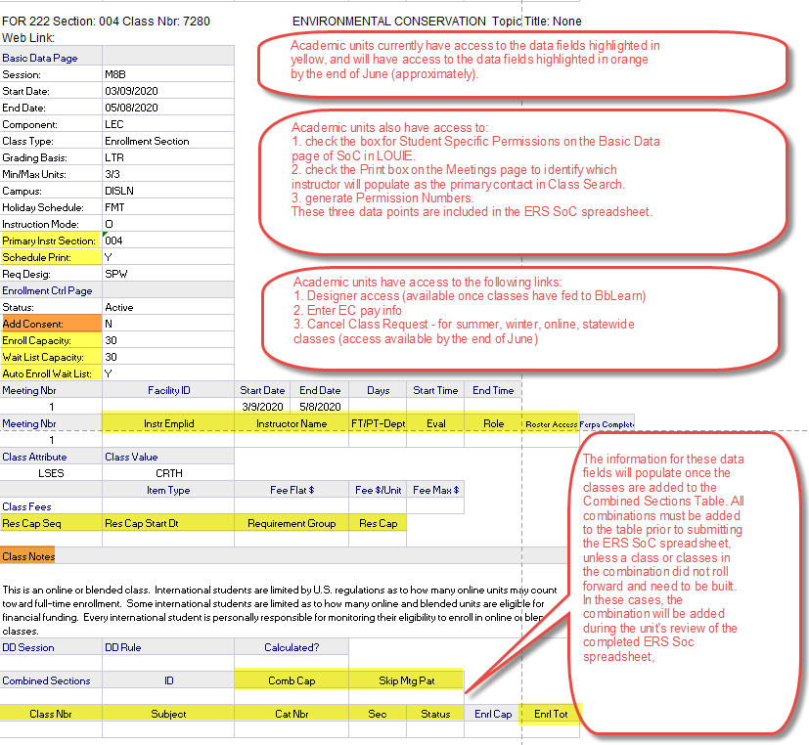

Academic unit schedulers will not need to add data for the highlighted fields, shown above, into the ERS SoC spreadsheet. Schedulers will add this data directly into LOUIE. The only exception is—accurate enrollment capacity for all in-person and blended classes must be added to the ERS SoC spreadsheet.

Data Fields That Are Not Available to Academic Units and May Require Input

Any changes required to the numbered fields will need to be entered on the ERS SoC spreadsheet. Please fully read the details listed below. The numbers in red correlate with the data field definition and instructions below the snap shot. Each academic unit will be responsible for understanding how and why changes need to be input in the ERS SoC spreadsheets.

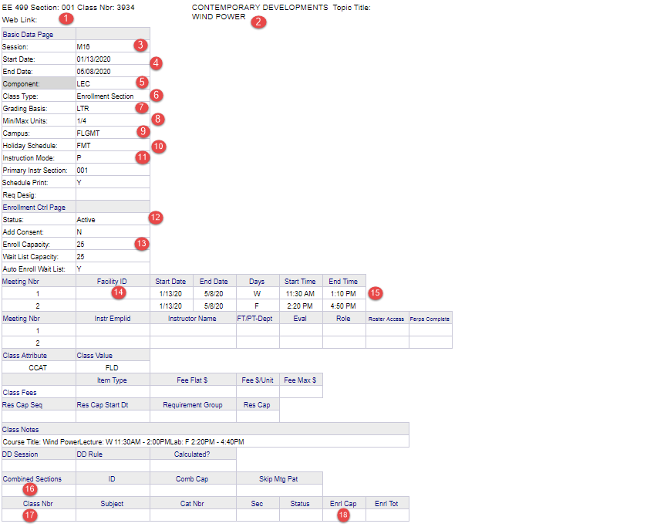
- Section Number –
- Changes to section numbers should be requested with discretion, especially if the classes are combined.
- Always ask for section number changes if multiple sessions (such as M16, M8A) are assigned to the same section number.
- Classes, including lectures and stand-alone labs, should be assigned three-digit section numbers (001, 002).
- Zero-unit labs should be assigned letters (A, B). When dual-component classes are rolled up, eLearning identifies non-enrollment, zero-unit labs based on the assignment of a letter for the section. eLearning will opt out enrollment, which is necessary if lecture/zero-unit lab classes are rolled up.
- Stand-alone labs should not be assigned letters.

- Topic –
- If the topic is determined prior to the submission of the ERS SoC spreadsheet, add the new title and topic ID number.
- If the topic isn’t known, strike through the existing topic. Request the topic during the time period allowed for AY 19/20 topic additions, which is October 31– December 14, with the exception of topics that will be combined as classes. Topics for combined classes must be requested no later than November 13 and the classes need to be added to the Combined Sections Table, prior to sending the request to add topics.
- Combined sections must be approved at the course level or they require a one-time approval prior to requesting that the classes be combined. See 16., below, for further details about one-time approvals.
- Do not leave a topic in place if it will not be offered.

- Session –
- DD sessions are discouraged due to issues they often create for students and manual processes required by internal units. DD sessions should be limited to classes that cannot be offered within a standard session, such as classes that must follow the schedule of FUSD, or a one-unit river-rafting class that will be completed within a couple of weeks.
- If a DD session is required, input DD. It isn’t necessary to identify DD1, DD2, etc.

- Session Start/End Date –
- Session start and end dates for DD classes need to be changed to match the class start and end dates. The dynamic-date rule will be calculated by SoC, based on the number of weeks the class is offered. The rule will determine the add/drop/withdraw dates.
- Session dates should never be changed for regular sessions (M16, M8A, etc.).

- Component –
- Dual-component classes, such as a lecture/zero-unit lab, require at least two sections. A lecture class should be requested, as well as a zero-lab. Depending on the instructor, class design, lab room capacities, etc., there may be one lecture class and multiple labs with the same course subject/ID number (i.e., ME 123), or there may be a matching number of lectures and labs – it can vary.
- When building lecture/zero-unit labs, the LEC component will populate for the lecture class. The LEC component should be requested to be changed on the ERS SoC spreadsheet to the LAB component for the lab class.

- Enrollment –
- Zero-unit labs must be changed to non-enrollment.

- Grading Basis –
- BTH/BIP classes are highlighted on the ERS SoC spreadsheet as a reminder that the grading basis must be changed to a grading basis within the parameters of what has been approved at the course level (Curriculum Management–>Course Catalog–>Course Catalog), such as Letter, Pass/Fail, or Letter in Progress.
- The grading basis should be identified on the ERS SoC spreadsheet.
- Classes will remain Tentative until the grading basis is determined and changed.
- Important: the grading basis may not be changed once classes are viewable/students are enrolled. Please share this with faculty.

- Min/Max Units –

- Variable units are highlighted on the ERS SoC spreadsheet as a reminder for schedulers to check with faculty and verify whether different min/max units should be input (1/3 instead of 1/12 units), or if the class should be scheduled for a set number, such as 1 unit or 3 units. Please share with faculty that units should not be changed after classes are viewable/students are enrolled.

- Campus –
- DISLN should be input as the campus for online classes.
- FLGMT, PHBIO or the appropriate statewide location should be input for in-person and blended classes.

- Holiday Schedule –
- FMT should be input for FLGMT campus classes and may also be used for online classes, if appropriate.
- STW should be input for statewide classes.

- Instruction Mode –
- P (in-person), BL (blended), O (online). Please click on the link, https://nau.edu/Registrar/Faculty-Resources/Instruction-Modes/, for definitions and requirements of each instruction mode.

- Class Status –
- Options include Cancelled, Active, or Tentative.
- Remember that Tentative Status is not an option for an online, summer, winter or statewide class. These classes will automatically move to active unless an instructor is input and the pay questions are not answered or are not answered correctly. Tentative classes are not viewable in class search.

- Enrollment Capacity –

- Academic units have access to this field, but still need to input changes to enrollment if the class is in-person or blended and requires a classroom.
- Enrollment capacity should never be increased above the room layout capacity, Layout Capacities by Location_All 25Live IDs. Complete the Schedule of Classes: Build and Change Request Form before increasing the enrollment capacity, and SoC will verify if a room is available for the requested meeting pattern and capacity.
- Likewise, notify SoC if the enrollment capacity is substantially decreased. SoC will search to see if a smaller room is available.

- Facility ID –

- Specialized Equipment:
  - Input the facility ID if the class is approved to be scheduled as a pre-assignment in a specific room (lab, kitchen, film equipment, piano).
  - The class must be listed on the unit’s pre-assignment spreadsheet, along with the approved classroom or classroom options.
  - Verify that the room assignment doesn’t overlap with another class, creating a room conflict.
  - If the classroom is used by another unit for approved pre-assigned classes, follow up with them to ensure there are no conflicts.
- 999-TBA:
  - Input 999-TBA if the class has a meeting pattern but will not meet in a classroom, such as a graduate class that will meet in an instructor’s lab. This is important. Failure to do so will result in a room assignment by 25Live (classroom scheduling system), despite the fact that a room isn’t needed for a class or a class meeting pattern.
- ADA Accommodations:
  - Input the facility ID and instructor EMPLID if an instructor has been approved for an ADA accommodation through Disability Resources.
  - Do not wait to request a specific room because it will likely involve the movement of multiple classes if requested after rooms are assigned.
- Blended, One-unit, Shorter Session Classes:
  - Blended, one-unit, and shorter session classes should be scheduled with another class that provides a balance.
  - Add a text box next to the entry of the facility ID to inform SoC about blended, one unit, or shorter session (M8A, M8B) classes, when another class is scheduled to provide a balance. SoC will ensure that both classes are assigned to the same room. Examples are:
    - scheduling a blended Monday class at the same time as a blended Wednesday class, both with similar or the same enrollment capacities
    - scheduling a 1 unit class on Tuesday at the same time as another 1 unit class with a similar capacity on Thursday
    - scheduling a M8A class with the same meeting pattern and similar capacity as a M8B.
  - These classes can use the same room and maximize classroom usage and, if two different classes are offered, this will also allow students an additional option to maximize their schedules.

- Meeting Pattern –

- Verify that the class meets for adequate Contact Hours if offered as in-person or blended.
- Standard meeting times should always be used, Standard Class Meeting Times, unless the class has been approved to meet outside standard meeting times. Failure to do so limits student’s ability to maximize their schedules and also impacts classroom utilization.
- If a meeting pattern will no longer be required (the class is online), strike through the meeting pattern on the ERS SoC spreadsheet.

- Combined Section –

- Enter the combined course information and class information into the Combined Sections Table (Curriculum Management–>Combined Sections–>Combined Sections Table).
- Input the class subject/ID number and the section number of any class or classes that will be combined on the ERS SoC spreadsheet.
- The only exception to not adding classes to the combined sections table in LOUIE is when a class that is part of a combination is new or didn’t roll forward for the previous like-term. In these cases, the class can’t be added to the table because it isn’t assigned a class number until it is built. After SoC completes input of the spreadsheet and builds the class, the academic unit will be asked to add the combination to the Combined Sections Table.
- Approved combinations are highlighted on the ERS SoC spreadsheet. The highlighted fields are:
  - Class Attribute (CSTL - cross-listed) and (CNVN - co-convened)
  - Class Value (course approved to be combined), for example, ES 191/WGS 191.
- If classes haven’t been approved at the course level to be combined, a one-time approval needs to be requested. Send an email to John Masserini (graduate) and/or Melinda Treml (undergraduate), with a justification for the combination and attach the syllabi for each class. CC: Registrar.ScheduleofClasses@nau.edu.
- Combinations need to be approved prior to the classes being scheduled to meet together – so prior to submitting the ERS SoC spreadsheet.

- Combined Section Class Number –

- If class numbers are available, enter them into the combined sections table and into the ERS SoC report.

- Combined Section Enrollment Capacity –

- Input the total enrollment capacity set for all the classes in the combination.

Examples - How to Input Changes on Fall 2019/Spring 2020 ERS SoC Spreadsheets

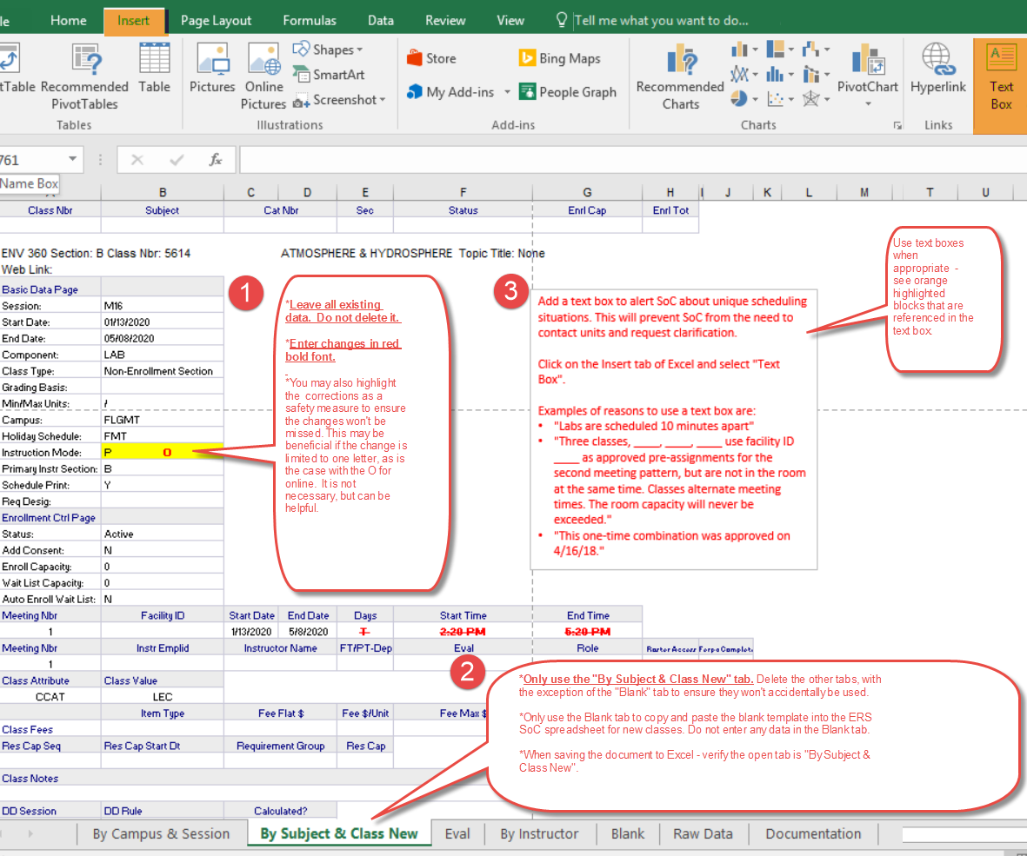

In the ERS SoC spreadsheet shown below, the following changes are requested:
- Topic Title
- Session
- Units
- Enrollment Capacity
- Facility ID
- Meeting/Pattern, including the deletion of one pattern and the addition of another meeting pattern

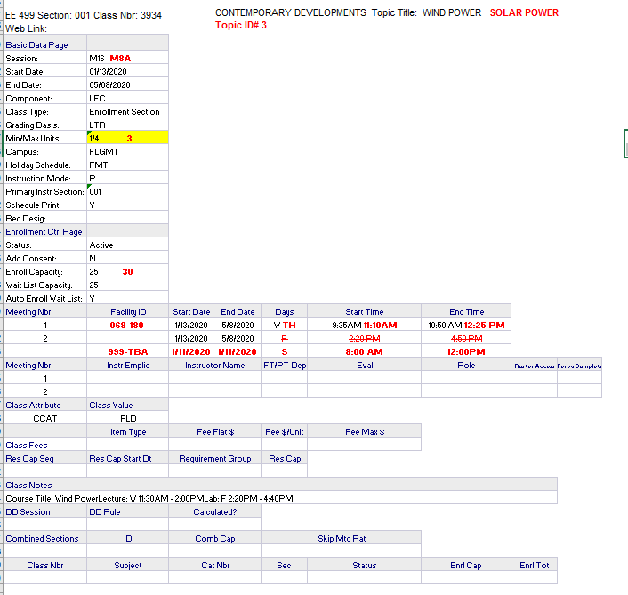

In the ERS SoC spreadsheet shown below, the following changes are requested:
- Facility ID
- Combined Section
- Combined Section ID (found on the Combined Sections Table)
- Class Number
- Enrollment Capacity of the combined section or sections

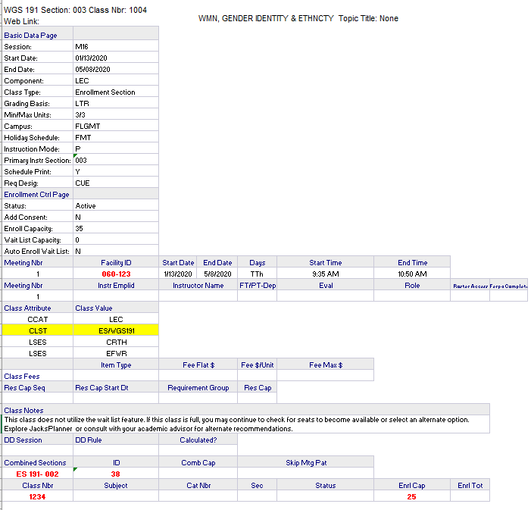

New class builds and classes requested to be deleted. (How to add a new section or class on your ERS sheet.)

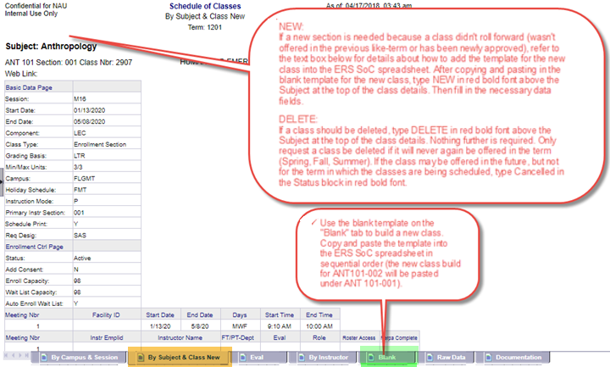

Please input NEW above each new class template. It is also a good idea to highlight the word NEW so it is easier to identify this is a new class and ensure the change won’t be missed.

Adding Rows to Excel Spreadsheet

