New function for 2019-2020: Return form to Chair

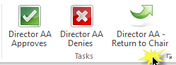
In the workflow, a form can now be returned to the Chair for edits. In your Notes section, please indicate the additional or edited information that is necessary to garner approval. Click SAVE before you select ‘Return to Chair’, so Notes are retained. When a form is returned to the Chair all approvals are cleared from the form, but Notes will be retained. Email notifications will be sent in the event of a return.

New placement and requirements for 2019-2020: Intentional Accrual
Course Fees balances cannot be carried over. The only exception is for intentional accrual for the repair, maintenance, or purchase of Specialized Equipment and computers. After checking Intentional Accrual, please list equipment, total amount, and expected fiscal year of purchase.
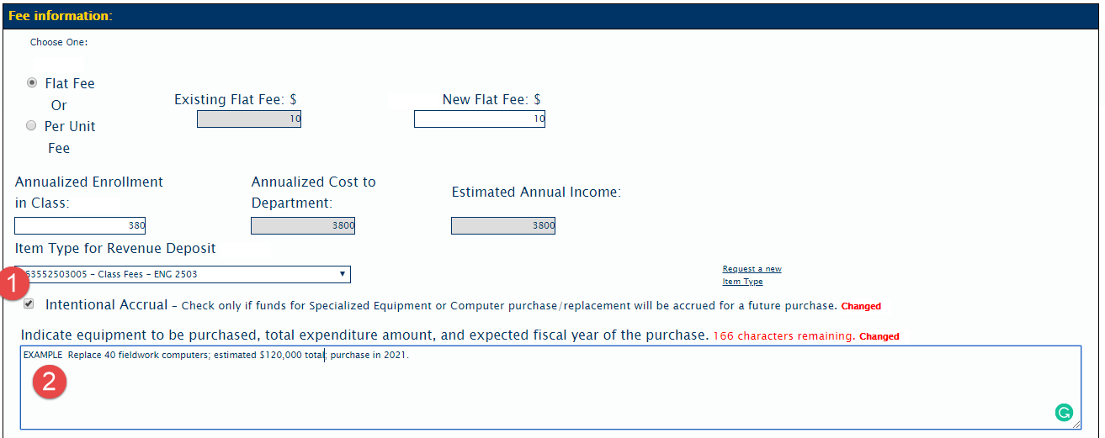
Edits An approver may edit any information on the submitted form. All changes are tracked by userid. Notes Use Notes to record any useful information for your department/unit, such as additional rationale or relevant history related to the course fee; noting future considerations. These notes are intended for local use. Remember any comments entered are viewable by all other parties involved in the course.
Character limits: Text boxes in the form have a character limit of 250 characters. If that limit is exceeded when editing and a Save is attempted, an error will appear such as “Keywords on the eform failed to Save”. The changes will not be saved. Recommendation: copy existing text into a word file, make edits, use character count to ensure the limit is not exceeded, then paste the text into the form. There is no character limit on approver’s notes.
Best practice After making edits on the form, list changes made in the Notes section, and click SAVE to retain edits and notes.

