Path to Enterprise Reporting (ERS) Schedule of Classes
and Instructions for Searching and Saving

*** Avoid using Internet Explorer as your Browser for
ERS reports. Chrome or Firefox is preferred.***

Navigation
Public Folders ➔ Louie –Student Reports ➔ Course and Class Information ➔ Schedule of Classes
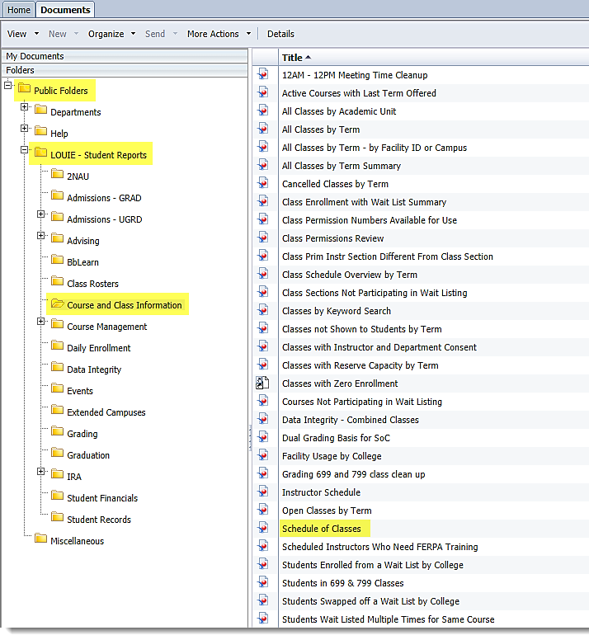

How to Select the “Prompts” to Get Your Information
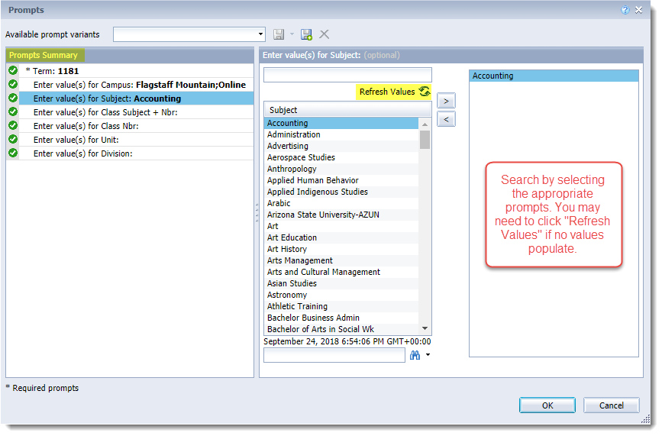

Input Controls
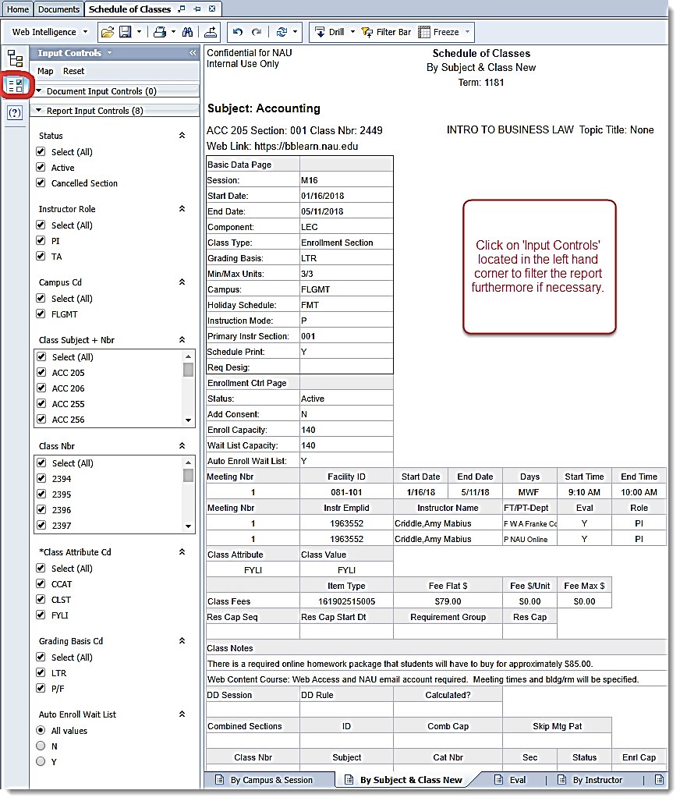

Downloading to Excel
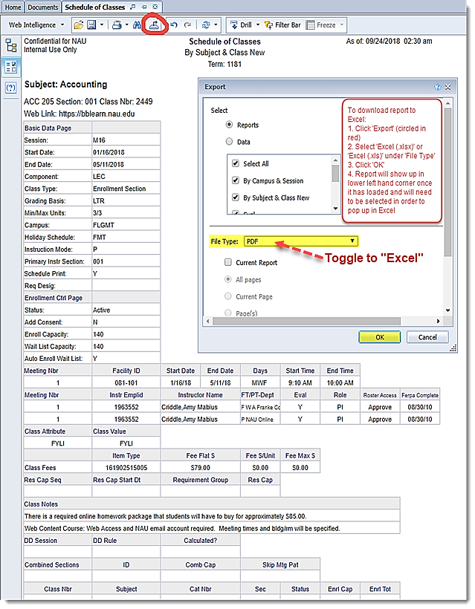
Indicating Changes
