Overview
When a faculty or staff member submits a Course Fee form for consideration, many approvals are required before it is final and may be charged to students upon their enrollment in classes. The purpose of this guide is to provide simple and quick directions for those individuals in the workflow review process.

Tutorial

Become familiar with OnBase
Course Fee approval is found in the Web Client for OnBase.
OnBase information, installation, and support: https://nau.edu/OnBase/Install-OnBase/

Email Notification Prompting Review
Course Fee reviewers will receive an email notification prompting them for review as requests are submitted. The email will contain a copy of the fee request, specify the course, the type of request (New, Edit, Cancel, Renew), and which queue the form is in. Simply follow the hyperlink in the email to enter the OnBase web client.
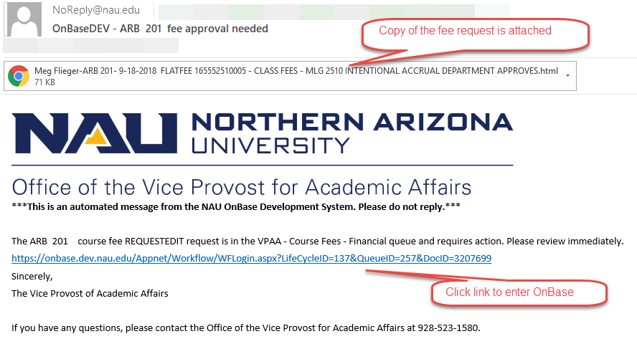

Review the Request
The hyperlink will open a browser window. Please note, Internet Explorer works best so if it isn’t your default browser, right click on the hyperlink to copy, open IE, and then paste in the URL. You will be presented with the OnBase web client which has a Life Cycle View pane (workflow queues), the Documents in the queue selected, and a preview pane below displaying the form selected.
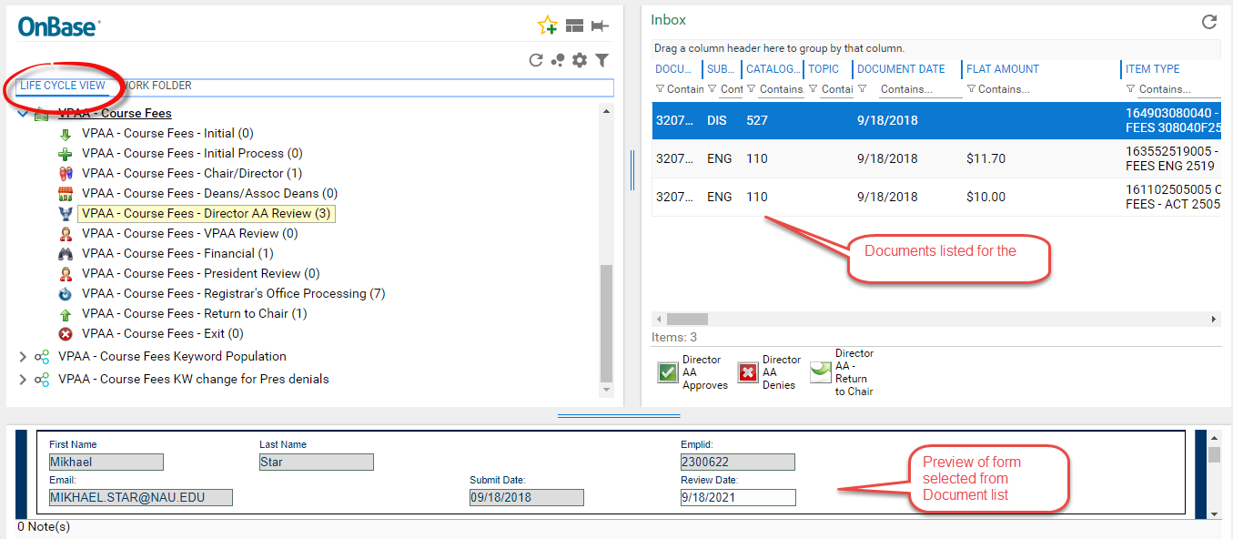

Review the form via the Preview. If this form is requesting edits, the fields being changed will be noted as such, quickly bringing your attention to those.

Make Notes/Corrections
If you have any comments that should be shared with the form submitter and all others in the workflow review process, you may input those into the appropriate Notes box. Please append any comments in the Notes box with your userid for future reference and tracking. You must click on Save at the bottom of the form to retain edits and notes.
As a reviewer, you also have the ability to correct any glaring errors on the request itself. Please use this access wisely for minor corrections, and note your corrections. Forms can also be returned to the Chair for major corrections or edits.

Scroll to the bottom of the preview and click SAVE if any comments are entered, Intentional Accrual is edited, or if any changes to the data in the form itself have been changed.
Remember any comments entered are viewable by all other parties involved in the course fees process.
Please note: If any edits are being made to the actual justification text in purpose of fees, those text boxes have a character limit of 250 characters. If that limit is exceeded and a Save is attempted, an error will appear such as “Keywords on the eform failed to Save” and the changes will not be saved. It is recommended that if edits need to be made to these text fields, the text be typed up in Word in order to do a character count to ensure the limit is not exceeded, then paste the text into the form.

Act on it
Select the appropriate button directly above the form preview in order to move the form to the next reviewer, deny the form, or return the form to the Chair (new for 2019-2020). There is no message when you act. The form disappears from your queue.
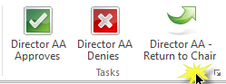
Closing your browser logs you out of OnBase.

Save Confirmation Notifications
Once the form is completely approved by all necessary parties and processed in LOUIE by the Registrar’s Office, you will receive a confirmation email with the final approved form attached.
Tip: Create a folder in your Inbox for Course Fees. Any final forms should be filed here for future reference in your department. Once a month, copy any emails in this folder to a shared drive location so others in the department may access the forms if needed and you are away from work.

Reference
Please refer to the FAQ’s document, videos, or contact us with additional questions.
Additional OnBase resources and information are also available online at www.nau.edu/onbase.

