Grant Chart Field Value Set
FOR QUESTIONABLE ACCOUNT CODES

Overview: This tool enables the department to quickly run an inquiry for expenditures that may have hit the Questionable account codes for unallowable costs on federal awards. Below is the list of the questionable accounts codes:
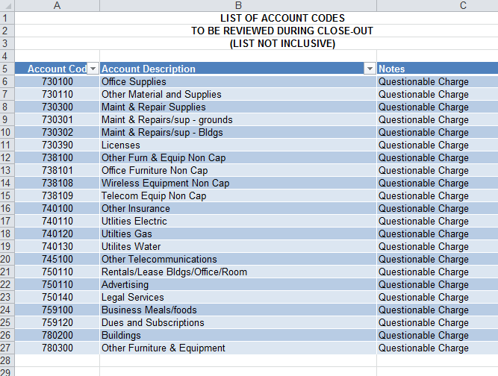

Step 1: Log into PeopleSoft Financials (example below is from the Comptrollers website)
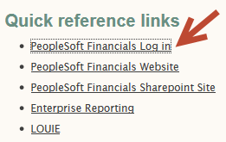

Step 2: From the main menu select “Commitment Control”
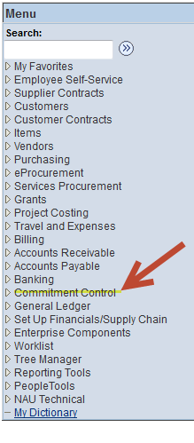
Step 3: Select the “Budgets Overview”
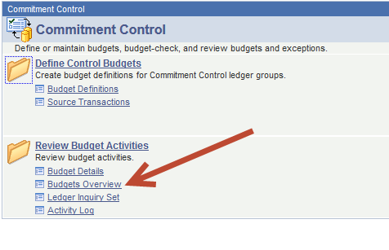
Step 4: Either Find an Existing Value that you have previously established for an PeopleSoft Inquiry or add a new value specific for this type of report. See PeopleSoft Training website for more detail information regarding adding a new value. https://nau.edu/its/learn/psfinancials_training_main/
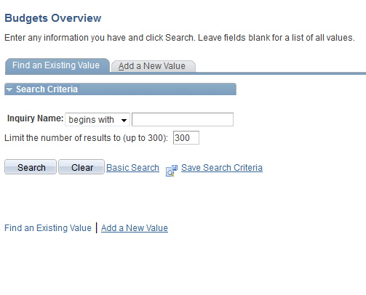
Step 5: Select the criteria to run your inquiry
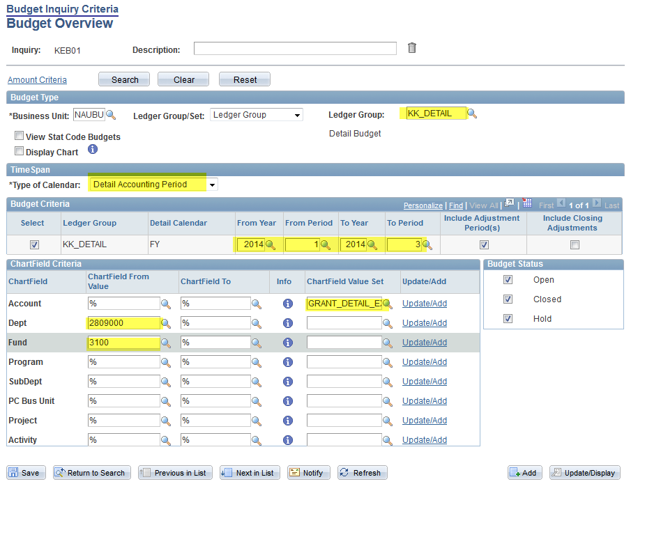

- Select Ledger Group “KK_Detail” by clicking on the magnifying glass
- Using the drop down menu select “Detail Accounting Period”
- Select the from year, period and the to year, period, this example is for the first quarter of FY14
- Using the magnifying glass select the “GRANT DETAIL EXP” chartfield value set, note this must be selected on the “Account” line.
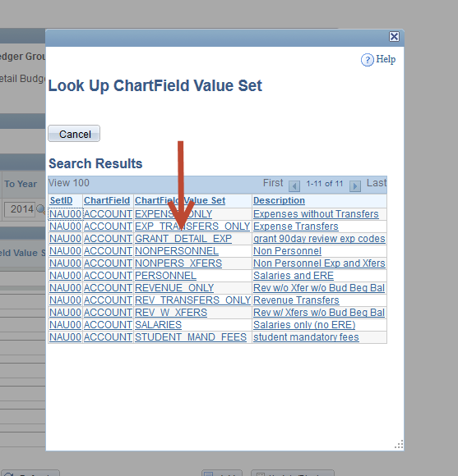
- In the department field put in your department ID number with the extension of 9000
- In the fund field put in 3100 for federal funds
Step 6: Once the criteria is in the fields indicated above click on the “Search” button locate at the top left side of the page.

Results of the Inquiry:
If your results come back as the example shown below, then you are done as no expenditures hit the Questionable Account codes for the period indicated in your search criteria.
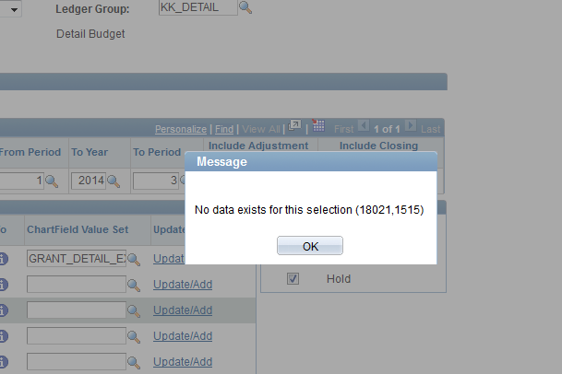
If you results come back as the example shown below, then you have expenditures that have hit the Questionable Account codes for the period indicated in your search criteria. Please contact your Post Award Administrator for assistance in either moving the expenses off of the project or providing a justification for the expenditure. 