|  |  |
| --- | --- |
|  |  |
|  |  |
| **NAU Cayuse SP Manual** | |

Table of Contents

A Quick Summary 3

Start a New Proposal File in Cayuse SP as soon as You Begin Writing A Proposal 5

Secure Cost Share Commitments as Early as Possible 5

Recommended Steps for Entering Information 6

Complete the *General Information* and *Investigators/Research Team* links. 6

If you are the PI, we suggest you focus next on the compliance sections highlighted to the right: 6

If you are entering information *for* the PI, we suggest you 6

Best Practice: Update your personal profile in Cayuse 424 7

Best Practice: Mozilla Firefox is the preferred browser for Cayuse SP/424 7

Preparing and Routing Internal Approval Documents in Cayuse SP 8

General Information Section 8

Investigator/Research Team 13

Budget Section 15

Subcontractors 19

The Compliance Sections: Conflict of Interest, Regulatory Compliance, Export Control, and Intellectual Property 19

Conflict of Interest 20

Regulatory Compliance 21

Export Control 22

Intellectual Property 22

Information for Institutional Users 23

Community Benefits 23

Location of Sponsored Activities 23

Proposal Abstract 24

Proposal Attachments 24

Approving Departments (and other Approvers) 25

Submission Notes 26

Prior to Submission: Review Cayuse SP Information 26

Submit the Proposal for Routing 26

PI and Co-PI Certification 27

Chair/Dean/Director and other Approvers 28

Cayuse 424 Grants.Gov Proposals 29

Steps for Linking Cayuse SP with a Cayuse 424 Grants.Gov Opportunity 29

**Using Cayuse SP: Proposal Routing and Approvals**

**Cayuse 424** has been used since 2011 for grants.gov proposal submissions. **Cayuse SP (Sponsored Projects)** builds on and is integrated with Cayuse 424 to provide pre-award and non-financial post-award sponsored projects administration. *This integration should make the proposal submission and award management processes much easier for all users.* As an early user, NAU is uniquely poised to help shape development of the software in the near and long term.

Key factors in selecting Cayuse SP were the ability to customize the software for NAU users and the responsiveness of developers to our concerns and suggestions. We invite faculty, staff, and administrators to put this new software to the test and offer your suggestions for how it can be made more functional for NAU users**.**

One of the most important pre-award features of Cayuse SP is that it provides a single point of entry for proposal data and any documents that are required for internal review. **It does not, however, link directly to sponsor websites, nor does it change the way that proposals are submitted, whether that is through Cayuse 424, grants.gov, a sponsor website, e-mail, or paper.**

Cayuse SP is the repository for institutional proposal and award data, with nearly twenty-five years of legacy data now available to NAU users. This extensive data repository will allow investigators to view and create reports on their pending proposals and awards; and chairs, deans/directors, and other administrators to view and create reports on pending proposals and awards in their departments/units and colleges. Data from Cayuse SP will be transferred to the NAU Data Warehouse and reports made available from there as well.

**A Quick Summary**

A direct link to Cayuse is provided on the [OSP homepage](https://in.nau.edu/osp/) page. Click on the Cayuse logo to open a link to the NAU Central Authentication Service (CAS); then enter your NAU user ID and CAS password. The Research Suite screen shown on the right is the home page for Cayuse SP. Under the Research Administration Modulesheading, you have the option to select Cayuse 424 or Cayuse SP. **Select Cayuse SP. You will create and route all proposals in Cayuse SP.** After all approvals are received, OSP will submit the proposal according to the sponsor’s requirements.

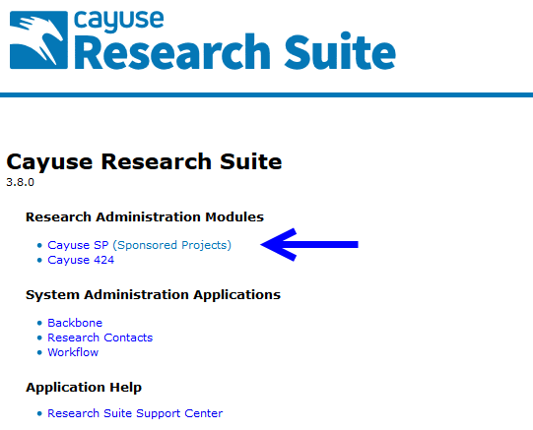

After you select the Cayuse SP module, you will see the “Welcome to Cayuse SP” home page:

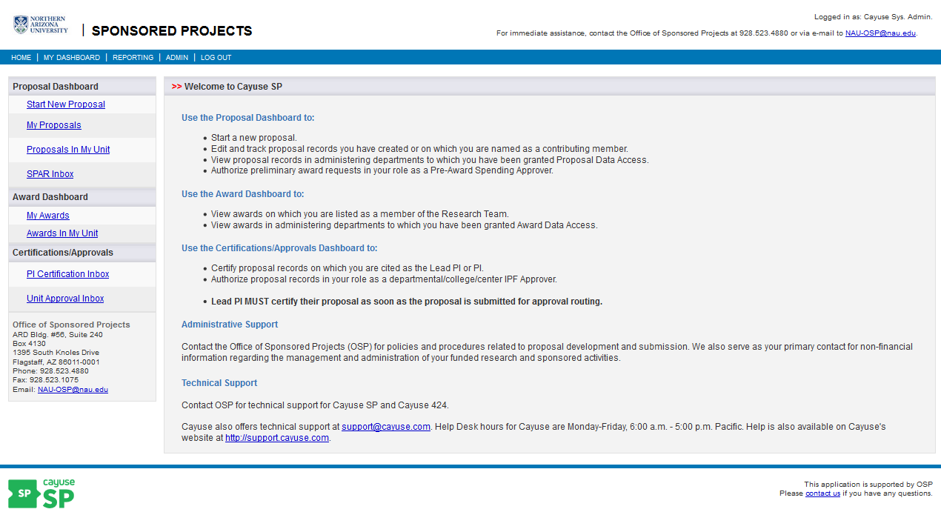

The left sidebar displays your Proposal Dashboard, Award Dashboard, and Certifications and Approvals.

The **Proposal Dashboard** provides access to:

* start a new proposal,
* review proposals you have created, and
* if your role requires links to Proposals in my Unit, you will see the SPAR inbox (this is also known as advance or Pre Award Spending).

The **Awards Dashboard** provides access to:

* awards that have been funded that involve your participation (you are named on the award research team), and
* viewing awards in your unit/department, center, school, or college depending on role and access.

The **Certifications/Approvals** section provides access to:

* the PI Certification Inbox (for investigators), and
* the Unit Approval Inbox (for chairs, deans, and other approvers).

The number of actions in each inbox is indicated on the left side of the link. If you are a chair, dean, or other approver (e.g., approving for cost share), open the unit approval inbox to review a proposal.

Note: Contact OSP at [NAU-OSP@nau.edu](mailto:NAU-OSP@nau.edu) for questions about your access level.

## Start a New Proposal Record in Cayuse SP

**Initiating the new proposal file in Cayuse SP is the first indication OSP has that you are preparing a proposal.** That information is important for planning, to balance workloads, and to prepare for other situations, such as limited submissions where an internal review is required to select the proposal(s) that may be submitted.

Another benefit to starting the Cayuse SP proposal file is that OSP Grant and Contract Administrators (GCAs) and Grant and Contract Coordinators (GCCs) can provide you and your team early assistance and useful information about preparing and submitting your proposal. Additionally, all administrators in the department(s)/ unit(s) or college(s)/center(s), etc., who have “view proposal” access will be alerted that you are preparing a proposal and also able to assist you.

## Secure Cost Share Commitments as Early as Possible

The University requires sponsored project costs to be funded to the greatest extent possible by the sponsor(s) and any cost share that is not required is discouraged. Types of internal cost share include tuition and/or fee waivers, cash match, and in-kind commitments of salary and wages. F&A waivers or reductions by the Vice President for Research are rarely approved.

If cost share will be proposed, request approvals (e-mail, memo, etc.) from each contributing office as early as possible and upload the approval(s) in the attachments section of Cayuse SP. The budget section of Cayuse SP includes space to itemize each item of cost sharing (internal and external). As each source of cost share is entered, the office providing the cost share is automatically added to the proposal routing chain. The Assistant Vice President for Research Administration will certify third party cost share based on the provided documentation.

In the case of cost-share agreements among several offices at the University, the most common form of documentation is a cost-share memo signed by each office. These documents should be uploaded in Cayuse SP.

## Recommended Steps for Entering Information

Information about the proposal is entered in each of the links that appear in the **Item List** shown to the left. Notice that the *Proposal Number* (in this case, 14-0129, next to the Item List) is automatically assigned in Cayuse SP; this reference number will stay with the project from proposal submission through award closeout.

**Complete the *General Information* and *Investigators/ Research Team* sections**. Information on these pages identifies the sponsor, investigator, and managing department. What you do next depends on whether you are Principal Investigator (PI) entering information about your own proposal, or you are entering information for the PI.

**If you are the PI, we suggest you focus next on the compliance sections highlighted to the right:** *Conflict of Interest, Regulatory Compliance, Export Control, Intellectual Property, Community Benefits* *and Location of Sponsored Activities*. These questions concern required certifications and/or contain information that is likely known only to the PI. The other sections can be completed by you or an assistant, including the budget, abstract, document uploads section, approving departments, notes section, and link to the Cayuse 424 Grants.Gov proposal (if applicable). As pages are saved, a green check box appears signifying that the requested information has been provided.

**If you are entering information *for* the PI, we suggest you** focus on the *Budget, Subcontractors, Application Abstract, Attachments, and Approving Departments* sections and the Cayuse 424 Proposal (if applicable). Once the proposal is ready for internal routing, the PI can log on and complete the sections highlighted above at the same time that he/she certifies the proposal.

The information on any of these links can be reviewed and updated prior to submission simply by clicking the link. Be sure to save your changes before moving to a different section.

With one exception, all proposal information is entered in Cayuse SP. The exception is for grants.gov proposals that are submitted through the Cayuse 424 S2S interface; information for these proposals is entered both in Cayuse SP and Cayuse 424. See below, pp. 27-30, for detailed guidelines for preparing a Cayuse 424 grants.gov proposal.

When all sections of the Item List have green check marks, the proposal is almost ready for internal routing. **Even though it’s very easy to enter and/or upload proposal information, wait to click the “*Submit for Routing”* link until *after* you’ve discussed the proposal with your OSP GCA/GCC.** The reason for this is to avoid having to pull the proposal back from routing to correct errors.

Once the proposal is authorized for routing, all the information that’s been input and/or uploaded can be viewed by all internal approvers, including the PI and any other department/college/unit-level approvers. Once all approvers have certified the proposal, the proposal gets a final review by the OSP GCA, and if everything is in good order, is authorized by an Authorized Institutional Representative/Signatory (AOR) and submitted following the sponsor’s instructions.

## Best Practice: Update your personal profile in Cayuse 424

One of the most common errors that we see is incorrect information about a faculty member’s title, department, and affiliation. We recommend that you review and update your information in the Investigator’s Personal Profile (found on the People tab in Cayuse 424) at least once a year, or if you have a title or department change. This information is used to auto-populate tables in Cayuse SP. The most important fields to update are the department, division, and title fields.

OSP will refresh the contact list on a daily basis for the next several months to assure that contact information is accurate.

## Best Practice: Use Mozilla Firefox

Currently, [Mozilla Firefox](https://www.mozilla.org/en-US/firefox/new/) is the preferred browser for working in Cayuse SP/424.

# Start a New Proposal Record

## General Information Section

Clicking on “**Start New Proposal**” opens the *General Information* section. This section only holds information about the proposal opportunity, sponsor, deadline, project dates, etc. Information about the Principal Investigator is entered in the next section, *Investigators/Research Team*.

This is the information you’ll need in order to complete the *General Information* section:

1. **Sponsor** refers to the agency that will *directly* fund the NAU sponsored project. Click the magnifying glass icon to bring up a list of sponsors. If the sponsor is not listed, send an e-mail to [NAU-OSP@nau.edu](mailto:NAU-OSP@nau.edu) to request the agency be added to the sponsor list. ***Please read the guidance below on Prime Funding Agency.*** **Tip: Search for Arizona-based entities by entering “Arizona” and/or “AZ” (e.g., Arizona Department of Game and Fish, but AZ Department of Education; or AZ State University instead of Arizona State University). This is an unfortunate legacy of our legacy systems.**

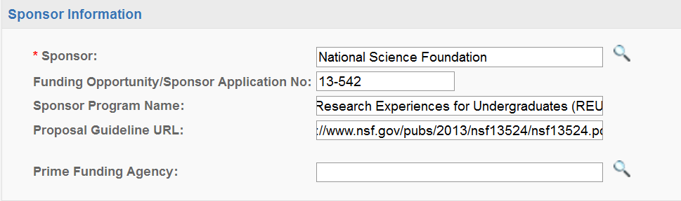

* **Funding Opportunity/Sponsor Application Number** (e.g. 13-542) provided by the sponsor.
* **Sponsor Program Name** as listed in the funding opportunity.
* If available, provide a web link to the **Proposal Guidelines.**
* The **Prime Funding Agency** field is used whenever NAU will receive a subcontract or subrecipient award from an intermediate funding source (for example, NAU is included as a subrecipient in a Colorado State University (CSU) proposal to NSF. In this case, NSF is the Prime Funding Agency and the intermediate funding source, CSU, is the Sponsor). ***If there is no Prime Funding Agency, leave this field blank.***

1. Provide a **Short Project Name** for internal reference using the following format:

Last Name, Sponsor, Deadline (e.g., Peters NIH 09/17/2013)

1. Click on the calendar icon to enter the **project start** and **end dates**. *Tip*: Select the month and year *first*, then the day of the month.
2. Click on the link to the **Activity Code** to select the type of activity that will be performed (usually, basic or applied research, development, instruction, or public service)**:** 
   * **Applied Research** is conducted to gain knowledge or understanding to meet a specific, recognized need. It includes R&D funds received through Federal cooperative agreements and Federal contracts, all state-funded R&D (except through Proposition 301), and R&D funds received from private for-profit institutions, and most (but not all) funding received from federal mission agencies such as the U.S. Department of Agriculture (USDA) or the Department of the Interior (DOI).
   * **Basic Research** is undertaken primarily to acquire new knowledge without any particular application or use in mind. It includes federally funded grants and R&D funds from other universities, some from foundations and nonprofit organizations.
   * **Development** is the systemic use of the knowledge or understanding gained from research directed toward the production of useful materials, devices, systems, or methods, including the design and development of prototypes and new processes to meet specific requirements.
   * **Fellowship/Scholarship** category includes expenses for scholarships and fellowships in the form of grants that neither require the student to perform service to the institution as consideration for the grant, nor require the student to repay the amount of the grant to the funding source. In public institutions, they may result from selection by the institution or from an entitlement program.
   * **Instruction/Training** category includes expenses for all activities that are part of an institutions instruction program. Expenses for credit and noncredit courses; academic, vocational, and technical instruction; remedial and tutorial instruction; and regular, special, and extension sessions should be included.
   * **Public Service** category includes expenses for activities established primarily to provide non-instructional services beneficial to individuals and groups external to the institution. These activities include community service programs (excluding instructional activities), and cooperative extension services. Included in this category are conferences, institutes, general advisory services, reference bureaus, radio and television, consulting, and similar non-instructional services to particular sectors of the community.
   * **Student Services** classification includes expenses incurred for offices of admissions and the registrar and activities that, as their primary purpose, contribute to students’ emotional and physical well-being and intellectual, cultural, and social development outside the context of the formal instruction program. This classification is not typically used for sponsored projects.
3. Select the **Proposal Type** from the drop-down menu, which include the following options:
   * **New** – a proposal that is being submitted for the **first** time.
   * **Preliminary Proposal** – usually the first part of a two-step process of prior review by the sponsor. May or may not require authorized official signature (check with your OSP GCA).
   * **Competitive renewal** – a competitively reviewed proposal requesting additional funds extending the program or research beyond the current project period.
   * **Non-Competing Continuation** – a proposal or request, usually in the form of a report providing information about progress and next steps, for the next increment of funding.
   * **Resubmission** – a proposal submitted for the **second** time; usually prepared in response to peer reviews and therefore is improving the original submission.
   * **Supplemental Funding** – a proposal for an additional scope of work and funds for an existing project during the same period of performance (POP).
4. Select the **Instrument Type** (agreement/funding mechanism) from the drop-down menu that will likely be used by the funding agency. This is often specified in the RFP:
   * **Clinical Trial** –A research study that typically involves testing an experimental drug or device using human subjects. **\***Note: not all studies involving human subjects are clinical trials. To be a clinical trial, the research study involves human subjects assigned to interventions for evaluating the effects of those interventions on health-related biomedical or behavioral outcomes. Please consult with the Pre- and Post-Award Directors before selecting this award type.
   * **Contract or Federal Contract** – Contracts are most often awarded based on proposals that are submitted in response to requests from sponsors, often called Requests for Proposals or RFPs. A contract award typically includes commitments to provide specific deliverables such as data analysis, surveys or tasks (task orders). Contracts issued by federal funding agencies typically contain FAR, DFAR and other regulatory contractual terms and conditions.
   * **Cooperative Agreement** – An award similar to a grant, but typically involve a significant level of sponsor participation in the administration and direction of the project. This mechanism is a common award type issued by federal funding agencies and is usually very specific that the award type is a Cooperative Agreement as oppose to a grant or other award mechanism.
   * **Grant** – Financial assistance award mechanisms predicated by a submission of a project proposal/application generally initiated by the PI/University. Ordinarily, grants do not include commitments to provide specific products (deliverables). Not all grants are for research. Some provide support for other sponsored activities related to instruction, public service, training, conference, or symposia attendance.
   * **IPA** **(Intergovernmental Personnel Act)** – An award based on a PI temporary assignment to or from the University to an organization (usually a federal gov’t agency) that facilitate cooperation between organization/agency and the University. The funding instrument is usually very specific that award type is an IPA.
   * **MOU** **(Memorandum of Understanding)** –An agreement that establishes the basic principles for guiding the implementation of a program or project. The word memorandum implies something less than a complete formal contract; however, MOUs do contain a brief written statement outlining the terms of an agreement or transaction. In these cases, the MOU functions only as evidence of an agreement/understanding without the need to specify every term and conditions generally associated with a formal contract. The funding instrument is usually very specific that award type is an MOU.
   * **Other** – Used to refer to another type of award mechanism that is distinct from a type referenced herein. *Please consult with the Pre- and Post-Award Directors before selecting this award type.
   * **Purchase Order (PO)** –A funding instrument with specific terms and conditions issued to the University from a vendor or entity serving as a vendor for the purpose of compensating work that the University will perform on behalf of the vendor. *Note: If the “vendor” issues a PO and a formal funding instrument (i.e., subaward/subcontract, etc.) for the same scope of work, then select the formal instrument as the award type instead of PO.
   * **Subcontract/Subaward** – A contract or award issued to the University by another institution, who is the prime recipient of an extramurally funded grant or contract. The primary purpose of the subcontract/subaward is for the University to implement or perform a portion of the scope of work under the prime recipient’s extramurally funded grant or contract.
5. Select the way the proposal will be submitted to the sponsor:

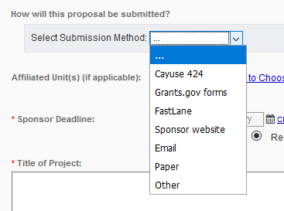

* **Cayuse 424** is used to prepare and submit most, but not all, grants.gov proposals (a few opportunities are still available only through grants.gov; check with your GCA/GCC if you have questions).
* Select the **Grants.gov forms** option if the opportunity is not available in Cayuse 424, and the proposal will be prepared and submitted through the grants.gov web portal.
  + Most proposals are submitted directly through sponsor web portals (like NSF FastLane, NASA NSPIRES, DOE E-Grants, etc.), by e-mail, or by regular mail.
    - Select **FastLane** if your proposal will be submitted to the National Science Foundation.
  + Select **Sponsor website** if you are using a sponsor’s web portal.
  + Select **e-mail** if the proposal will be submitted via e-mail, and discuss with your GCA who will be responsible for submitting the proposal to the sponsor (in most cases, OSP will submit the proposal on your behalf).
  + If the sponsor requires a **paper** submission, OSP will send the proposal by overnight delivery to meet the sponsor’s submission deadline. Enter the number of copies required by the agency and provide the sponsor’s express mail address in the blocks provided.
  + **Other** indicates any other type of submission that is not listed or described above. Contact your GCA/GCC to discuss the submission.

1. In the **Award Admin Dept.** block, select the department/unit, center or institute that will *manage* the award (Award Admin Dept. may be different from the Lead PI’s academic department).
2. The **Primary Administrative Contact** is typically a Business Manager within a department/unit or college, center or institute.
3. **Affiliated Dept(s)/Centers.** Use this field to identify co-PI departments and affiliated centers and institutes. **Do not use this field to identify the unit which will manage the award (see #7 above) or to list the Lead PI’s department*.***
4. Enter the **Sponsor Deadline**. If the deadline is both date and time specific, be sure to indicate whether the time is based on local (Arizona) or a different time zone. Depending on daylight savings, for example, there is a two- or a three- hour time difference between Arizona and Washington D.C. A proposal due at 5pm EDT (Eastern Daylight Time) would be due at 2pm MST (Mountain Standard Time). **In Cayuse SP, enter the hour, minutes and am/pm. If it is due at 5pm, enter “5:00pm.”**
5. Enter the **Title of Project** that will be used on all Sponsor forms.
6. At the bottom of the General Information page, you are given the options to (a) create a paired proposal (one that will be submitted through grants.gov), (b) pair a Cayuse SP proposal with an existing Cayuse 424 proposal, or (c) un-pair a Cayuse SP proposal from a Cayuse 424 proposal. **Even if your proposal will be submitted to grants.gov through Cayuse 424, we suggest you wait to create the paired proposal until you’ve completed the Cayuse SP sections.**See pages 27-30 for detailed instructions for this section.
7. Click the *Save* button at the bottom of the page.

You can return to this section any time by clicking on the *General Information* link.

## Investigator/Research Team

The Principal Investigator (or “Lead Principal Investigator” in *Cayuse SP-speak*) and Co-Investigators (called Principal Investigators) are identified in this section of the Item List. **The Lead Principal Investigator and Principal Investigators are the only roles that are required to certify the proposal and that are automatically added to the proposal routing chain;** other roles may be added as appropriate (for example, you can list everyone who will assist with proposal preparation). Cayuse SP allows only one Lead PI to be listed, although other investigators may have the Principal Investigator or Investigator roles. **You must list all Co-PIs (Investigators) involved in the project to properly trigger internal routing.**

Please enter the name of the OSP GCA who is responsible for the proposal and assign the role “Proposal Editor” to that individual; you can assign this same role to anyone else who will be assisting you with the proposal.

#### **Add Personnel Information**

1. The **Lead Principal Investigator** MUST be entered first; “Lead Principal Investigator” is the default role for this individual. This role also should be selected for a Project Director. Click in the answer block or on the magnifying glass icon to search for the PI’s last name. Most of his/her information will be auto-filled, and, except for the Lead Investigator, you must select a role before you can save the entry.
2. Enter the total number of person months (AY plus summer) and the percentage that will be paid by the sponsor or cost shared. For example, a 20% course buy out and two months summer salary equate to (2 x 9 months) 1.8 Academic Year and 2 Summer months, or 3.8 months total.
3. The *Allocation of Credit* field is not used by NAU.
4. After you’ve completed entering information for the Lead Principal Investigator, click the *Save Personnel* button.
5. Add other team members using the same procedure. Be sure to click the *Save Personnel* button for each entry. Enter “zero” person months and “zero” effort for anyone whose only role is assisting with proposal preparation.

**Research Team Role Definitions**

* **Lead Principal Investigator**: The first person you add must be the individual responsible for the technical, regulatory and financial aspects of the project. This person will have the role Lead Principal Investigator. One person on the proposal must have this role before the proposal can be successfully submitted for routing.
* **Principal Investigator**: Select this role for Co-PIs (or co-PDs). Other roles that may fall under this designation include: Research Scientist, Research Specialist, Research Associate, or Scholar. *Note: ALL Co-PIs must be listed in the Investigators/Research Team section whether or not they are included in the budget. If Co-PIs are not listed, they will not be included in proposal routing and they will not be able to certify the proposal.*
* **Investigator**: Considered to be a primary contributor to the successful conduct of a research project; any person who is responsible for the design, conduct, or reporting of research. Select this role for non-co-PI key personnel.
* **Proposal Editor**: Grants simultaneous permissions equal to the Proposal Creator in the SP record and 424 record.

**List of Personnel**

The List of Personnel area displays the personnel that have been added to the research team. Click the “Edit” link to make changes to an individual, or click “Delete” to remove them from the proposal.

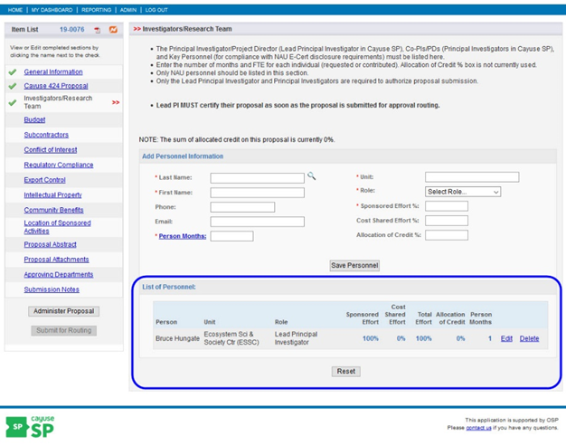

It’s important to complete this section accurately, since this information populates the electronic proposal routing list. Only the Lead PI and Co-PI roles certify the proposal (contrast to Investigator role, for which the department, and NOT the individual, is included in the proposal routing chain). You may add, edit, or remove individuals from the list by reopening the Investigators/ Research Team section PRIOR to submitting the proposal for routing. After the proposal is submitted for routing, the Lead Principal Investigator and all Principal Investigators will receive an electronic notification to certify the proposal.

There can be only one individual with the Lead Principle Investigator role on the proposal. Once the Lead Principle Investigator role has been assigned, the Lead Principle Investigator role will no longer be available in the role drop down menu.

**Reset**

Caution: Clicking “Reset” will remove all personnel from the Investigators/Research Team section of the proposal.

*Note: While building the research team, all personnel’s affiliated units will be automatically added to the “Approving Departments” section. It is recommended that you also verify the information in the “Approving Departments” section is accurate after completing the Investigators/Research Team section.*

## Budget Section

The budget section contains summary (not detailed) information about the initial and cumulative budgets, internal and third-party cost share/match, and additional needed resources (if applicable) for internal NAU use. These data are used in institutional reports about proposal submissions and awards which are directly accessible to investigators and other users according to their roles.

#### **Overview**

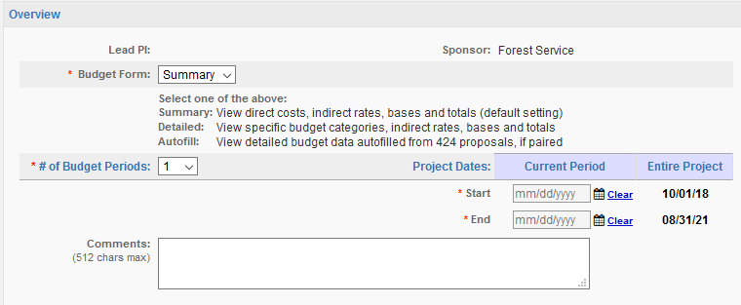

The overview section lists the Lead PI and Sponsor. If that’s correct, enter the following information in the blocks, as shown above:

1. Budget Form: NAU does not use the detailed budget. Select “Summary” unless the proposal is a paired Cayuse 424 proposal and you have completed the SF424 budget pages. In this case, you have the option to auto-fill the Cayuse SP budget summary from the Cayuse 424 grants.gov budget forms, which assures that the Cayuse 424 proposal and the information in Cayuse SP are in sync.
2. Enter the number of budget periods and the start- and end- dates for the first year (current period). The program default is one budget period; adjust this block for multi-year projects.
3. Click on the calendar icon to enter the start and end dates for the first budget period (Current Period). The dates for the entire project are auto-filled from the *General Information* section.

#### **Cost Sharing**

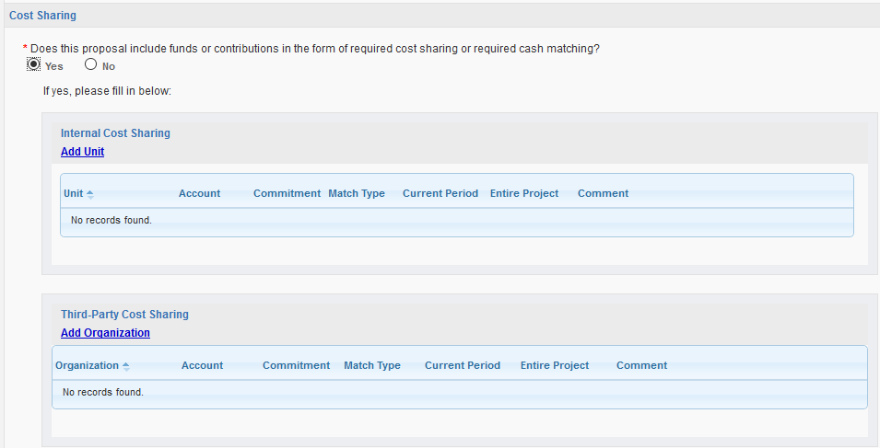

Internal cost sharing is recorded directly in Cayuse SP, creating a permanent, searchable record for each proposal. Select “yes” if the budget includes cost sharing, then click on the **Add Unit** link to identify the source and amount of cost share. You may add as many cost sharing units as necessary to capture all cost sharing. If the account is unknown, enter TBD. Also indicate whether the commitment type is **Mandatory** or **Voluntary**. In either case, check all applicable types of cost share (F&A, In-Kind, Cash, etc.). Follow the same procedure to add each cost sharing unit, including Third Party Match. Upload cost sharing documentation in the *Attachments Section.*

**As each cost sharing unit is added, the source department/unit, etc. is added to the electronic approval list. The proposal cannot be submitted until all cost sharing has been approved.**

**IMPORTANT: All cost sharing requests from the Vice President for Research (VPR), including cash match, tuition waivers, F&A waiver/reduction, etc. must be approved by the PI’s chair, director and/or dean prior to consideration by the VPR. Please submit early to allow sufficient time for thoughtful consideration of the request; late requests may be declined without consideration. Your college grant administrator or OSP GCA/GCC can advise you about preparing the request.**

#### **F&A Rates**

NAU’s most recent F&A rate agreement was effective March 16, 2017. The rates are as follows:

|  |  |  |  |  |  |
| --- | --- | --- | --- | --- | --- |
| **Type** | **From** | **To** | **Rate (%)** | **Location** | **Applicable to:** |
| PRED. | 07/01/2015 | 06/30/2021 | 52.0 | On-Campus | Organized Research |
| PRED. | 07/01/2015 | 06/30/2021 | 26.0 | Off-Campus | Organized Research |
| PRED. | 07/01/2015 | 06/30/2021 | 51.2 | On-Campus | Instruction |
| PRED. | 07/01/2015 | 06/30/2021 | 26.0 | Off-Campus | Instruction |
| PRED. | 07/01/2015 | 06/30/2021 | 30.9 | On-Campus | Other Sponsored Activity |
| PRED. | 07/01/2015 | 06/30/2021 | 26.0 | Off-Campus | Other Sponsored Activity |

In Cayuse SP, up to three different F&A rates may be entered. Since the NAU **research** rate escalates three times during the term of the agreement, many research proposal budgets will require at least two rates depending on the length of the project. The **instructional** and **other sponsored activity** rates, however, are fixed for the term of the agreement.

More information about NAU’s F&A rate is available in the [Frequently Requested Information about Proposal Development and Award Management](https://nau.edu/uploadedFiles/Administrative/Research/Sponsored_Projects/_Forms/Frequently_Requested_Information.pdf) quick reference guide on the OSP web page. The [Colleges and Universities Rate Agreement](https://nau.edu/uploadedFiles/Administrative/Research/Sponsored_Projects/_Forms/NAU%20IDC%20Rate%20Agreement,%20Mar%2016,%202017.pdf) also is available for review.

#### **Budget Categories**

1. Enter the total direct costs, F&A Base and Rate for the first budget period (see the example on the next page).
2. Verify that the correct F&A Rate is shown. Open the *Change Rate* link if you need to correct the rate. If you aren’t certain which rate applies to your project, contact your GCA/GCC.
3. These fields may be edited manually by unchecking the boxes. You will need to recalculate totals if the direct and F&A base amounts are changed.
4. When developing your project budget, do not use multiple F&A rates within the same budget period unless you are advised to do so by your GCA/GCC. (Explanation: budgets are estimates and expenditures may or may not correlate with an artificial allocation of costs over the period of a year. While the use of multiple rates *is* typicalfor a cost/price analysis type proposal, your GCA/GCC will advise you when that’s required.)
5. Under the Entire Project column, enter the total amount (all years) of direct funding, the F&A base(s), and the F&A rate(s) as shown in the example below.

**Example: Research budget with two different F&A rates:**

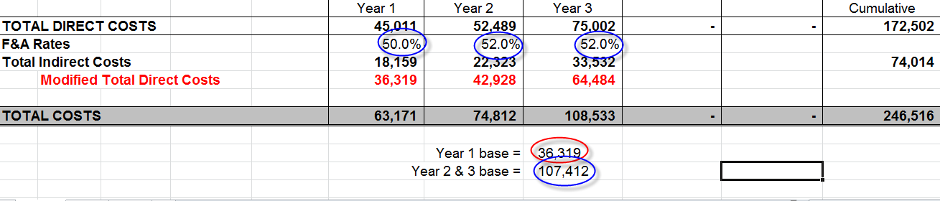

The above example is for a three-year on-campus research project with a start date of July 1, 2014. The Year 1 rate is 50% MTDC, and 52% MTDC for Years 2 and 3. The F&A base(s) for Y1 and Y2/Y3 are $36,319 and $107,412 respectively. (In contrast, an on-campus public service project would be fixed at 30.9% MTDC for the life of the project; similarly, an on-campus instructional project would be fixed at 51.2% MTDC.)

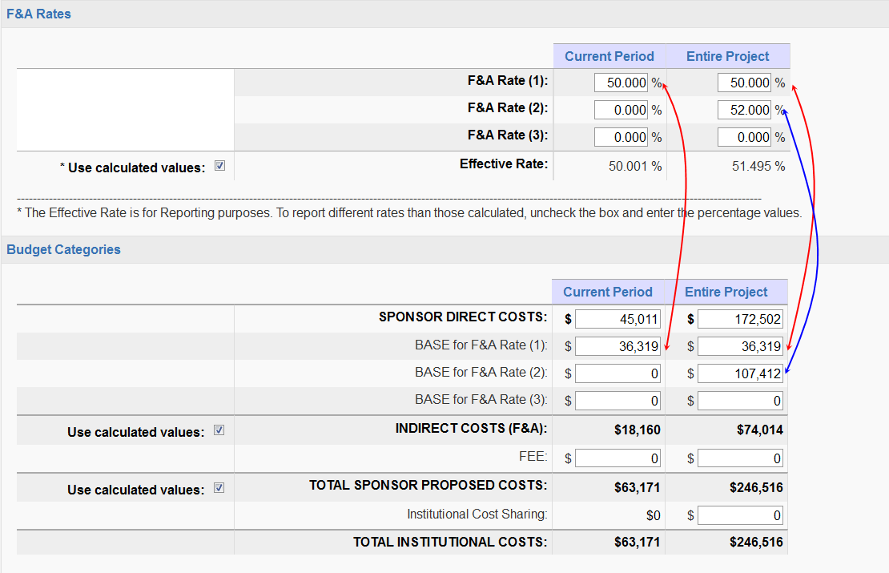Transferring the numbers from the above spreadsheet to the Cayuse SP F&A rate section produces the following entries. The arrows show how the F&A rate for the first year corresponds to the F&A base shown for the Year 1 budget, and similarly, the F&A rate for Years 2-3 corresponds to the F&A base for Years 2-3.

#### **Additional Resources**

1. If additional personnel, space, or equipment from outside the University is necessary to complete the proposed project, check all that apply, and provide a justification for each item in the space provided. If space needs will involve new construction or renovation of current facilities, upload a copy of the proposed changes and approval from Facility Services in the *Attachments* section. **Discuss the resource needs with your Chair/Dean/ Director, etc. if you answer “yes” in this section PRIOR to routing the proposal for approvals.**
2. Once this section is complete, clickthe *Save* button. The budget section should now have a green check mark.

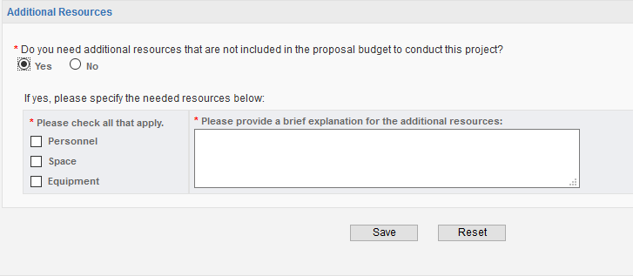

## 

## Subcontractors

If there are no subcontractors, click on the *No Subcontractors* button; otherwise click on the magnifying glass icon to identify the subcontractor, and then click on the *Add Subcontractor* button to add the subcontractor. Upload the required subcontractor documents in the *Attachments* section. If the subcontractor is not listed, contact your GCA to have the entity added to the vendor list.

# 

# The Compliance Sections: Conflict of Interest, Regulatory Compliance, Export Control, and Intellectual Property

The questions in these sections are required for compliance with federal regulations. Each section contains one to three questions and a contact for questions. All questions in these sections *must* be answered by the Lead PI. Even if someone other than the Lead PI is entering most of the information in Cayuse SP, the Lead PI must log on to answer the compliance questions when s/he logs on to certify the proposal.

## Conflict of Interest

NAU’s Conflict of Interest in Sponsored Projects Policy includes the requirement that the Lead Principal Investigator, Principal Investigators, and other key personnel review and, if necessary, update their NAU E-CERT Program disclosures PRIOR to proposal submission. The Lead PI and Principal Investigators certify to this review when each certifies the proposal.

**The Lead PI is responsible for assuring that other key personnel have completed and/or updated the E-Cert prior to proposal submission.**

OSP has worked with Cayuse to set up the Conflict of Interest page to make the COI questions self-explanatory, and have included additional links within the COI page for assistance in completing the COI section.

**If you have questions, please contact your GCA.**

**Conflict of Interest Questions**

All Northern Arizona University Investigators seeking external sponsored funding from a PHS agency, NSF and other applicable agencies (<http://sites.nationalacademies.org/PGA/fdp/PGA_070596>) are required to complete the following questions before a proposal can be submitted.

Instructions: The Principal Investigator (Lead Principal Investigator) is required to answer the following questions. All Co-Investigators and/or Co-Principal Investigators are required to complete the [Disclosure of Significant Financial Interest questionnaire certification](https://in.nau.edu/wp-content/uploads/sites/147/2018/08/Disclosure-of-Significant-Financial-Interest-Questionnaire-Certification-ek.pdf) and submit in the Proposal Attachments section in Cayuse.

* All questions on the COI page are required fields

* 1 Do you or your family member* hold a position of management, such as board member, director, officer, partner, trustee, employee or consultant with a sponsor, a vendor or (sub) contractor related to the proposed sponsored program activity?

* Family member incudes Investigator’s immediate family; specifically dependent children, spouse or domestic partner.

* 2 Do you or your family member have a Significant Financial Interest (SFI) in a Sponsor, a vendor or (sub) contractor related to your proposed sponsored program activity?

Significant Financial Interest includes payments (including salary, consulting fees, honoraria and gifts) stock, stock options, and/or any other ownership interest valued at more than $5,000 or 5% ownership and/or a Financial Interest that:

* if with a publicly traded entity, the aggregate value of any salary or other payments for services received during the 12-month period preceding the disclosure, and the value of any equity interest during the 12-month period preceding or as of the date of disclosure, exceeds $5,000; or
* if with a non-publicly traded entity, the aggregate value of any salary or other payments for services received during the 12-month period preceding the disclosure exceeds $5,000; or
* if with a non-publicly-traded company, is an equity interest of any value during the 12-month period preceding or as of the date of disclosure; or
* is income exceeding $5,000 related to intellectual property rights and interests not reimbursed through the Institution, or
* reimbursed travel related to your institutional responsibilities (teaching, research, academic advising, etc.), excluding travel reimbursed by U.S. Federal, state or local governmental agencies, U.S. institutions of higher education, research institutes affiliated with institutions of higher education, academic teaching hospitals, and medical centers

* 3 Could the value of your or your family’s Significant Financial Interest reasonably affect the outcome of the proposed sponsored research/activity?

Complete the [Section II SFI Supplemental Disclosure Form](https://in.nau.edu/wp-content/uploads/sites/147/2018/08/SFI-Supplemental-Disclosure-Form-ek.pdf) only if you answered “Yes” to question 1, 2, or 3 above.

* 4 I certify that I have read and understand the [NAU Conflict of Interest in Sponsored Projects (COISP) policy](https://nau.edu/university-policy-library/wp-content/uploads/sites/26/COI-in-Sponsored-Projects.pdf) and if applicable, the Addendum for PHS-funded projects. I will cooperate in the development of a conflict management plan if determined to be necessary by the University; and I will comply with the conditions or restrictions imposed by the University to manage, reduce, or eliminate actual or potential conflicts of interest.

* 5 Has the NAU Foundation received a cash or in-kind gift from the Sponsor of this project for the use or benefit of any investigator or key person?

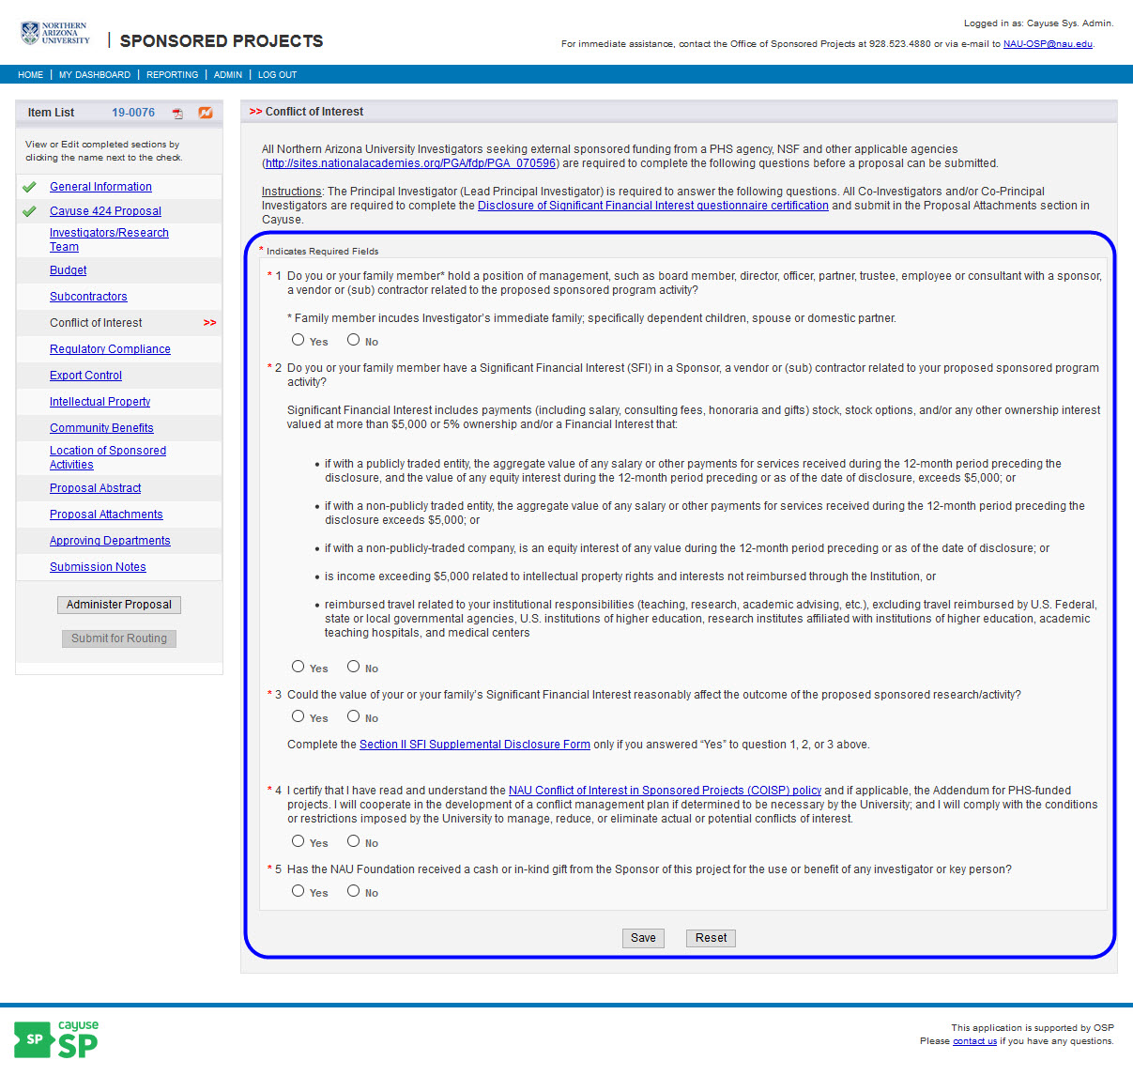

## Regulatory Compliance

If the answer to a Human or Animal Subjects question is “yes”, a new section opens to indicate whether an IRB or IACUC protocol has been submitted. If the protocol is pending, indicate “Submission is pending.” For animal subjects, each species must be listed.

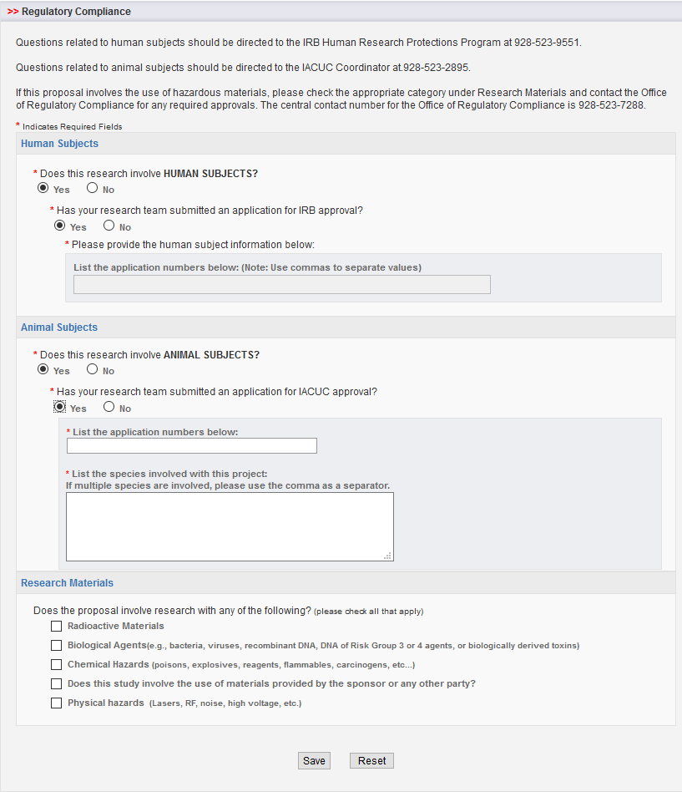

## Export Control

NAU is required to comply with Federal regulations governing the distribution of controlled information and technology to foreign nationals and foreign countries for reasons of foreign policy and national security. Areas of concern include preventing terrorism, restricting exports of goods and technologies that may contribute to military potential of foreign adversaries, and protecting the loss of goods and key technologies that could affect the U.S. economy. The questions in this section are intended to assure that any potential issues related to your project are addressed *prior* to award.

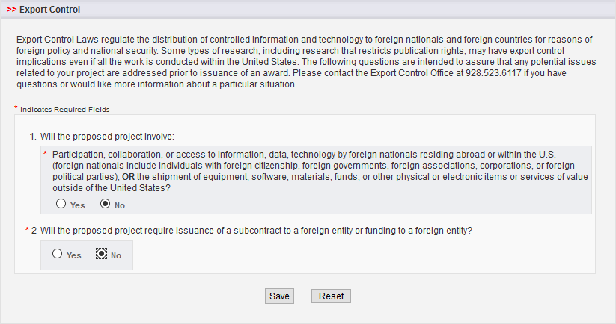

## Intellectual Property

Terms and conditions in sponsored research agreements and licensing or material transfer agreements can sometimes conflict with one another, affecting the management of intellectual property. Your answers to these questions will help speed communication and avoid problems that may delay your project. If you have questions or would like more information, please contact your [NAUInnovations@nau.edu](mailto:NAUInnovations@nau.edu). Once this section is complete, be sure to click on the *Save* button at the bottom on the page.

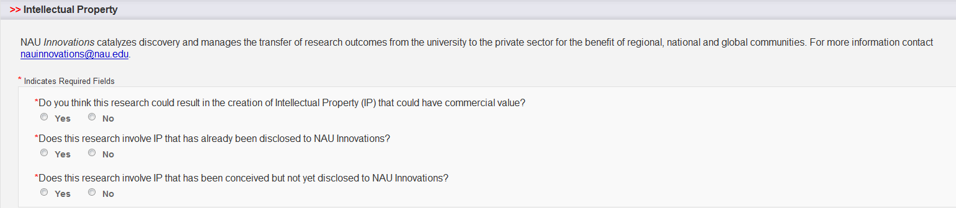

# Information for Institutional Users

## Community Benefits

The information in this section is related to NAU’s strategic mission and goals, and the questions are drawn from the current strategic plan. There are questions about services to Native American, Hispanic, and other minority students; undergraduate research; environmental and sustainable system, economic development, etc. One of the questions allows you to select the primary activity most closely identified with your project, and there is also space provided to select additional areas that describe your activity. Once this section is complete, click on the *Save* button at the bottom on the page.

## Location of Sponsored Activities

NAU reports space usage biannually to the federal government and this information is also used in calculating our Indirect Cost Rate. There are four possible locations: on-campus, in-state, out-of-state, and out-of-country. You may list multiple sites under each location but the sum of all percentages in all locations must equal 100%.

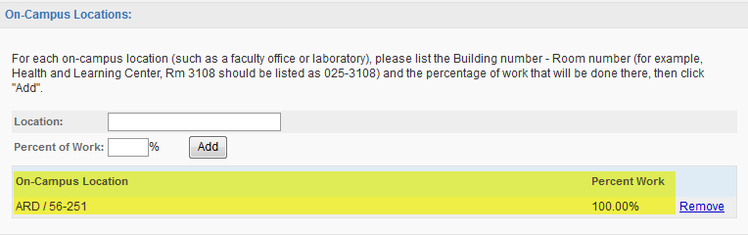

For *each* on-campus location (such as a faculty office or laboratory), provide the abbreviated building NAME and NUMBER, and the room number. For example, Room 3108 of the Health and Learning Center would be listed as “HLC/025-3108”. Indicate the percentage of work that will be done at that location, then click "Add". Follow a similar process to enter in-state, out-of-state, and out-of-country locations. Note the drop-down boxes to enter in-state and out-of-state information.

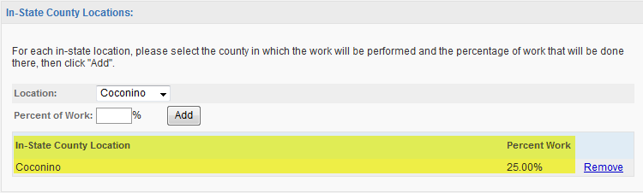

## Proposal Abstract

Information provided in the abstract is included in many reports, including the annual research report. It also can be used for keyword searches if you choose to include a list of keywords. **Important:** *Please do not include proprietary information in the abstract.* **Important:** *Please do not paste the summary section from your proposal; write something brief for this section.*

In this section you may also select the Field of Science (FOS) code that best describes the proposal; the categories are provided by the federal government for use in reporting research. For instruction and service projects, select the field that best describes the activity. If you don’t know, ask your OSP GCA/GCC for assistance. Remember to click on the *Save* button at the bottom of the page.

## Proposal Attachments

The *Proposal* *Attachments* section is a key resource for investigators, departmental administrators, and approvers in Cayuse SP. The uploaded documents are a permanent record of the proposal, including the opportunity announcement, proposal, excel budget, cost share documentation, letters of support, subcontract/subrecipients commitment forms, etc. Simply select the appropriate document type, browse for the file, and upload the document.

There is no restriction on the number of attachments that may be added, and there is no restriction on file size although larger documents will take more time to upload. **Any file type (with the exception of .exe) is acceptable.**Attachments may be viewed by the Research Team, Approvers from approving departments and colleges, etc., and OSP.

## Approving Departments (and other Approvers)

Cayuse SP automatically includes the Lead Principal Investigator, Principal Investigators, Award Department (managing department), PI department(s), cost share sources, and affiliated centers and institutes in the list of Approving Departments. The Award Department is always listed first and cannot be changed or removed. The additional departments listed are those that must approve the proposal record. **Each college must be manually added to the Approving Departments list, unless one is already listed because it is providing cost share. (This is a known problem and will be corrected in an upcoming update to Cayuse SP).**

One change that you’ll note from Cayuse 424 is that *offices* rather than *individuals* are listed. The names of individuals only appear when the proposal is certified.

The Research Contacts list for the department/unit, college, center or institute can include several approvers in case the primary approver is unavailable (for example, the department chair and a delegate). To add or remove approvers, please send an e-mail to NAU-OSP@nau.edu.

Primary approvers will need to discuss with their delegates the circumstances under which they may provide the approval, since all approvers are notified of the need for the approval (and only one approval is required). Note: Cayuse SP uses the acronym “IPF” for Internal Processing Form and the term “IPF approver” to designate the individuals/offices which must approve a proposal.

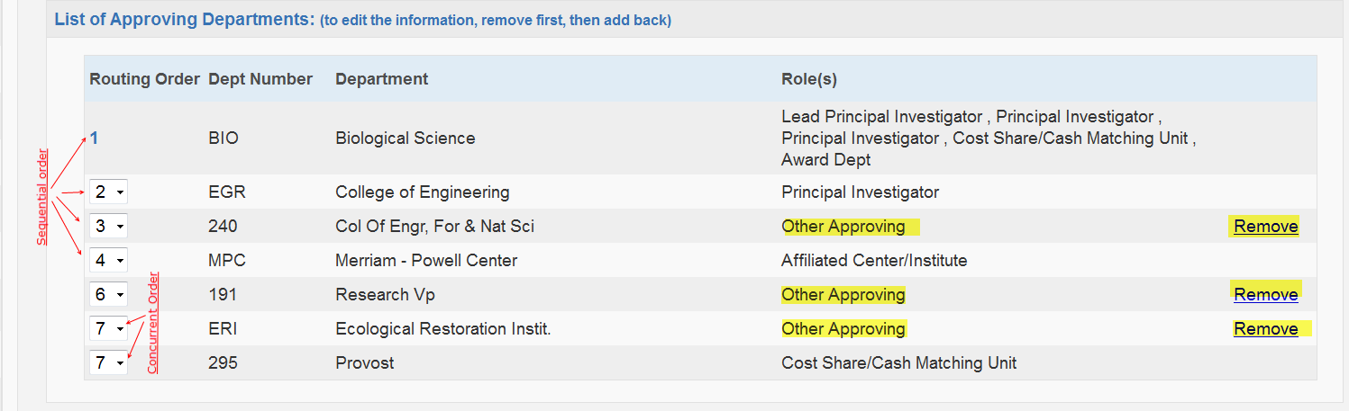The routing order for approving departments can be made *sequential* or *concurrent* by changing the number in the drop down box. The Award Department will always be listed first, but the order of other entries can be changed from *sequential* to *concurrent* to expedite review (this is useful in cases where multiple PIs must approve the proposal). See the examples in the figure above.

Approvers that were added based on information provided in the *General Information*, *Key Personnel, Budget,* etc. sections cannot be removed, but other approvers can be added.To add another department, click the magnifying glass icon and choose from the alphabetical list.

When all necessary departments, colleges, and other approving units are listed, click the *Authorize Department Listing* button. Note: you can make changes to this list until the proposal is submitted for internal review; contact your GCA if changes need to be made after review is initiated.

## Submission Notes

Provide any additional information, comments, or instructions regarding the proposal in this section. There is no limit on the number of notes. Notes are visible to all members listed on the Research Team, proposal approvers, and OSP, and may not be changed or deleted after creation.

**Prior to Submission: Review Cayuse SP Information**

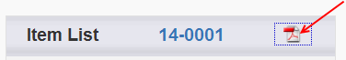An easy way to review all the entries you’ve made in Cayuse SP, including the research team, attachments, approving departments, etc. is to print the PDF copy of the proposal summary. The proposal summary can be used by approvers to review the proposal and can be printed as a permanent record of the approval.

## Submit the Proposal for Routing

As pages are saved, a green check box appears signifying that the requested information has been provided. When all sections of the Item List have green check marks, the proposal is almost ready for internal routing. **Important: Even though it’s very easy to enter and/or upload proposal information, wait to click the “Submit for Routing” link until after you’ve discussed the proposal with your OSP Grant and Contract Administrator (GCA) or Coordinator (GCC).**

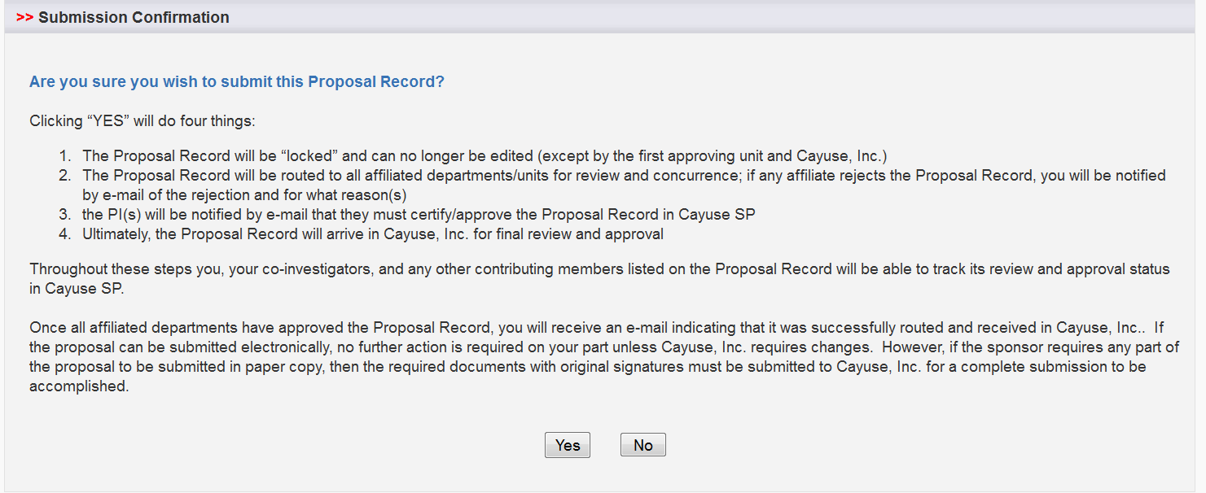To initiate internal routing, click the *Submit Proposal* button. A new window opens asking you to confirm that the proposal is ready for internal review:

When you click on the *Yes* button, proposal routing commences, triggering email notifications to the Lead Principal Investigator, Principal Investigators, Chair, Dean, and other individuals whose approval is required. Each of these individuals must log in to Cayuse SP to certify the proposal and/or provide other approvals.

Routing is the movement of a proposal through the internal reviews necessary for compliance and university approvals. During the routing process, the proposal record is certified by the PI, authorized by department/school/college/center administrators, and reviewed and authorized by the Office of Sponsored Projects. All review and approval of the proposal record is handled electronically within Cayuse SP. Paired Cayuse 424/Cayuse SP proposals also are routed in Cayuse SP. To view actions awaiting your review, open Cayuse SP and click on the link to *My Proposals* or *Proposals in My Dept.* on the Proposal Dashboard.

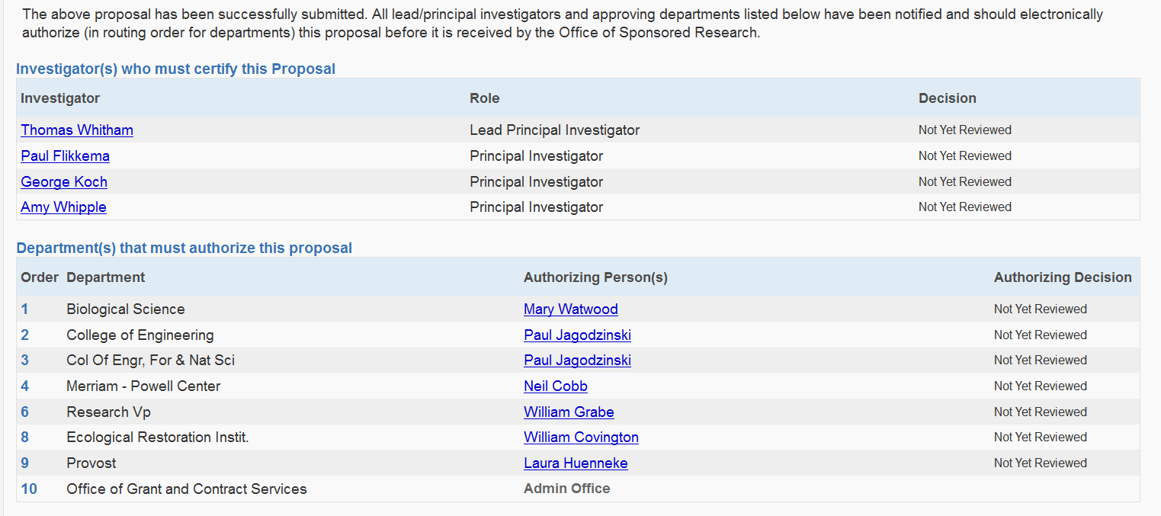

## PI and Co-PI Certification

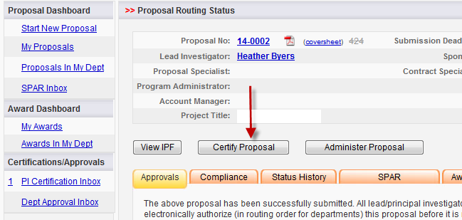The Lead Principal Investigator and Principal Investigators review and certify the proposal for submission by opening the *PI Certification Inbox*.

The PI certification is as follows:

In my role as an investigator, I understand and certify that:

* + - * The information submitted within this application is true, complete and accurate to the best of my knowledge. Any false, fictitious, or fraudulent statements or claims may subject me to criminal, civil, or administrative penalties.
      * I am responsible for the scientific/programmatic, fiscal and ethical conduct of the project and for providing the required deliverables if an award is made.
      * I will comply with all relevant state and federal regulations, Arizona Board of Regents (ABOR)/NAU policies, and contractual obligations in administering the resultant award.
      * I am not current debarred or suspended by the Federal Government.
      * I am award of federal lobbying requirements and am in compliance or have disclosed any lobbying activity.
      * I am not delinquent on any federal debt, such as taxes, student loans, etc.
      * I will work to ensure that my relationship with the sponsor of this project is either free of conflict of interest or consistent with a previously disclosed conflict of interest management plan.
      * I acknowledge my obligation to assign to the Arizona Board of Regents (“the Board”) any rights in Intellectual Property in which the Board claims an ownership interest under ABOR Policy 6-908 (“Policy”) and by submitting this form, I acknowledge that such assignment has been made in accordance with the Policy.
      * I understand that unallowable or unpaid costs under an award for this project may be transferred from the project account to a local account.

## Chair/Dean/Director and other Approvers

Once the proposal has been approved by the Principal Investigator, other internal approvers receive an email notification and link to Cayuse SP. These Approvers should open the Department (Dept.) Approval Inbox to review the proposal. The Chair/Dean/Director, other approver certification is shown below.

As Dean/Chair/Director, I understand and assume the following responsibilities with respect to this application:

* The project is an appropriate activity within the Department/Center/Institute; and supports NAU’s mission.
* The Department/Center/Institute has agreed to provide the resources identified in this application.
* When applicable, these resources could include cost sharing and the responsibility for unallowable or unpaid costs.
* When applicable, my authorization on this form indicates approval for faculty buyout and level of effort as stated in the proposal and proposal budget.

As each individual certifies the proposal, the date and time of the approval is indicated on the routing form. After all required approvals are received, the proposal is routed to OSP for final review by your GCA, and then submitted for approval by an individual authorized to approve documents on behalf of the Arizona Board of Regents (ABOR).

When all approvals have been provided, the proposal is submitted by the method you identified in the *General Information* section of the Item List.

# Cayuse 424 Grants.Gov Proposals

Cayuse SP does not change the way that S2S grants.gov proposals are submitted, but the procedures have changed. **Even if you’re very familiar with Cayuse 424 grants.gov submissions, please review this section carefully.**

All proposals, including Cayuse 424 grants.gov proposals, are begun in Cayuse SP. The Cayuse SP proposal is “linked” or “paired”, signified by the pairing icon, to a Cayuse 424 grants.gov application form set. When the Cayuse 424 proposal is complete and all required internal approvals have been given, the completed proposal will be submitted to grants.gov using the Cayuse 424 system-to-system (S2S) interface.

When you begin a proposal in Cayuse SP, the *General Information* tab is the first section you complete. If you are preparing a Cayuse 424 grants.gov proposal, you may create a new “paired” proposal; pair a Cayuse SP proposal with an existing Cayuse 424 proposal, or un-pair a Cayuse SP proposal from an existing Cayuse 424 proposal as shown in the graphic below. The link can be created or removed at any time by returning to this section of the *General Information* tab.

## Steps for Linking Cayuse SP with a Cayuse 424 Grants.Gov Opportunity

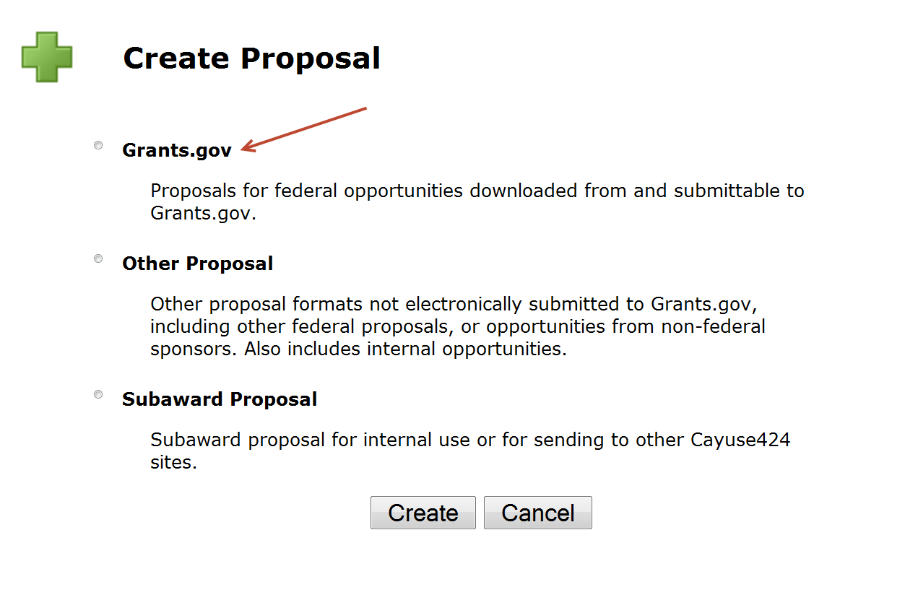When you click on the “Create a Paired Proposal” link, a *Create Proposal* window opens as shown below. For grants.gov submissions through Cayuse, select Grants.gov, and then click on the *Create* button, which opens the list of opportunities shown on the following page.



Select the applicable Opportunity Number by clicking on the icon next to the Opportunity Number. *If the funding opportunity does not appear in the list, contact your GCA/GCC to verify that a Cayuse 424 form set is available. If it is not available, the opportunity will have to be downloaded from and submitted directly to grants.gov.*

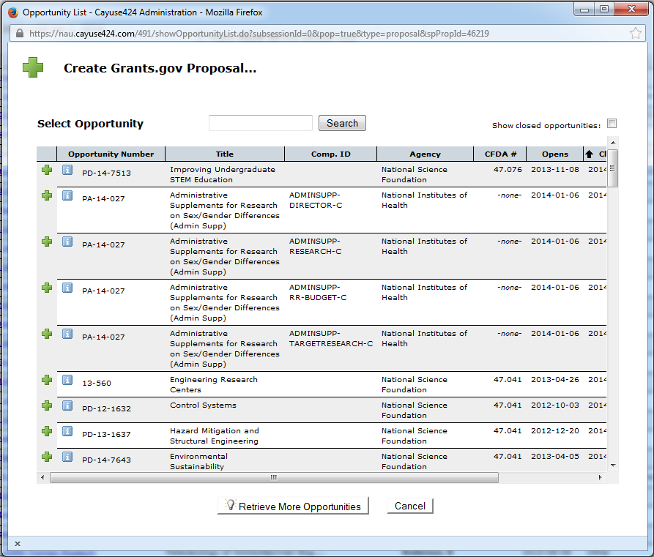

After you select an opportunity, the *Create Grants.gov Proposal* window opens as shown below. Enter the same short **Proposal Name** that you entered in Cayuse SP (Last Name, Sponsor, Deadline) and select the lead **PI**, the **Default IDC Rate**, **Number of Budget Periods**, and **Validation Type**. Then click the *Create Proposal* button to open the Cayuse 424 grants.gov application form set.

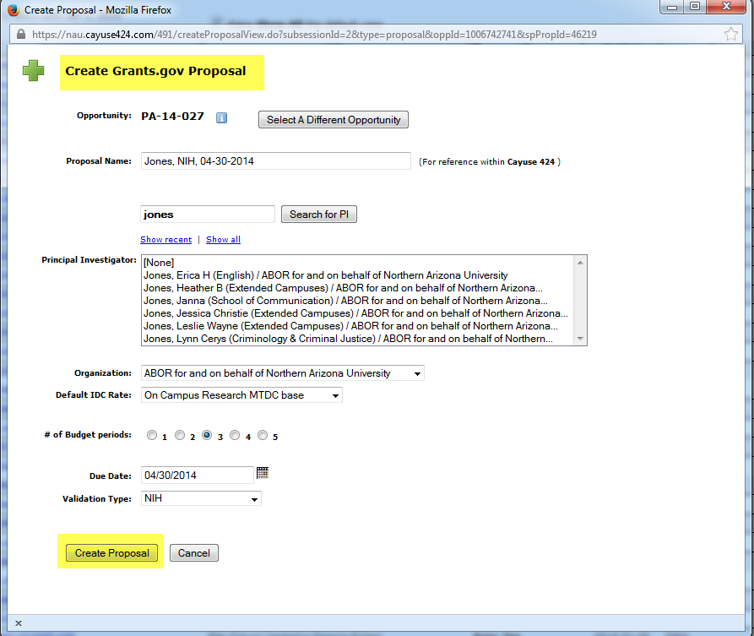

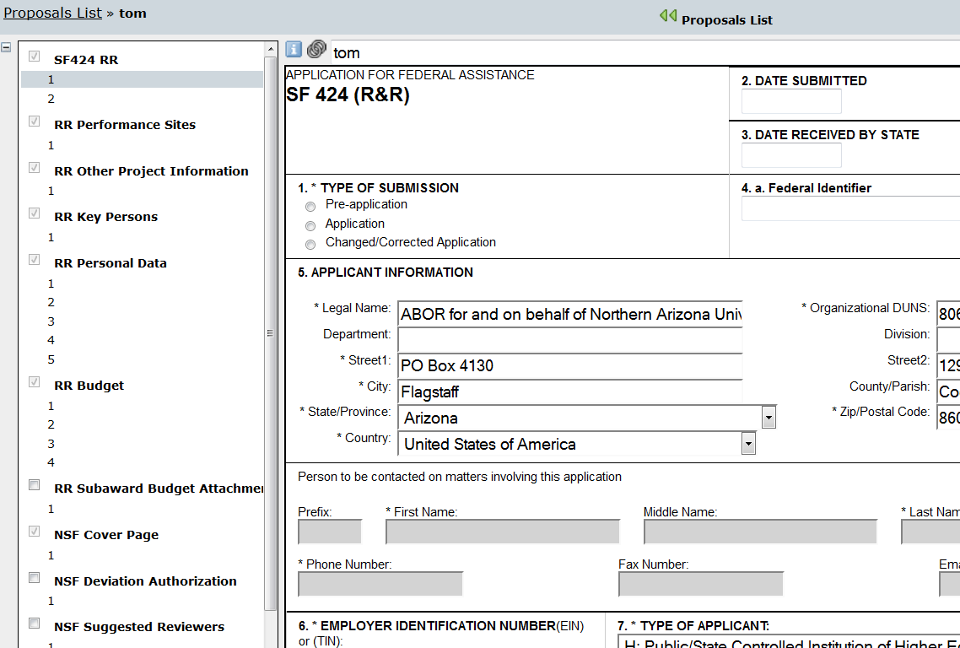Below is an example of a Cayuse 424 grants.gov form set. As with all grants.gov proposals, you will complete the required forms and load all sponsor-required attachments in the Cayuse 424 application form set. One important difference between Cayuse 424 and Cayuse SP is that you will not load any attachments in the Cayuse 424 Summary – Documents section. Instead, load these attachments in Cayuse SP.



*Tip: As shown above, keep both the Cayuse SP proposal file and the linked Cayuse 424 file open in your browser, switching back and forth by clicking on either tab.*

After initiating internal proposal routing, the Cayuse 424 proposal file is locked. *Tip: To continue work on your proposal during the internal routing period, un-pair the Cayuse 424 proposal* ***prior to routing*** *(click on the “Un-pair with 424 Proposal” in the General Information section of Cayuse SP).* Your GCA/GCC will guide you through this process, which is intended to maximize the time you have available to finalize the technical proposal. After proposal routing is completed, the Cayuse 424 grants.gov proposal can be “re-paired” with the Cayuse SP file by the same method.

That’s it. Questions? Call 928-523-4880 or e-mail [NAU-OSP@nau.edu](mailto:NAU-OSP@nau.edu) or contact your GCA/GCC directly.