PeopleSoft Financials-Grant Balance Inquiry Instructions
Purpose: These instructions are for PIs and departmental grant administrators on how to set up an inquiry that can be used to determine an award’s balance within the PeopleSoft Financials system. After setting up an initial inquiry and saving it as a Favorite, the inquiry will be available for quick and easy retrieval in the future.
SETTING UP AN INQUIRY
To begin, use the NAU CAS sign on to log on to PeopleSoft Financials. The PeopleSoft Financials login is located on NAU’s Office of Sponsored Projects website http://nau.edu/Research/Sponsored-Projects/ under RESOURCES.
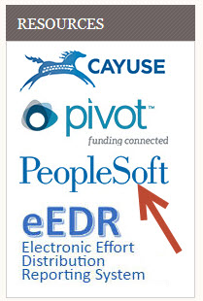
After signing into PeopleSoft; Click on the Main Menu, and then select Commitment Control as shown below
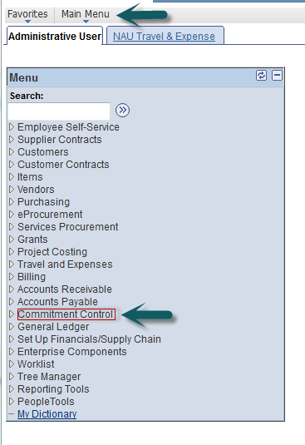
Page 1
Within the Commitment Control menu, select Budget Overview, under Review Budget Activities
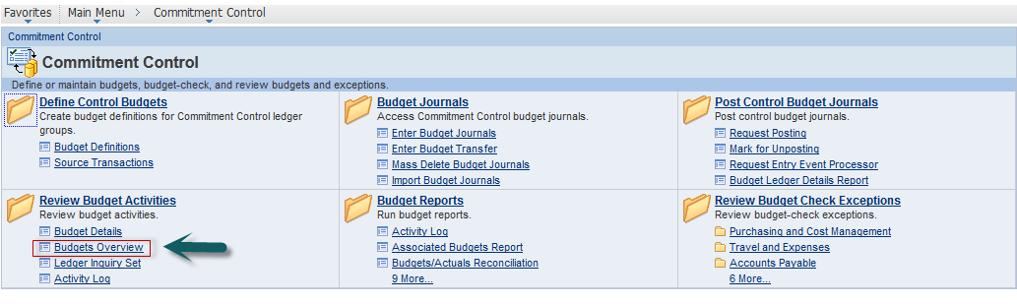
The Budget Overview screen will appear. The screen defaults to the “Find an Existing Value” tab, but you will want to navigate to the ”Add a New Value” Tab by clicking on that tab so that you can set up your initial inquiry.
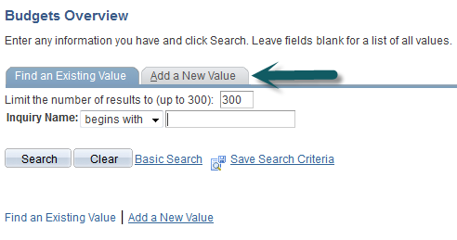
You will need to name the inquiry that is unique to you and the award that you want to query. The example below has the initials of the PI and/or person creating the inquiry (KB) and the sponsor (NSF). Once the name has been typed in the Inquiry Name box, click on the “Add” button.
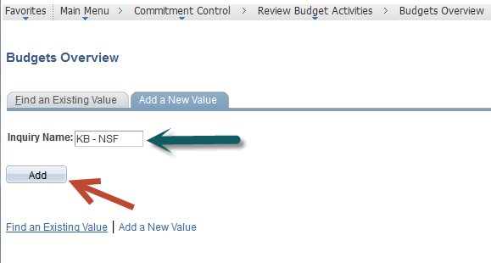
Now you are in the Budget Inquiry Criteria screen of the Budget Overview where you set up the criteria for the project you wish to have associated with the inquiry you’ve just named. The first two steps you need to complete on this screen are as follows: (1) Provide a description for the inquiry in the Description box. The example below has the sponsor, project id and the type of research. You may choose any description that best meets your needs. (2) Select the “Ledger Group” by clicking on the magnifying glass.

Page 2
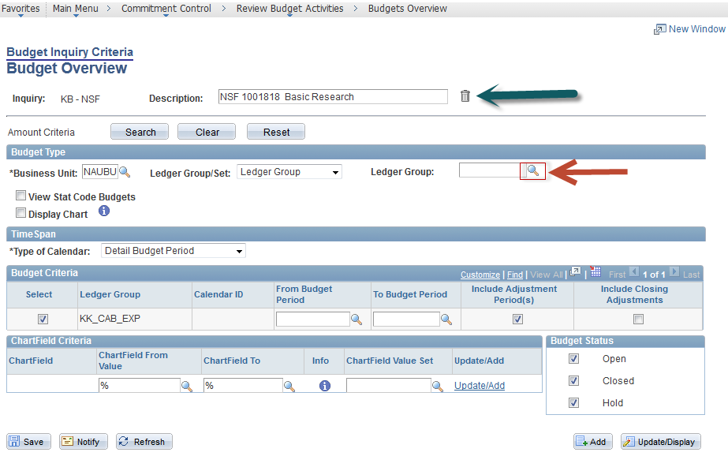
By selecting the magnifying glass, a pop up window will appear with a list of ledger groups to select from. You must select “KK_GMD”. Note that you will need to use the side scroll bar to scroll down to the section of the list where “KK_GMD” appears. Once you have found the “KK_GMD” ledger group click on any of the blue items on that line.
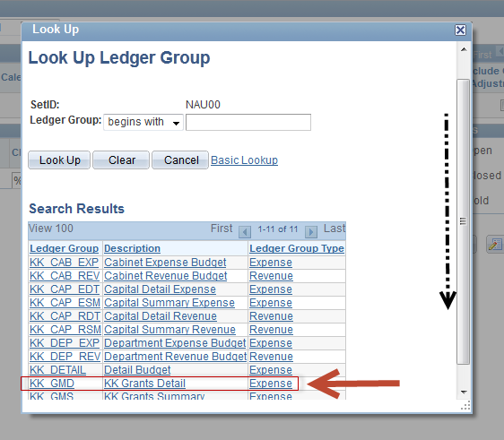
Notice that the Budget Inquiry Criteria Screen has now been updated and shows additional fields for inquiry criteria. You will see a Project field and will enter the project number of your award in this field as noted in the example below. If you do not know your project number, you could use the magnifying glass to open a window from which you could search for the number. This may be more time consuming to search through the entire listing of project numbers though.
Page 3
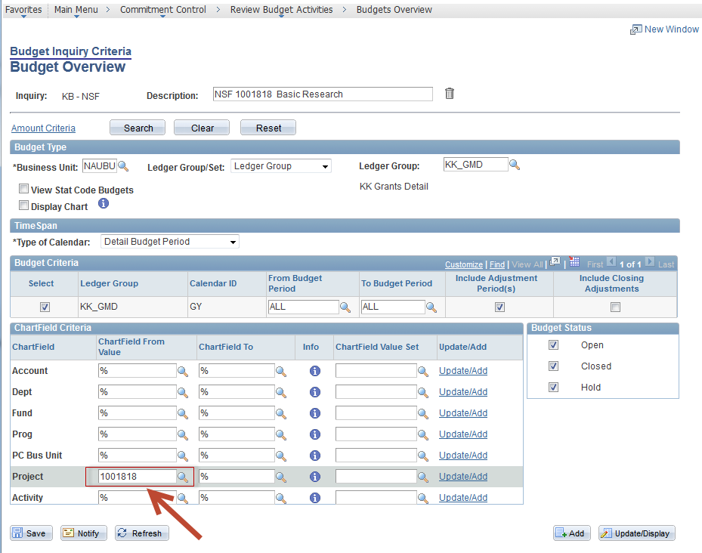
After having completed these steps, you are now ready to run your inquiry by clicking on the “Search” button.
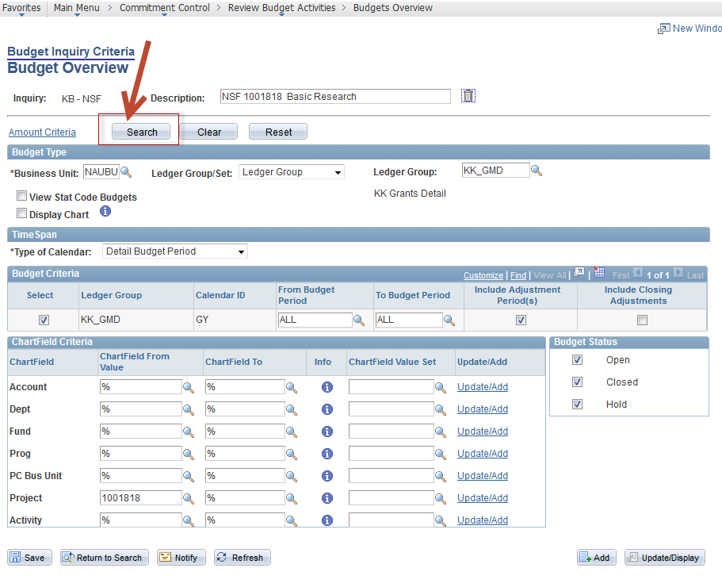
Page 4
Your inquiry may take a few seconds to run, and you can tell a query is running by this 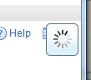 icon which is located at the top right corner of the screen. Please DO NOT continue to click the search button while this icon is present.

After the inquiry has finished running, you will see the Inquiry Results screen as shown below.
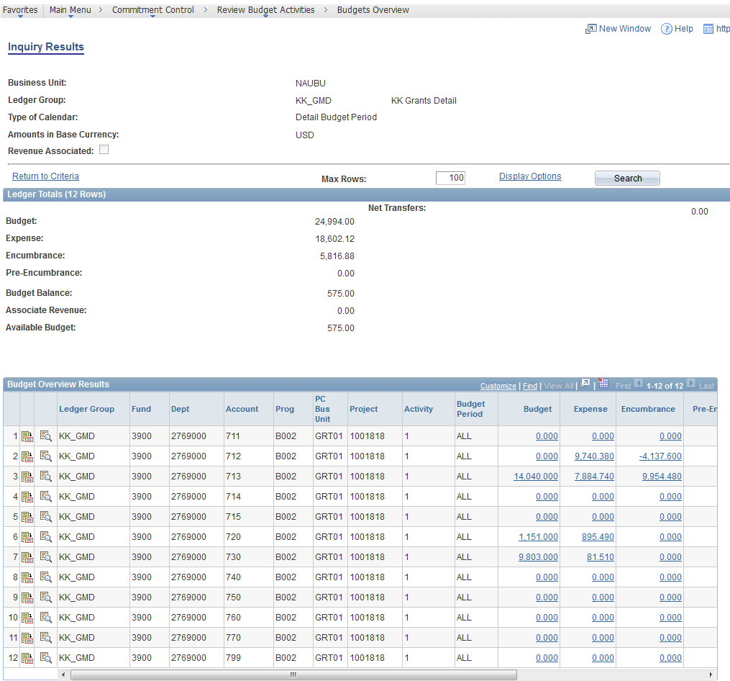
Using this example, you see that the Budget for this project is $24,994 and the remaining balance after subtracting both expenses and encumbrances is $575. A listing of the account numbers and their descriptions appears at the end of these instructions to assist you in reviewing the results.

Page 5

SAVING AN INQUIRY AS A FAVORITE
Now that you have set up your inquiry and viewed the results, you will save this inquiry into your favorites so that you can access the inquiry in the future through only a couple of clicks.
At the top left side of the screen, you will see a drop down menu labeled “Favorites”
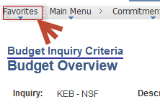
By clicking on the drop down menu the screen below will appear
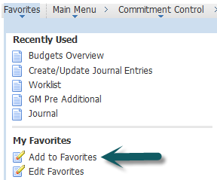
Click on the “Add to Favorites” and a pop up window will appear as shown below. Here you will enter a unique description for this Favorite. The example below has the agency, project id and the word Balance as this saved inquiry will be used to find the award balance.
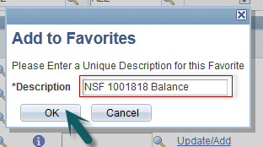
You have now successfully saved your inquiry for quick and easy retrieval!!

Page 6
RETRIEVING AN INQUIRY SAVED AS A FAVORITE
To retrieve your inquiry in the future, simply log into PeopleSoft Financials via the NAU CAS sign, or if you are already in PeopleSoft Financials, navigate to the Favorite drop down menu at the top left of the screen.
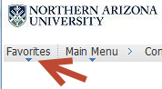
Click on the drop down menu and identify the name of the Favorite you wish to view then click on it.
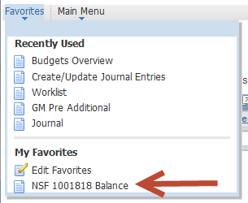
The Budget Overview screen will display where you will click on the “Search” button. This will run the inquiry that you previously created for this project.
Page 7

Once the inquiry has completed running, the award balance will appear in the Inquiry Results screen.
You have now successfully completed the steps to create an inquiry, save the inquiry as a favorite and retrieve the inquiry from your favorites listing. If you have questions on creating or running a Budget Inquiry using these steps, please contact your Post Award Administrator.

Page 8

